To: MSU University Council
From: R. Mark Worden, Chair 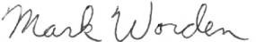

Topic: Interim Report by the Ad-Hoc Committee on Free Speech and Hate Speech Date: May 1, 2024

Origin of the University Council Ad-Hoc Committee on Free Speech and Hate Speech

At the Nov. 28, 2023 University Council (UC) meeting, Prof. Mark Worden, a UC member from the
College of Engineering, made a PowerPoint presentation on the status of free speech at MSU. The slides are attached to this report. The presentation described three instances that suggested the University
Council might want to assess the status of free speech on campus: (1) hecklers cursing and shouting
down an invited speaker on campus; (2) MSU’s low ranking on the 2024 Foundation for Individual Rights and Expression (FIRE) Free Speech Survey (in the bottom 36% nationally and lower than Michigan Tech, University of Michigan, and Wayne State; and (3) an MSU website being mocked by national news sources for claiming common words including gift, bunny, Christmas tree, and America were offensive.

After that presentation, Prof. Worden moved that a UC ad-hoc committee be established to assess free speech on MSU’s campus. During the subsequent UC discussion, the motion was amended to expand
the ad-hoc committee’s scope to include hate speech, and the amended motion was approved, thereby establishing the University Council Ad-Hoc Committee on Free Speech and Hate Speech.

According to MSU’s Bylaws (Section 5.4.2), the “Steering Committee shall recommend to the University Council the composition, method of selecting members, functions, and procedures of ad hoc
committees.” At the Jan. 30, 2024 UC meeting, the Steering Committee’s recommendations were
presented to, and approved by, the UC. The approved recommendations are attached to this report.
The Steering Committee’s recommended composition, and the constituent groups responsible for selecting the 16 Committee members, are copied below:
- 4 faculty/academic staff selected by Faculty Senate; not limited to faculty senators
- 2 undergraduate students selected by ASMSU
- 2 graduate students selected by COGS
- 4 administrators selected by the Provost
- 4 staff from unions selected by the Executive Vice President for Administration

Each constituent group selected its representatives, except for the four faculty/academic staff representatives, who were selected by the Steering Committee from a pool of nominated/self-
nominated candidates. The resulting 16 members of the Ad-Hoc Committee are listed in Table 1.

The first meeting of the Ad-Hoc Committee was organized and run by a representative of MSU’s Office of the Secretary for Academic Governance (graduate assistant Heidi Pineda) on April 2, 2024. The sole agenda item was to implement a process to select a chair and co-chair of the Ad-Hoc Committee. The process consisted of a self-nomination process followed by a secret vote by Email. The outcome of this process was that Prof. Mark Worden and Prof. John Zubek will serve as chair and co-chair, respectively.

Table 1. Members of Ad-Hoc Committee on Free Speech and Hate Speech, and their affiliation and Email addresses

College/Department/Group | Name | Email
College of Education | Kristine Bowman | klbowman@msu.edu
College of Engineering | R. Mark Worden | worden@msu.edu
College Communication Arts and Sci | Anastasia Kononova | kononova@msu.edu
College of Natural Science | John F. Zubek | zubekjoh@msu.edu
ASMSU | Kirti Deshpande | cdeio@asmsu.msu.edu
ASMSU | Ahmed Amir | amirahme@msu.edu
COGS | Laleh Dinpazhouh | dinpazho@msu.edu
COGS | Lindsey Sime | simelind@msu.edu
Office of Faculty and Staff Affairs | Kate Birdsall | birdsal5@msu.edu
International Studies and Programs | Anjam Chaudhary | chaud110@msu.edu
Student Life and Engagement | Genyne Royal | royalgen@msu.edu
College of Law | Nancy Costello | costel29@msu.edu
APSA | Joe Garza | garza@msuapsa.org
SSTU | Mitch Gast | gastrobe@msu.edu
UNTF | Victor Rodriguez-Pereira | president@untf.org
CTU | Steve Stofflet | stoffle1@msu.edu

Initial activities of the University Council Ad-Hoc Committee on Free Speech and Hate Speech

The Committee chair worked with MSU Information Technology staff to establish both an MSU Sharepoint Communication Site and a Sharepoint Teams Site for the Committee. The Teams site has been organized into sections and populated with electronic resources relevant to the Committee’s mission.

Due to the end-of semester creation of the Committee, it has proven difficult to schedule a time for the second Committee meeting until after finals week. That meeting is scheduled for May 2, 2024. Likely agenda items for this, and future, Committee meetings include the following:

- Discussing whether to meet over the summer as a full committee or a sub-committee.
- Formulating a list of high-priority issues related to free speech and hate speech at MSU to be considered; examples include the abovementioned three instances suggesting that the University Council might want to assess the status of free speech on campus.
- Identifying additional experts/committees on campus with whom the Committee could seek synergy of efforts and sharing of expertise.
- Expanding the Committee’s Teams Site’s archive of reference materials related to free speech and hate speech at public universities.
- Developing a list of target milestones/deliverables/recommendations the Ad-Hoc Committee could pursue as goals to simultaneously (1) increase freedom of speech on campus and (2) improve
collegiality on campus via discouraging hate speech.
- Considering venues for publishing the Committee’s results with participating Ad-Hoc Committee members being co-authors.

Enhancing Free Speech at MSU

Sen. Mark Worden (worden@msu.edu)
MSU’s Trustees have posted a Statement on Free Speech*
  - Key excerpts:
    - “Fundamental to Michigan State University’s philosophy on campus dissent is a belief that the rights guaranteed in the First and Fourteenth amendments of the Constitution must be protected.”
    - “Each right of an individual places a reciprocal duty upon others: the duty to permit the individual to exercise the right.”
    - “Regulations shall respect the free expression of ideas and shall encourage the competition of ideas from diverse perspectives.”
    - “The robust exchange of ideas and perspectives can be indicative of a healthy intellectual environment.”
    - It is impermissible for an individual or group to deny free expression to others who are engaged in peaceable discourse or dissent.”
* https://trustees.msu.edu/about/statement-free-speech.html

Questions of potential interest University Council members
- Should MSU embody the principles in its Statement of Free Speech?
- Who is responsible for safeguarding free speech on campus?
- Is there evidence of serious free‐speech violations on campus?
  - If so, how did MSU respond?
- Have any external survey(s) assessed free speech at MSU?
  - If so, what did the survey(s) show?
- What is the public’s perception of free speech at MSU?
  - Is that public perception helpful or damaging to MSU?
- What could be done to strengthen free speech at MSU?
Should MSU embody the principles in its Statement of Free Speech?
- Freedom of speech has long been considered a cornerstone of universities
- Evidence shows that university policies, culture increasingly restrict free speech
  - Damages the universities’ reputations
  - Damages the education they provide their students
- Several US Congressional hearings have documented this trend
  - https://edworkforce.house.gov/calendar/eventsingle.aspx?EventID=403038
  - https://docs.house.gov/meetings/JU/JU10/20180927/108458/HHRG‐115‐JU10‐ Wstate‐WoodP‐20180927.pdf
  - https://edworkforce.house.gov/uploadedfiles/3.29.23_owens_hewd_subcomittee_ hearing_opening_statement.pdf

Is there evidence of serious free‐speech violations on campus? *
- A nationally known invited speaker was shouted down by about 20 “protesters” in a large MSU auditorium (Oct, 2022).
- The student group that invited the speaker anticipated such problems and paid for MSU police to be present.
- The police eventually removed the “protesters” so the talk could resume.
- As attendees left the building, the “protesters” cursed them.
* https://statenews.com/article/2022/10/turning‐point‐msu‐ hosts‐candace‐owens‐protesters‐condemn‐her‐ideologies

Have any external survey(s) assessed free speech at MSU? *
- 2024 National College Free Speech Rankings
  - Conducted by Foundation for Individual Rights and Expression (FIRE)
  - Survey of 55,000 currently enrolled students at 250 colleges/universities
  - Comprehensive comparison of student experiences of on‐campus free speech
- MSU ranked in the bottom 36% nationally for free speech
- MSU ranked lowest of four large Michigan universities
  - MTU, UM, WSU, and MSU

- https://rankings.thefire.org/rank/school/michigan‐state‐university

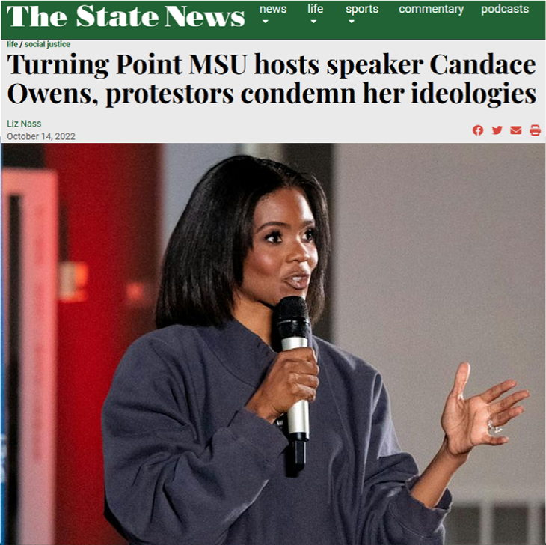
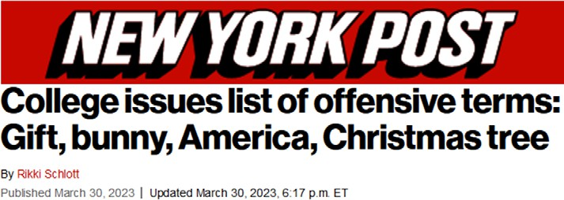
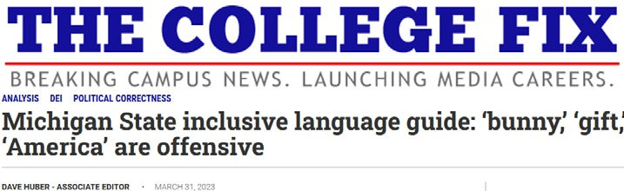
What is the public’s perception of free speech at MSU? *
- MSU was derided nationally for claiming that common words were offensive (March, 2023)
  - “Gift”
  - “Bunny”
  - “America”
  - “Christmas tree”

- https://nypost.com/2023/03/30/gift‐bunny‐and‐christmas‐tree‐are‐offensive‐words‐on‐campus/ https://www.thecollegefix.com/michigan‐state‐inclusive‐language‐guide‐bunny‐gift‐america‐are‐offensive/

What could be done to strengthen free speech at MSU?
- University Council (UC) could express support for free speech at MSU
- UC could encourage efforts to assess and strengthen free speech at MSU
  - Proposal: Independent, Ad‐Hoc Committee to study free speech at MSU
  - Membership:
    - Small, grass‐roots group of faculty, staff, and students
    - Qualifications: Participants should want to strengthen free speech at MSU
  - Mission:
    - Collect information relevant to free speech at MSU
    - Study best practices for strengthening free speech in academia
    - Identify potential opportunities to strengthen free speech at MSU
    - Submit final report to UC for its consideration and possible resolutions

Thank You
Mark Worden
worden@msu.edu

Steering Committee Recommendations for the Ad Hoc Committee on Free Speech and Hate Speech
On November 28, 2023, the University Council held a meeting where the council voted to “authorize an ad hoc committee to consider issues of free speech and hate speech on MSU’s campus” and referred the issue back to the Steering Committee.
At the January 9, 2024, Steering Committee meeting, recommendations were drafted in accordance with Section 5.4.2. of the Bylaws for Academic Governance that charge the Steering Committee with creating
recommendations to the University Council concerning “the composition, method of selecting members, functions, and procedures of ad hoc committees.”
The recommendations are as follows:

Composition/Method of Selecting Members
  - The committee shall be comprised of 16 total members
    - 4 faculty/academic staff selected by Faculty Senate; not limited to faculty senators
    - 2 undergraduate students selected by ASMSU
    - 2 graduate students selected by COGS
    - 4 administrators selected by the Provost
    - 4 staff from unions selected by the Executive Vice President for Administration
  - Each constituency should identify its representatives by the next University Council meeting on February 20, 2024. Each should do so by procedures of their choosing

Functions
  - “Consider issues of free speech and hate speech on MSU’s campus.” – University Council
  - Emphasis on campus climate – Steering Committee

Procedures
  - Chairperson and Vice Chairperson to be elected by the Ad Hoc Committee members
  - The committee should prepare an interim report to University Council by the end of the spring 2024 semester with a final report with recommendations by the end of the fall 2024 semester
    - A minority/dissenting report is welcome

  - The Ad Hoc Committee is welcome to invite guests or experts
    - It is suggested that the Ad Hoc Committee consult with
administration’s free speech committee

