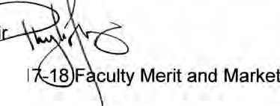

**MICHIGAN STATE**

UNIVERSITY

April 11, 2017

MEMORANDUM

TO :

Dr . June Youatt, Provost

FROM:

Dr. Phylis Floyd, Chai

SUBJECT:

Recommendation for 201 Pool Increase

-18

The University Committee on Faculty Affairs (UCFA) recommendation for the faculty merit and market pool increase in the 2017-18 academic year was developed on the basis of the following goals:

•

•

recruitment and retention of high quality faculty; maintenance of the quality and integrity of our academic programs;

recognition of faculty productivity as enrollments and competitive pressure for grants escalate; and

a desire to maintain and enhance morale in the context

of ensuring teaching and research quality and productivity.

•

**s**

•

UCFA remains concerned about the long term impact that the erosion of university-funded health benefits will have on faculty compensation; specifically, the;

**UNIVERSITY**

**COMMITTEE ON FACULTY AFFAIRS**

**Mictiigan StateUniversity 321.AdminisbationBuilding**

**East lmlsing, Ml 48824-1046**

**517(J56-e271**

•

initiation of health care premium sharing for all faculty as of July 2002;

elimination of funded post-retirement health care coverage for spouses for new hires as of July 2005; elimination of funded post-retirement health care coverage for new hires as of July 2010;

substantial increases in premiums for health care and pharmaceutical coverage; and

long-term implications of potential changes to federal and state funding of health care.

•

•

•

•

Together, these elements all point to tangible decreases in compensation benefits for faculty at MSU, which should ideally be counterbalanced by commensurate salary increases.

***MSU*** is **an*al /irmaliw•lctian.***

*equal-oppoftlnilyils1ilUlial.*

UCFA

April 11, 2017 Page2

Over the past decade, UCFA has used MSU's relative position among Big Ten universities as a key indicator of the university's performance in achieving the goals identified above. In 2016, with expectations of stable state funding, UCFA recommended an overall increase of 4.75 percent and received 3.5 percent.

As of 2016-17, MSU faculty salaries ranked 12th (of 14 institutions) in the Big Ten, one position lower than 2015-2016 and down from 9th place in 2009-10 (see attachment). Our goal in recent years has been to reach the middle of the Big Ten by exceeding the anticipated Big Ten average increase. This goal has not been achieved.

For the current year, however, the faculty also recognize that the university faces substantial budgetary uncertainty stemming from potential cuts to federal research funding and relatively low state funding for higher education, as well as possible challenges related to recruiting tuition-paying international students in the context of potential visa restrictions and wait times. The faculty also remain concerned about the affordability of higher education for many students.

Given that the need to remain competitive must be balanced against current financial uncertainties and access to university education for students, **we recommend a 4.0 percent salary increase for 2017-18 academic year.** Our recommendation includes a 3.5 percent general merit pool increase and 0.5 percent market adjustment pool increase.

Given that the average Big Ten continuing salaries have increased between 3 to 4 percent in recent years, a 4.0 percent total increase akin to last year would likely only allow us to maintain our lagging pos.ition at 12th out of 14. We therefore expect to request greater increases in the future.

MSU's faculty is a formidable force for discovery, creativity, and learning. Our salary request reflects an ongoing desire to ensure that the university continues to make a positive and significant impact on the life of the people of Michigan, the United States, and the world.

2



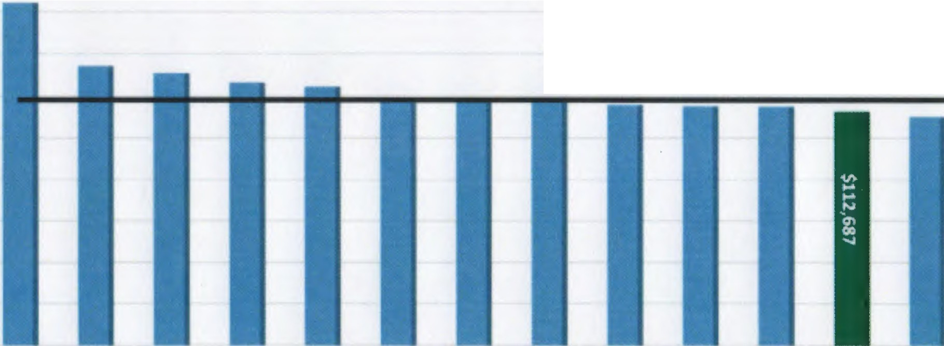

*?i*

n>

0

3

-

CD

:::,

**2016-17 Faculty Salary**

$180,000

$160,000

Big Ten average*: $118,800

$140,000

$UO,OOO

$100,000

$80,000

$60,000

$40,000

$20,000

.,.,..)

..

,.)

$0

/

.)

/

/

/

/+

,

/

.)

/.)

/

.)

♦.)

/

**MSU Rank in Big10 Institutions for Facul Sala**

16-161

16-171

**Rank**

05-06

06-07

10-11

11-12

13-1,&

**07-08**

10

08-09

10

**09-10**

12-13

11

**14-15**

9

8

13

10

9

8

14

11

9

8

13

12

10

9

14

13

Profess«

ki s ociate Professor ki sistant Profess or All Ranks Average

8

5

14

9

9

6

14

12

8

9

14

13

8

9

14

11

6

9

14

12

7

14

11

7

13

11

9

14

13

•Does not include NOl'f1M11111em - avwage indudin; NOlttlwntern $122,040

1 Rankings OYeffin1e adjuated ID include Rutgen and Maryland