

April 7, 2020

MEMORANDUM

To:

Dr. Teresa Sullivan Interim Provost

FROM: Richard Fulton

UCFA Chair

SUBJECT: Recommendation for the Long-term Faculty Merit and Market Pool Increase

This past fiscal year 2019-2020 represents the second of a two-year General Fund budget. Since 2018, we have seen a 2.0 percent salary adjustment (1.5 percent merit adjustment plus a 0.5 percent Provost Market adjustment) in 2018-19, and a 3.0 percent adjustment (2.5 percent merit adjustment, plus a 0.5 percent Provost Market adjustment) in 2019-20.

This spring, over the period of days, the faculty was challenged to convert traditional classes to an on-line format to mitigate the threat of COVID-19. This accomplishment and similar actions for the summer semester mark an extraordinary success for the faculty, but, also for the entire University. This year, the UCFA highlights the university’s continuing response to the COVID-19 crisis as evidence of the commitment and acumen of the faculty. Moving forward, the UCFA proposes that the principles of diversity, equity, and inclusion provide guidance for overall University operation and faculty compensation policies, in particular.

The UCFA recommendation for the faculty merit and market pool increase is rooted in the following goals:

•

•

Leading the Big Ten in recruitment and retention of high-quality faculty. Maintaining and building on the excellence, quality, and integrity of our academic programs.

Continued growth and improvement of student success (e.g. graduation

rates, persistence rates, and future employment rates), as well as the closing of the gap between white-minority students on these dimensions.

Excellence in research productivity, grantsmanship, and serving as in our respective fields.

R~~e~~cognition of faculty productivity as enrollments and competitive pressure for grants escalate.

A desire to maintain and enhance faculty morale in the context of ensuring teaching and research quality and productivity.

•

•

•

•

•

Challenges of recruiting leading researchers and scholars to East Lansing and retaining them once here.

Compensating for the East Lansing city income tax levied on all residents and employees in the city of East Lansing and enacted in January 2019.

Taking into account the increase in allocation of personal funds faculty have had to make for attending professional meetings, which contribute to professional development.

•

•

Moreover, UCFA remains concerned about the long-term impact that the erosion of university-funded health benefits will have on faculty compensation; specifically, the:

•

•

Initiation of health care premium sharing for all faculty as of July 2002.

Elimination of funded post-retirement health care coverage for spouses of new hires as July 2005.

Elimination of funded post-retirement health care coverage for new hires as of July 2010.

Substantial increases in premium sharing for health care and pharmaceutical coverage over the past decade.

Long-term implications of potential changes to federal and state funding of health care.

•

•

•

The UCFA has used MSU’s relative position among Big Ten universities as a key indicator of the university’s performance in achieving the goals identified above. As can be seen in Table 3, for the past decade MSU has typically ranked in the bottom quartile in faculty salary with MSU’s ranking being no higher than 11th (of 14 institutions) since 2010-2011.

As can be seen in Table 2, MSU’s ranking improves when viewed from a

compensation perspective; however, due to its reliance upon post-retirement health care provisions that are not applicable to faculty appointed after 2010, this position will deteriorate over time unless augmented by salary increases. For the past few years, the UCFA has sought, with modest success to improve MSU’s relative position among Big Ten universities in faculty salary by suggesting slightly above average annual increases in faculty salary as noted 2018.

Understanding that we are in the midst of COVID-19, but with an eye towards the longer term health of MSU, we recommend a 4.5 percent increase in annual faculty salary increments over the longer term inclusive of a 4.0 percent increase in the general merit pool and a 0.5 percent increase in the market adjustment pool in order to remain competitive and retain our leading researchers, given our goal of reaching the middle of the Big Ten in faculty salary. While this proposal is complicated by the continuing COVID-19 crisis at this time, it is hoped that by stating it now, the University can plan for its inclusion in the 2021-22 budget. As the financial situation changes due to COVID-19, we ask that we be included in conversations with the administration about any updates to this request.

Finally, we would appreciate President Stanley and Interim Provost Sullivan’s commitment to recommend support in the 2020-21 budget to provide MSU’s standard retirement contribution to qualifying academic year faculty appointed on summer budgets funded through either Research or General Fund and other accounts.

The UCFA salary recommendation reflects our ongoing desire to ensure that the University continues to make a positive impact on the life of the people of Michigan, the United States, and

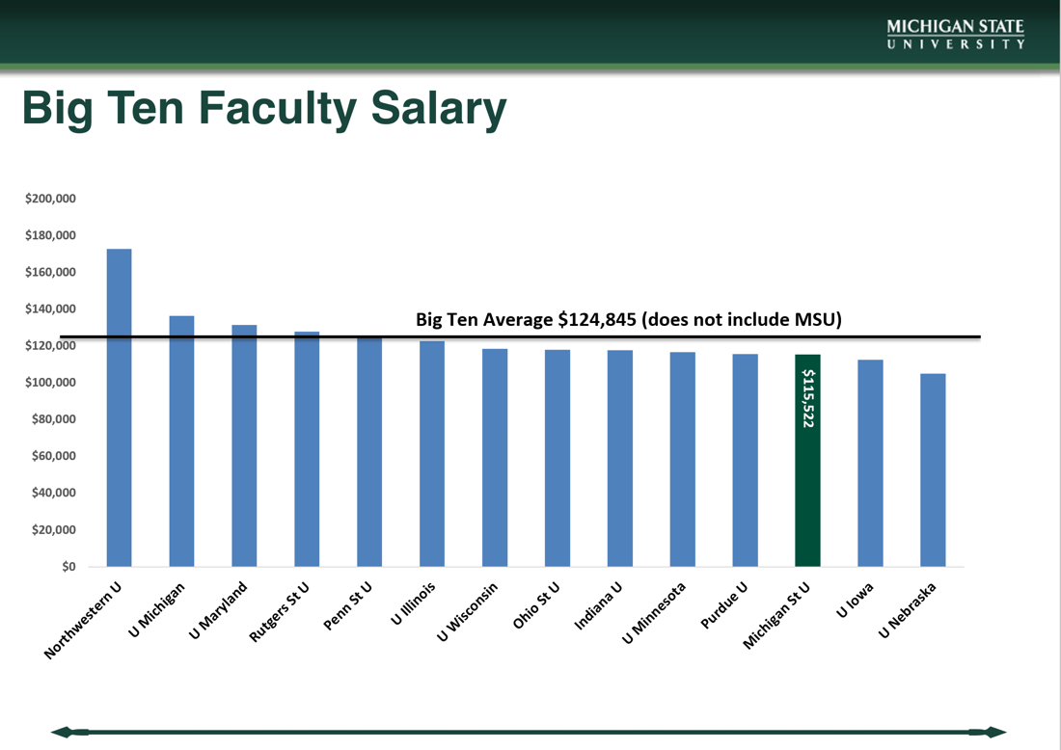

the world. The UCFA appreciates your consideration of our recommendation. Whatever the decision is regarding our recommendation, we are honored to continue to serve MSU.

Table 1

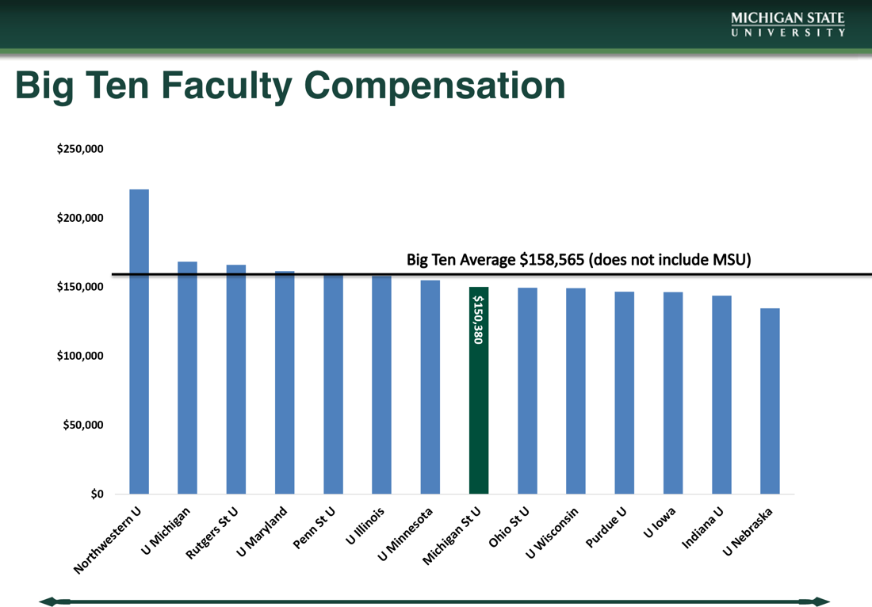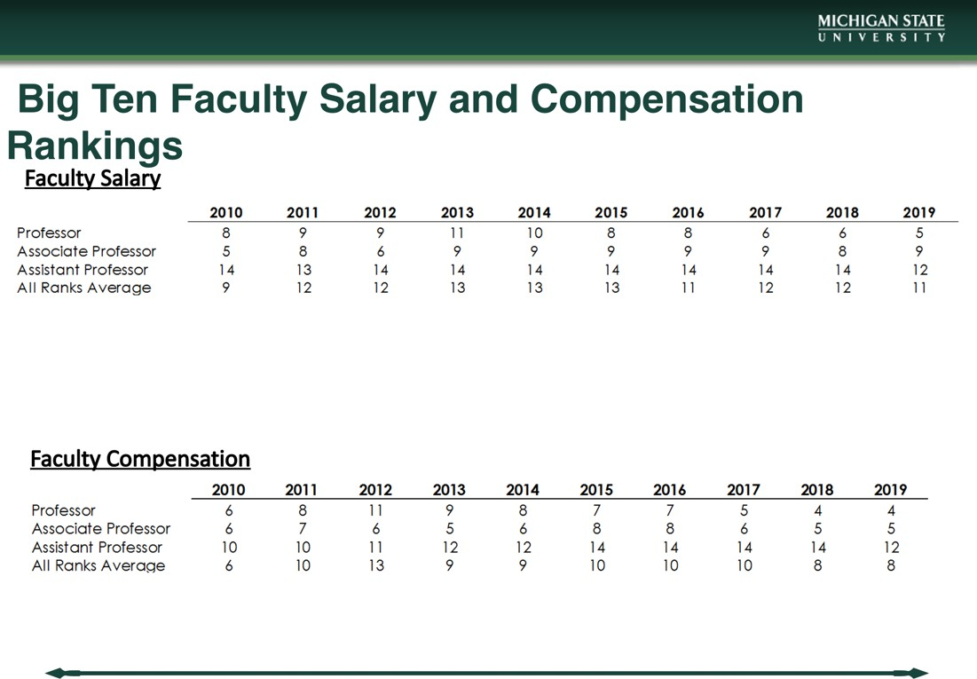

Table 3

Table 2

Near Term History of Proposed Salary Adjustments

•

For 2014-15, the UCFA recommended a 5.2 percent increase in faculty salary with a 4.0

percent increase in the general merit pool and a 1.25 percent increase in the market adjustment pool. MSU faculty received a 3.0 percent increase in inclusive of a 2.0

percent increase in the general merit pool and a 5.0 percent increase for retention concerns out of the University Academic Competitiveness Pool in 2014-15.

•

For 2015-16, the UCFA recommended a 5.25 percent increase in faculty salary with

a 4.0 percent increase in the general merit pool and a 1.25 percent increase in the market adjustment pool. MSU faculty received a 3.0 percent increase in salary inclusive of a 2.0 percent increase in the general merit pool, a 0.5 percent increase in the market adjustment pool and a 0.5 percent increase for retention concerns out of the University Academic Competitiveness Pool in 2015-16.

•

For 2016-17, the UCFA recommended a 4.75 percent increase in faculty salary with

a 4.0 percent increase in the general merit pool and a 0.75 percent increase in the market adjustment pool. MSU faculty received a 2.5 percent increase in salary inclusive of a 2.5 percent increase in the general merit pool, a 0.5 percent increase in the market adjustment pool and a 0.5 percent increase for retention concerns out of the University Academic Competitiveness Pool in in 2016-17.

•

For 2017-18, the UCFA recommended a 4.0 increase in faculty salary with a 3.5

percent increase in the general merit pool and a 0.5 percent increase in the market adjustment pool. MSU faculty received a 3.0 percent increase in salary with a 2.5

percent increase in the general merit pool and a 0.5 percent increase in the market adjustment pool in 2017-18.

•

For 2018-19, the UCFA recommended a 4.5 percent increase in faculty salary with a 4.0

percent increase in the general merit pool and a 0.5 percent increase in the market

adjustment pool. MSU faculty received a 1.5 percent increase in the general merit pool and a 0.5 percent increase in the market adjustment pool in 2018-19.