Materials for Faculty Senate Orientation, September 14, 2021
- Welcome and Opening Remarks
Chairperson Karen Kelly-Blake: Welcome to the Faculty Senate Orientation. My pronouns are she/her. I was on the receiving end of this orientation last year. A lot has changed in a very short time. Firstly, I am the newly installed Chair of the Faculty Senate for the 2021-2022 academic year, and we will learn our academic governance jobs together.
We have a packed agenda, so I want to keep this short because several things will be reiterated and expanded upon at other points in today’s orientation.
- First, thank you for serving on the Faculty Senate. I appreciate you being willing to speak up on behalf of your colleagues. Academic governance is the process by which the people affected by decisions get to participate in the making of the decisions, and it is important work that we need to take seriously. With that in mind—[proceed to point 2].
- Faculty Senate meetings are working meetings. Senators must come prepared to do the work of academic governance. What does that mean? Review the preparatory meeting materials ahead of the meeting so that we are ready to handle the business outlined in the agenda. Those materials are provided with plenty of lead time to get ready.
  - The Faculty Senate body is advisory and consultative. It is largely not a decision-making body. What does that mean for the work? The Faculty Senate role is to communicate faculty positions on issues, and those issues are primarily academic, e.g. curricular issues. The Senate is not the administration. The Senate is expected to raise issues, but with identified solutions.
  - How do you do this? You must communicate with your constituency, which is your college. You will share information and seek input from them.
- Read the Bylaws for Academic Governance. Senators would be well advised to take time to do so.
- Attend Board of Trustee meetings. These meetings along with agendas and webinar information is available on the MSU website. The board meetings are also now being held in person in the Hannah Administration Building on Central Campus. That information is also found on the website. I strongly encourage Senators to attend to inform your understanding of what happens at that administrative level. It is probably not what you might imagine.
- Update Zoom. We will repeat this in the Zoom etiquette portion of Orientation, but it bears stating here at the outset. Ensure that you have the most up to date version of Zoom prior to each meeting. Doing so ensures that these working meetings are time efficient and productive.
Thank you very much. And again, welcome to the Faculty Senate.

- Overview of Academic Governance | Tyler
Academic Governance in General
Tyler will present.
The Role of Faculty Senate
Tyler will present.
The Role of the At-Large Members and the Secretary for Academic Governance
Tyler will present.
- Breakout Groups – “Given Faculty Senate’s role, what are your goals for this year?” (5 minutes in group, 3 minutes report-out)
- Housekeeping
Best Practices for Meetings | Karen
- Referring to one another at meetings – Last year, following feedback from senators and in the interest of the most respectful meeting environment possible, we agreed to use the following guidelines for referring to one another in Faculty Senate and University Council meetings:
  - The Faculty Senate chairperson should be referred to as “Chairperson [Last Name]” or “the chairperson.”
  - Students should be referred to as “Representative [Last Name].”
  - Members of Faculty Senate should be referred to as “Senator [Last Name].”
  - Administrators should be referred to by their title and last name, e.g., “Associate Provost Largent” or “Secretary Silvestri/the secretary.”
- Discussion/Diatribes
  - These meetings are a space for individuals to bring their concerns, ideas, suggestions to the table without feeling like they can’t speak up for themselves, colleagues, and students. All senators should conduct themselves in a professional and courteous manner. We discuss ideas, not personalities. Most of you know how to do this with your classes: be respectful, debate ideas, and behave appropriately. The same rules apply here.
  - To that effect, Robert’s Rules of Order make clear that comments should be directed to the chairperson, not one another (except during a designated period of questions and answers).
  - As we’ve discussed, most of Faculty Senate’s discussions are action-oriented; we are working toward adopting or not adopting something. The point of discussion is to convince the other side that your position is the correct one. It is not to simply share your position. If your position is clearly the majority one, reconsider whether it is necessary to weigh in. If the content of your contribution is unlikely to convince anyone or bring the body closer to consensus, consider whether it is necessary or whether it could be rephrased in a way that is more in the spirit of a “deliberative” body like Faculty Senate.
- Read the Materials - Reading the materials will allow for a smooth and productive meeting. Attendees should come with questions about agenda items and/or ideas on how to improve or amend suggested motions. Last year, a significant portion of our time was spent explaining what each document being presented was rather than actual discussion on its merits or the next steps for dealing with the issue. Reading the materials carefully and in advance will help with that significantly.
- Keep in mind that meetings are recorded and transcribed, and both the video and the transcript are released publicly. Meetings are also generally livestreamed. Last year, we had media monitoring the livestream of at least one meeting.
Zoom Etiquette | Karen
Holding meetings on Zoom, which we will do for at least the Fall Semester, has its advantages: attendance has increased significantly, some people report feeling more comfortable participating, and guest speakers can more easily attend. But there are things we need to keep in mind when meeting using this medium.
- Update Zoom - Please make sure that your Zoom is always up to date. You can find your current version of Zoom by logging on to your Zoom account, going to “Check for Updates” under your profile on the top left and updating Zoom if need be.
  - 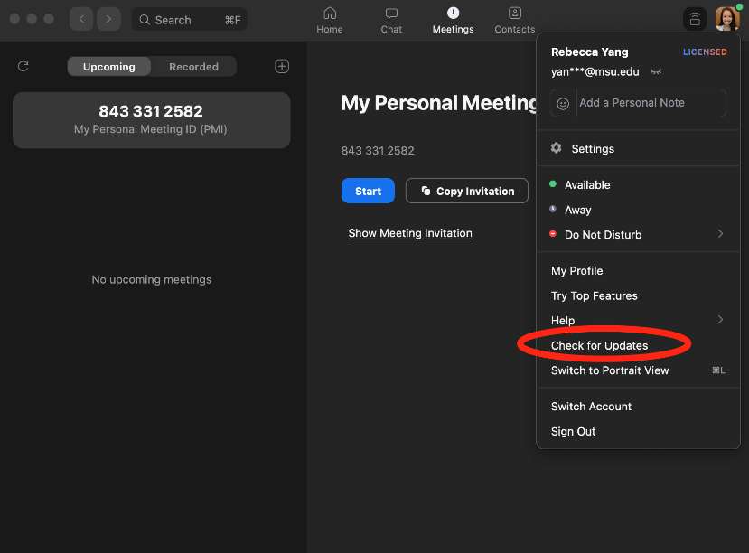
- Motions in chat - Feel free to use the chat feature in Zoom for making points relevant to the issue being discussed. You can also use it for questions, although speakers often don't see questions posed in the chat, particularly if they're sharing their screen. Note, however, that unlike last year, motions or seconds to motions cannot be made in the chat. To make a motion, raise your hand and wait to be recognized by the chairperson, at which point you can make the motion aloud. Seconds do not need recognition; just unmute and say "Second."
- How to raise hand - At the bottom right corner, click on “Reactions,” then “Raise Your Hand” to ask for permission to speak. This will notify the host, Chairperson, and all other attendees that you have something to say. Please use this function so that we are not talking over one another and that everyone has the opportunity to speak. Make sure you lower your hand when you are done speaking.
  - Refer to this website for detailed instructions. [Tyler will send out to everyone]
  - 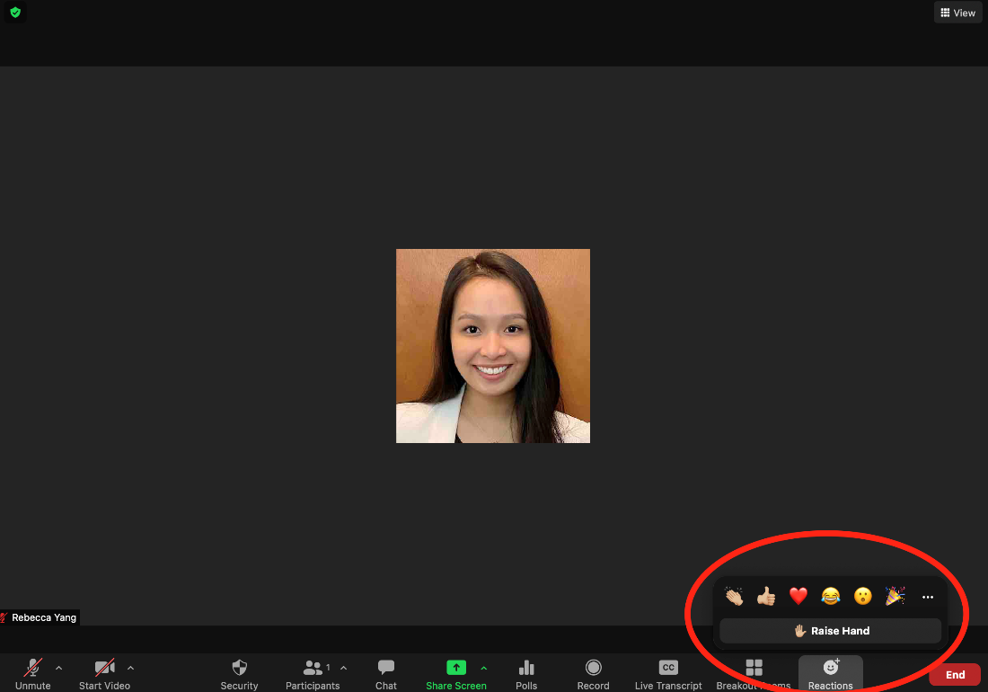

- Renaming yourself and staying muted - After joining, please rename yourself to “Sen. [NAME]” and make sure you are muted until you are called on. Also make sure you re-mute yourself when you are done speaking.
  - 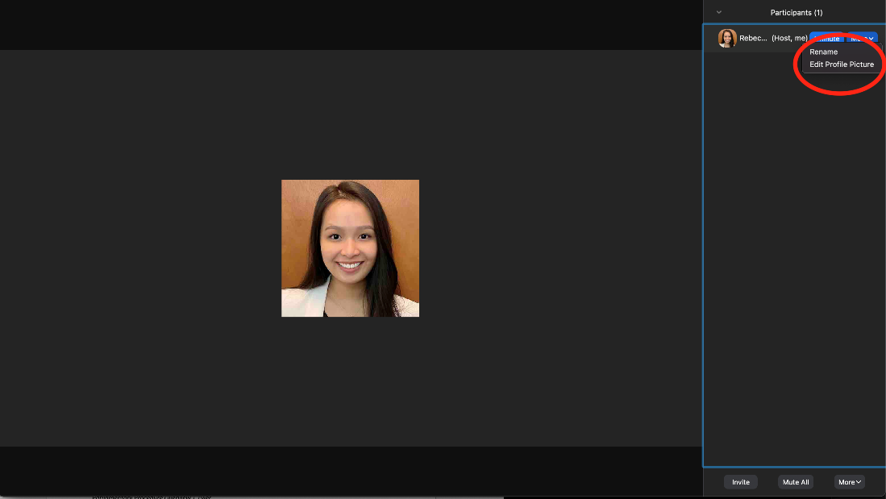
- Voting via poll - All voting will be done through Zoom polls. Secretary Silvestri will be monitoring poll results as they trickle in. You need to have the MOST up to date version or else the poll may not show up on your screen.
Breakout Groups – “What do you expect from one another” as far collegiality, conduct, etc.?
Sharing Information with Constituents and Submitting Items Accordingly
Last year, some senators have wondered whether they are allowed to share meeting materials with their colleagues. To be clear, all meeting materials are public and can be shared with constituents. Indeed, senators are encouraged to share the materials so that their constituents are well-informed and can give their opinions.
If a constituent wants to attend a meeting and not participate, send them the livestream link instead. If they want to speak, feel free to share the link, but email the secretary at acadgov@msu.edu so that he can remind you of the procedures for granting voice to a gues
The Office of Academic Governance strives to get all materials out to senators a week before the meetings. To ensure that goal can be met, please provide the secretary with any and all of the materials you want to be considered consistent with the standard meeting schedule.
The standard schedule is that the secretary will send a call for agenda items ten days before each Steering Committee meeting. Agenda items and accompanying materials should be submitted at least seven days before the relevant Steering Committee meeting. Most Steering Committees are fourteen days before Faculty Senate meetings and twenty-one days before University Council meetings. As such, items and materials would ideally be submitted three to four weeks before the meeting at which something is to be presented. This schedule can be inconvenient, but it is the best way to ensure that everyone has time to review materials they are supposed to consider.
If complying with that schedule is not feasible, try to err on the side of submitting before Steering Committee meetings rather than after them. It is less of a problem if something is submitted to the Office of Academic Governance two days before a Steering Committee meeting than two days after.
Senators are entitled to move to amend the agenda at the beginning of the meeting to add items, but it is discouraged unless absolutely necessary, as fellow senators will not be able to review the associated materials.
Attendance Requirements | Tyler
The Bylaws for Academic Governance say that senators are removed from office if they miss two meetings in a semester or three meetings in an academic year without sending a designee in their place.
If you need to miss a meeting, let the secretary know who your replacement will be by emailing acadgov@msu.edu. Designees must be of the same “eligibility and constituency” as the replaced member, and they have full voting rights.
If you miss one meeting without a designee, you will receive a warning email. If you miss a second meeting in a semester, you will be removed from the Faculty Senate. There will be absolutely no exceptions.
Parliamentary Procedure Overview | Tyler
- Motion
- Second
- Discussion
  - Directed to the chairperson
  - Two, ten-minute speeches, although we may adopt a different rule by a 2/3 vote
- Vote
  - Abstaining
- Special considerations
  - Amendments
    - “Friendly amendments”
    - “Call the question”
    - “Any objection?” / consent
- Anticipated Items for 2021-2022 Term
- Regular items – Every meeting
  - Remarks from President/Provost/EVPHS/Chairperson
  - University Committee on Curriculum report
  - Comments from the floor
- Regular items – Annual
  - Nominations/elections for:
    - At-Large Members of the Steering Committee
    - Department of Police and Public Safety Oversight Committee
    - Athletic Council
    - University Committee on Student Affairs
    - University Military Education Advisory Committee
  - Annual consideration of faculty salary raise request from University Committee on Faculty Affairs
- Anticipated Items
  - COVID-19 issues
  - Diversity, equity, and inclusion
- Interesting example from next week’s agenda
  - “Regular” faculty terminology
- Questions

