January 2023
Prepared by

Christopher Krebs, PhD Christine Lindquist, PhD Philip Lee, BS
Ana Saravia, BA Andrew Moore, MS Jesse Lopez, PhD

RTI International
P.O. Box 12194
Research Triangle Park, NC 27709-2194
https://www.rti.org/
RTI Project Number 0218352

Findings from the 2022 Know More @ MSU
Campus Survey

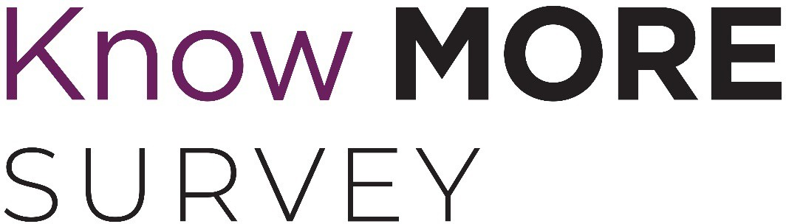

Table of Contents

Executive Summary ES-1
- Background 1
- Students’ Victimization Experiences 13
  - Overall Prevalence of Victimization 14
  - Differences in Prevalence Among Student Populations 17
  - Additional Details: Sexual Harassment 28
  - Additional Details: Sexual Assault 32
    - Incident Characteristics 32
    - Disclosure of Experiences 37
    - Incident Impact 41
  - Workplace Incivility 43
- Faculty’s/Staff’s Experiences with Work-Related Sexual Misconduct and Workplace
Incivility 45
  - Work-Related Sexual Harassment 45
  - Workplace Incivility 50
- Perceptions of Climate and Awareness of Resources 56
  - Summary of Climate Perceptions Among the MSU Community 56
  - Perceptions of Hypothetical Treatment by MSU in the Event of Sexual Misconduct or
Assault 59
  - Awareness of MSU Services and Resources 59
  - Participation in Trainings 61
  - Faculty’s and Staff’s Confidence in Responding to Student and Staff Disclosure 64
- Changes from the 2018–2019 to the 2021–2022 Academic Year 66
- Conclusions 97

List of Figures
No. Page
ES-1. Victimization Prevalence ES-3
ES-2. Prevalence of Work-Related Sexual Harassment Among Faculty and Staff, 2021–2022 ....... ES-4 ES-3. Campus Climate (Standardized Scale Scores), by Population................................................. ES-6 1. Victimization Prevalence 15
- Prevalence of Sexual Harassment in 2021–2022 Academic Year, by Student
Characteristics, Undergraduates 20
- Prevalence of Sexual Assault in 2021–2022 Academic Year, by Student Characteristics, Undergraduates 21
- Prevalence of Intimate Partner Violence in 2021–2022 Academic Year, by Student Characteristics, Undergraduates 22
- Prevalence of Stalking in 2021–2022 Academic Year, by Student Characteristics, Undergraduates 23
- Prevalence of Sexual Harassment in 2021–2022 Academic Year, by Student
Characteristics, Graduate/Professional Students 24
- Prevalence of Sexual Assault in 2021–2022 Academic Year, by Student Characteristics, Graduate/Professional Students 25
- Prevalence of Intimate Partner Violence in 2021–2022 Academic Year, by Student Characteristics, Graduate/Professional Students 26
- Prevalence of Stalking in 2021–2022 Academic Year, by Student Characteristics, Graduate/Professional Students 27
- Prevalence of Specific Types of Sexual Harassment in 2021–2022 Academic Year 28
- Impact of Sexual Harassment 29
- Sexual Harassment Perpetrator 30
- Sexual Harassment Disclosure 31
- Reasons for Not Disclosing Sexual Harassment 32
- Location of Rape and Sexual Battery Incidents Experienced by Undergraduate
Cisgender Women 33
- Characteristics of Sexual Battery and Rape Incidents Experienced by Undergraduate
Cisgender Women 34
- Characteristics of Sexual Battery and Rape Incidents Experienced by Undergraduate
Cisgender Men 35
- Characteristics of Sexual Battery and Rape Incidents, Cisgender Women
Graduate/Professional Students 36
- Number of Incidents by Month and Year of Study, Undergraduate Cisgender Women 37
- Disclosure of Sexual Battery and Rape Incidents, Undergraduate Cisgender Women 37
- Reasons for Not Disclosing Sexual Battery and Rape Incidents, Undergraduate
Cisgender Women 39
- Reasons for Not Disclosing Sexual Battery and Rape Incidents, Undergraduate
Cisgender Men 40
- Reasons for Not Disclosing Sexual Battery and Rape Incidents, Cisgender Women Graduate/Professional Students 41
- Perception of Rape and Sexual Battery Incidents, Undergraduate Cisgender Women 42
- Perception of Sexual Battery Incidents, Undergraduate Cisgender Men 42
- Perception of Sexual Battery Incidents, Cisgender Women Graduate/Professional
Students 42

- Impact of Sexual Battery and Rape Incidents, Undergraduate Cisgender Women 43
- Mean Workplace Incivility Scores Among Students Employed by MSU, 2021–2022
Academic Year 44
- Prevalence of Types of Work-Related Sexual Harassment Among Faculty/Staff, 2021–
2022 .................................................................................................................................. 45
- Prevalence of Work-Related Sexual Harassment (2021–2022), by Faculty/Staff Characteristics 47
- Impact of Work-Related Sexual Harassment 48
- Perpetrators of Work-Related Sexual Harassment 48
- Disclosure of Work-Related Sexual Harassment 49
- Reasons for Not Disclosing Work-Related Sexual Harassment 50
- Mean Workplace Incivility Scores and Prevalence Among Faculty and Staff, 2021–2022 Academic Year 51
- Identity-Based Workplace Incivility 52
- Prevalence of Workplace Incivility, by Faculty/Staff Characteristics, 2021–2022 54
- Campus Climate (Mean Scale Scores), by Population 57
- Campus Climate (Sample Items Paraphrased), by Population 58
- “If I were to experience sexual misconduct, MSU would treat me with dignity and respect” 59
- Awareness of MSU Resources 60
- Training on Specific Topics 62
- Undergraduate Student Participation in Specific Trainings 63
- Graduate/Professional Student Participation in Specific Trainings 63
- Faculty/Staff Participation in Specific Trainings 64
- Faculty’s/Staff’s Confidence in Their Ability to Respond According to MSU’s Official
Procedures to a Student Disclosing RVSM 65
- Comparison of Victimization Prevalence for Undergraduate Women During 2019–2020
and 2021–2022 Academic Years 67
- Comparison of Victimization Prevalence for Undergraduate Men During 2019–2020 and 2021–2022 Academic Years 68
- Comparison of Victimization Prevalence for Graduate/Professional Women During 2019–
2020 and 2021–2022 Academic Years 69
- Comparison of Victimization Prevalence for Graduate/Professional Men During 2019–
2020 and 2021–2022 Academic Years 70
- Comparison of Disclosure Rates for Sexual Battery and Rape Incidents Experienced by Undergraduate Women During 2019–2020 and 2021–2022 Academic Years 71
- Comparison of Disclosure Rates for Sexual Harassment Incidents Experienced by
Undergraduate Women During 2019–2020 and 2021–2022 Academic Years 72
- Comparison of Disclosure Rates for Sexual Harassment Incidents Experienced by
Undergraduate Men During 2019–2020 and 2021–2022 Academic Years 72
- Comparison of Disclosure Rates for Sexual Harassment Incidents Experienced by Graduate/Professional Women During 2019–2020 and 2021–2022 Academic Years 73
- Comparison of Disclosure Rates for Sexual Harassment Incidents Experienced by Graduate/Professional Men During 2019–2020 and 2021–2022 Academic Years 73
- Comparison of Workplace Incivility and Sexual Harassment Prevalence for Faculty
Women During 2019–2020 and 2021–2022 Academic Years 74
- Comparison of Workplace Incivility and Sexual Harassment Prevalence for Faculty Men
During 2019–2020 and 2021–2022 Academic Years 74
- Comparison of Workplace Incivility and Sexual Harassment Prevalence for Staff Women
During 2019–2020 and 2021–2022 Academic Years 74

- Comparison of Workplace Incivility and Sexual Harassment Prevalence for Staff Men
During 2019–2020 and 2021–2022 Academic Years 74
- Comparison of Disclosure Rates for Sexual Harassment Incidents Experienced by
Faculty Women During 2019–2020 and 2021–2022 Academic Years 75
- Comparison of Disclosure Rates for Sexual Harassment Incidents Experienced by
Faculty Men During 2019–2020 and 2021–2022 Academic Years 76
- Comparison of Disclosure Rates for Sexual Harassment Incidents Experienced by Staff
Women During 2019–2020 and 2021–2022 Academic Years 76
- Comparison of Disclosure Rates for Sexual Harassment Incidents Experienced by Staff
Men During 2019–2020 and 2021–2022 Academic Years 77
- Comparison of Standardized Climate Scale Scores for Undergraduate Women During
2019–2020 and 2021–2022 Academic Years 78
- Comparison of Standardized Climate Scale Scores for Undergraduate Men During 2019–
2020 and 2021–2022 Academic Years 79
- Comparison of Standardized Climate Scale Scores for Graduate/Professional Women
During 2019–2020 and 2021–2022 Academic Years 79
- Comparison of Standardized Climate Scale Scores for Graduate/Professional Men
During 2019–2020 and 2021–2022 Academic Years 80
- Comparison of Standardized Climate Scale Scores for Faculty Women During 2019–
2020 and 2021–2022 Academic Years 80
- Comparison of Standardized Climate Scale Scores for Faculty Men During 2019–2020
and 2021–2022 Academic Years 81
- Comparison of Standardized Climate Scale Scores for Staff Women During 2019–2020
and 2021–2022 Academic Years 81
- Comparison of Standardized Climate Scale Scores for Staff Men During 2019–2020 and 2021–2022 Academic Years 82
- Comparison of Undergraduate Women’s Awareness of Various MSU Offices and
Resources During 2019–2020 and 2021–2022 Academic Years 83
- Comparison of Undergraduate Men’s Awareness of Various MSU Offices and Resources
During 2019–2020 and 2021–2022 Academic Years 83
- Comparison of Graduate/Professional Women’s Awareness of Various MSU Offices and Resources During 2019–2020 and 2021–2022 Academic Years 84
- Comparison of Graduate/Professional Men’s Awareness of Various MSU Offices and
Resources During 2019–2020 and 2021–2022 Academic Years 84
- Comparison of Faculty Women’s Awareness of Various MSU Offices and Resources
During 2019–2020 and 2021–2022 Academic Years 85
- Comparison of Faculty Men’s Awareness of Various MSU Offices and Resources During 2019–2020 and 2021–2022 Academic Years 86
- Comparison of Staff Women’s Awareness of Various MSU Offices and Resources During 2019–2020 and 2021–2022 Academic Years 87
- Comparison of Staff Men’s Awareness of Various MSU Offices and Resources During
2019–2020 and 2021–2022 Academic Years 87
- Comparison of the Percentage of Undergraduate Women Who Received Training on
Various Topics During 2019–2020 and 2021–2022 Academic Years 88
- Comparison of the Percentage of Undergraduate Men Who Received Training on
Various Topics During 2019–2020 and 2021–2022 Academic Years 89
- Comparison of the Percentage of Graduate/Professional Women Who Received Training
on Various Topics During 2019–2020 and 2021–2022 Academic Years 89
- Comparison of the Percentage of Graduate/Professional Men Who Received Training on
Various Topics During 2019–2020 and 2021–2022 Academic Years 90

- Comparison of the Percentage of Faculty Women Who Received Training on Various
Topics During 2019–2020 and 2021–2022 Academic Years 91
- Comparison of the Percentage of Faculty Men Who Received Training on Various Topics
During 2019–2020 and 2021–2022 Academic Years 91
- Comparison of the Percentage of Staff Women Who Received Training on Various
Topics During 2019–2020 and 2021–2022 Academic Years 92
- Comparison of the Percentage of Staff Men Who Received Training on Various Topics
During 2019–2020 and 2021–2022 Academic Years 92
- Comparison of the Percentage of Undergraduate Women Who Received Specific
Trainings During 2019–2020 and 2021–2022 Academic Years 93
- Comparison of the Percentage of Undergraduate Men Who Received Specific Trainings
During 2019–2020 and 2021–2022 Academic Years 93
- Comparison of the Percentage of Graduate/Professional Women Who Received
Trainings During 2019–2020 and 2021–2022 Academic Years 94
- Comparison of the Percentage of Graduate/Professional Men Who Received Trainings
During 2019–2020 and 2021–2022 Academic Years 94
- Comparison of the Percentage of Faculty Women Who Received Trainings During 2019–
2020 and 2021–2022 Academic Years 94
- Comparison of the Percentage of Faculty Men Who Received Trainings During 2019–
2020 and 2021–2022 Academic Years 95
- Comparison of the Percentage of Staff Women Who Received Trainings During 2019–
2020 and 2021–2022 Academic Years 95
- Comparison of the Percentage of Staff Men Who Received Trainings During 2019–2020
and 2021–2022 Academic Years 95

List of Tables
No. Page

- Number of Survey Participants and Average Survey Completion Time 3
- Distribution of Respondents, Undergraduate Students 5
- Distribution of Respondents, Graduate and Professional Students 7
- Distribution of Respondents, Faculty and Staff 10
- Sexual Victimization Definitions 13
- Climate Scale Description 56

Executive Summary
Michigan State University (MSU) sponsored the Know More @ MSU Campus Survey to assess the culture, perceptions, and policies associated with sexual misconduct among the entire MSU campus community. All undergraduate students, graduate and professional students, faculty, and staff were invited to participate in a brief, web-based survey in spring 2022. The Know More @ MSU Campus Survey was previously administered in spring 2019. This report primarily presents the 2022 results, although comparisons of the 2019 and 2022 results are presented in a dedicated chapter. RTI International, an independent, nonprofit research organization, collected and analyzed the data.
Members of the MSU campus community completed more than 11,500 surveys. Throughout this report, results are shown for multiple gender identity groups; the categorization of respondents was done according to self-reported gender identity. For the 2022 Know More @ MSU Campus Survey, gender identity information was collected using an approach that differs from the approach used in 2019, and 2022 results are presented separately for students, faculty, and staff who identify as being transgender and/or nonbinary. Survey respondents who identified as being transgender or nonbinary were grouped together in an effort to create groups with enough respondents to enable analysis. The definitions used in the survey for various terms related to gender identity were provided by the MSU Gender and Sexuality Campus Center.1
The Know More @ MSU Campus Survey results are presented in tables and figures throughout this report. Additional tables presenting all of the results and associated confidence intervals are presented in separate, linked appendices. The surveys covered three broad areas: students’ experiences with various types of victimization (primarily relationship violence and sexual misconduct [RVSM]); faculty and staff experiences with workplace incivility and work-related sexual harassment; and perceptions of campus climate and awareness of resources among students, faculty, and staff. Key highlights for each area are summarized below.

1 Gender and Sexuality Campus Center, Michigan State University. (n.d.) Glossary. https://gscc.msu.edu/education/glossary.html

ES.1 Students’ Victimization Experiences
Key findings pertaining to students’ victimization experiences included the following:
  - Sexual harassment2 was the most prevalent type of victimization students experienced (Figure ES-1). Nearly two-thirds of undergraduate cisgender women3 (61.0%), 72.8% of transgender and/or nonbinary undergraduates, 37.5% of cisgender women graduate/professional students, 65.1% of transgender and/or nonbinary graduate/professional students, 35.7% of undergraduate cisgender men, and 17.3% of cisgender men graduate/professional students experienced sexual harassment during the 2021–2022 academic year.
    - The most common forms of sexual harassment were someone making “inappropriate or offensive comments about your or someone else’s body, appearance, or sexual activities” and “someone referring to people of your gender in insulting or offensive terms.”
  - About 11.8% of undergraduate cisgender women, 2.8% of undergraduate cisgender men, 10.6% of transgender and/or nonbinary undergraduates, 3.1% of cisgender women graduate/professional students, 0.7% of cisgender men graduate/professional students, and
14.4% of transgender and/or nonbinary graduate/professional students experienced sexual assault4 during the 2021–2022 academic year. These last two estimates are, however, not considered reliable statistically because they are based on fewer than 10 people or have a relative standard error greater than 30%.
    - Sexual battery—defined as any unwanted, nonconsensual sexual contact that involved forced touching of a sexual nature but without penetration—was more common than rape.
    - People committing a sexual assault most commonly used the tactic of “ignoring you when you said ‘no’ or just [doing] it without your consent, when you did not want it to happen.”
    - Most perpetrators were MSU students, and the most common location of rape incidents was an off-campus private residence.
    - A disproportionately high number of incidents took place for first-year undergraduate cisgender women in September and October.
    - Most incidents were disclosed to someone close to the survivor (e.g., a roommate, friend, or family member). In about 16.2% of rape incidents and 4.1% of sexual battery incidents undergraduate cisgender women experienced, the student disclosed the incident to, or sought services from, an MSU office.
    - Students who experienced sexual assault were affected in a number of ways; rape incidents were considered to be much more upsetting to the student than sexual battery incidents and led to more problems in various areas of their lives.
  - When considering longer-term experiences, about a quarter (24.8%) of undergraduate cisgender women had experienced sexual assault since enrolling at MSU. This estimate was 5.5% for undergraduate cisgender men, 25.3% for transgender and/or nonbinary undergraduates, 7.3% for cisgender women graduate/professional students, 1.6% for men graduate or professional students, and 18.6% for transgender and/or nonbinary graduate/professional students. These last two estimates are, however, not considered

2 Sexual harassment included a number of behaviors pertaining to sexual remarks; continued sexual advances; sharing of sexual photos or videos; use of offensive, gender-based language; or someone in a position of authority promising better treatment (or threatening worse treatment) associated with sexual contact. See Table 5 for a detailed description of how sexual harassment was measured in the survey.
3 Throughout this report, all results for students, faculty, and staff are shown according to self-reported gender identity.
4 Sexual assault was defined as sexual contact that the person did not consent to and did not want to happen. See Table 5 for a detailed description of how sexual assault was measured in the survey.

reliable statistically. The lifetime sexual assault rate was 38.6% for undergraduate cisgender women and 39.8% for cisgender women graduate/professional students.
  - Detailed estimates were developed for numerous subgroups of students. The most consistent findings were that students with a diagnosed or documented disability and students who were bisexual, pansexual, queer, or another combination of orientations tended to have the highest likelihood of experiencing various forms of victimization. There were no other clear patterns of association between various types of victimization and other student characteristics (e.g., race/ethnicity).

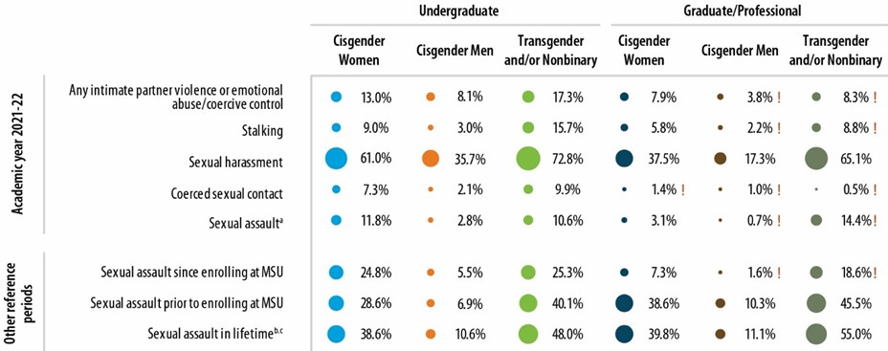Figure ES-1. Victimization Prevalence
Notes: Percentages are of students. ! Estimate is considered not statistically reliable because it is either based on fewer than 10 people or has a relative standard error greater than 30%. For an accessible version of the information shown in this figure, see Appendix Tables D-1a and D-1b.

ES.2 Faculty’s and Staff’s Experiences with Workplace Incivility and Work-Related Sexual Harassment
Key findings pertaining to faculty and staff experiences included the following:
  - The majority of faculty and staff (of all gender identities) experienced at least some workplace incivility. The most common types were that a supervisor or coworker paid little attention to their statements or showed little interest in their opinions, doubted their judgment on a matter for which they were responsible, or interrupted or spoke over them.
    - Cisgender women and transgender and/or nonbinary faculty and staff experienced more workplace incivility than cisgender men, younger faculty and staff experienced more workplace incivility than their older counterparts, and faculty and staff with a diagnosed or documented disability experienced more workplace incivility than those without a disability. Among cisgender women faculty, those who identified as lesbian, bisexual, pansexual, or queer; white, multiracial,5 or Hispanic; or as being in the associate professor role were more likely to experience workplace incivility. There were no other clear patterns of association between various types of victimization and other faculty/staff characteristics (e.g., race/ethnicity).

5 Among faculty who selected more than one race, the most common pattern was American Indian/Alaska Native and White. Among staff, it was Black and White, Asian and White, and American Indian/Alaska Native and White.

  - The prevalence of work-related sexual harassment was 12.3% for cisgender women faculty, 3.8% for cisgender men faculty, 9.2% for cisgender women staff, 8.7% for cisgender men staff, and 21.5% for transgender and/or nonbinary faculty/staff (Figure ES-2). The most common types of sexual harassment were someone referring to people of one’s gender in insulting or offensive terms; someone making inappropriate or offensive comments about the person’s or someone else’s body, appearance, or sexual activities; and someone making sexual remarks or telling jokes or stories that were insulting to the person. No faculty or staff indicated they experienced “quid pro quo” harassment, such as someone in a position of authority promising them better treatment or implying favors if they engaged in sexual contact (or implying/threatening worse treatment if they refused it).
    - Substantial proportions of faculty and staff (particularly cisgender women faculty) indicated that the experience affected them negatively. Survey participants indicated that their sexual harassment experiences interfered with their ability to do their job or created an intimidating, uncomfortable, or offensive work environment; damaged their relationships with coworkers, supervisors, students, or others they were in contact with for their job at MSU; affected their emotional well-being in a negative way (e.g., increased stress, fear, anxiety, or depression); or hindered their ability to complete their work or do their jobs.
    - When faculty experienced sexual harassment, the perpetrator was most commonly an MSU professor, instructor, or postdoctoral scholar. For staff, the perpetrator was most commonly an MSU staff member or administrator.
    - Disclosure of work-related sexual harassment was less common for cisgender men than cisgender women.

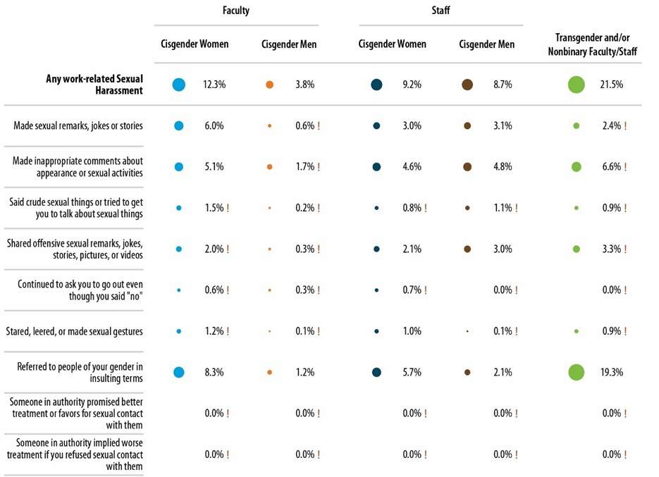Figure ES-2. Prevalence of Work-Related Sexual Harassment Among Faculty and Staff, 2021–2022
Notes: Percentages are of faculty and staff. ! Estimate is considered not statistically reliable because it is either based on fewer than 10 people or has a relative standard error greater than 30%. All statistically unreliable percentages in this figure were <1 and thus too small to be displayed. For an accessible version of the information shown in this figure, see Appendix Table E-4.

ES.3 Perceptions of Climate and Awareness of Resources
Key findings related to campus climate included the following.
  - Across the dimensions of climate explored in the study (Figure ES-3), undergraduate cisgender men, cisgender faculty men, and cisgender staff men provided the most positive perceptions of climate, whereas transgender and/or nonbinary undergraduate students, transgender and/or nonbinary graduate/professional students, and transgender and/or nonbinary faculty/staff had the most negative perceptions of climate. Cisgender women’s perceptions of climate were between those of cisgender men and transgender and/or nonbinary respondents.
  - Overall, the most positive dimensions of climate were survey participants’ perceptions of school leadership climate for sexual misconduct, perceptions of the school leadership climate for relationship violence, connectedness to MSU, and awareness of school sexual assault policy and resources. The most negative dimensions of climate were related to general perceptions of the highest administrative leadership and other administration at the school.
  - Awareness of MSU-specific resources and programs related to RVSM was fairly high, and the majority of undergraduate students, graduate/professional students, and faculty and staff indicated that they had received training on a number of specific topics (e.g., the legal definitions of sexual assault, obtaining consent). Survey participants perceived online trainings as less helpful than the in-person trainings in which they participated.

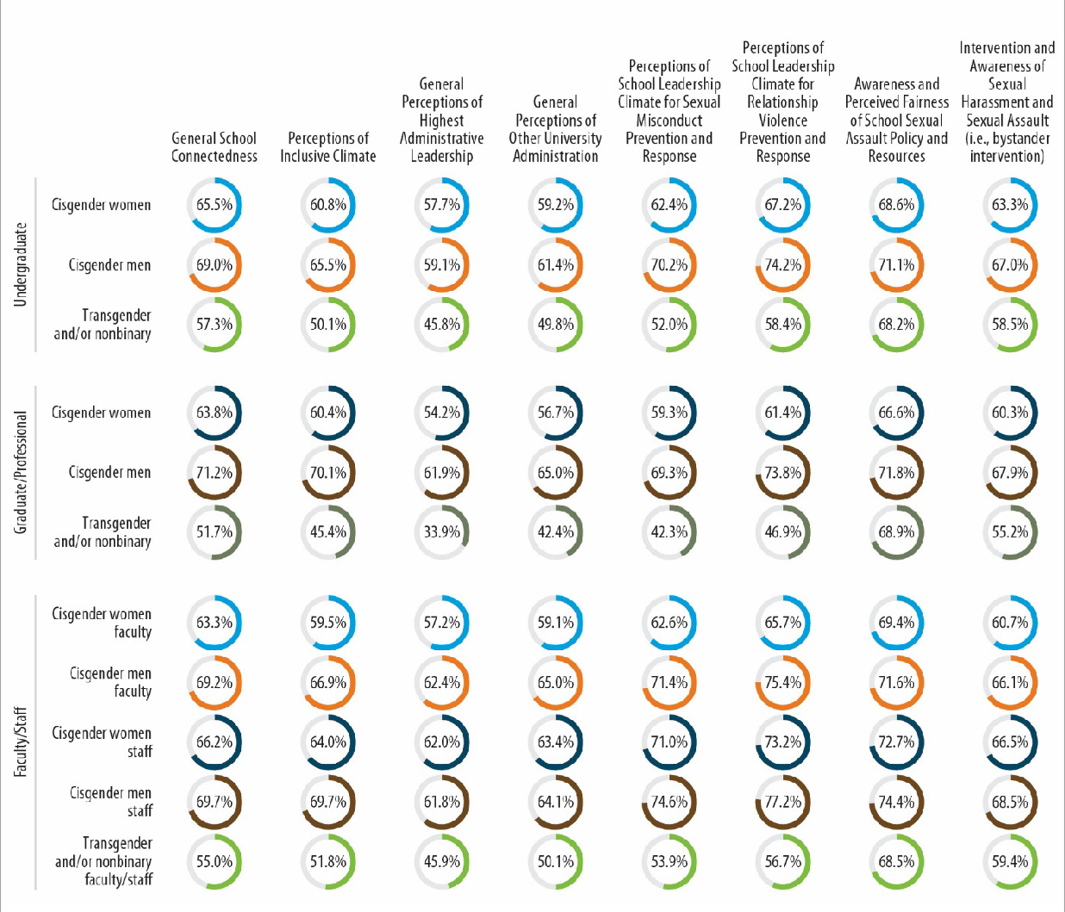Figure ES-3. Campus Climate (Standardized Scale Scores), by Population
For an accessible version of the information shown in this figure, see Appendix Tables F-8a1 through F-8b5, as well as (for “Students offer support to other students who they suspect are in an abusive relationship”) Appendix Tables F-3a1 through F-3a6.

ES.4 Change from 2019 to 2022
A number of significant changes occurred from 2019 to 2022 at MSU. Both undergraduate and graduate/professional students experienced a decrease in the prevalence of multiple types of victimization. Similarly, MSU faculty and staff experienced decreases in the prevalence of workplace incivility and workplace sexual harassment. In addition, from 2019 to 2022, a number of improvements occurred in terms of the climate or culture on campus, and there were considerable increases in awareness of offices and resources charged with addressing RVSM at MSU and in the participation in related trainings. The one area in which change was not detected was in the prevalence of disclosing victimization experiences to different groups, such as roommates, friends, and family; any MSU or off- campus office/organization; an MSU office; or an off-campus organization.

ES.5 Conclusions
Overall, the 2022 Know More @ MSU Campus Survey findings provided a breadth of information that the MSU community can use to continue to improve its RVSM policies, prevention programming, and services to survivors, as well as to target specific areas of the campus climate for intervention and improvement. The study also provides MSU with an opportunity to compare the 2022 results with the results from 2019, the last time the Know More @ MSU Campus Survey was administered. Together, the findings are indicative of whether and how things have changed over time and will help MSU understand student, faculty, and staff victimization experiences and the related campus culture or climate.
The remainder of this report presents and describes the 2022 Know More @ MSU Campus Survey results. After a description of the study background and methodology, the report describes students’ victimization experiences; faculty and staff experiences with workplace incivility and work- related sexual harassment; and perceptions of campus climate among students, faculty, and staff. The comparisons between the 2019 and 2022 Know More @ MSU Campus Survey results are presented in Chapter 5.

Background
As part of its efforts to understand the experiences and challenges the Michigan State University (MSU) community has faced concerning relationship violence and sexual misconduct (RVSM), in 2019 MSU sponsored the school-wide Know More @ MSU Campus Survey. The findings were used to inform a number of activities at MSU designed to improve climate and the institution’s response to RVSM. Most notably, MSU developed an RVSM Strategic Plan, alongside a general university strategic plan and a plan focused on diversity, equity, and inclusion (DEI). The RVSM Strategic Plan outlined initiatives for expanding trauma-informed services; building a trauma-informed culture; strengthening RVSM policy violation, sanction, and discipline processes; assessing resources and support for respondents; strengthening RVSM prevention programming; creating respectful work environments; and promoting accountability. Many of these initiatives were directly related to findings from the 2019 Know More @ MSU Campus Survey. Interested parties can track progress on the strategic plan and review a more comprehensive list of actions MSU has engaged in over the past several years through a dashboard.
Recognizing the importance of collecting data as a means of assessing progress on these and other initiatives, MSU committed to conducting the Know More @ MSU Campus Survey at regular intervals. The survey was revised slightly and administered again in spring 2022.
Both the 2019 and 2022 surveys were led by the RVSM Expert Advisory Workgroup at MSU. The Know More @ MSU Campus Surveys were intended to comprehensively assess the culture, perceptions, and policies associated with sexual misconduct, relationship violence, stalking, and workplace incivility among the entire MSU campus community, including undergraduate students, graduate and professional students, faculty, and staff.
To ensure the objectivity and quality of the study and protect survey participant confidentiality, MSU contracted with an independent research organization, RTI International, to design and administer the 2019 and the 2022 Know More @ MSU Campus Surveys, process and analyze the data, and report the results.6 The 2022 survey is largely similar to the 2019 survey, which was developed by experts at RTI and key members of the RVSM Expert Advisory Workgroup, drawing on established, reliable, and valid measurement tools.7 The student survey primarily focused on students’ perceptions of the climate related to sexual misconduct at MSU and experiences with various forms of victimization (including sexual assault, sexual harassment, coerced sexual contact, intimate partner violence, and stalking). The faculty and staff survey covered employees’ perceptions of the climate related to sexual misconduct at MSU and experiences with workplace incivility and work-related sexual harassment.
For the 2022 administration, a number of improvements were made to the Know More @ MSU Campus Survey instruments: making minor wording changes; updating the names of relevant MSU

6 RTI is a nonprofit research organization with previous experience conducting student surveys on sexual assault victimization and campus climate related to sexual misconduct (see https://www.bjs.gov/content/pub/pdf/ccsvsftr.pdf).
7 Krebs, C., Lindquist, C., Berzofsky, M. Shook-Sa, B., Peterson, K., Planty, M., Langton, L., & Stroop, J. (2016, January). Campus Climate Survey validation study: Final technical report (NCJ 249545). U.S. Department of Justice, Office of Justice Programs, Bureau of Justice Statistics. https://bjs.ojp.gov/content/pub/pdf/ccsvsftr.pdf

offices, organizations, and programs; revising response options to better reflect respondent perspectives and experiences; adding a series of questions (scale) related to bystander intervention behaviors; adding a series of questions that ask students who were employed by MSU about their experiences with workplace incivility; and revising the questions about gender identity and sexual orientation to be more inclusive and accurate. The complete 2022 Know More @ MSU Campus Survey instruments are included in Appendix A.
Data collection took place from March 16 through May 15, 2022. After extensive awareness- raising activities by MSU, all undergraduate students,8 graduate and professional students, faculty, and staff were invited via email to take the survey.9 The survey was programmed for web-based administration and was mobile device friendly. Participation was voluntary and the survey was confidential; each survey participant received a survey access code to take the survey, but survey participants’ identities were kept confidential (and no individual-level data were shared with MSU). Over the field period, RTI sent a number of follow-up emails.
The time period covered by this survey includes times in which university operations were affected by the COVID-19 pandemic. For example, during the 2021–2022 academic year, which was the primary reference period for many survey questions, the university had a number of COVID precautions in place, including mandatory masks and vaccines, activities that occurred online or had robust online options, and periods of the academic year in which classes were shifted online for a short period of time to control spread of disease. Other questions ask about broader time periods that could include 2020– 2021, a time when the university was operating primarily online, with few students living on campus and many faculty and staff working remotely. Although some research suggests that rates of intimate partner violence in the general public increased during COVID,10, 11 there is less clarity around how university students, faculty, and staff experiences with sexual assault, sexual harassment, stalking, intimate partner violence, and workplace incivility were affected by COVID. We are unable to identify exactly how these unprecedented conditions may have influenced the results of this survey, though we do believe it is important contextual information.
Table 1 presents the total number of survey participants and average survey completion times for each of 11 populations or groups of respondents: (1) Undergraduate—Cisgender Women,
(2) Undergraduate—Cisgender Men, (3) Undergraduate—Transgender and/or Nonbinary,
- Graduate/Professional—Cisgender Women, (5) Graduate/Professional—Cisgender Men,

8 The following categories of students were excluded: students who were under 17 at the start of data collection and students in the following programs: high school guest, language program, lifelong education, or Visiting Graduate
- Non MSU Credit. Students who were also employed as faculty or staff were also excluded and received the faculty/staff version of the survey.
9
A random sample of undergraduate students was selected to receive a modest incentive to participate in the survey.
This decision was made to ensure that statistically precise estimates could be developed for undergraduate students, who typically have lower response rates than graduate/professional students, faculty, and staff. Therefore, 5,200 undergraduate students received a $20 gift card for completing the survey.
10
Kourti, A., Stavridou, A., Panagouli, E., Psaltopoulou, T., Spiliopoulou, C., Tsolia, M., Sergentanis, T. N., & Tsitsika,
A. (2021). Domestic violence during the COVID-19 pandemic: A systematic review. Trauma, Violence, & Abuse. Advance online publication. https://doi.org/10.1177/15248380211038690
11 Piquero, A. R., Jennings, W. G., Jemison, E., Kaukinen, C., & Knaul, F. M. (2021). Domestic violence during the COVID-19 pandemic—Evidence from a systematic review and meta-analysis. Journal of Criminal Justice, 74, Article 101806. https://doi.org/10.1016/j.jcrimjus.2021.101806

(6) Graduate/Professional—Transgender and/or Nonbinary, (7) Faculty—Cisgender Women,
(8) Faculty—Cisgender Men, (9) Staff—Cisgender Women, (10) Staff—Cisgender Men, and
(11) Faculty/Staff—Transgender and/or Nonbinary. In some places, mostly in tables and figures, cisgender and transgender are shortened to cis and trans to save space.

Table 1. Number of Survey Participants and Average Survey Completion Time

Average Survey
Population Number of Respondents Completion Time (minutes)*
Undergraduates—Cisgender Women | 4,070 | 16.2
Undergraduate—Cisgender Men | 2,017 | 14.9
Undergraduate—Trans and/or Nonbinary | 323 | 16.4
Graduate/Professional—Cisgender Women | 522 | 15.7
Graduate/Professional—Cisgender Men | 314 | 16.6
Graduate/Professional—Trans and/or Nonbinary | 52 | 16.3
Faculty—Cisgender Women | 802 | 17.8
Faculty—Cisgender Men | 636 | 17.9
Staff—Cisgender Women | 1,473 | 19.4
Staff—Cisgender Men | 687 | 19.7
Faculty/Staff—Trans and/or Nonbinary | 97 | 19.0
*For students, the average survey completion time was longer for survivors of sexual assault than for nonvictims because detailed questions were asked about the incidents they had experienced.

Throughout this report, results are shown for each group; the categorization of respondents was done according to self-reported gender identity. For the 2022 Know More @ MSU Campus Survey, gender identity information was collected using an approach that differs from that used in 2019, and results are presented separately for students, faculty, and staff who identify as being transgender and/or nonbinary. In 2022, two survey questions were used to determine gender identity (Appendix A).
Respondents who did not answer either survey question, selected “prefer not to answer” on both questions, or answered “no” to the first gender identity question and “prefer not to answer” to the second gender identity question were excluded from analysis because it was not possible to put them in a gender category (n = 546).
Cisgender women undergraduates, graduate/professional students, and faculty/staff are those who identified themselves as being a “woman” and “cisgender,” or identified themselves as being a “woman” and did not select any other gender identities in either of the two survey questions.12
Cisgender men undergraduates, graduate/professional students, and faculty/staff are those who identified themselves as being a “man” and “cisgender,” or identified themselves as being a “man” and did not select any other gender identity in either of the two survey questions.

12 In a small number of cases when a respondent selected only “cisgender” and no other identities, registrar data were used to select a category. Registrar data were never used to assign respondents to the transgender or nonbinary categories and were not consulted for any other categorizations.

Transgender and/or nonbinary undergraduates, graduate/professional students, and faculty/staff are those who identified themselves as being transgender, genderqueer, nonbinary, agender, genderfluid, two-spirit, or intersex in either of the two survey questions.
Throughout this report, we identify any estimate that is considered imprecise or not reliable statistically because it is based on fewer than 10 people or has a relative standard error greater than 30%. Any victimization estimates or descriptive results that are considered not statistically precise will be included and identified in figures and tables but will not be described in the text of the report.
Response rates varied considerably across the groups. Because calculating response rates requires information for both respondents and nonrespondents, it is not possible to compute response rates by gender identities self-reported in the survey. Instead, MSU registrar data on the sex of students, faculty, and staff, in which everyone was categorized as female or male, were used for the calculation of response rates. As a result, the following discussion of response rates does not refer to women or men as being cisgender and does not discuss response rates for transgender or nonbinary respondents.
Undergraduate women (based on data from the MSU Registrar) responded to the survey at a rate of 23.5% overall, whereas 12.3% of undergraduate men responded to the survey. Among undergraduate students, however, response rates were substantially higher for the incentive samples (35.9% for women and 18.7% for men) than the non-incentive samples (10.4% for women and 4.2% for men). Women graduate/professional students responded at the rate of 10.1%, compared to 7.8% of men graduate/professional students. For faculty and staff, 8.3% of women faculty, 4.5% of men faculty, 25.5% of women staff, and 18.0% of men staff responded to the survey.13
Nonresponse bias analyses (comparisons of those who participated in the survey with those who were invited to participate but did not) were conducted separately for each population using available administrative data. Among undergraduate students, those with higher grade point averages and standardized test scores were generally more likely to participate. Undergraduates who were in their first or second years at MSU were also more likely to participate. Some differences with race/ethnicity were also observed, with White, Hispanic, and Asian students slightly more likely to participate than Black students. Among graduate and professional students, those with higher grade point averages and who were graduate (as opposed to professional) students were more likely to participate. Age was positively correlated with participation, and White and Hispanic students, as well as those who indicated being two or more races, were more likely to participate than Asian and Black students. Among faculty, age and years of service were positively associated with participation, and associate professors and professors were more likely to participate than were assistant professors and instructors. Finally, among staff, those with more years of service, older staff, staff on main campus, and union staff were generally more likely to participate. (Detailed results of the nonresponse bias analysis are included in Appendix B.) For most characteristics included in the nonresponse bias analysis, the effect sizes were small to medium (i.e.,

13 For 2022, the sample includes faculty and staff who are part of a group labeled “non-pay employees,” which was not included in the 2019 Know More @ MSU Campus Survey. Fifty-four of the 10,218 faculty and staff in this group participated in the 2022 Know More @ MSU Campus Survey, representing 1.5% of the 3,695 faculty and staff respondents. The inclusion of this group suppresses response rates dramatically. If this group had been excluded, response rates would be 29.1% for women faculty and 19.3% for men faculty.

< 0.5) for student and staff groups. For the faculty groups, however, the effect sizes were large for some characteristics. The data were weighted to adjust for this potential nonresponse bias, but because of the smaller number of faculty respondents, some covariates in the weighting models had to be collapsed.
Although this adjustment reduces the variance of estimates by reducing unequal weighting effects, the trade-off is a diminished ability to negate bias for this group through weighting. In other words, the differential response rates and small sample sizes for some faculty subgroups led to substantial variation in the sampling weights assigned to certain respondents. This variation, in turn, decreases the precision of estimates produced with the data (i.e., larger standard errors and wider confidence intervals). To reduce this variation and increase the precision of estimates, certain groups were combined for weighting purposes (e.g., instructors and assistant professors). Although this process can lead to a significant increase in precision, it also has the potential to decrease the accuracy of an estimate if the groups being combined differ with respect to a particular outcome (i.e., differ in terms of prevalence).
The remainder of this report summarizes the findings from the study, based on the weighted data. Characteristics of the student samples are included in Tables 2 (undergraduates) and Table 3 (graduate/ professional students). Characteristics of the faculty and staff samples are shown in Table 4, with additional details included in Appendix C.

Table 2. Distribution of Respondents, Undergraduate Students

Transgender and/or Undergraduate Undergraduate Nonbinary
Cisgender Women Cisgender Men Undergraduates
Characteristic # % # % # %
All persons | 4,070 | 100.0 % | 2,017 | 100.0 % | 323 | 100.0 %
Year of study
1st-year undergrad | 1,121 | 27.5 | % | 540 | 26.8 | % | 98 | 30.3 | %
2nd-year undergrad | 1,066 | 26.2 |  | 527 | 26.1 |  | 79 | 24.5
3rd-year undergrad | 969 | 23.8 |  | 510 | 25.3 |  | 72 | 22.3
4th-year undergrad | 901 | 22.1 |  | 439 | 21.8 |  | 74 | 22.9
Other | <10 | 0.0 | ! | <10 | 0.0 | ! | <10 | 0.0 | !
Length of enrollment
Less than 24 months | 2,413 | 59.3 | % | 1,176 | 58.3 | % | 197 | 61.0 | %
24 months or more | 1,648 | 40.5 |  | 829 | 41.1 |  | 121 | 37.5
Age
18 | 667 | 16.4 | % | 261 | 12.9 | % | 55 | 17.0 | %
19 | 1,083 | 26.6 |  | 501 | 24.8 |  | 90 | 27.9
20 | 976 | 24.0 |  | 493 | 24.4 |  | 65 | 20.1
21 | 813 | 20.0 |  | 403 | 20.0 |  | 59 | 18.3
22 | 383 | 9.4 |  | 236 | 11.7 |  | 37 | 11.5
23+ | 135 | 3.3 |  | 122 | 6.0 |  | 17 | 5.3
Involved in Greek Life
Yes | 784 | 19.3 | % | 279 | 13.8 | % | 24 | 7.4 | %
No | 3,286 | 80.7 |  | 1,738 | 86.2 |  | 299 | 92.6
(continued)

Characteristic  Involved in religious or faith- based group | Unde Cisge  # | rgraduate nder Women  % | Unde Cis  # | rgraduate gender Men  % | Transge  No Unde  # | nder and/or nbinary rgraduates  %
Yes | 384 | 9.4 % | 161 | 8.0 % | 15 | 4.6 %
No | 3,686 | 90.6 | 1,856 | 92.0 | 308 | 95.4
Member of intercollegiate athletic team
Yes | 116 | 2.9 % | 48 | 2.4 % | <10 | 2.2 %!
No | 3,954 | 97.1 | 1,969 | 97.6 | 316 | 97.8
Race
White | 2,967 | 72.9 % | 1,400 | 69.4 % | 240 | 74.3 %
Black or African American | 236 | 5.8 | 108 | 5.4 | <10 | 2.2 !
Hispanic | 269 | 6.6 | 116 | 5.8 | 29 | 9.0
Asian | 417 | 10.2 | 293 | 14.5 | 24 | 7.4
Native Hawaii/Pacifica Islander | <10 | 0.0 ! | <10 | 0.0 ! | <10 | 0.0 !
American Indian/Alaska Native | 10 | 0.2 | <10 | 0.3 ! | <10 | 0.6 !
More than one race a | 160 | 3.9 | 84 | 4.2 | 21 | 6.5
International student
Yes | 142 | 3.5 % | 143 | 7.1 % | <10 | 2.2 %!
No | 3,928 | 96.5 | 1,872 | 92.8 | 315 | 97.5
Sexual orientation
Straight/Heterosexual | 3,037 | 74.6 % | 1,704 | 84.5 % | 16 | 5.0 %
Gay, lesbian, or same gender loving | 54 | 1.3 | 87 | 4.3 | 26 | 8.0
Bisexual or pansexual | 557 | 13.7 | 88 | 4.4 | 92 | 28.5
Asexual | 70 | 1.7 | 15 | 0.7 | 25 | 7.7
Queer | 131 | 3.2 | 24 | 1.2 | 119 | 36.8
Additional combinations of multiple orientations | 84 | 2.1 | 31 | 1.5 | 29 | 9.0
Gender Identity
Cisgender woman | 4,070 | 100.0 % | n/a | n/a % | n/a | n/a %
Cisgender man | n/a | n/a | 2,017 | 100.0 | n/a | n/a
Nonbinary | n/a | n/a | n/a | n/a | 223 | 69.0
Transgender woman | n/a | n/a | n/a | n/a | 19 | 5.9
Transgender man | n/a | n/a | n/a | n/a | 19 | 5.9
Transgender and nonbinary or trans only | n/a | n/a | n/a | n/a | 48 | 14.9
Disability Status b
Yes | 693 | 17.0 % | 176 | 8.7 % | 142 | 44.0 %
No | 3,368 | 82.8 | 1,836 | 91.0 | 178 | 55.1
(continued)

Characteristic  Conditions or Disabilities | Unde Cisge  # | rgraduate nder Women  % | Unde Cisge  # | rgraduate nder Men  % | Transge  No Unde  # | nder and/or nbinary rgraduates  %
Autism Spectrum Disorders | 20 | 0.5 % | 23 | 1.1 % | 31 | 9.6 %
Blindness of visual impairment | 25 | 0.6 | <10 | 0.1 ! | <10 | 1.9 !
Brain injury | 17 | 0.4 | <10 | 0.3 ! | <10 | 1.2 !
Chronic health conditions | 168 | 4.1 | 33 | 1.6 | 36 | 11.1
Deaf/Hard of hearing | 33 | 0.8 | <10 | 0.4 ! | <10 | 1.2 !
Learning disabilities or attention deficit | 314 | 7.7 | 90 | 4.5 | 73 | 22.6
Mobility conditions | 15 | 0.4 | <10 | 0.2 ! | 14 | 4.3
Psychiatric conditions | 1,058 | 26.0 | 182 | 9.0 | 186 | 57.6
Something else not listed here | 46 | 1.1 | 28 | 1.4 | 10 | 3.1
None | 2,384 | 58.6 | 1,524 | 75.6 | 85 | 26.3
Notes: Percentages may not sum to 100% because of nonresponse in the survey item.
a Among students who selected more than one race, the most common pattern was Asian and White, followed by Black and White and American Indian/Alaska Native and White.
b Students were asked if they had a diagnosed or documented disability.
! Estimate is considered not reliable statistically because it is either based on fewer than 10 people or has a relative standard error greater than 30%. < 10 indicates that 0–10 students in the school are in this category. The exact number is suppressed to protect the identity of the students.

Table 3. Distribution of Respondents, Graduate and Professional Students

Cisgender Graduate Women |  |  | Cisgender Graduate Men |  | Transgender and/or Graduate
Characteristic | # | % | # | % | # | %
All persons | 522 | 100.0 % | 314 | 100.0 % | 52 | 100.0 %
Student Type
Graduate Student | 434 | 83.1 % | 264 | 84.1 % | 47 | 90.4 %
Professional Student | 86 | 16.5 | 50 | 15.9 | <10 | 9.6 !
Length of enrollment
Less than 24 months | 284 | 54.4 % | 159 | 50.6 % | 23 | 44.2 %
24 months or more | 235 | 45.0 | 152 | 48.4 | 29 | 55.8
(continued)

Characteristic  Age | Cisge # | nder Graduate Women  % | Cisge # | nder Graduate Men  % | Trans # | gender and/or Graduate  %
<22 | 38 | 7.3 % | 17 | 5.4 % | <10 | 5.8 %!
23 | 58 | 11.1 | 18 | 5.7 | <10 | 13.5 !
24 | 44 | 8.4 | 24 | 7.6 | <10 | 7.7 !
25 | 59 | 11.3 | 27 | 8.6 | <10 | 5.8 !
26 | 46 | 8.8 | 23 | 7.3 | <10 | 17.3 !
27 | 42 | 8.0 | 22 | 7.0 | <10 | 9.6 !
28 | 31 | 5.9 | 30 | 9.6 | <10 | 5.8 !
29 | 34 | 6.5 | 23 | 7.3 | <10 | 5.8 !
30+ | 168 | 32.2 | 130 | 41.4 | 15 | 28.8
Involved in religious or faith- based group
Yes | 33 | 6.3 % | 28 | 8.9 % | <10 | 0.0 %!
No | 489 | 93.7 | 286 | 91.1 | 52 | 100.0
Race
White | 339 | 64.9 % | 154 | 49.0 % | 30 | 57.7 %
Black or African American | 28 | 5.4 | 27 | 8.6 | <10 | 3.8 !
Hispanic | 42 | 8.0 | 29 | 9.2 | <10 | 11.5 !
Asian | 92 | 17.6 | 85 | 27.1 | <10 | 13.5 !
Native Hawaii/Pacifica Islander | <10 | 0.0 ! | <10 | 0.0 ! | <10 | 1.9 !
American Indian/Alaska Native | <10 | 0.6 ! | <10 | 0.3 ! | <10 | 0.0 !
More than one race a | 13 | 2.5 | 11 | 3.5 | <10 | 9.6 !
International student
Yes | 113 | 21.6 % | 114 | 36.3 % | <10 | 13.5 %!
No | 408 | 78.2 | 200 | 63.7 | 45 | 86.5
Sexual orientation
Straight/Heterosexual | 381 | 73.0 % | 252 | 80.3 % | <10 | 11.5 %!
Gay, lesbian, or same gender loving | <10 | 1.5 ! | 19 | 6.1 | <10 | 11.5 !
Bisexual or pansexual | 57 | 10.9 | 13 | 4.1 | <10 | 11.5 !
Asexual | 13 | 2.5 | <10 | 1.0 ! | <10 | 1.9 !
Queer | 34 | 6.5 | <10 | 1.9 ! | 26 | 50.0
Gender Identity
Woman | 522 | 100.0 % | n/a | n/a % | n/a | n/a %
Man | n/a | n/a | 314 | 100.0 | n/a | n/a
Nonbinary | n/a | n/a | n/a | n/a | 29 | 55.8
Transgender woman | n/a | n/a | n/a | n/a | <10 | 7.7 !
Transgender man | n/a | n/a | n/a | n/a | <10 | 3.8 !
Transgender and nonbinary or trans only | n/a | n/a | n/a | n/a | 14 | 26.9
(continued)

Characteristic  Disability Status b | Cisgend # | er Graduate Women  % | Cisgend # | er Graduate Men  % | Transge  G  # | nder and/or raduate  %
Yes | 123 | 23.6 % | 35 | 11.1 % | 26 | 50.0 %
No | 395 | 75.7 | 278 | 88.5 | 25 | 48.1
Conditions or Disabilities
Autism Spectrum Disorders | <10 | 0.6 %! | <10 | 1.0 %! | <10 | 9.6 %!
Blindness of visual impairment | <10 | 0.6 ! | <10 | 0.6 ! | <10 | 0.0 !
Brain injury | <10 | 0.6 ! | <10 | 0.6 ! | <10 | 7.7 !
Chronic health conditions | 48 | 9.2 | 13 | 4.1 | <10 | 17.3 !
Deaf/Hard of hearing | <10 | 0.2 ! | <10 | 0.6 ! | <10 | 3.8 !
Learning disabilities or attention deficit | 51 | 9.8 | 18 | 5.7 | 18 | 34.6
Mobility conditions | <10 | 0.8 ! | <10 | 1.0 ! | <10 | 3.8 !
Psychiatric conditions | 150 | 28.7 | 45 | 14.3 | 29 | 55.8
Something else not listed here | 12 | 2.3 | <10 | 1.0 ! | <10 | 9.6 !
None | 264 | 50.6 | 218 | 69.4 | 11 | 21.2
Notes: Percentages may not sum to 100% because of nonresponse in the survey item.
a Among students who selected more than one race, the most common pattern was Asian and White.
b Students were asked if they had a diagnosed or documented disability.
! Estimate is considered not statistically reliable because it is either based on fewer than 10 people or has a relative standard error greater than 30%. < 10 indicates that 0–10 students in the school are in this category. The exact number is suppressed to protect the identity of the students.

Table 4. Distribution of Respondents, Faculty and Staff

Cisgender Women Faculty |  |  | Cisgender Men Faculty |  | Cisgender Women Staff |  | Cisgender Men Staff |  | Transgender and/ or Nonbinary Faculty/Staff
Characteristic | # | % | # | % | # | % | # | % | # | %
All persons | 802 | 100.0 % | 636 | 100.0 % | 1,473 | 100.0 % | 687 | 100.0 % | 97 | 100.0 %
Age a
18–29 | 16 | 2.0 % | 15 | 2.4 % | 141 | 9.6 % | 49 | 7.1 % | 27 | 27.8 %
30–39 | 166 | 20.7 | 89 | 14.0 | 329 | 22.3 | 163 | 23.7 | 25 | 25.8
40–49 | 261 | 32.5 | 155 | 24.4 | 338 | 22.9 | 178 | 25.9 | 22 | 22.7
50–59 | 194 | 24.2 | 160 | 25.2 | 418 | 28.4 | 174 | 25.3 | 12 | 12.4
60 or older | 165 | 20.6 | 217 | 34.1 | 247 | 16.8 | 123 | 17.9 | 11 | 11.3
Race
White | 647 | 80.7 % | 482 | 75.8 % | 1,237 | 84.0 % | 557 | 81.1 % | 83 | 85.6 %
Black | 44 | 5.5 | 38 | 6.0 | 72 | 4.9 | 32 | 4.7 | <10 | 3.1 !
Hispanic | 43 | 5.4 | 37 | 5.8 | 79 | 5.4 | 46 | 6.7 | <10 | 6.2 !
Asian | 51 | 6.4 | 68 | 10.7 | 52 | 3.5 | 38 | 5.5 | <10 | 3.1 !
Native Hawaiian/Pacific Islander | <10 | 0.0 ! | <10 | 0.2 ! | <10 | 0.1 ! | <10 | 0.0 ! | <10 | 0.0 !
American Indian/Alaska Native | <10 | 0.5 ! | <10 | 0.0 ! | <10 | 0.3 ! | <10 | 0.1 ! | <10 | 1.0 !
More than one race b | 13 | 1.6 | 10 | 1.6 | 27 | 1.8 | 13 | 1.9 | <10 | 1.0 !
Highest Degree Earned
Less than a high school diploma | <10 | 0.0 %! | <10 | 0.0 %! | <10 | 0.1 %! | <10 | 0.1 %! | <10 | 0.0 %!
High school diploma or equivalent (e.g., GED) | <10 | 0.0 ! | <10 | 0.2 ! | 41 | 2.8 | 19 | 2.8 | <10 | 2.1 !
Some college, no degree | <10 | 0.9 ! | <10 | 0.8 ! | 189 | 12.8 | 76 | 11.1 | <10 | 5.2 !
Associate degree (e.g., AA, AS) | <10 | 0.4 ! | <10 | 0.3 ! | 131 | 8.9 | 55 | 8.0 | <10 | 4.1 !
Bachelor's degree (e.g., BA, BS) | 35 | 4.4 | 18 | 2.8 | 625 | 42.4 | 274 | 39.9 | 27 | 27.8
Master's degree (e.g., MA, MS, MEd) | 210 | 26.2 | 107 | 16.8 | 386 | 26.2 | 171 | 24.9 | 25 | 25.8
Professional school degree (e.g., MD, JD, DDS) | 79 | 9.9 | 53 | 8.3 | 23 | 1.6 | 19 | 2.8 | <10 | 4.1 !
Doctorate degree (e.g., PhD, EdD) | 463 | 57.7 | 449 | 70.6 | 63 | 4.3 | 66 | 9.6 | 30 | 30.9
Other | <10 | 0.2 ! | <10 | 0.2 ! | <10 | 0.1 ! | <10 | 0.3 ! | <10 | 0.0 !
(continued)

Characteristic  Years of Service/a | Cisge # | nder Women Faculty  % | Cisgend # | er Men Faculty  % | Cisge # | nder Women Staff  % | Cisgen # | der Men Staff  % | Transge  N  Fac
0–1 year | 123 | 15.3 % | 73 | 11.5 % | 241 | 16.4 % | 123 | 17.9 % | 33 | 34.0 %
2–3 years | 109 | 13.6 | 80 | 12.6 | 190 | 12.9 | 77 | 11.2 | 19 | 19.6
4–7 years | 176 | 21.9 | 123 | 19.3 | 306 | 20.8 | 149 | 21.7 | 17 | 17.5
8–16 years | 198 | 24.7 | 149 | 23.4 | 355 | 24.1 | 170 | 24.7 | 13 | 13.4
17 years or more | 196 | 24.4 | 211 | 33.2 | 381 | 25.9 | 168 | 24.5 | 15 | 15.5
Faculty Rank
Assistant professor (tenure-track) | 58 | 7.2 % | 47 | 7.4 % | n/a | n/a % | n/a | n/a % | <10 | 3.1 | %!
Associate professor (tenure-track) | 95 | 11.8 | 73 | 11.5 | n/a | n/a | n/a | n/a | <10 | 4.1 | !
Professor (tenure-track) | 89 | 11.1 | 153 | 24.1 | n/a | n/a | n/a | n/a | 10 | 10.3
Instructor (non-tenure track) | 169 | 21.1 | 113 | 17.8 | n/a | n/a | n/a | n/a | <10 | 7.2 | !
Temporary/non-tenure track (including adjunct, lecturer, visiting scholar, etc.) | 24 | 3.0 | 21 | 3.3 | n/a | n/a | n/a | n/a | <10 | 0.0 | !
Academic specialist | 22 | 2.7 | 26 | 4.1 | n/a | n/a | n/a | n/a | <10 | 0.0 | !
Clinical, health programs, or other specialized faculty appointment | 31 | 3.9 | 27 | 4.2 | n/a | n/a | n/a | n/a | <10 | 0.0 | !
Other | 48 | 6.0 | 29 | 4.6 | n/a | n/a | n/a | n/a | <10 | 2.1 | !
Campus location a
Main | 773 | 96.4 % | 606 | 95.3 % | 1,362 | 92.5 % | 650 | 94.6 % | 93 | 95.9 %
Off | 29 | 3.6 | 30 | 4.7 | 111 | 7.5 | 37 | 5.4 | <10 | 4.1 | !
Employee group a
Union | 127 | 15.8 % | 77 | 12.1 % | 1,181 | 80.2 % | 542 | 78.9 % | 52 | 53.6 %
Non-Union | 658 | 82.0 | 539 | 84.7 | 282 | 19.1 | 139 | 20.2 | 44 | 45.4
Sexual orientation
Straight/Heterosexual | 677 | 84.4 % | 553 | 86.9 % | 1,265 | 85.9 % | 603 | 87.8 % | 17 | 17.5 %
Gay, lesbian, or same gender loving | 12 | 1.5 | 28 | 4.4 | 35 | 2.4 | 28 | 4.1 | 15 | 15.5
Bisexual or pansexual | 27 | 3.4 | 12 | 1.9 | 53 | 3.6 | 15 | 2.2 | 19 | 19.6
(continued)

Characteristic  Asexual | Cisge  #  <10 | nder Women Faculty  %  1.0 ! |  | Cisgend #  <10 | er Men Faculty  %  0.9 ! |  | Cisgend #  16 | er Women Staff  %  1.1 |  | Cisgen |  |  | Transge Nonbina  #  <10 | nder and/ or ry Faculty/Staff  %  6.2 !
Queer | 22 | 2.7 |  | <10 | 0.6 | ! | 24 | 1.6 |  | <10 | 0.4 | ! | 26 | 26.8
Additional combinations of multiple orientations | <10 | 1.0 | ! | <10 | 0.5 | ! | 13 | 0.9 |  | <10 | 0.6 | ! | <10 | 6.2 | !
Gender Identity
Cisgender woman | 802 | 100.0 % |  | n/a | n/a % |  | 1,473 | 100.0 % |  | n/a | n/a % |  | n/a | n/a %
Cisgender man | n/a | n/a |  | 636 | 100.0 |  | n/a | n/a |  | 687 | 100.0 |  | n/a | n/a
Nonbinary | n/a | n/a |  | n/a | n/a |  | n/a | n/a |  | n/a | n/a |  | 61 | 62.9
Transgender woman | n/a | n/a |  | n/a | n/a |  | n/a | n/a |  | n/a | n/a |  | 12 | 12.4
Transgender man | n/a | n/a |  | n/a | n/a |  | n/a | n/a |  | n/a | n/a |  | <10 | 1.0 | !
Transgender and nonbinary or trans only | n/a | n/a |  | n/a | n/a |  | n/a | n/a |  | n/a | n/a |  | <10 | 7.2 | !
Disability Status
Yes | 97 | 12.1 % |  | 54 | 8.5 % |  | 201 | 13.6 % |  | 71 | 10.3 % |  | 40 | 41.2 %
No | 699 | 87.2 |  | 578 | 90.9 |  | 1,249 | 84.8 |  | 611 | 88.9 |  | 55 | 56.7
Conditions or Disabilities
Autism spectrum disorders | <10 | 0.2 | %! | <10 | 0.8 | %! | 12 | 0.8 % |  | <10 | 1.0 | %! | <10 | 8.2 | %!
Blindness of visual impairment | <10 | 0.6 | ! | <10 | 0.3 | ! | <10 | 0.6 | ! | <10 | 0.6 | ! | <10 | 1.0 | !
Brain injury | <10 | 1.0 | ! | <10 | 0.3 | ! | <10 | 0.6 | ! | <10 | 0.4 | ! | <10 | 1.0 | !
Chronic health conditions | 89 | 11.1 |  | 46 | 7.2 |  | 190 | 12.9 |  | 41 | 6.0 |  | 26 | 26.8
Deaf/Hard of hearing | 14 | 1.7 |  | 19 | 3.0 |  | 22 | 1.5 |  | 16 | 2.3 |  | <10 | 6.2 | !
Learning disabilities or attention deficit | 33 | 4.1 |  | 21 | 3.3 |  | 78 | 5.3 |  | 31 | 4.5 |  | 14 | 14.4
Mobility conditions | 14 | 1.7 |  | <10 | 1.3 | ! | 20 | 1.4 |  | 10 | 1.5 |  | <10 | 7.2 | !
Psychiatric conditions | 106 | 13.2 |  | 40 | 6.3 |  | 271 | 18.4 |  | 84 | 12.2 |  | 44 | 45.4
Something else not listed here | 12 | 1.5 |  | <10 | 1.1 | ! | 44 | 3.0 |  | 12 | 1.7 |  | <10 | 5.2 | !
None | 485 | 60.5 |  | 469 | 73.7 |  | 895 | 60.8 |  | 463 | 67.4 |  | 31 | 32.0
Notes: Percentages may not sum to 100% because of nonresponse in the survey item.
a Categorizations come from administrative records.
b Among faculty who selected more than one race, the most common pattern was American Indian/Alaska Native and White. Among staff, it was Black and White, Asian and White, and American Indian/Alaska Native and White.
! Estimate is considered not statistically reliable because it is either based on fewer than 10 people or has a relative standard error greater than 30%. < 10 indicates that 0–10 faculty/staff in the school are in this category. The exact number is suppressed to protect the identity of the faculty/staff.

Students’ Victimization Experiences
One of the primary goals of the Know More @ MSU Campus Survey was to understand the magnitude and nature of students’ experiences with sexual assault and other forms of victimization. This section summarizes the prevalence of various types of victimization among undergraduate and graduate/professional students, as well as key characteristics of sexual harassment and sexual assault incidents, to better inform MSU’s prevention resources and support services for survivors.
The types of victimization that were covered in the student survey are described in Table 5.14 Victimization indicators were developed for 21 different outcomes reflecting different types of victimization and an array of reference periods.

Table 5. Sexual Victimization Definitions

Measure | Description
Intimate partner violence (experienced during 2021–2022 academic year) | Includes any of the following behaviors by an intimate partner (boyfriend, girlfriend, spouse, or anyone the student was in an intimate relationship with or hooked up with, including exes and current partners):  - (physical) threats that made the student think they might really get hurt; pushing, grabbing, or shaking; and hitting, kicking, slapping, or beating up the student  - (emotional/controlling) insulting, intentionally humiliating, or making fun of the student in front of others; or attempting to control the student
Stalking (experienced during 2021–2022 academic year) | Includes several experiences that caused students emotional distress or made them afraid for their personal safety. Students were classified if they experienced one of the following and indicated that the same person did any of them more than once:  - following you around, watching you, showing up, riding by, or waiting for you at home, work, school, or any other place when you didn’t want them to; sneaking into your home, car, or any place else and doing unwanted things to let you know they had been there; giving or leaving you unwanted items, cards, letters, presents, flowers, or any other unwanted items; harassing or repeatedly asking your friends or family for information about you or your whereabouts  - (contacts or behaviors using various technologies, such as your phone, the Internet, or social media apps): making unwanted phone calls to you, leaving voice messages, sending text messages, or using the phone excessively to contact you; spying on you, tracking your whereabouts, or monitoring your activities using technologies, such as a listening device, camera, GPS, computer, or cell phone monitoring software, or social media apps like Instagram, Twitter, Facebook, Snapchat, or Tinder; posting or threatening to post inappropriate, unwanted, or personal information about you on the Internet; sending unwanted emails or messages using the Internet, for example, using social media apps or websites like Instagram, Twitter, Facebook, Snapchat, or Tinder
(continued)

14 Note that this study’s operationalization of these forms of victimization may differ from definitions under MSU’s RVSM policy.

Findings from the Know More @ MSU Campus Survey November 2022
13

Table 5. Sexual Victimization Definitions (cont.)

Measure  Sexual harassment (experienced during 2021–2022 academic year) | Description  Includes any of the following behaviors (which could have happened in person or by phone, text message, email, or social media):  - someone making sexual remarks or telling jokes or stories that were insulting to you; making inappropriate or offensive comments about your or someone else’s body, appearance, or sexual activities; saying crude or gross sexual things to you or trying to get you to talk about sexual matters when you didn’t want to; sharing offensive sexual remarks, jokes, stories, pictures, or videos with you that you didn’t want; continuing to ask you to go out, get dinner, have drinks, or have sex even though you said “no”; staring, leering, or making gestures of a sexual nature that made you feel uncomfortable or offended; or referring to people of your gender in insulting or offensive terms  - someone in a position of authority over you promising you better treatment or implying favors if you engaged in sexual contact or implying or threatening worse treatment if you refused sexual contact
Coerced sexual contact (experienced during 2021–2022 academic year) | Includes situations where someone had sexual contact (touching of a sexual nature, oral sex, or vaginal or anal sex) with the student by threatening to tell lies, end their relationship, or spread rumors about them; making promises the student knew or discovered were untrue; or continually verbally pressuring the student after they said they did not want to
Sexual assault, rape, and sexual battery (experienced during 2021–2022 academic year, before entering college, before entering MSU, since entering MSU, and in the student’s lifetime) | Includes any unwanted, nonconsensual sexual contact (“sexual contact that you did not consent to and that you did not want to happen”). It does not include sexual harassment or coerced sexual contact. For each reference period, estimates are further broken down into rape and sexual battery, which are mutually exclusive:  - Sexual battery is defined as any unwanted, nonconsensual sexual contact that involved forced touching of a sexual nature but not penetration. It could include forced kissing, touching, grabbing, or fondling of sexual body parts.  - Rape is defined as any unwanted, nonconsensual sexual contact that involved a penetrative act, including oral sex, anal sex, sexual intercourse, or sexual penetration with a finger or object. Sexual battery and rape are mutually exclusive categories (i.e., a survivor or a sexual victimization incident would be counted as one or the other, but not both).

Overall Prevalence of Victimization
Figure 1 shows the prevalence of various forms of victimization (i.e., the percentage of students who experienced each type) for undergraduate and graduate/professional students, by gender identity. The first set of estimates reflects various forms of victimization experienced in the 2021–2022 academic year, and the second set focuses on sexual assault experienced in broader reference periods.

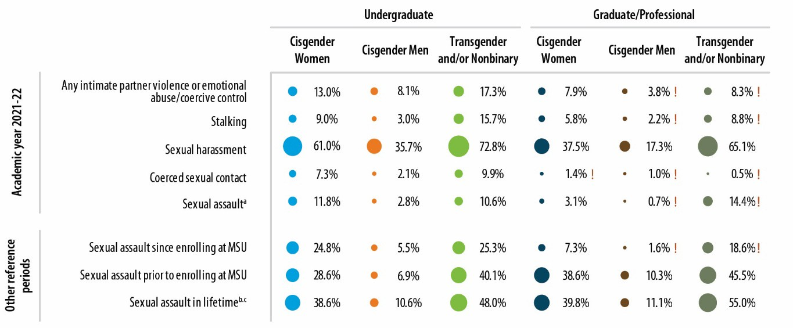Figure 1. Victimization Prevalence
Notes: Percentages are of students. ! Estimate is considered not statistically reliable because it is either based on fewer than 10 people or has a relative standard error greater than 30%. For an accessible version of the information shown in this figure, see Appendix Tables D-1a and D-1b.

Key findings pertaining to students’ victimization experiences included the following:
    - Sexual harassment15 was the most prevalent type of victimization during the 2021–2022 academic year (Figure ES-1), experienced by 61.0% of undergraduate cisgender women,16 72.8% of transgender and/or nonbinary undergraduates, 37.5% of cisgender women graduate/professional students, 65.1% of transgender and/or nonbinary graduate/professional students, 35.7% of undergraduate cisgender men, and 17.3% of cisgender men graduate/professional students.
      - The most common forms of sexual harassment were someone making “inappropriate or offensive comments about your or someone else’s body, appearance, or sexual activities” and “someone referring to people of your gender in insulting or offensive terms.”
    - About 9.0% of undergraduate cisgender women, 3.0% of undergraduate cisgender men, 15.7% of transgender and/or nonbinary undergraduates, and 5.8% of cisgender women graduate/professional students experienced stalking in the 2021–2022 academic year. The stalking estimates for cisgender men graduate/professional students and transgender and/or nonbinary graduate/professional students are not discussed in the text because they were not reliable statistically.
    - About 11.8% of undergraduate cisgender women, 2.8% of undergraduate cisgender men, 10.6% of transgender and/or nonbinary undergraduates, and 3.1% of cisgender women graduate/professional student experienced sexual assault17 during the 2021–2022 academic year.

15 Sexual harassment included a number of behaviors pertaining to sexual remarks; continued sexual advances; sharing of sexual photos or videos; use of offensive, gender-based language; or someone in a position of authority promising better treatment (or threatening worse treatment) associated with sexual contact. See Table 5 for a detailed description of how sexual harassment was measured in the survey.
16 Throughout this report, all results for students, faculty, and staff are shown according to self-reported gender identity.
17 Sexual assault was defined as sexual contact that the person did not consent to and did not want to happen. See Table 5 for a detailed description of how sexual assault was measured in the survey.

      - Sexual battery, defined as any unwanted, nonconsensual sexual contact that involved forced touching of a sexual nature but not penetration, was more common than rape.
      - People committing a sexual assault most commonly used the tactic of “ignoring you when you said ‘no’ or just [doing] it without your consent, when you did not want it to happen.”
      - Most perpetrators were MSU students, and the most common location of rape incidents was an off-campus private residence.
      - A disproportionately high number of incidents took place for first-year undergraduate cisgender women in September and October.
      - Most incidents were disclosed to someone close to the survivor (e.g., a roommate, friend, or family member). In about 16.2% of rape incidents and 4.1% of sexual battery incidents undergraduate cisgender women experienced, the student disclosed the incident to, or sought services from, an MSU office.
      - Students who experienced sexual assault were affected in a number of ways; rape incidents were considered to be much more upsetting to the student than sexual battery incidents and led to more problems in various areas of their lives.
      - When other reference periods are considered, key findings shown in the figure include the following.
        - Among undergraduate cisgender women, 28.6% experienced sexual assault before enrolling in MSU, 24.8% experienced sexual assault since enrolling at MSU, and 38.6% experienced sexual assault in their lifetimes.
        - Among undergraduate cisgender men, 6.9% experienced sexual assault before enrolling in MSU, 5.5% experienced sexual assault since enrolling at MSU, and 10.6% experienced sexual assault in their lifetimes.
        - Among transgender and/or nonbinary undergraduates, 40.1% experienced sexual assault before enrolling in MSU, 25.3% experienced sexual assault since enrolling at MSU, and 48.0% experienced sexual assault in their lifetimes.
        - Among cisgender women graduate/professional students, 38.6% experienced sexual assault before enrolling in MSU, 7.3% experienced sexual assault since enrolling at MSU, and 39.8% experienced sexual assault in their lifetimes.
        - Among cisgender men graduate/professional students, 10.3% experienced sexual assault before enrolling in MSU, and 11.1% experienced sexual assault in their lifetimes.
        - Among transgender and/or nonbinary graduate/professional students, 45.5% experienced sexual assault before enrolling in MSU, and 55.0% experienced sexual assault in their lifetimes.
Additional key findings were as follows:
    - Regarding the components of sexual assault, sexual battery was more common than rape. Among undergraduate cisgender women, 4.4% experienced rape and 6.9% experienced sexual battery during the 2021–2022 academic year. During the same reference period, 1.9% of undergraduate cisgender men experienced sexual battery, and 4.5% of transgender and/or nonbinary undergraduates experienced sexual battery. Comparable estimates for other groups are not discussed because they were not reliable statistically.18
      - The most common types of sexual battery students experienced were someone “touching, grabbing, or fondling your sexual body parts” and “someone rubbing up against you in a sexual way.”
    - Some students experienced more than one incident of sexual assault during the 2021–2022 academic year. For example, among undergraduate cisgender women, 6.4% of students

18 The estimates for cisgender men graduate/professional students were statistically imprecise.

experienced one incident and 5.4% experienced two or more incidents. Among undergraduate cisgender men, 1.9% experienced one incident and 0.9% experienced two or more incidents.
      - When weighted to reflect the entire student population at MSU, the total number of sexual assault incidents experienced during the 2021– 2022 academic year was 3,631 for undergraduate cisgender women, 619 for undergraduate cisgender men, 221 for transgender and/or nonbinary undergraduates, 332 for cisgender women graduate/professional students, 46 for cisgender men graduate/professional students, and 77 for transgender and/or nonbinary graduate/professional students (see sidebar).
Clery Act Data Comparisons
Sexual assault is the most underreported crime in the world (Krebs et al., 2016; Thompson & Tapp, 2022). The incident counts derived from the Know More @ MSU Campus Survey cannot be directly compared to data reported by MSU (regarding the number of sexual assault incidents) under the Clery Act. The estimates included in this report are based on data that students provided about their sexual assault experiences through a confidential survey, whereas data reported under the Clery Act are based on official reports and are limited to incidents that were formally reported to school officials. Given the extreme underreporting of sexual assault, Clery Act data are expected to be much lower than estimates obtained from a self-reported, confidential survey. Other factors that preclude direct comparisons are the Clery Act’s focus on rape incidents (whereas the survey estimates include both sexual battery and rape) and differences in the reference period (Clery Act reporting is based on a calendar year reference period, whereas the survey used an academic year reference period).
Thompson, A.., & Tapp, S. N. (2022, September). Criminal victimiza- tion, 2021 (NCJ 305101). U.S. Department of Justice, Office of Justice Programs, Bureau of Justice Statistics. https://bjs.ojp.gov/content/pub/pdf/cv21.pdf
Krebs, C., Lindquist, C., Berzofsky, M. Shook-Sa, B., Peterson, K., Planty, M., Langton, L., & Stroop, J. (2016, January). Campus Climate Survey validation study: Final technical report (NCJ 249545). U.S. Department of Justice, Office of Justice Programs, Bureau of Justice Statistics. https://bjs.ojp.gov/content/pub/pdf/ccsvsftr.pdf
    - The incident rates (number of incidents per 1,000 students in a given academic year) for sexual assault were 197.0 for undergraduate cisgender women,
36.7 for undergraduate cisgender men, 12.1 for transgender and/or nonbinary undergraduates, and
60.9 for cisgender women graduate/professional students.
    - Among types of intimate partner violence that students experienced, emotional abuse or coercive control by an intimate partner was more common than physical intimate partner violence. For example, 5.9% of undergraduate cisgender women experienced physical intimate partner violence and 10.3% experienced emotional abuse or coercive control by an intimate partner during the 2021–2022 academic year.

Differences in Prevalence Among Student Populations
One goal of this study was to determine whether—within each of the six student populations (undergraduate cisgender women, undergraduate cisgender men, transgender and/or nonbinary undergraduates, cisgender women graduate/professional students, cisgender men graduate/professional students, and transgender and/or nonbinary graduate/professional students)—some student subgroups appear to be at a greater risk of experiencing different types of victimization than others. For each of the 21 victimization outcomes, separate estimates were developed for as many student subgroups as possible (e.g., year of study, length of enrollment, age, student participation in various student groups, race/ethnicity, international status, sexual orientation, and disability status).
The prevalence estimates for sexual assault (Figure 2), sexual harassment (Figure 3), intimate partner violence (Figure 4), and stalking (Figure 5) experienced in the 2021–2022 academic year are

shown for specific subgroups of undergraduate students. Figures 6 through 9 show the same estimates for specific subgroups of graduate and professional students. Estimates that are considered statistically imprecise (due to small numbers of students in the particular subgroup) are flagged and should be interpreted with caution. Appendix D contains additional subgroup information and prevalence estimates for all types of victimization explored in the survey, including coerced sexual contact, sexual battery, and rape; and, for sexual assault, rape, and sexual battery, estimates for additional reference periods (e.g., before enrolling at MSU, since enrolling at MSU, and in students’ lifetimes) are included. The figures, which present a lot of data and results, are followed by some bullets and text that summarize just some of the findings for various student groups, victimization types, and reference periods.
Overall patterns from the subgroup analyses suggest the following:
    - For undergraduate cisgender women, the subgroups of students who tended to have the highest prevalence rates for multiple types of victimization include cisgender women with a diagnosed or documented disability19; those who were bisexual, pansexual, queer, or another combination of orientations; and domestic (as opposed to international) students.20
      - Analysis of 2021–2022 prevalence estimates showed that 73.0% of undergraduate cisgender women who indicated that they had a diagnosed or documented disability experienced sexual harassment; 58.5% of undergraduate cisgender women without a diagnosed or documented disability experienced sexual harassment. Undergraduate cisgender women who were bisexual, pansexual, queer, or another combination of orientations and domestic (as opposed to international) were more likely to be sexually harassed.
      - In terms of stalking, fourth-year students seem to be at greater risk than students in other years of study, and domestic students are at greater risk of experiencing stalking than their international counterparts. Black and Hispanic undergraduate cisgender women appear to experience stalking at higher rates than other races/ethnicities. Having a diagnosed or documented disability and being bisexual, pansexual, queer, or another combination of orientations were also associated with an increased risk of experiencing stalking.
      - Cisgender women who had a diagnosed or documented disability; were bisexual, pansexual, queer, or another combination of orientations; or were domestic (as opposed to international) were more likely to be sexually assaulted. First-year undergraduate cisgender women students and younger students also appeared to have higher rates of sexual assault, rape, and sexual battery than those in other years of study. Higher rates of sexual assault were associated with women who described themselves as being of more than one race (16.7%), White (12.4%), or Hispanic (11.1%).
      - Analysis of sexual assaults experienced during other reference periods showed that undergraduate cisgender women who described themselves as queer had the highest rates for multiple reference periods, including lifetime (58.1%) and before enrolling at MSU (51.0%). Cisgender women who indicated they had a diagnosed or documented disability had a higher rate of sexual assault since enrolling at MSU (35.7%) than cisgender women without a diagnosed or documented disability (22.5%). Not surprisingly, upperclassmen, those who had been enrolled for longer periods of time, and older students had higher lifetime rates and “since enrolling at MSU” rates. Cisgender women who were involved in Greek life had a higher rate of sexual assault since entering MSU (31.4%) than cisgender women who were not (23.1%).

19 We are unable to determine whether the documented disability is a result of an assault (e.g., PTSD) or if a student’s disability existed prior to being assaulted.
20 However, coerced sexual contact appeared to be higher among undergraduate women who were international students than those who were not.

    - For undergraduate cisgender men, the subgroups of students who tended to have the highest prevalence estimates across victimization types included cisgender men with diagnosed or documented disabilities; cisgender men who were gay, bisexual, or pansexual; Hispanic and White cisgender men; and cisgender men involved in Greek organizations.
      - Analysis of the 2021–2022 prevalence estimates revealed that undergraduate cisgender men who described themselves as gay, bisexual, or pansexual had the highest rates of sexual harassment of any subgroup. Intimate partner violence was most prevalent among Hispanic cisgender men (18.9%) and cisgender men who indicated that they had a diagnosed or documented disability (13.0%). Cisgender men who indicated they were involved in Greek life had higher rates of sexual harassment (40.2%) than cisgender men who were not (34.9%).
      - Analysis of sexual assaults experienced during other reference periods showed that undergraduate cisgender gay men had the highest rates of sexual assault experienced before MSU (23.3%) and since enrolling at MSU (21.3%) of any subgroup. Not surprisingly, upperclassmen, those who had been enrolled for longer periods of time, and older students had higher lifetime rates and “since enrolling at MSU” rates. Cisgender men who were involved in Greek life had a higher rate of sexual assault since entering MSU (10.6%) than cisgender men who were not (4.6%).
    - For transgender and/or nonbinary undergraduates, many of the prevalence estimates for subgroups are based on relatively small numbers of respondents and are therefore not statistically precise, so the number of findings that can be credibly described is limited.
      - Sexual harassment rates were higher for transgender and/or nonbinary undergraduates with a diagnosed or documented disability (76.1%) than for those without a diagnosed or documented disability (70.7%). Stalking rates were also higher for transgender and/or nonbinary undergraduates with a diagnosed or documented disability (21.1%) than for those without a diagnosed or documented disability (11.3%).
    - For cisgender women graduate/professional students, the subgroups of students who tended to have the highest prevalence estimates across victimization types include cisgender women with documented or diagnosed disabilities and those who were queer, bisexual, or pansexual.
      - Analysis of the 2021–2022 prevalence estimates showed that cisgender women graduate/professional students who described themselves as anything other than straight/heterosexual or gay/lesbian/same gender loving (e.g., queer, bisexual, or pansexual) experienced the highest rate of sexual harassment. Cisgender women graduate/professional students who indicated that they had a diagnosed or documented disability had higher rates of stalking than those who did not (15.5% and 2.3%, respectively), as well as higher rates of emotional abuse/coercive control by an intimate partner (13.1% and 4.8%), intimate partner violence (15.1% and 5.5%), and sexual harassment (48.2% and 33.8%). White cisgender women had a higher rate of sexual harassment (40.9%) than those in other racial/ethnic groups, and cisgender women who were professional students had higher rates of sexual harassment (46.3%) than graduate students (33.3%).
      - Analysis of sexual assaults experienced during other reference periods showed that cisgender women graduate/professional students who described themselves as queer, bisexual, or pansexual had the highest rates of sexual assault of any subgroup before enrolling at MSU and in their lifetimes. Cisgender women who indicated that they had a diagnosed or documented disability had a higher rate of sexual assault since enrolling at MSU than cisgender women without a diagnosed or documented disability (17.1% and 3.9%).
    - Among cisgender men and transgender and/or nonbinary graduate/professional students, the prevalence estimates for subgroups are based on very small numbers of respondents, are not statistically precise, and are therefore not described.

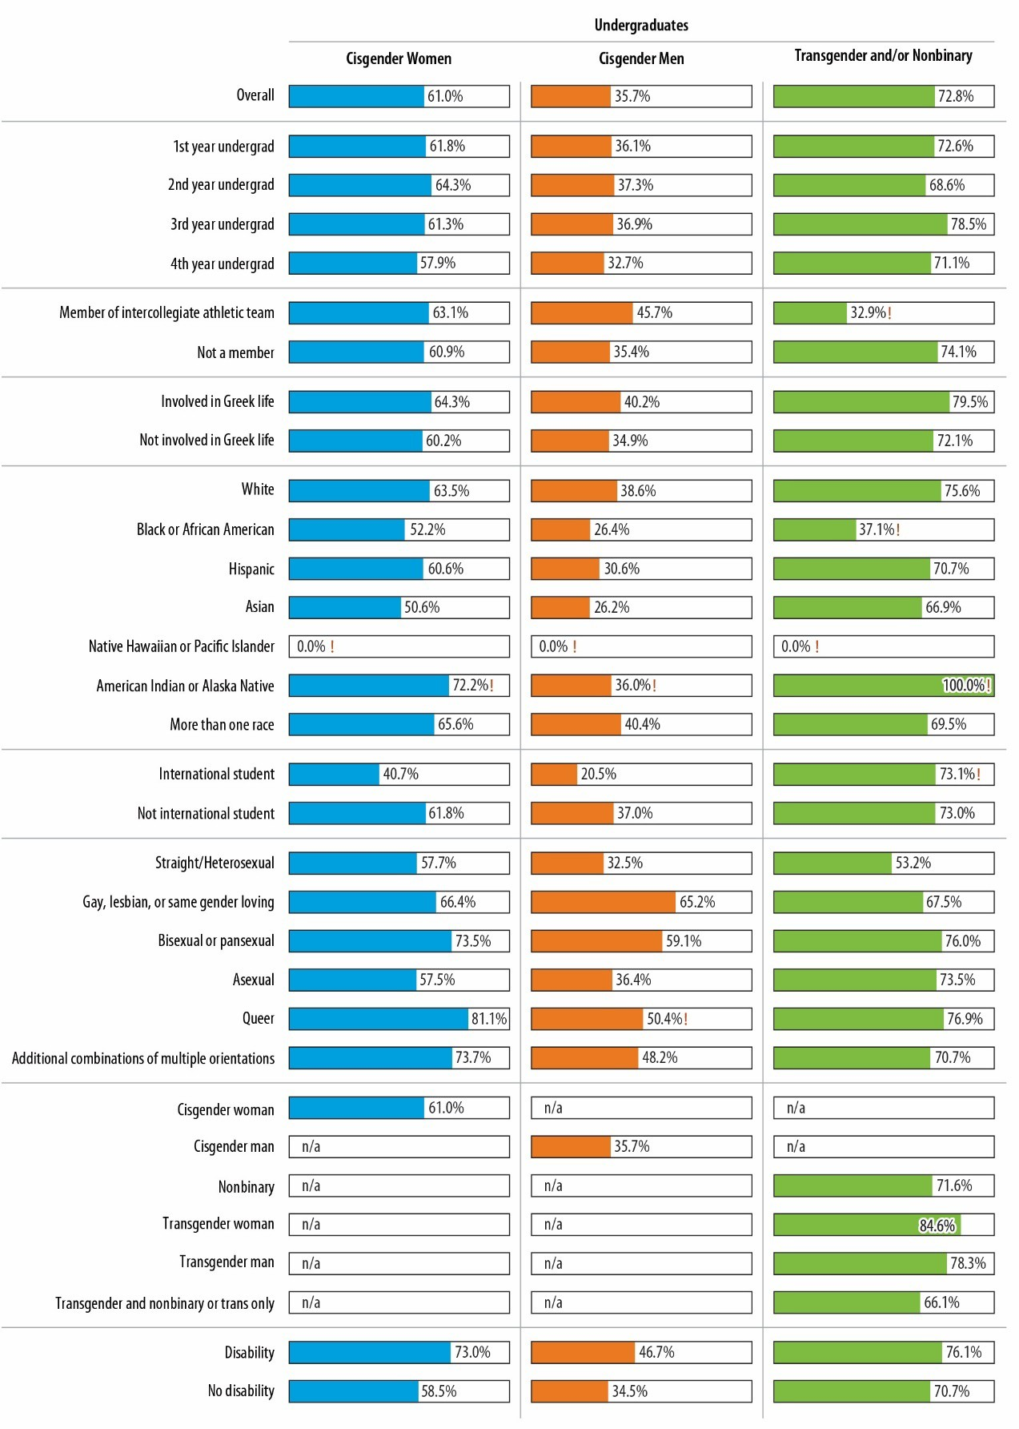Figure 2. Prevalence of Sexual Harassment in 2021–2022 Academic Year, by Student Characteristics, Undergraduates
Notes: Percentages are of students. ! Estimate is considered not statistically reliable because it is either based on fewer than 10 people or has a relative standard error greater than 30%. For an accessible version of the information shown in this figure, see Appendix Tables D-3a1 through D-3a3.

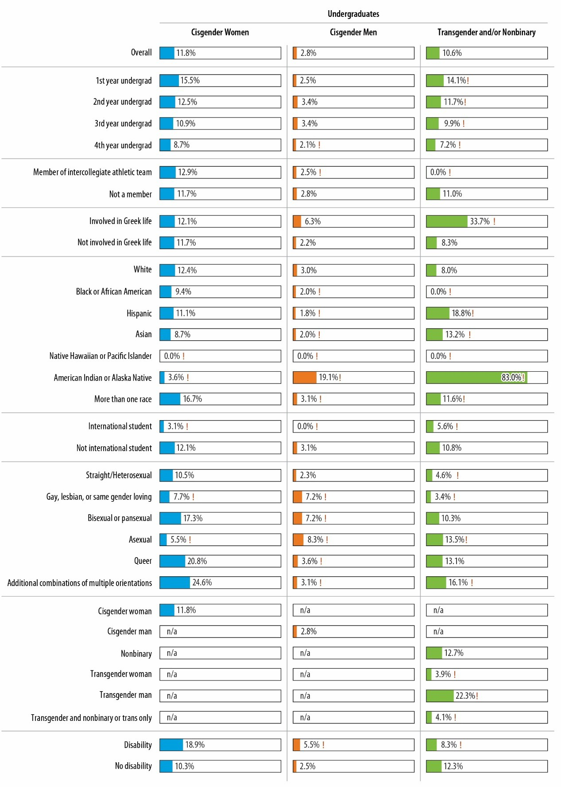Figure 3. Prevalence of Sexual Assault in 2021–2022 Academic Year, by Student Characteristics, Undergraduates
Notes: Percentages are of students. ! Estimate is considered not statistically reliable because it is either based on fewer than 10 people or has a relative standard error greater than 30%. For an accessible version of the information shown in this figure, see Appendix Tables D-3a1 through D-3a3.

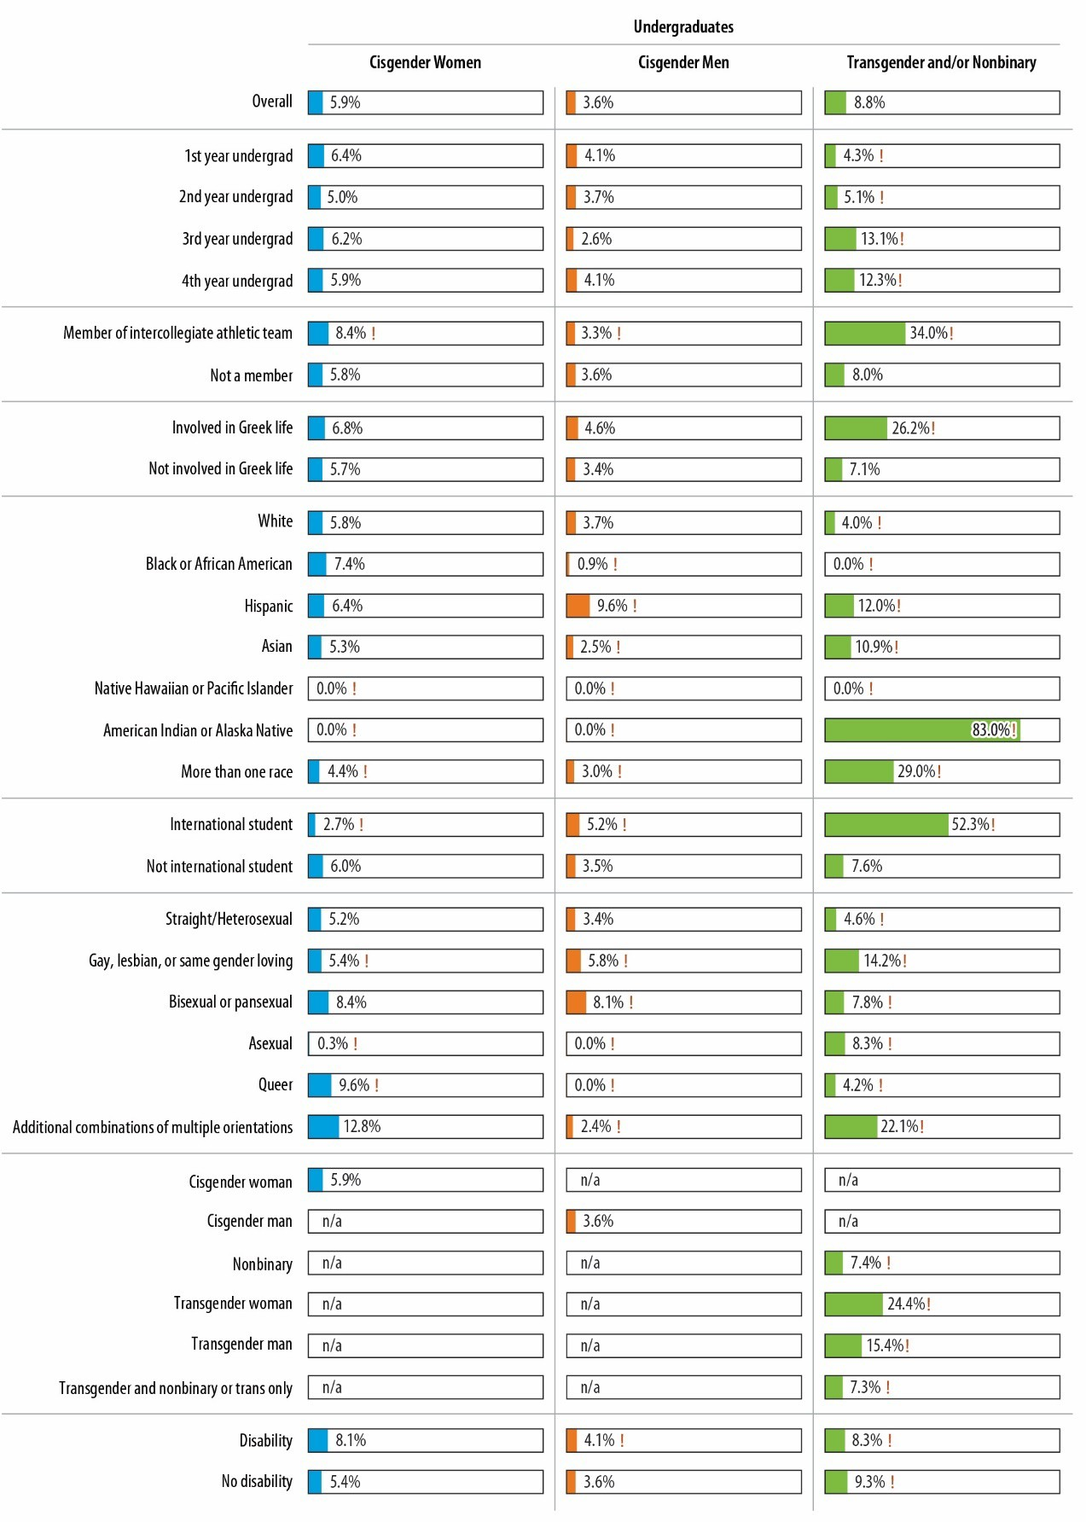Figure 4. Prevalence of Intimate Partner Violence in 2021–2022 Academic Year, by Student Characteristics, Undergraduates
Notes: Percentages are of students. ! Estimate is considered not statistically reliable because it is either based on fewer than 10 people or has a relative standard error greater than 30%. For an accessible version of the information shown in this figure, see Appendix Tables D-3a1 through D-3a3.

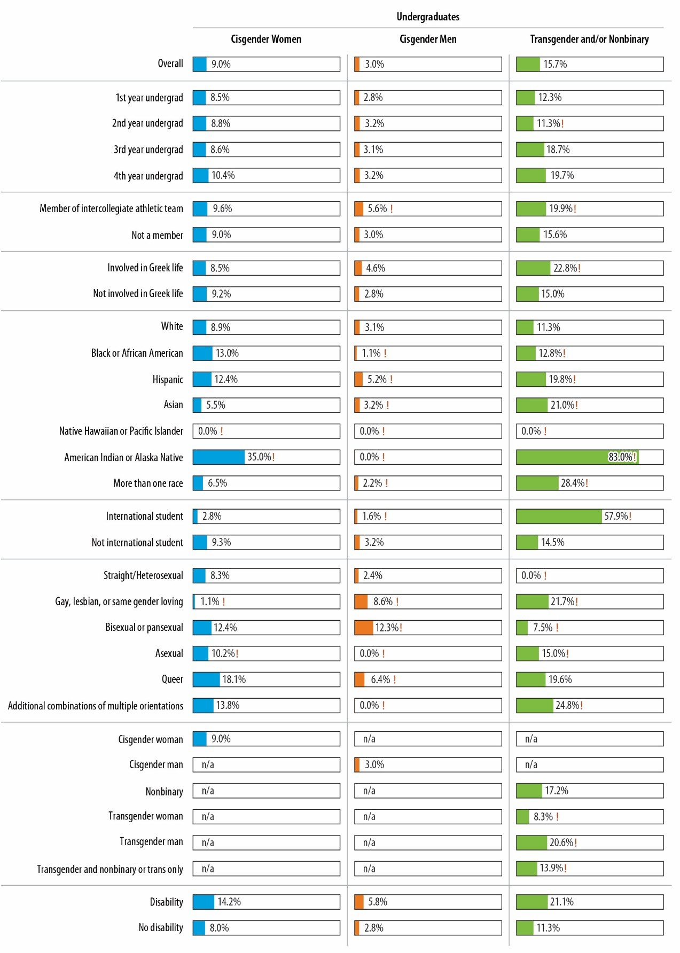Figure 5. Prevalence of Stalking in 2021–2022 Academic Year, by Student Characteristics, Undergraduates
Notes: Percentages are of students. ! Estimate is considered not statistically reliable because it is either based on fewer than 10 people or has a relative standard error greater than 30%. For an accessible version of the information shown in this figure, see Appendix Tables D-3a1 through D-3a3.

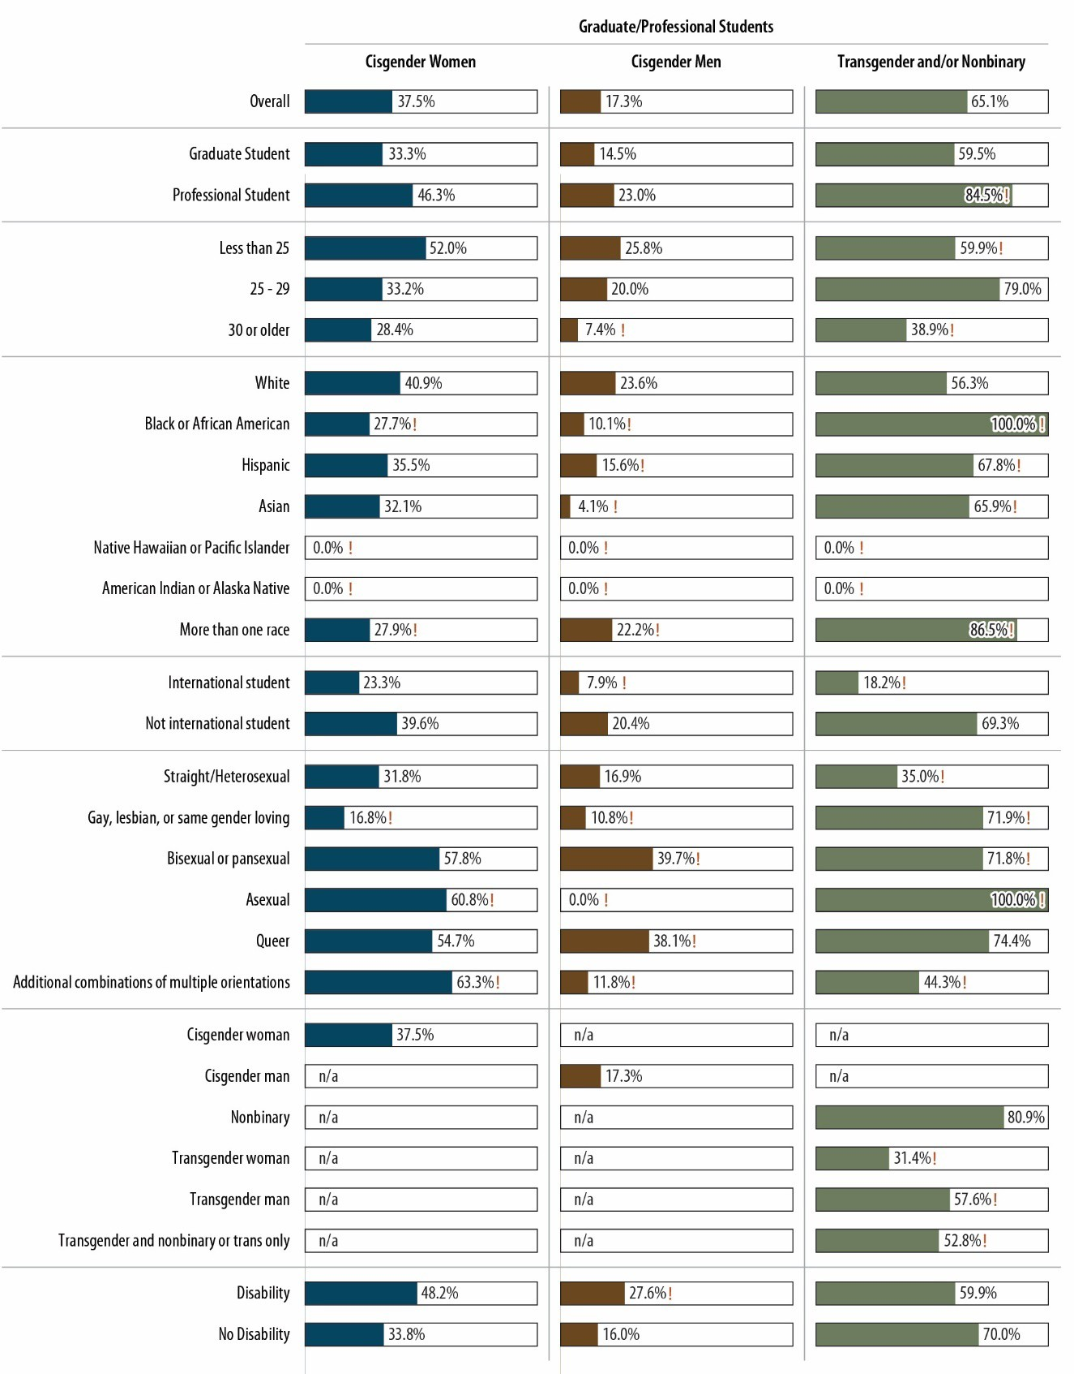Figure 6. Prevalence of Sexual Harassment in 2021–2022 Academic Year, by Student Characteristics, Graduate/Professional Students
Notes: Percentages are of students. ! Estimate is considered not statistically reliable because it is either based on fewer than 10 people or has a relative standard error greater than 30%. For an accessible version of the information shown in this figure, see Appendix Tables D-3a4 through D-3a6.

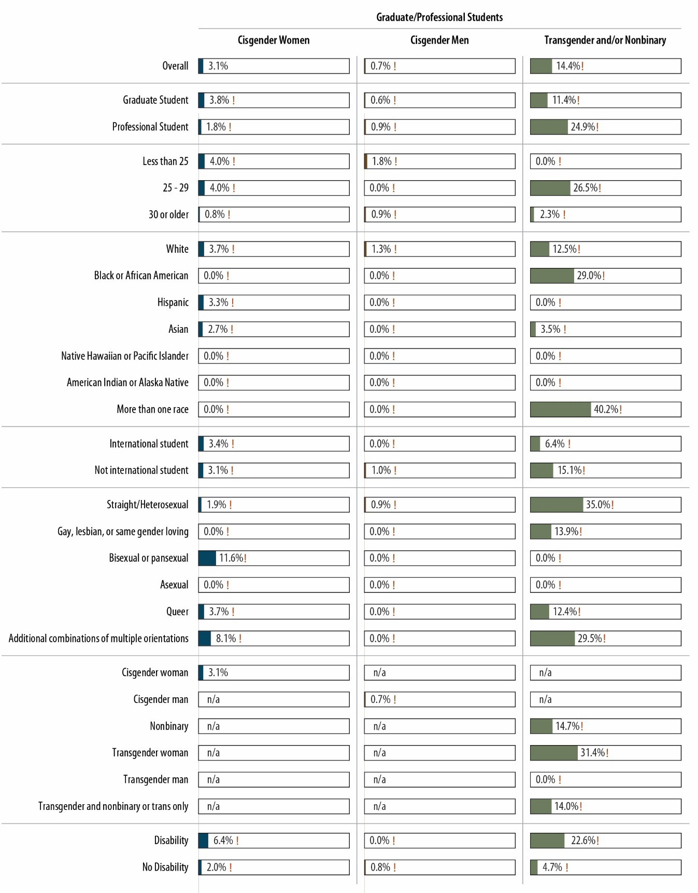Figure 7. Prevalence of Sexual Assault in 2021–2022 Academic Year, by Student Characteristics, Graduate/Professional Students
Notes: Percentages are of students. ! Estimate is considered not statistically reliable because it is either based on fewer than 10 people or has a relative standard error greater than 30%. For an accessible version of the information shown in this figure, see Appendix Tables D-3a4 through D-3a6.

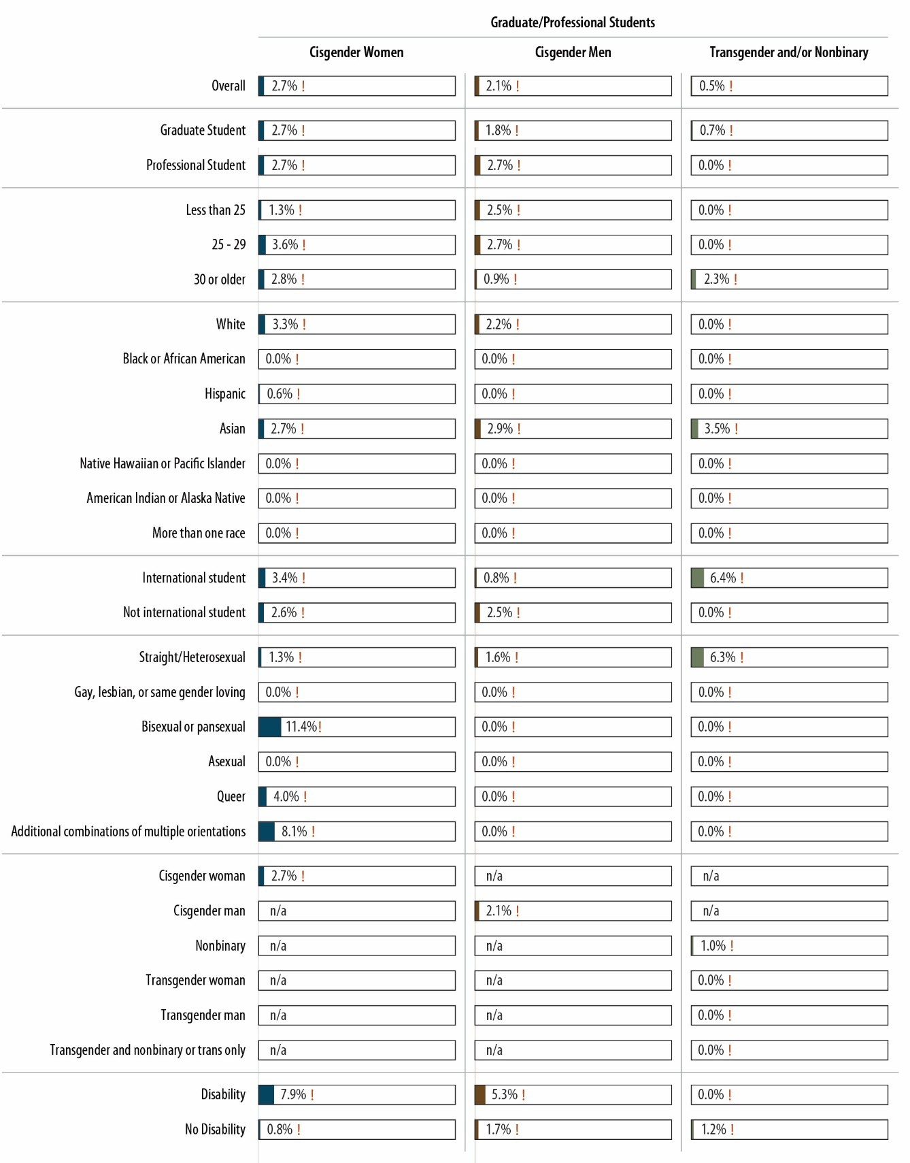Figure 8. Prevalence of Intimate Partner Violence in 2021–2022 Academic Year, by Student Characteristics, Graduate/Professional Students
Notes: Percentages are of students. ! Estimate is considered not statistically reliable because it is either based on fewer than 10 people or has a relative standard error greater than 30%. For an accessible version of the information shown in this figure, see Appendix Tables D-3a4 through D-3a6.

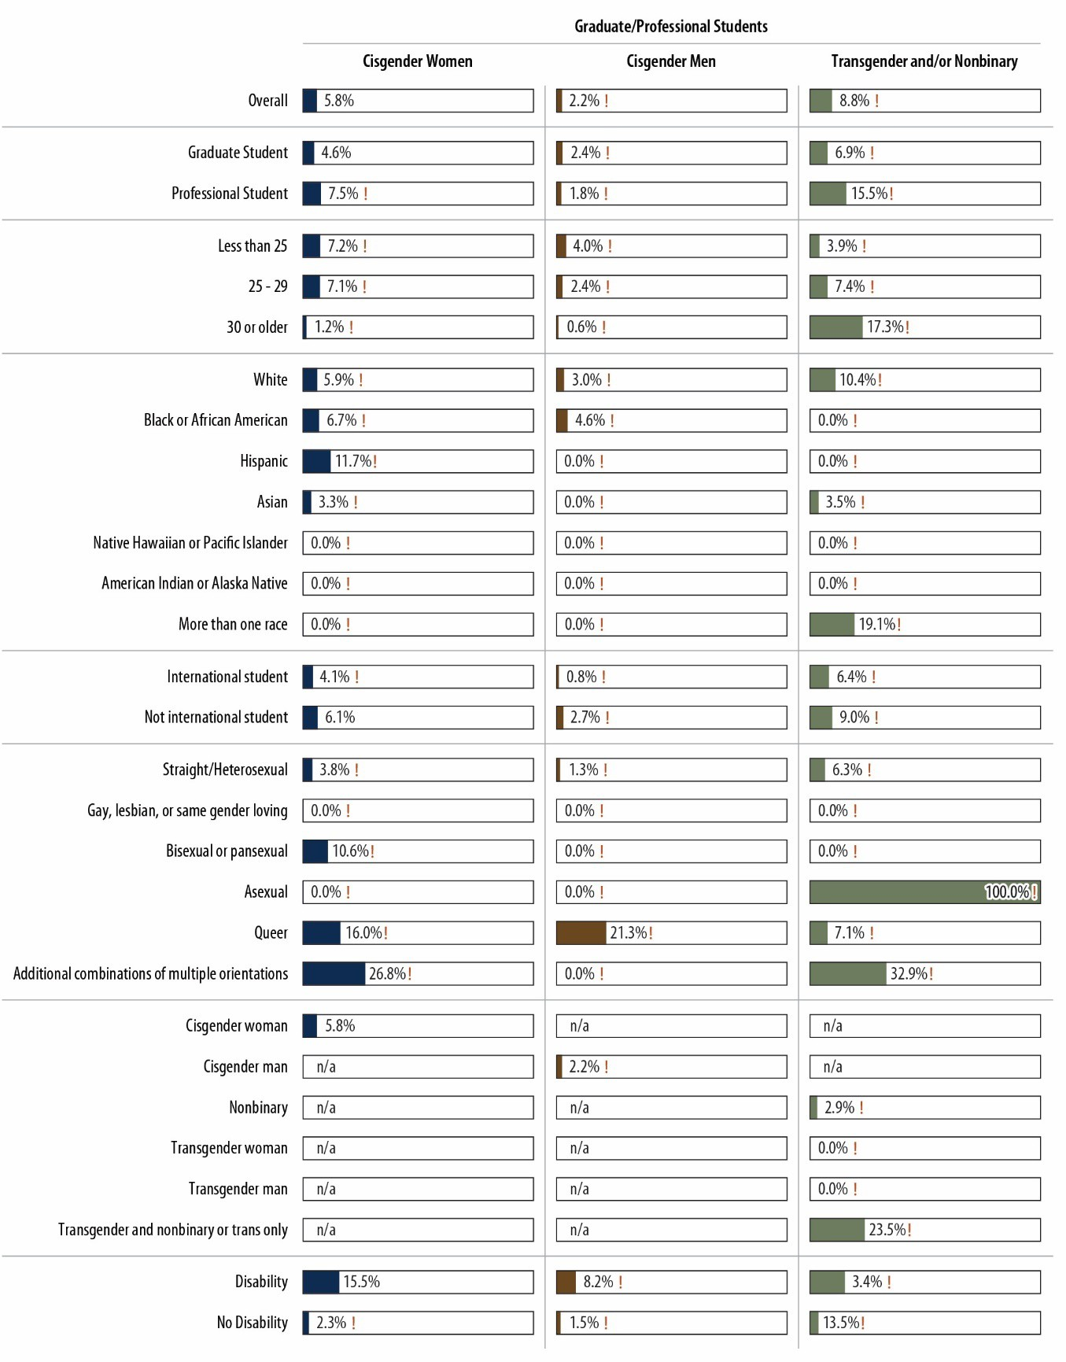Figure 9. Prevalence of Stalking in 2021–2022 Academic Year, by Student Characteristics, Graduate/Professional Students
Notes: Percentages are of students. ! Estimate is considered not statistically reliable because it is either based on fewer than 10 people or has a relative standard error greater than 30%. For an accessible version of the information shown in this figure, see Appendix Tables D-3a4 through D-3a6.

Additional Details: Sexual Harassment
To understand the sexual harassment that students experienced, consider Figure 10, which shows the percentage of students who indicated they experienced specific types of sexual harassment during the 2021–2022 academic year. As evident, the two most common types of sexual harassment were “someone making inappropriate or offensive comments about your or someone else’s body, appearance, or sexual activities” and someone “referring to people of your gender in insulting or offensive terms.” Both behaviors were common experiences: nearly half of undergraduate cisgender women experienced each behavior. Very few students indicated that someone in a position of authority over them had promised them better treatment or implied favors if they engaged in sexual contact or implied or threatened worse treatment if they refused sexual contact.

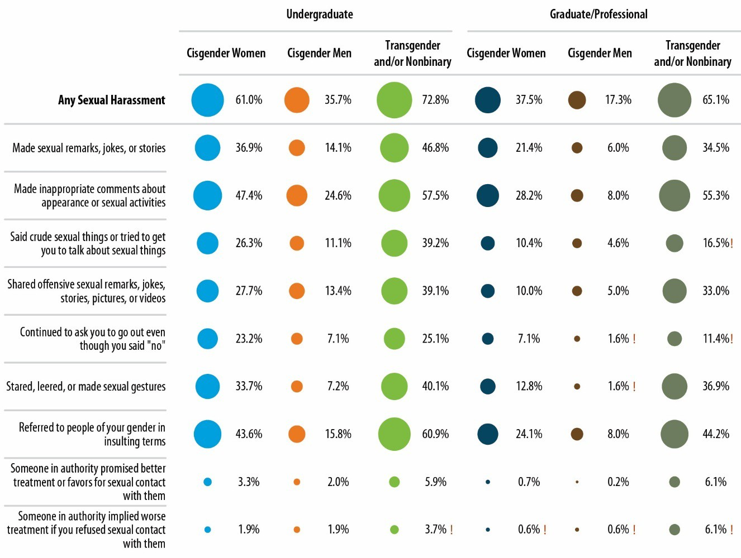Figure 10. Prevalence of Specific Types of Sexual Harassment in 2021–2022 Academic Year
Notes: Percentages are of students. ! Estimate is considered not statistically reliable because it is either based on fewer than 10 people or has a relative standard error greater than 30%. For an accessible version of the information shown in this figure, see Appendix Table D-4.

Details about the impact of the sexual harassment that students experienced are shown in Figure 11. Most commonly, the sexual harassment led to problems with the students’ mental health. For cisgender women undergraduates, 54.1% indicated experiencing mental health problems, as did 33.3% of cisgender men undergraduates, 71.9% of transgender and/or nonbinary undergraduates, 52.2% of

cisgender women graduate/professional students, 45.8% of cisgender men graduate/professional students, and 70.7% of transgender and/or nonbinary graduate/professional students. The next most common problems had to do with friends, roommates, or peers. About 29.0% of undergraduate cisgender women, 26.1% of undergraduate cisgender men, 42.2% of transgender and/or nonbinary undergraduates, 19.1% of cisgender women graduate/professional students, and 24.4% of cisgender men graduate/professional students indicated experiencing problems with friends, roommates, or peers as a result of their sexual harassment experiences.

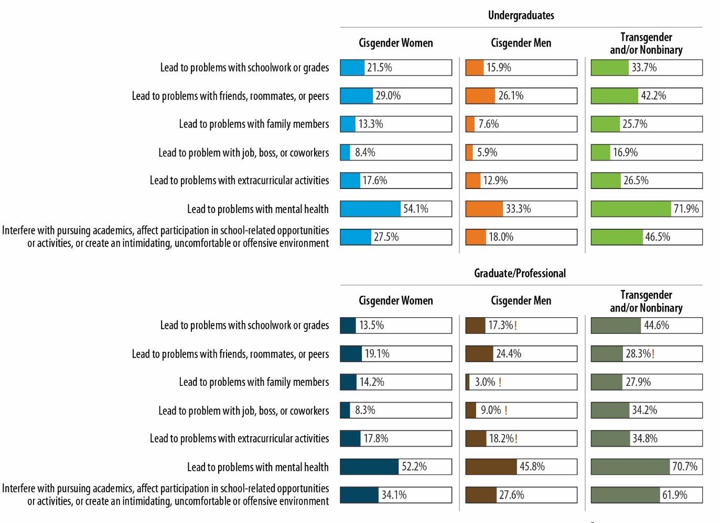Figure 11. Impact of Sexual Harassment
Notes: Percentages are of sexual harassment survivors. ! Estimate is considered not statistically reliable because it is either based on fewer than 10 people or has a relative standard error greater than 30%. For an accessible version of the information shown in this figure, see Appendix Table D-5.

Those who acknowledged experiencing sexual harassment indicated that MSU students were the most common perpetrators of sexual harassment (Figure 12). This was the case for about three-quarters of undergraduate cisgender women, undergraduate cisgender men, transgender and/or nonbinary undergraduates, and cisgender men graduate/professional students who experienced sexual harassment. About half of cisgender women graduate/professional students and transgender and/or nonbinary graduate/professional students indicated their sexual harassment perpetrators were MSU students. Individuals not affiliated with MSU were also responsible for a substantial proportion of sexual

harassment incidents. In addition, 12.6% of cisgender women graduate/professional students and 47.7% of transgender and/or nonbinary graduate/professional students indicated that an MSU professor, instructor, or postdoctoral scholar engaged in sexual harassment.

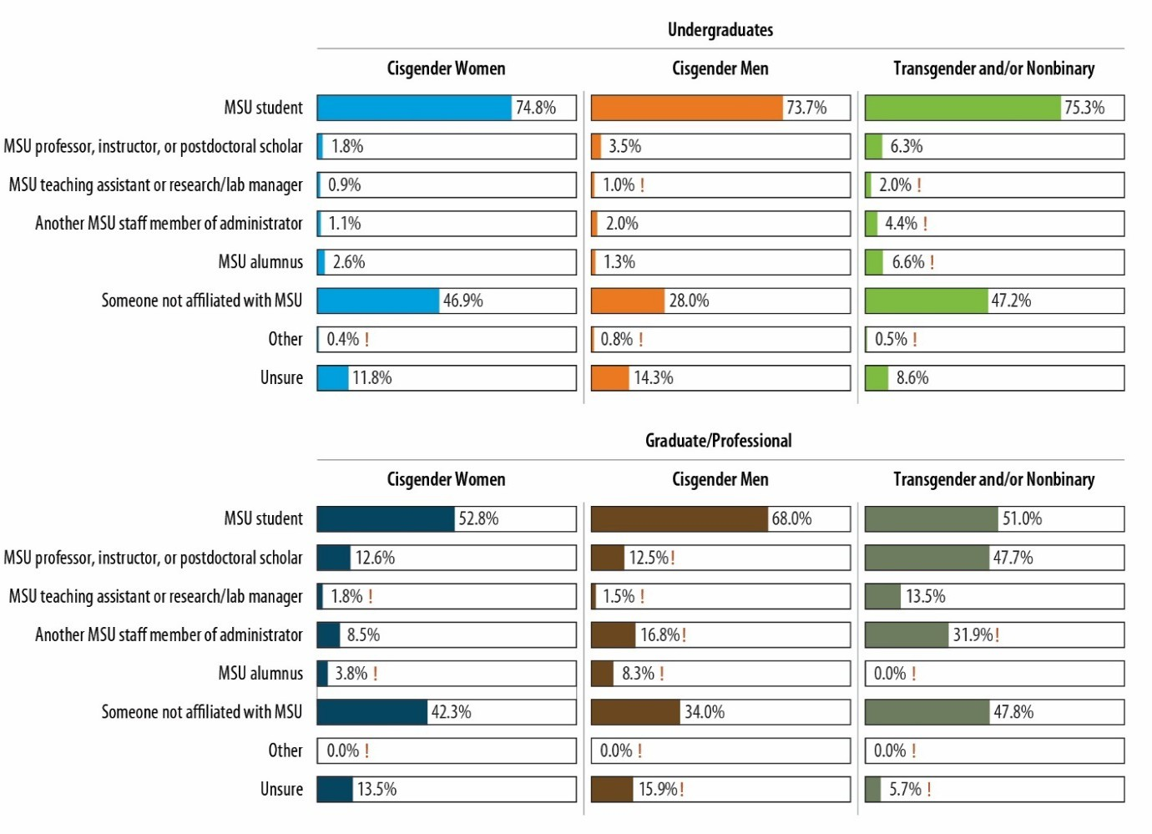Figure 12. Sexual Harassment Perpetrator
Notes: Percentages are of sexual harassment survivors. ! Estimate is considered not statistically reliable because it is either based on fewer than 10 people or has a relative standard error greater than 30%. For an accessible version of the information shown in this figure, see Appendix Table D-5.

Of those who indicated having experienced sexual harassment, about three-quarters of cisgender women and transgender and/or nonbinary students (both undergraduate and graduate/professional students) and half of cisgender men (both undergraduate and graduate/professional students) told someone close to them (i.e., friend, classmate, family member, or intimate partner) about the experience (Figure 13). Very small proportions of students notified an office or resource at MSU, although 14.0% of cisgender women graduate/professional students told a faculty member, teaching/research assistant, or MSU staff member about their experiences.

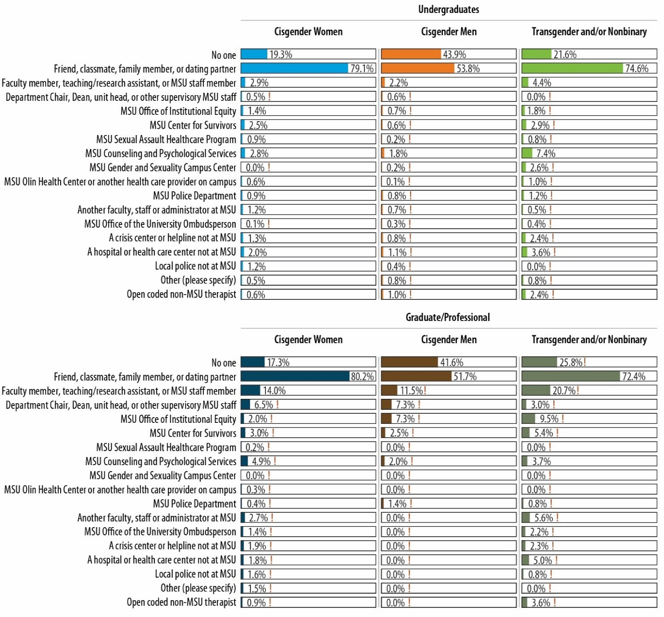Figure 13. Sexual Harassment Disclosure
Notes: Percentages are of sexual harassment survivors. ! Estimate is considered not statistically reliable because it is either based on fewer than 10 people or has a relative standard error greater than 30%. For an accessible version of the information shown in this figure, see Appendix Table D-6.

Students who experienced sexual harassment and did not disclose their experience to a formal source of support were asked a follow-up question about their reasons for not disclosing. The results are shown in Figure 14. For almost all student groups, the most common reason cited for not contacting any people or organizations was that they did not think their experiences were serious enough to disclose. For transgender and/or nonbinary graduate/professional students, the most common reason was having concerns that they would be treated poorly. The next most common reasons for all student groups except transgender and/or nonbinary graduate/professional students were that students did not need any help assistance or did not want any action taken. Transgender and/or nonbinary graduate/professional students were more likely to express concerns about whether authorities would be responsive to or have

negative attitudes toward their identities, but they also endorsed the reasons provided by the other student groups.

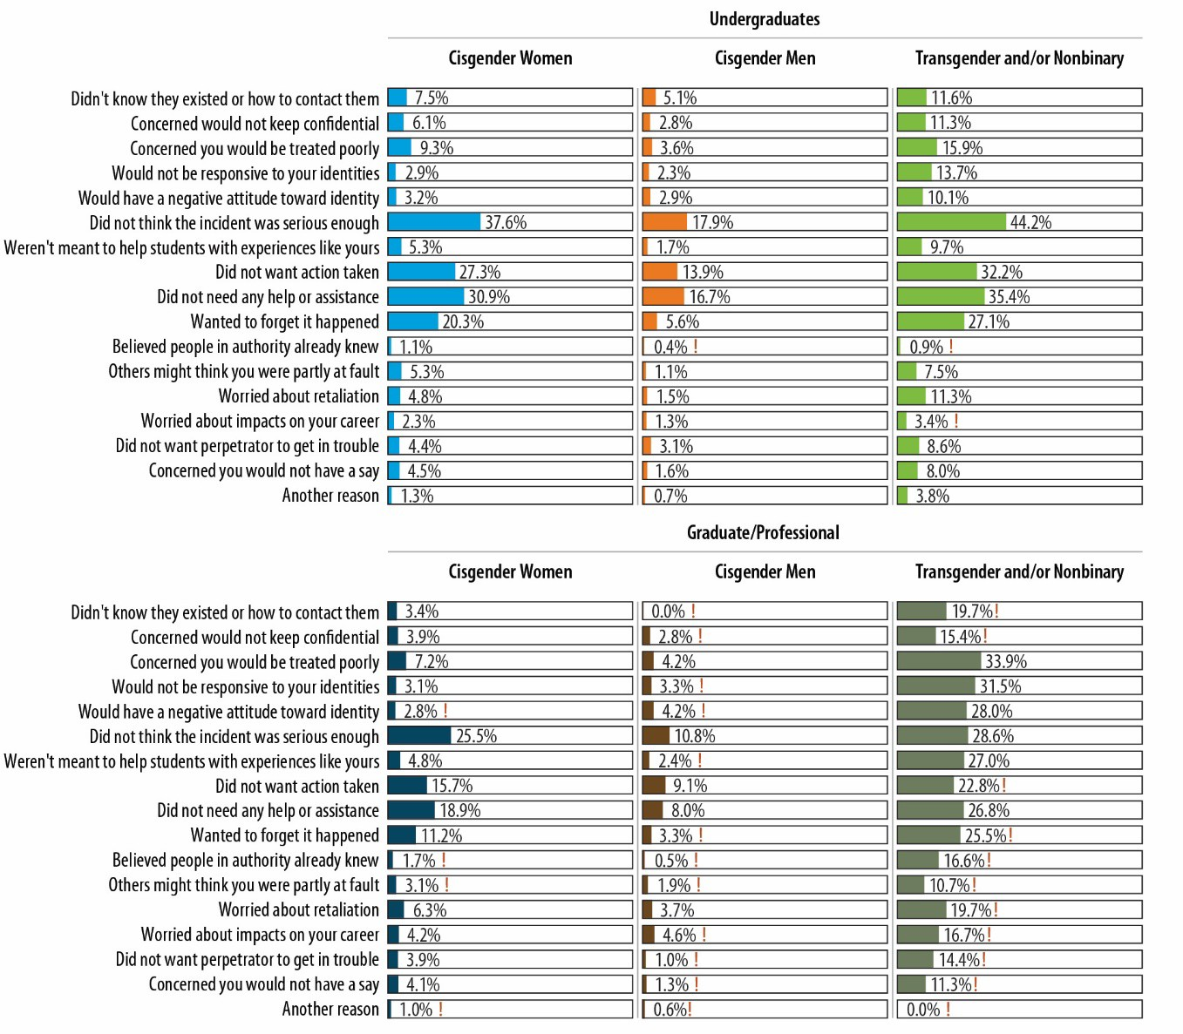Figure 14. Reasons for Not Disclosing Sexual Harassment
Notes: Percentages are of sexual harassment survivors who did not disclose. ! Estimate is considered not statistically reliable because it is either based on fewer than 10 people or has a relative standard error greater than 30%. For an accessible version of the information shown in this figure, see Appendix Tables D-7a and D-7b.

Additional Details: Sexual Assault
Recent sexual assault survivors (i.e., students who indicated that they had experienced one or more incidents of sexual assault during the 2021–2022 academic year) were asked a detailed set of questions about each incident (up to three incidents) in the survey. These questions were asked to improve understanding of the context in which sexual assault incidents occur, students’ experiences with disclosure, and the impact of the incidents.

Incident Characteristics
The survey gathered detailed information about the tactic used during the incident (e.g., force, incapacitation), the location of incidents, number and gender of perpetrators, perpetrator affiliation with MSU, the survivor’s relationship to the perpetrator, and drug and alcohol use by the perpetrator and survivor. All details were analyzed separately for rape and sexual battery incidents experienced in 2021– 2022, for each student population (undergraduate cisgender women, undergraduate cisgender men, transgender and/or nonbinary undergraduates, cisgender women graduate/professional students, cisgender men graduate/professional students, and transgender and/or nonbinary graduate/professional students) to understand the differences in the rape and sexual battery incidents. (Details for all sexual assault incidents experienced in 2021–2022 are in Appendix D.)
Figure 15 shows the location of rape and sexual battery incidents experienced by undergraduate cisgender women (the student population with the highest number of incidents). As evident, the majority of rape incidents (42.2%) took place in off-campus private residences, and the second most common location for rape incidents (27.5%) was on-campus residence halls/dorms. For sexual battery incidents experienced by undergraduate cisgender women, the most common locations were restaurants, bars, and clubs (33.3%); off-campus private residences (22.5%); and fraternity houses (17.8%), The most common locations for both rape and sexual battery incidents were similar for the other student groups, but most of these estimates lack statistical power and precision and are therefore considered imprecise or not reliable statistically.

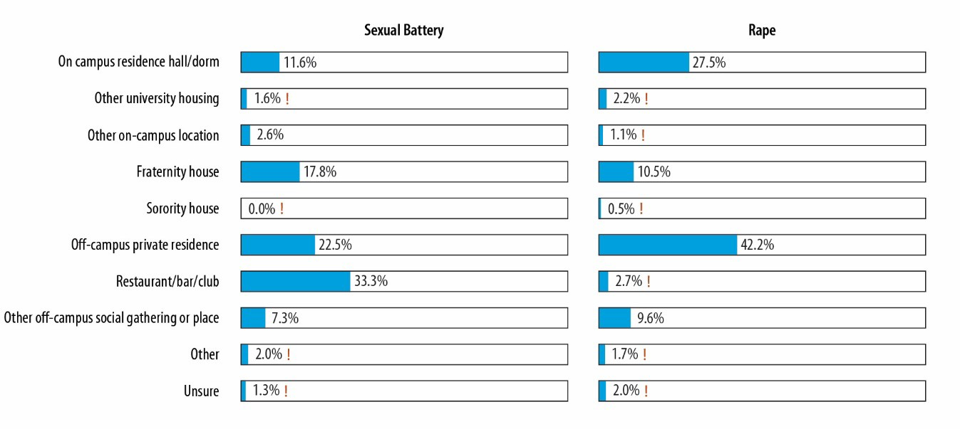Figure 15. Location of Sexual Battery and Rape Incidents Experienced by Undergraduate Cisgender Women
Notes: Percentages are of incidents. ! Estimate is considered not statistically reliable because it is either based on fewer than 10 people or has a relative standard error greater than 30%. For an accessible version of the information shown in this figure, see Appendix Tables D-8b and D-8c.

Other contextual characteristics of rape and sexual battery incidents that undergraduate cisgender women experienced in the 2021–2022 academic year are shown in Figure 16. Several differences in rape and sexual battery incidents are evident. For example, although the most common tactic used to achieve both rape and sexual battery incidents was the person “ignoring you when you said ‘no’ or just [doing] it without your consent, when you did not want it to happen,” it is clear that threats and physical force were fairly common among rape incidents (37.2%), along with the survivor’s being “unable to provide consent or stop what was happening because [you] were incapacitated, passed out, unconscious, blacked out, or asleep” (51.2%), whereas fewer than a quarter of the sexual battery incidents experienced by undergraduate cisgender women were attributed to these two tactics. Other differences were that sexual battery incidents were more likely to be perpetrated by a stranger (49.9%) and rape incidents by an “acquaintance, friend of a friend, or someone you just met” (45.2%), and that sexual battery incidents were slightly more likely than rape incidents to involve alcohol or drug use on the part of the perpetrator, the survivor, or both. The most common category of perpetrator was an MSU student, which was the case for both rape (59.0%) and sexual battery (64.1%) incidents.

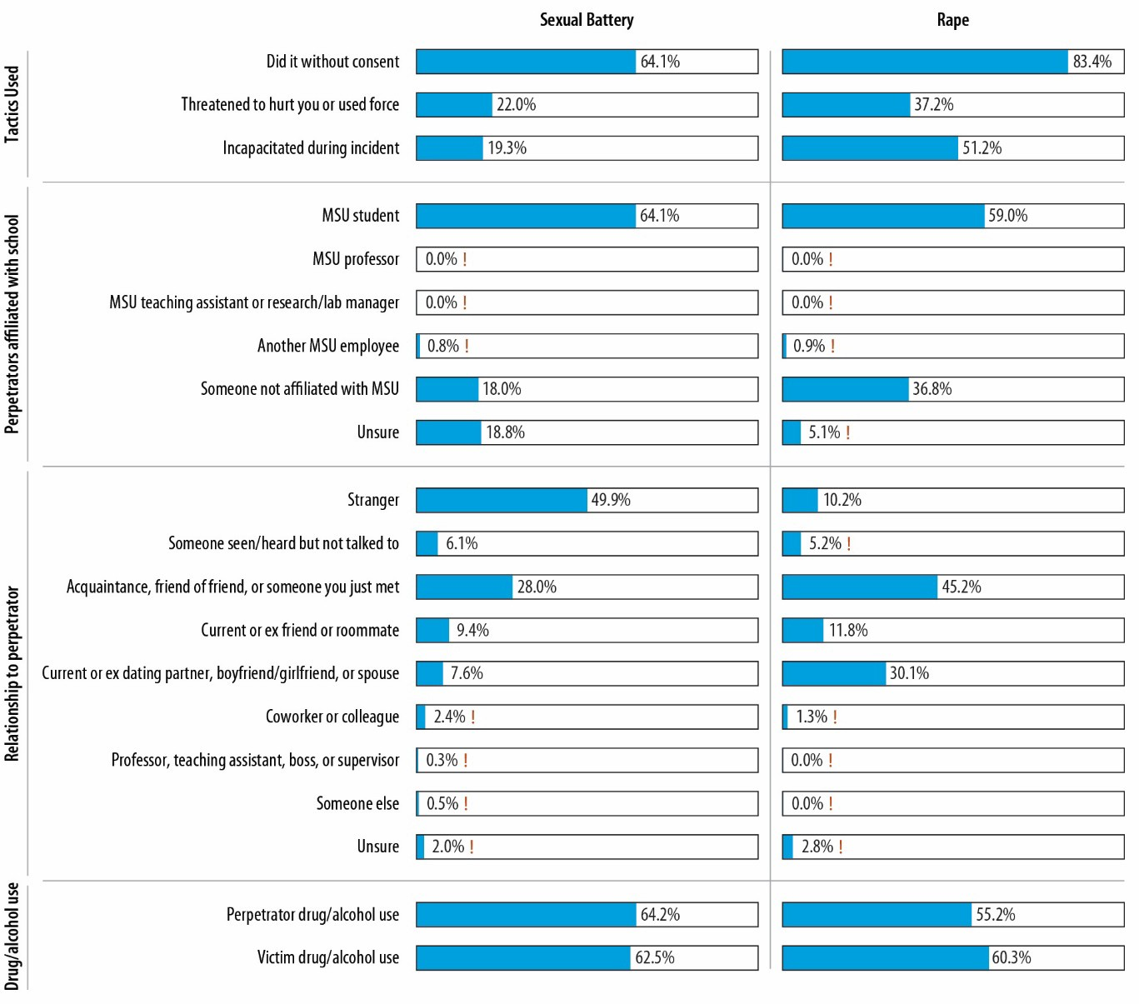Figure 16. Characteristics of Sexual Battery and Rape Incidents Experienced by Undergraduate Cisgender Women
Notes: Percentages are of incidents. ! Estimate is considered not statistically reliable because it is either based on fewer than 10 people or has a relative standard error greater than 30%. For an accessible version of the information shown in this figure, see Appendix Tables D-8b and D-8c.

Most of the incident characteristics estimates for sexual battery and rape incidents experienced by members of the other student groups lack statistical power and precision and are therefore considered imprecise or not reliable statistically (see Figures 17 and 18 for what can be reported).

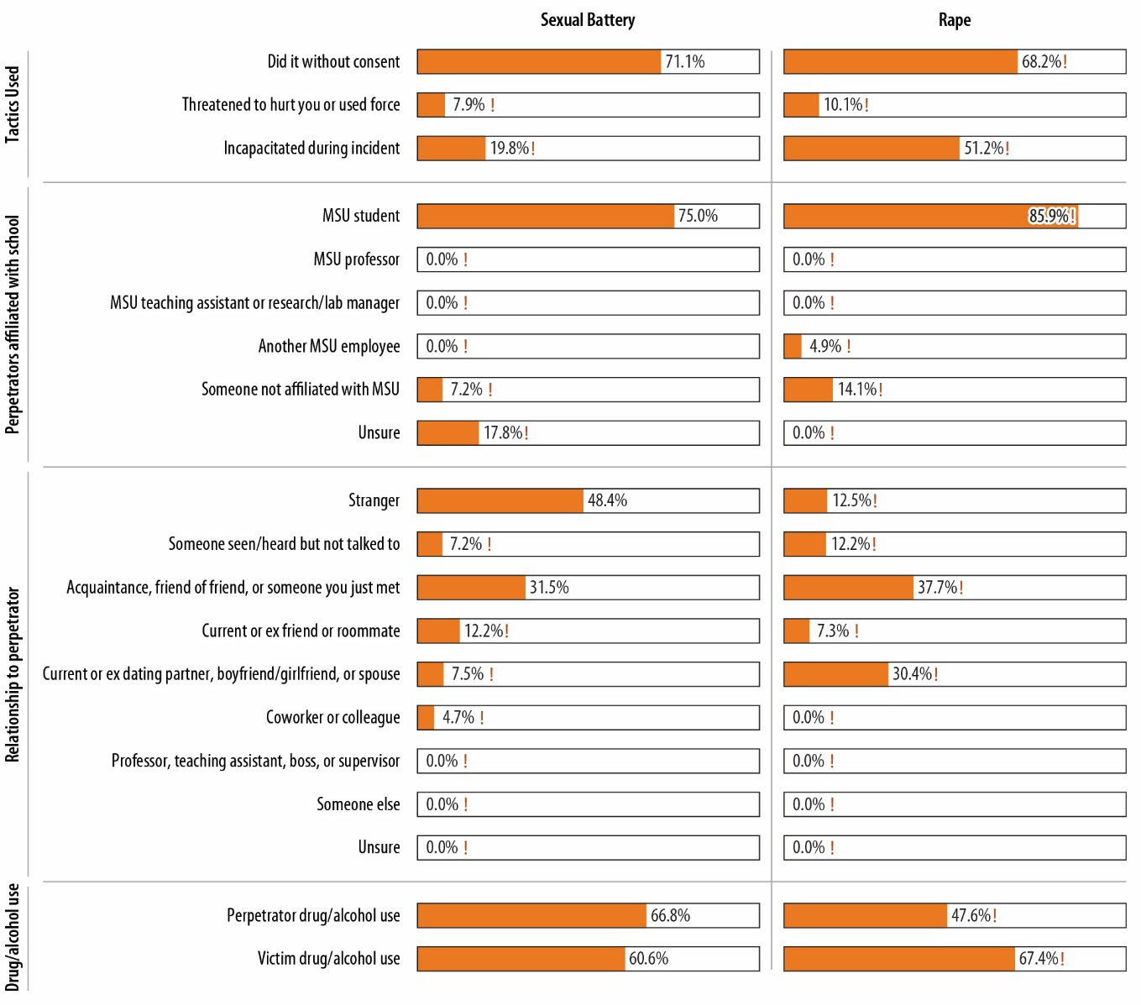Figure 17. Characteristics of Sexual Battery and Rape Incidents Experienced by Undergraduate Cisgender Men
Notes: Percentages are of incidents. ! Estimate is considered not statistically reliable because it is either based on fewer than 10 people or has a relative standard error greater than 30%. For an accessible version of the information shown in this figure, see Appendix Tables D-8b and D-8c.

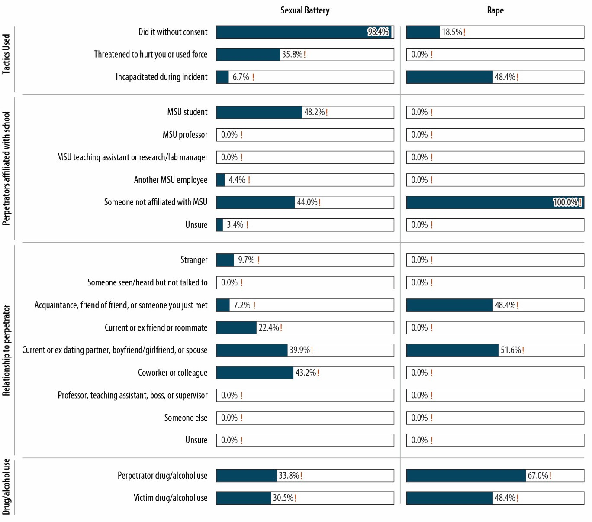Figure 18. Characteristics of Sexual Battery and Rape Incidents, Cisgender Women Graduate/Professional Students
Notes: Percentages are of incidents. ! Estimate is considered not statistically reliable because it is either based on fewer than 10 people or has a relative standard error greater than 30%. For an accessible version of the information shown in this figure, see Appendix Tables D-8b and D-8c.

For undergraduate cisgender women, the largest number of sexual assault incidents took place in October. (These estimates for the other student groups lack statistical power and precision and are therefore considered imprecise or not reliable statistically.) The 3,631 sexual assault incidents undergraduate cisgender women experienced during 2021–202221 are detailed by month and year of study in Figure 19. September and October are seemingly high-risk months for cisgender women in all years of study, but the disproportionately high number of incidents for first- and second-year students

21 As noted earlier, this is a weighted number, which reflects the entire population of undergraduate cisgender women at MSU.

(freshmen and sophomores) during these months shows prominent evidence of a “red zone” for first- and second-year undergraduate cisgender women22 during September and October.

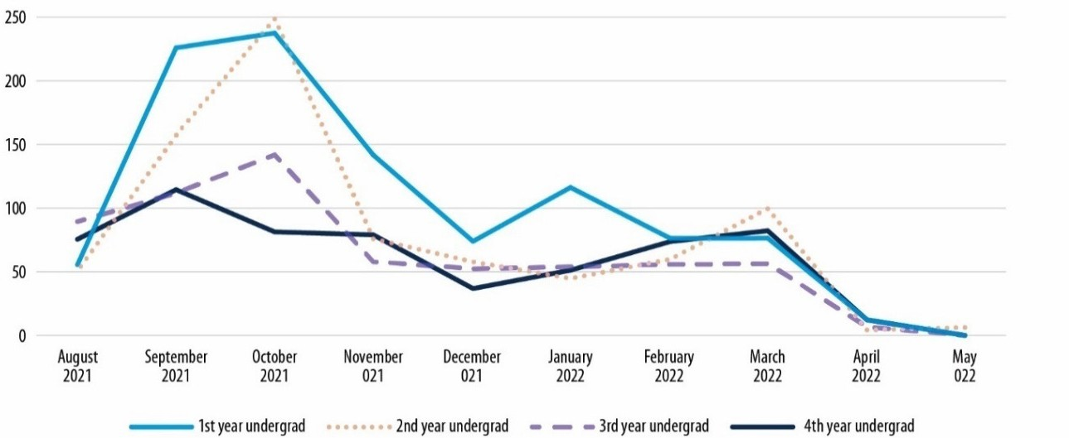Figure 19. Number of Incidents by Month and Year of Study, Undergraduate Cisgender Women
Notes: Students who selected “other” and indicated they were in their 5th or 6th year of undergraduate work were included with seniors/4th year undergraduates. For an accessible version of the information shown in this figure, see Appendix Table D-9b.

Disclosure of Experiences
Survivors’ disclosure of sexual assault incidents to various sources was covered in detail in the survey. Figure 20 shows the proportion of rape and sexual battery incidents that undergraduate cisgender women experienced in 2021–2022 that were disclosed to various sources. Additional specificity in terms of the sources to which survivors disclosed their victimization experiences can be found in Appendix Tables D-11b and D-11c, although many of the source-specific estimate are imprecise statistically. As a reminder, throughout this report figures or results are not presented for certain groups whenever the estimates are imprecise statistically. This is particularly evident in this section.

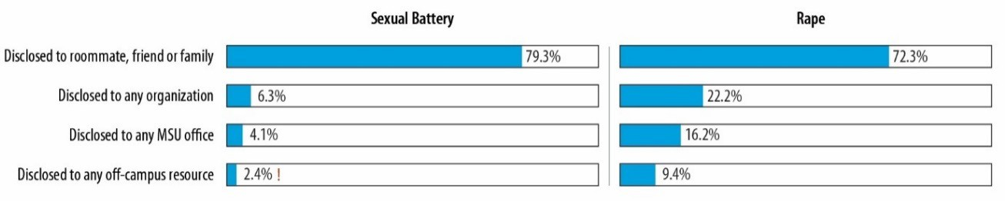Figure 20. Disclosure of Sexual Battery and Rape Incidents, Undergraduate Cisgender Women
Notes: Percentages are of incidents. ! Estimate is considered not statistically reliable because it is either based on fewer than 10 people or has a relative standard error greater than 30%. For an accessible version of the information shown in this figure, see Appendix Tables D-11b and D-11c.

22 This analysis could not be conducted for undergraduate cisgender men, transgender and/or nonbinary undergraduates, or graduate/professional students because the majority of estimates by month were imprecise statistically.

A few patterns are evident, which are summarized below.
      - In over three-fourths of sexual battery incidents (79.3%) and 72.3% of rape incidents that undergraduate cisgender women experienced, the survivors disclosed the assault to a roommate, friend, or family member.
        - Slightly lower levels of disclosure of sexual battery incidents were found for undergraduate cisgender men (71.2%) and transgender and/or nonbinary undergraduates (75.1%), and lower levels of disclosure of rape incidents were found for transgender and/or nonbinary undergraduates (64.6%).23
      - Formal disclosure, including disclosure to any MSU office/resource24 or off-campus office/resources25 by the survivor (or someone else), was considerably lower. About a quarter (22.2%) of rape incidents and 6.3% of sexual battery incidents experienced by undergraduate cisgender women were disclosed to any formal source. In 16.2% of rape incidents and 4.1% of sexual battery incidents that undergraduate cisgender women experienced, the student disclosed the incident to, or sought services from, an MSU office. In 9.4% of rape incidents experienced by undergraduate cisgender women, the student disclosed the incident to, or sought services from, off-campus resources.
        - Estimates for all other student populations were statistically imprecise.
      - Among the incidents for which the student disclosed or sought services from an MSU office, the vast majority of survivors perceived that the organization was helpful, treated them with respect, responded quickly enough, and is an organization they would recommend to others who had a similar experience.26
        - Undergraduate cisgender women who disclosed their experience to an MSU office (e.g., Office of Institutional Equity, Center for Survivors, CAPS, Gender and Sexuality Campus Center) indicated that the office was helpful in 99.2% of rape incidents and 91.3% of sexual battery incidents; treated them respectfully in 100% of rape incidents and 95.2% of sexual battery incidents; responded quickly enough in 100% of rape incidents and 100% of sexual battery incidents; and is an organization they would recommend to others in 100% of rape incidents and 81.2% of sexual battery incidents.
        - Undergraduate cisgender women who disclosed their experience to an off-campus resource indicated that the office was helpful in 94.9% of rape incidents and 73.8% of sexual battery incidents; treated them respectfully in 87.2% of rape incidents and 100% of sexual battery incidents; responded quickly enough in 84.6% of rape incidents; and is an organization they would recommend to others in 87.2% of rape incidents and 82.3% of sexual battery incidents.
        - Estimates for all other student populations were statistically imprecise.
Undergraduate cisgender women cited a number of reasons that they did not disclose rape and sexual battery incidents (Figure 21). Among the survivors who did not disclose the incident or seek services from any resource (either on or off campus), the reasons differed based on the type of incident. For sexual battery incidents, the student most commonly did not disclose the incident or seek services because she did not think the incident was serious enough to disclose, did not want any action taken, did not need any assistance, or wanted to forget it happened. For rape incidents, the student most commonly

23 The other estimates were statistically imprecise.
24 Resources included the MSU Office of Institutional Equity (OIE; Title IX); MSU Center for Survivors; MSU Sexual Assault Healthcare Program; MSU Counseling and Psychological Services (CAPS); MSU Gender and Sexuality Campus Center; MSU Olin Health Center or another health care provider on campus; MSU Police Department; MSU Office of the University Ombudsperson; and another faculty, staff, or administrator at MSU.
25 These resources included a crisis center or helpline not at MSU, a hospital or health care center not at MSU, or local police not at MSU, such as the county or city police department.
26 Some survivors who filled in the open-ended question in the survey noted that specific MSU resources (e.g., MSU Center for Survivors, CAPS) were helpful and supportive.

did not disclose the incident or seek services because she did not want action taken, wanted to try to forget it happened, or did not think the incident was serious enough to disclose.

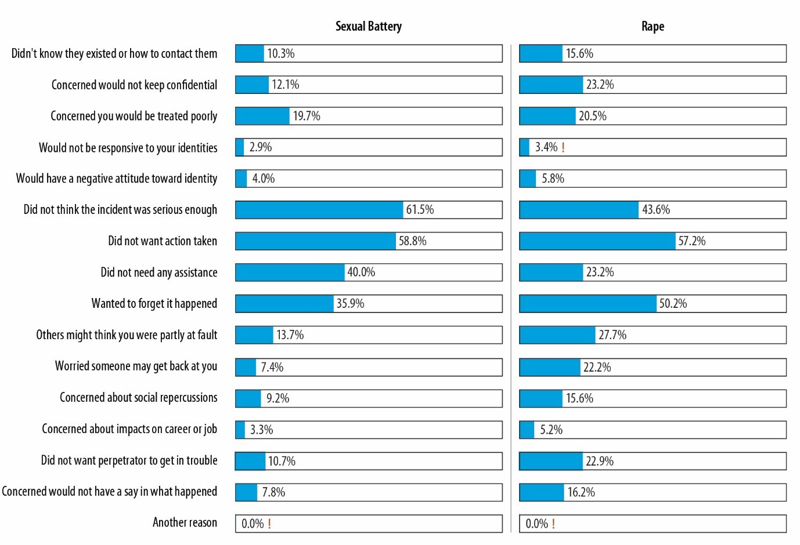Figure 21. Reasons for Not Disclosing Sexual Battery and Rape Incidents, Undergraduate Cisgender Women
Notes: Percentages are of incidents. ! Estimate is considered not statistically reliable because it is either based on fewer than 10 people or has a relative standard error greater than 30%. For an accessible version of the information shown in this figure, see Appendix Tables D-12b and D-12c.

Undergraduate cisgender men also cited a number of reasons that they did not disclose sexual battery incidents (Figure 22), including that the student did not think the incident was serious enough to disclose, did not want any action taken, or did not need any assistance. The only statistically precise reason cited by cisgender women graduate/professional students was that the student did not think the incident was serious enough to disclose (Figure 23).27

27 Estimates for men undergraduates, nonbinary undergraduates, cisgender men graduate/professional students, and transgender/nonbinary graduate/professional students were statistically imprecise.

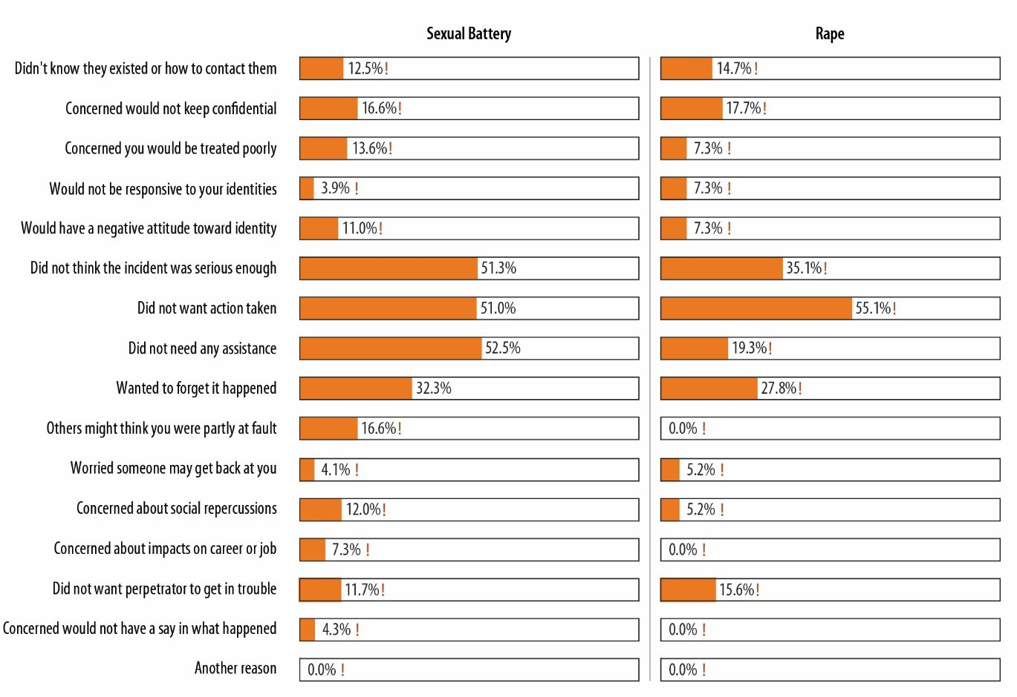Figure 22. Reasons for Not Disclosing Sexual Battery and Rape Incidents, Undergraduate Cisgender Men
Notes: Percentages are of incidents. ! Estimate is considered not statistically reliable because it is either based on fewer than 10 people or has a relative standard error greater than 30%. For an accessible version of the information shown in this figure, see Appendix Tables D-12b and D-12c.

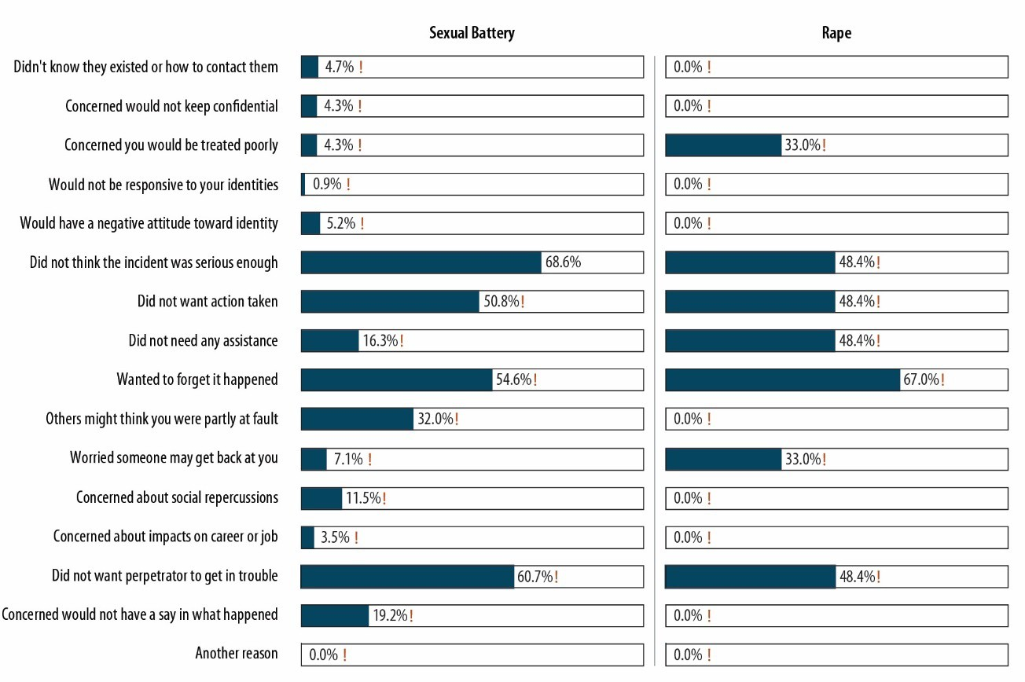Figure 23. Reasons for Not Disclosing Sexual Battery and Rape Incidents, Cisgender Women Graduate/Professional Students
Notes: Percentages are of incidents. ! Estimate is considered not statistically reliable because it is either based on fewer than 10 people or has a relative standard error greater than 30%. For an accessible version of the information shown in this figure, see Appendix Tables D-12b and D-12c.

Incident Impact
Students who experienced sexual assault were affected in a number of ways; rape incidents were more upsetting to students and led to more problems in various areas of their lives than sexual battery incidents. Figure 24 shows the impact of rape and sexual battery incidents that undergraduate cisgender women experienced during the 2021–2022 academic year. As evident, over half of rape incidents and a fifth of sexual battery incidents were considered to be “very upsetting” to the student, and about a third of rape incidents and over half of sexual battery incidents were considered to be “upsetting.”

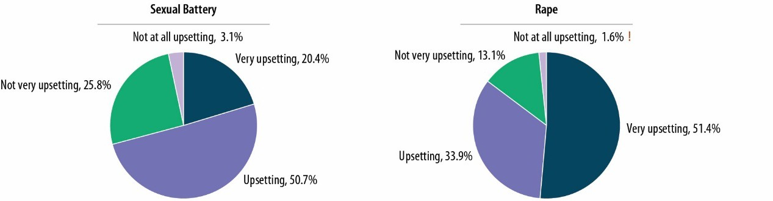Figure 24. Perception of Rape and Sexual Battery Incidents, Undergraduate Cisgender Women
Notes: Percentages are of incidents. ! Estimate is considered not reliable statistically because it is either based on fewer than 10 people or has a relative standard error greater than 30%. For an accessible version of the information shown in this figure, see Appendix Tables D-13b and D-13c.

About 32.2% of undergraduate cisgender men (Figure 25) and 81.1% of cisgender women graduate/professional students (Figure 26) indicated that the sexual battery incidents they experienced were upsetting.

Figure 25. Perception of Sexual Battery Incidents, Undergraduate Cisgender Men
Figure 26. Perception of Sexual Battery Incidents, Cisgender Women Graduate/Professional Students

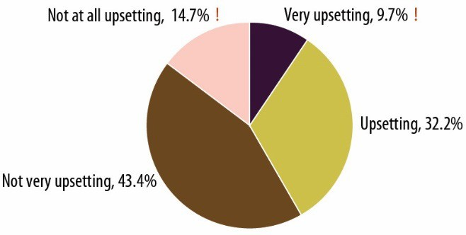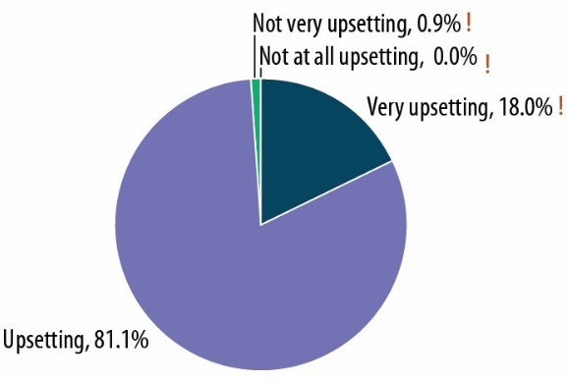
Notes: Percentages are of incidents. ! Estimate is considered not reliable statistically because it is either based on fewer than 10 people or has a relative standard error greater than 30%. For an accessible version of the information shown in this figure, see Appendix Table D-13c.

Responses to questions in the survey revealed that the most common effects of the incident were problems with schoolwork or grades (e.g., “missing or being late to class, having trouble concentrating, or not completing assignments”) and problems with friends, roommates, or peers (e.g., “getting into more arguments or fights than you did before, not feeling you could trust them as much, or not feeling as close to them as you did before”). Undergraduate cisgender women survivors indicated experiencing these problems in 40–58% of rape incidents and in 23–26% of sexual battery incidents (Figure 27). A sizeable number of rape incidents led the survivor to consider making various changes, such as taking time off from school, transferring, or dropping out (29.4%); dropping classes or changing schedules (22.5%); or moving or changing their living situation (19.2%). Fewer actually made these changes. (Note that the

survey was unable to capture the experiences of those who actually dropped out or were away from school as a result of the assault.)

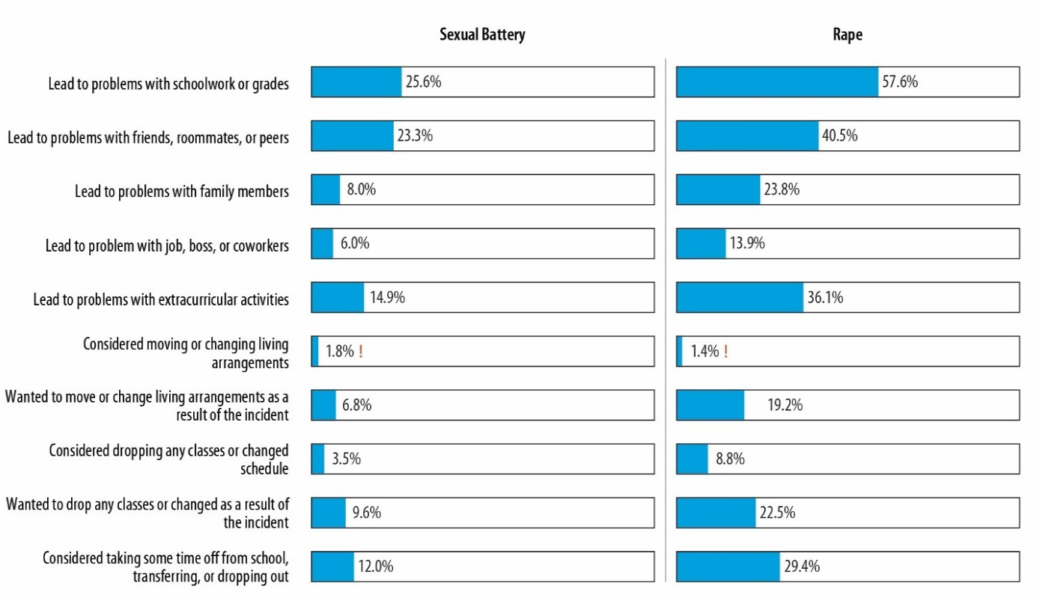Figure 27. Impact of Sexual Battery and Rape Incidents, Undergraduate Cisgender Women
Notes: Percentages are of incidents. ! Estimate is considered not statistically reliable because it is either based on fewer than 10 people or has a relative standard error greater than 30%. For an accessible version of the information shown in this figure, see Appendix Tables D-13b and D-13c.

Many of the estimates for the impact of incidents experienced by undergraduate cisgender men, transgender and/or nonbinary undergraduates, and graduate/professional students were statistically imprecise.

Workplace Incivility
For the 2021–2022 academic year Know More @ MSU Campus Survey, students were asked whether they were employed by MSU. Responses indicate that about 33% of undergraduate cisgender women, 27% of undergraduate cisgender men, 42% of transgender and/or nonbinary undergraduates, 52% of cisgender women graduate/professional students, 52% of cisgender men graduate/professional students, and 61% of transgender and/or nonbinary graduate/professional students were employed by MSU during the 2021–2022 academic year.
The students who indicated they were employed by MSU during the 2021–2022 academic year were asked about their experiences with workplace incivility. First, the survey asked survey participants how often they had experienced behaviors that reflect incivility in the workplace (e.g., making insulting or disrespectful remarks, interrupting, paying little attention to their statements or showing little interest in

their opinions, making jokes at their expense).28 The mean workplace incivility scores for the six student groups, which can range from 0 to 48 with higher scores reflecting more incivility, are presented in Figure 28. The scores are very low and are considerably lower than their faculty/staff counterparts, which means MSU students rarely experience various types of workplace incivility. The one exception is for
transgender and/or nonbinary graduate/professional students, who have a mean workplace incivility score (9.5) that is higher than that of any other student or faculty/staff group.29

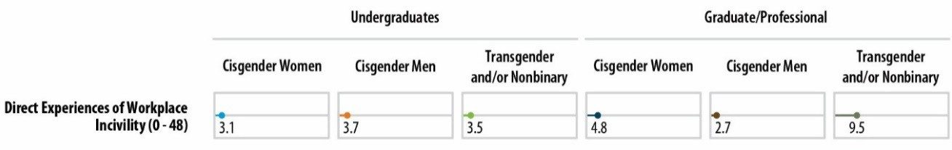Figure 28. Mean Workplace Incivility Scores Among Students Employed by MSU, 2021–2022 Academic Year
Note: For an accessible version of the information shown in this figure, see Appendix Table D-15g.

28 The Workplace Incivility Scale was used. See Cortina, L. M., Kabat-Farr, D., Leskinen, E. A., Huerta, M., & Magley,
V. J. (2013). Selective incivility as modern discrimination in organizations: Evidence and impact. Journal of Management, 39(6), 1579–1605. https://doi.org/10.1177/0149206311418835
29 Responses were limited to the 2021–2022 academic year as opposed to an extended reference period to allow for a benchmark estimate against which improvements (or deteriorations) over time could be assessed in a subsequent climate survey.

Faculty’s/Staff’s Experiences with Work-Related Sexual Misconduct and Workplace Incivility
Note that faculty/staff were not asked about their experiences with relationship violence, stalking, or sexual assault. They were, however, asked about their perceptions of the climate and work related to RVSM.

Work-Related Sexual Harassment
Faculty and staff members’ experiences with work-related sexual harassment are shown in Figure 29. Respondents were asked to indicate whether they had experienced the behaviors shown while they were working or doing any activity associated with their work at MSU, as well as whether an MSU coworker, supervisor, student, or anyone else they had contact with as part of their role as an MSU employee had behaved this way to them.

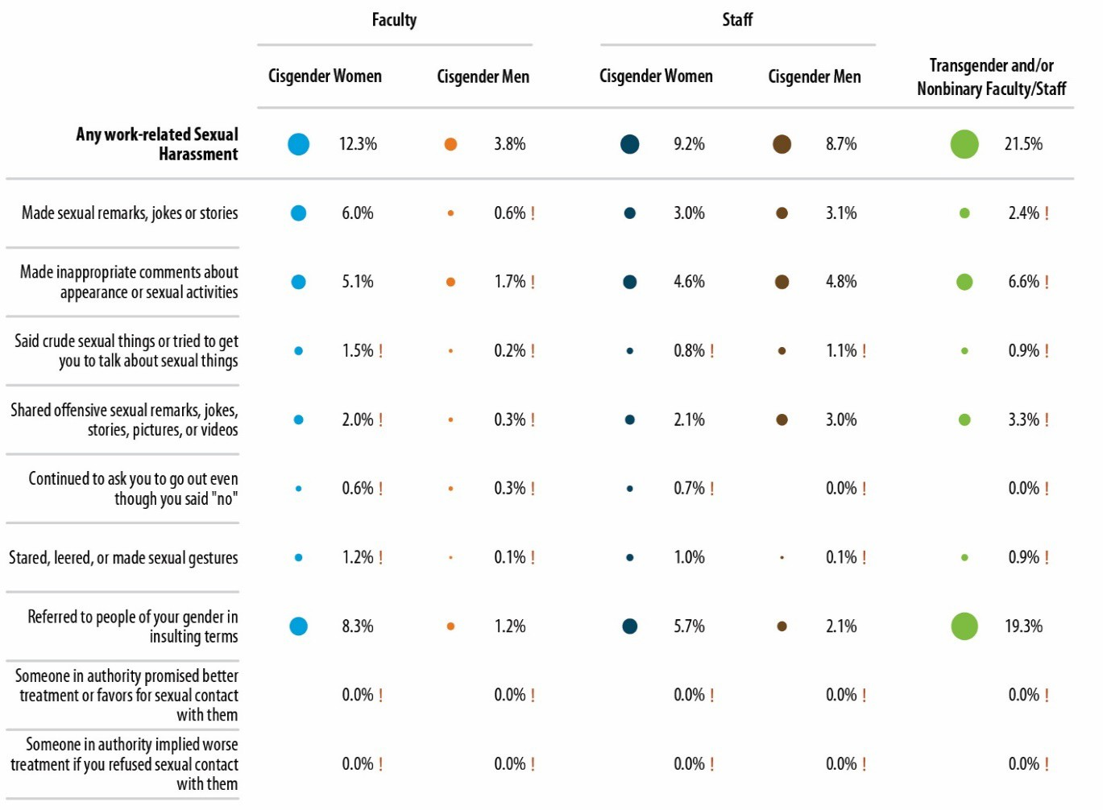Figure 29. Prevalence of Types of Work-Related Sexual Harassment Among Faculty/Staff, 2021–2022
Notes: Percentages are of faculty and staff. ! Estimate is considered not statistically reliable because it is either based on fewer than 10 people or has a relative standard error greater than 30%. All statistically unreliable percentages in this figure were <1 and thus too small to be displayed. For an accessible version of the information shown in this figure, see Appendix Table E-4.

As evident in the figure, cisgender men faculty were the least likely to experience work-related sexual harassment (3.8%), and transgender and/or nonbinary faculty/staff were the most likely to experience work-related sexual harassment (21.5%). The most common types of sexual harassment included someone referring to people of one’s gender in insulting or offensive terms (particularly for cisgender women faculty); someone making inappropriate or offensive comments about the person’s or someone else’s body, appearance, or sexual activities; and someone making sexual remarks or telling jokes or stories that were insulting to the person. No faculty or staff indicated they experienced any quid- pro-quo harassment, such as someone promising them better treatment or implying favors if they engaged in sexual contact (or implying/threatening worse treatment if they refused it).30
The likelihood of experiencing sexual harassment by additional background characteristics is shown in Figure 30. Because of the large number of statistically imprecise estimates, there are few, if any, clear patterns in terms of whether faculty and staff with certain characteristics are more or less likely to experience work-related sexual harassment. It does seem that cisgender men staff with a documented or diagnosed disability were at increased risk of experiencing work-related sexual harassment.
Details about the impact of the sexual harassment experienced by faculty and staff in the 2021– 2022 academic year are shown in Figure 31. Substantial proportions of faculty and staff (particularly cisgender women and transgender and/or nonbinary faculty and staff) indicated that the experience affected them negatively. Survey participants indicated that their sexual harassment experiences interfered with their ability to do their job or created an intimidating, uncomfortable, or offensive work environment; damaged their relationships with coworkers, supervisors, students, or others they were in contact with for their job at MSU; affected their emotional well-being in a negative way (e.g., increased stress, fear, anxiety, or depression); or hindered their ability to complete their work or do their jobs. A sizeable minority also indicated that they requested a transfer or change of assignment or considered leaving MSU as a result of the experience.
Among faculty and staff, the role of the perpetrator varied (Figure 32). Faculty were most likely to indicate that the person was an MSU professor, instructor, or postdoctoral scholar, but a sizeable percentage indicated that the person was an MSU staff member or administrator. The majority of staff indicated that the person was an MSU staff member or administrator. MSU students appeared to be involved in perpetrating sexual harassment as well, particularly for cisgender women faculty.31
Analysis of faculty and staff members’ disclosure of sexual harassment experiences (Figure 33) showed that many told a friend, family member, or intimate partner about their experiences. Cisgender women faculty and staff, in particular, often told work colleagues about the experience. Disclosure to any source was less common for cisgender men than cisgender women.

30 The survey also asked about work-related sexual assault and found that very few MSU faculty or staff had experienced work-related rape or sexual battery during the 2021–2022 academic year. The estimates (which are statistically imprecise) are not discussed further in the report.
31 The estimate for cisgender men faculty was statistically imprecise.

Figure 30. Prevalence of Work-Related Sexual Harassment (2021–2022), by Faculty/Staff Characteristics
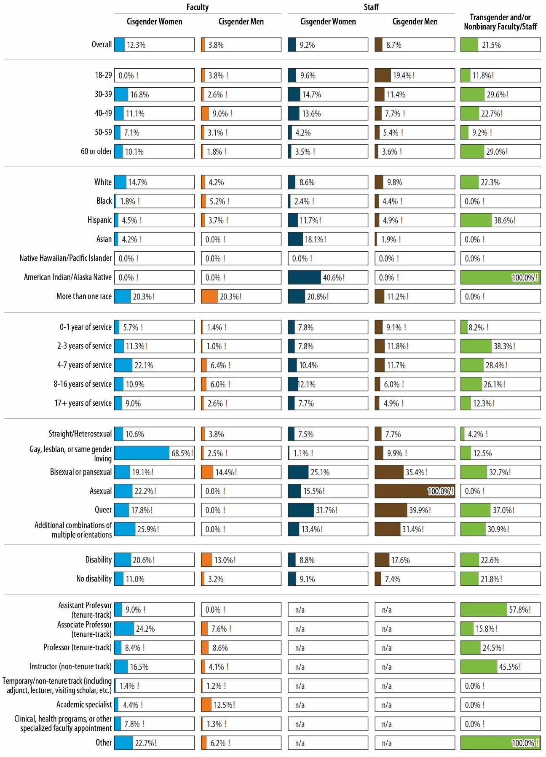
Notes: Percentages are of faculty and staff. ! Estimate is considered not statistically reliable because it is either based
on fewer than 10 people or has a relative standard error greater than 30%. For an accessible version of the information shown in this figure, see Appendix Tables E-5.

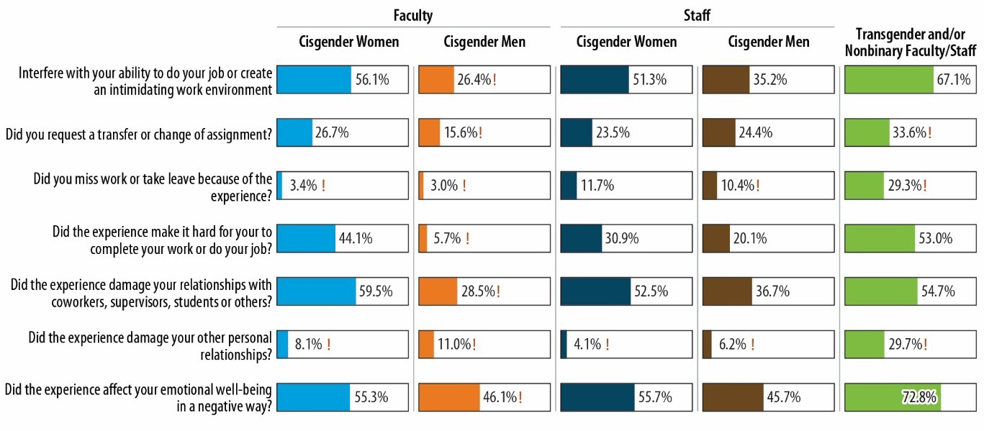Figure 31. Impact of Work-Related Sexual Harassment
Notes: Percentages are of sexual harassment survivors. ! Estimate is considered not statistically reliable because it is either based on fewer than 10 people or has a relative standard error greater than 30%. For an accessible version of the information shown in this figure, see Appendix Table E-6.

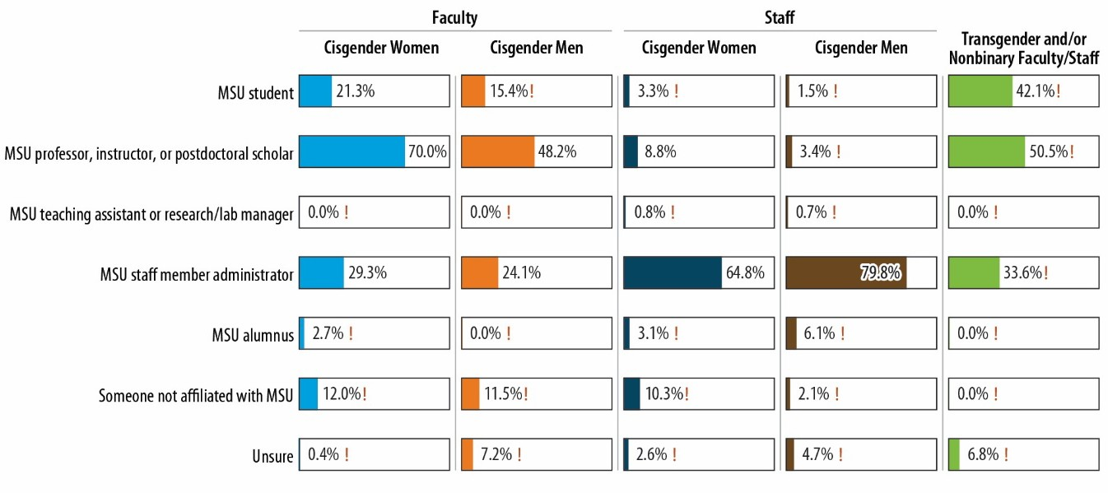Figure 32. Perpetrators of Work-Related Sexual Harassment
Notes: Percentages are of sexual harassment survivors. ! Estimate is considered not statistically reliable because it is either based on fewer than 10 people or has a relative standard error greater than 30%. For an accessible version of the information shown in this figure, see Appendix Table E-6.

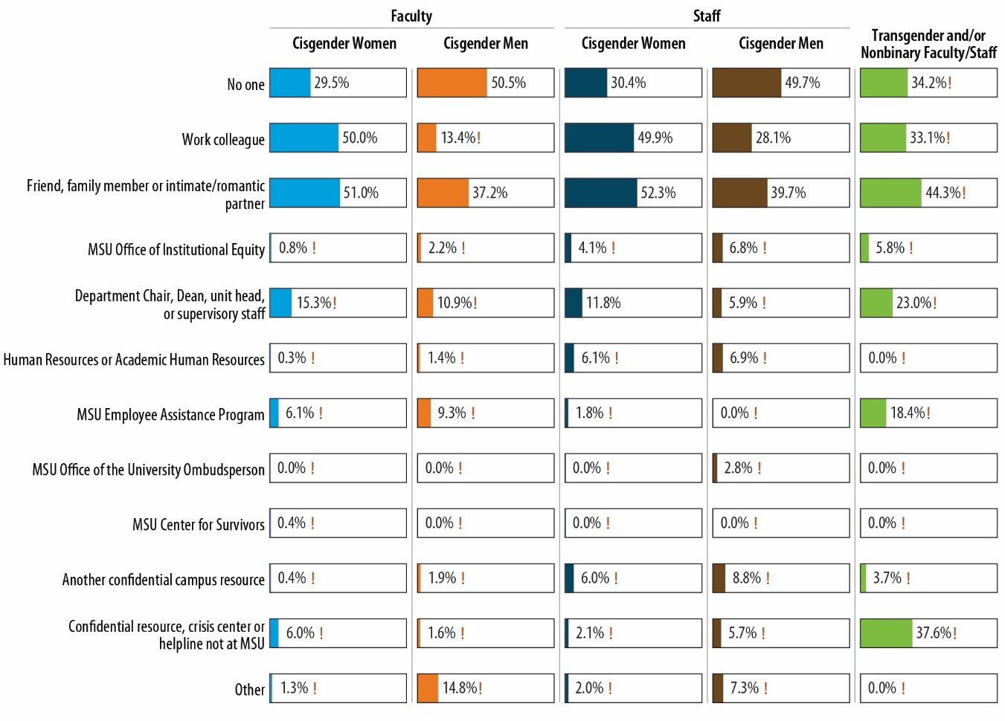Figure 33. Disclosure of Work-Related Sexual Harassment
Notes: Percentages are of sexual harassment survivors. ! Estimate is considered not statistically reliable because it is either based on fewer than 10 people or has a relative standard error greater than 30%. For an accessible version of the information shown in this figure, see Appendix Table E-7.

Faculty and staff who experienced work-related sexual harassment and did not disclose their experience to a formal source of support were asked a follow-up question about their reasons for not disclosing. The results are shown in Figure 34. For all five faculty-staff groups, survivors did not contact any people or organizations because they did not think their experiences were serious enough to disclose (most common reason endorsed). Cisgender women (both faculty and staff) were also concerned about impacts on their career/job, and about a third of cisgender women faculty indicated being worried about possible retaliation or being concerned they would be treated poorly. Cisgender men faculty expressed not needing any help or assistance or not wanting any action taken. Cisgender women staff also endorsed not needing any help or assistance. About half (52.6%) of transgender and/or nonbinary faculty/staff who did not disclose their experience did so because they feared they would be treated poorly, and 59.8% did not contact any people or organizations because they did not think their experiences were serious enough to disclose. As a reminder, percentages like these can sum to over 100 because respondents could endorse multiple response options.

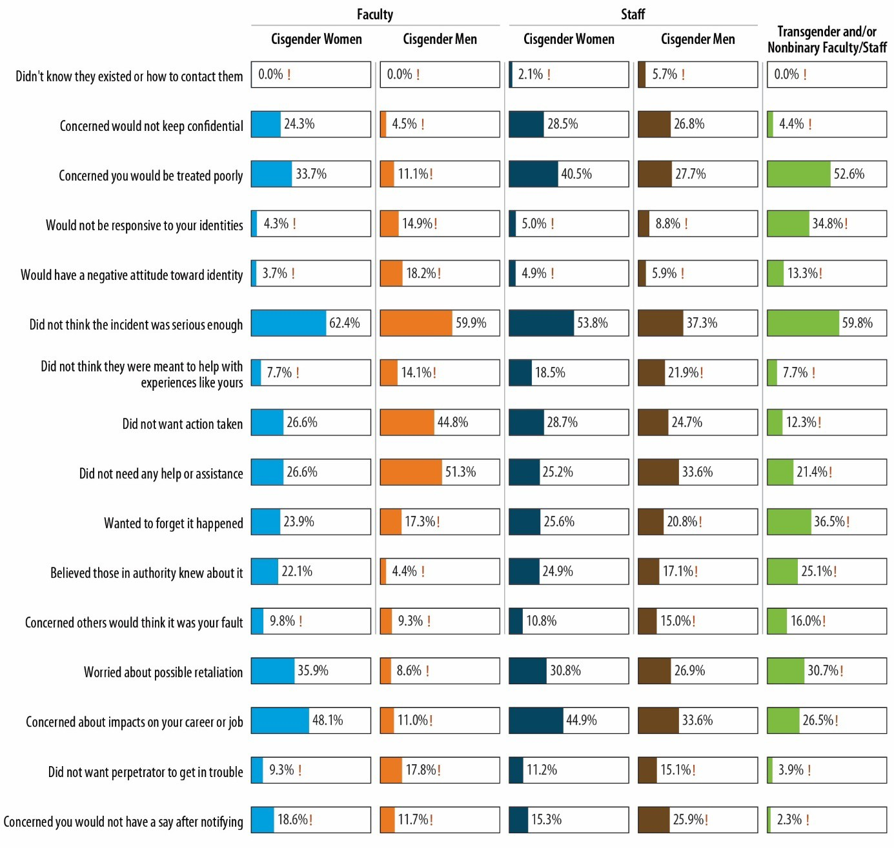Figure 34. Reasons for Not Disclosing Work-Related Sexual Harassment
Notes: Percentages are of sexual harassment survivors who did not disclose. ! Estimate is considered not statistically reliable because it is either based on fewer than 10 people or has a relative standard error greater than 30%. For an accessible version of the information shown in this figure, see Appendix Table E-7.

Workplace Incivility
The faculty and staff survey also asked about employees’ experiences with workplace incivility and work-related sexual harassment. First, the survey asked survey participants how often they had experienced behaviors that reflect incivility in the workplace (e.g., making insulting or disrespectful remarks, interrupting, paying little attention to their statements or showing little interest in their opinions,

making jokes at their expense).32 The various faculty/staff groups that experienced at least one type of workplace incivility ranged from 61.3% of cisgender men faculty (lowest) to 75.3% of cisgender women faculty (highest). Figure 35 shows the mean workplace incivility scores for the five faculty/staff groups, which can range from 0 to 48, with higher scores reflecting more incivility, as well as the prevalence of specific behaviors that survey participants experienced from any of their supervisors or coworkers. The figure shows the percentage of faculty and staff (by gender identity) who experienced each behavior “often” or “very often” during the 2021–2022 academic year.33 Additional details are shown in Appendix E.

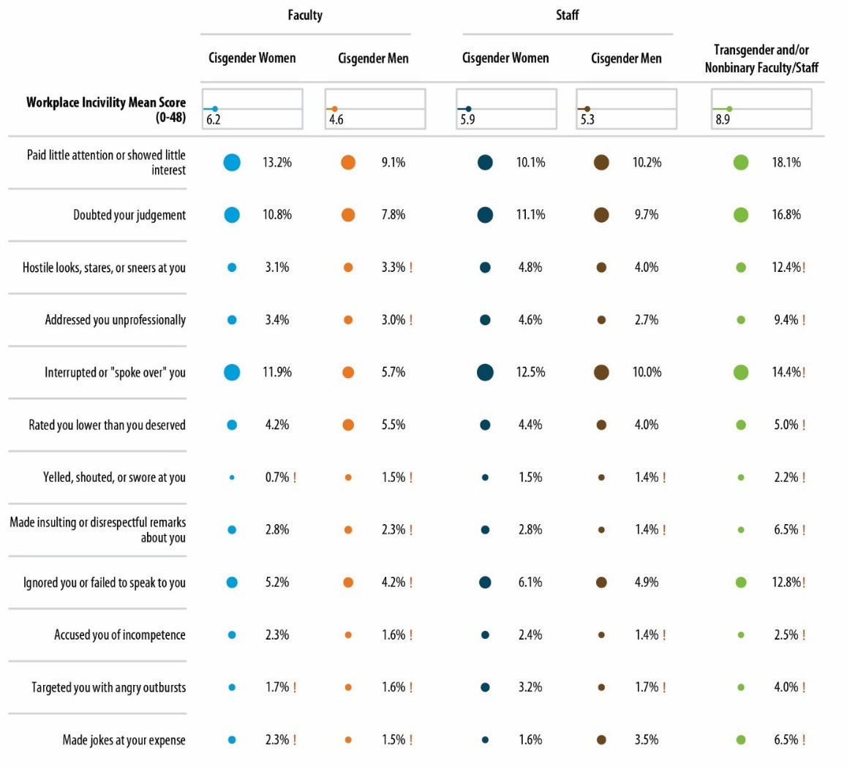Figure 35. Mean Workplace Incivility Scores and Prevalence Among Faculty and Staff, 2021–2022 Academic Year
Notes: Percentages are of those experiencing behaviors “often” or “very often.” ! Estimate is considered not statistically reliable because it is either based on fewer than 10 people or has a relative standard error greater than 30%. For an accessible version of the information shown in this figure, see Appendix Tables E-1a through E-1f.

32 The Workplace Incivility Scale was used. See Cortina, L. M., Kabat-Farr, D., Leskinen, E. A., Huerta, M., & Magley,
- J. (2013). Selective incivility as modern discrimination in organizations: Evidence and impact. Journal of Management, 39(6), 1579–1605. https://doi.org/10.1177/0149206311418835
33 Responses were limited to the 2021–2022 academic year as opposed to an extended reference period to allow for a benchmark estimate against which improvements (or deteriorations) over time could be assessed in a subsequent climate survey.

In all five faculty and staff groups, most common types of workplace incivility were a supervisor or coworker who paid little attention to their statements or showed little interest in their opinions, who doubted their judgment on a matter for which they were responsible, and who interrupted or spoke over them. As evident from the figure, there is some variation in the frequency of workplace incivility: cisgender women faculty and staff and transgender and/or nonbinary faculty/staff experienced more frequent direct workplace incivility than did cisgender men faculty and staff.
Survey participants who experienced any type of workplace incivility were asked whether they thought they experienced the mistreatment because of their age, gender identity, race or ethnicity, religious/spiritual views, sexual orientation, socioeconomic status, disability status, or any combination of these (Figure 36). Cisgender women faculty were far more likely to perceive that the incivility was gender related (43.1% felt that their experiences were because of their gender identity) than the other groups; only 2.8% of cisgender men staff felt that the incivility they experienced was gender related, and 20.9% of cisgender women staff and 37.9% of transgender and/or nonbinary faculty/staff felt this way.
Respondents in all five groups felt that age was also a fairly common reason for the incivility, and race/ethnicity was perceived to be a factor in incivility for all five groups. Not surprisingly, among Black, Indigenous, and people of color (BIPOC) faculty and staff, workplace incivility based on race or ethnicity was more prevalent than for White faculty and staff. For example, among faculty who had experienced workplace incivility, nearly half of BIPOC cisgender women faculty (46.2%) and almost a third of BIPOC cisgender men faculty (30.4%) perceived that the incivility was based on race or ethnicity, whereas only 3.9% of White cisgender women faculty and 5.9% of White cisgender men faculty had this perception. These estimates for White faculty are, however, not statistically precise.

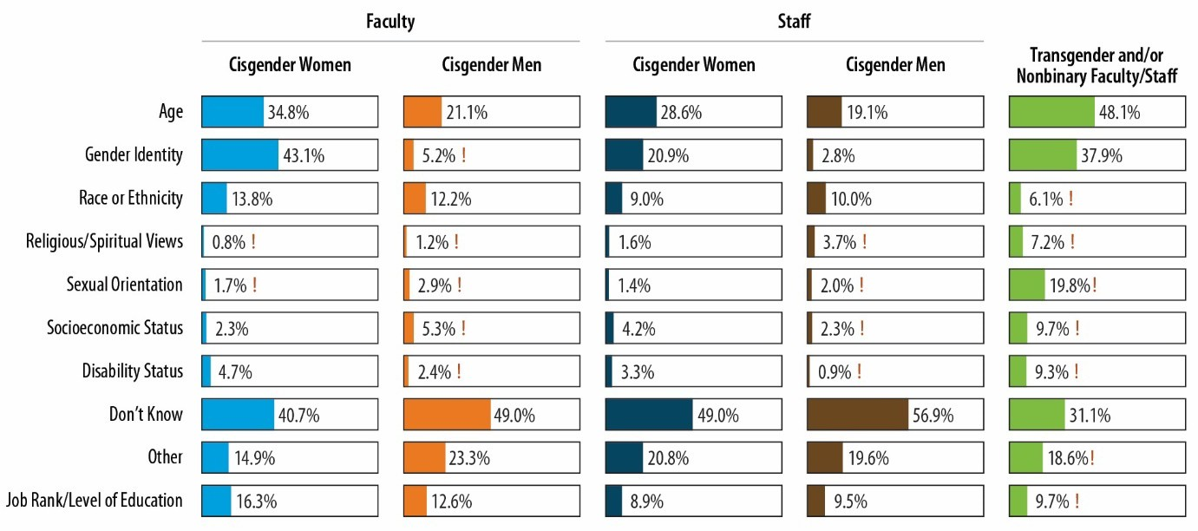Figure 36. Identity-Based Workplace Incivility
Notes: Percentages are of faculty/staff attributing incivility they experienced to various characteristics. ! Estimate is considered not statistically reliable because it is either based on fewer than 10 people or has a relative standard error greater than 30%. For an accessible version of the information shown in this figure, see Appendix Table E-2a.

The mean workplace incivility score for transgender or nonbinary faculty/staff who completed the survey (8.9) was higher than the mean score for the other four groups. Cisgender women faculty (6.2) and cisgender women staff (5.9) had the next highest scores. Scores for cisgender men staff and cisgender men faculty were 5.3 and 4.6, respectively. As was the case with the student data, these results suggest the importance of understanding more about the experiences of transgender and/or nonbinary faculty/staff and ensuring that services are in place to adequately support them.
The survey also explored additional variation in direct experiences of workplace incivility for the five faculty/staff groups in order to better understand differences by age, race/ethnicity, educational attainment, years of service, campus location, sexual orientation, gender identity, disability status, and, for faculty, faculty rank. Key highlights from these analyses are shown in Figure 37. The figure shows the mean workplace incivility score for key subgroups; the scores, which range from 0 to 48, reflect the frequency with which employees experienced the various types of workplace incivility (higher values reflect a greater frequency of workplace incivility). The most consistent finding is that among all groups, faculty/staff with a diagnosed or documented disability experienced higher levels of workplace incivility. It also seems there is an inverse relationship between experiencing incivility and age, such that younger faculty and staff seem to be more likely to experience workplace incivility. Other patterns depend on the faculty/staff subgroup.
  - Among cisgender women faculty, those who identified as lesbian, bisexual, pansexual, or queer; were White, multiracial,34 or Hispanic; or were in the associate professor role were more likely to experience workplace incivility.
  - Among cisgender men faculty, those who had more years of service; were Black or Hispanic; or were in the associate professor, full professor, or academic specialist roles were more likely to experience workplace incivility.
  - Among cisgender women staff, those who were White, Hispanic, or more than one race; had bachelor’s or master’s degrees; or identified as lesbian, bisexual, pansexual, asexual, or queer were more likely to experience workplace incivility.
  - Among cisgender men staff, those who were younger; White; did not have a bachelor’s degree; worked on the main campus; or identified as bisexual or pansexual were more likely to experience workplace incivility.
  - Among transgender and/or nonbinary faculty/staff, those who identified as gay or queer were more likely to experience workplace incivility.

34 As noted in Table 4, among faculty who selected more than one race, the most common pattern was American Indian/Alaska Native and white. Among staff, it was black and white, Asian and white, and American Indian/Alaska Native and white.

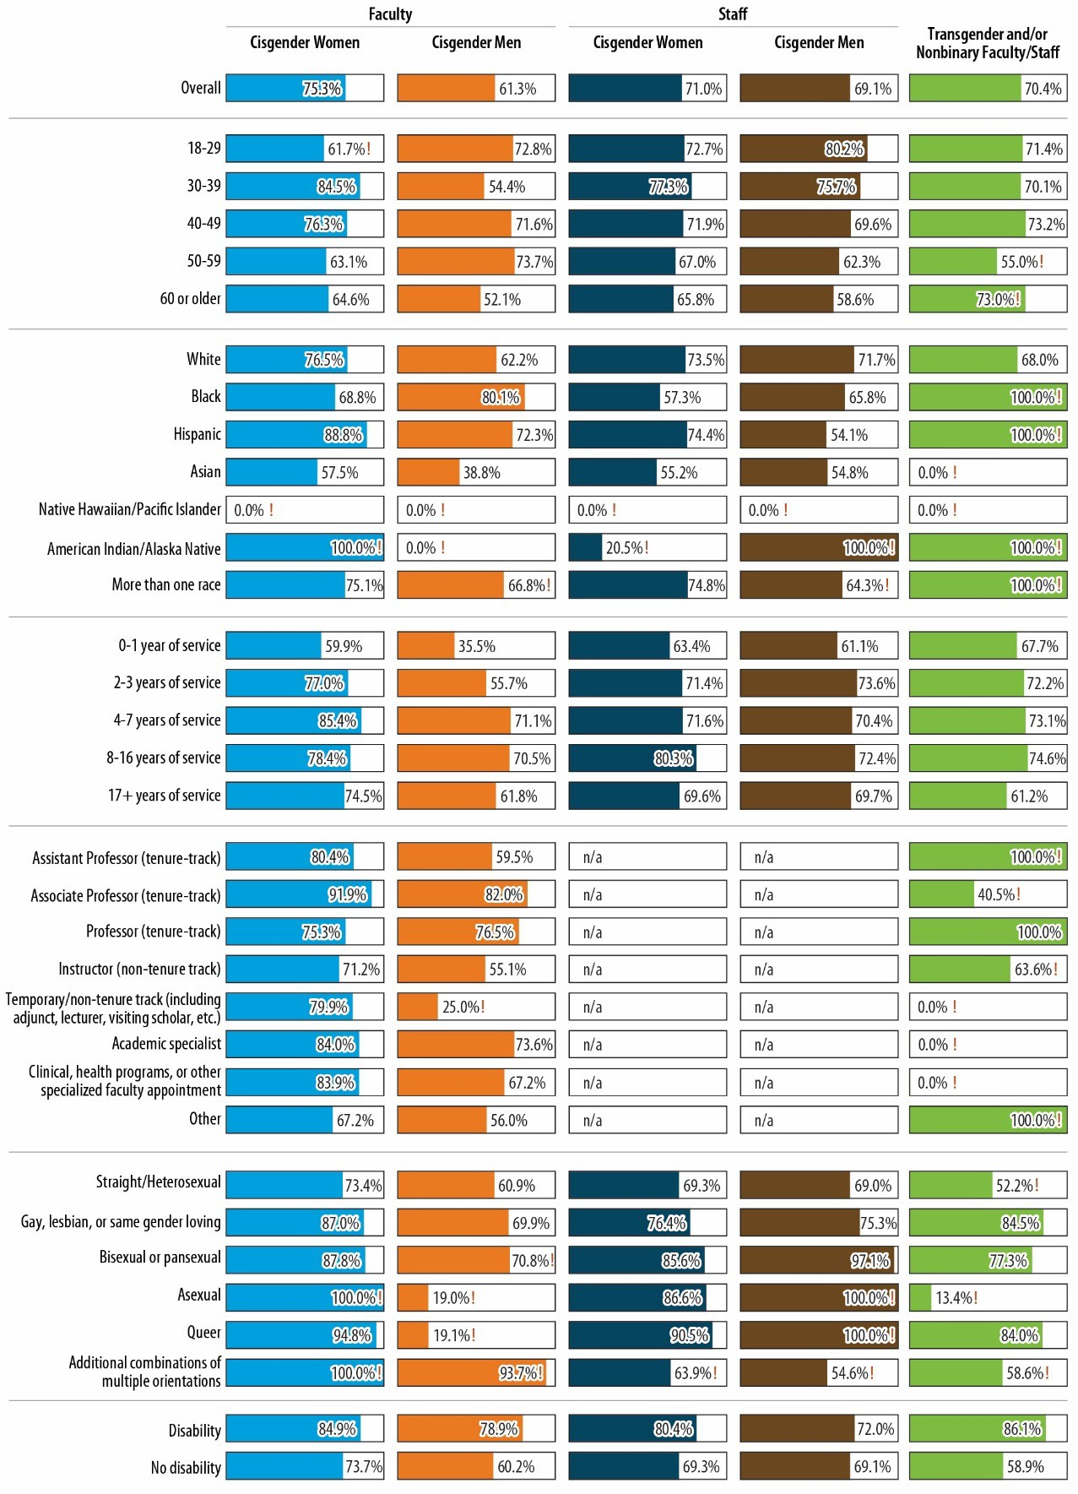Figure 37. Prevalence of Workplace Incivility, by Faculty/Staff Characteristics, 2021–2022
Notes: Percentages are of faculty/staff. ! Estimate is considered not statistically reliable because it is either based on fewer than 10 people or has a relative standard error greater than 30%. All statistically unreliable percentages in this figure were <1 and thus too small to be displayed. For an accessible version of the information shown in this figure, see Appendix Table E-3a.

The survey also asked about participants’ indirect experiences with the same types of workplace incivility. These are situations in which they observed their supervisors or coworkers mistreating their coworkers.35 Indirect experiences were indicated with slightly less frequency than direct experiences, but the same types of behaviors were most commonly observed (i.e., a supervisor or coworker paid little attention to their statements or showed little interest in their opinions, interrupted or spoke over them, and doubted their judgment on a matter for which they were responsible). Cisgender women and transgender and/or nonbinary faculty and staff observed uncivil behaviors happening to their coworkers more frequently than cisgender men faculty and staff.

35 This series of questions used the same Workplace Incivility Scale as for direct experiences (Cortina et al., 2013), but it was modified to ask about things that happened to their coworkers.

Perceptions of Climate and Awareness of Resources

Summary of Climate Perceptions Among the MSU Community
Perceptions of the climate at MSU were assessed among all survey populations. Eight scales reflecting various dimensions of climate were created. The scales are composite scores derived from sets of related, individual survey items (typically worded as statements with which survey participants indicated their level of agreement), with higher scores reflecting more positive perceptions of climate. The dimensions of climate that were measured are shown in Table 6; some scales are specific to the climate or culture related to sexual misconduct and some scales measure other dimensions of campus climate.

Table 7. Climate Scale Description

Scale | Example Item
General Climate
General School Connectedness (12 items) | I feel like I am a part of this school.
Perceptions of Inclusive Climate (7 items) | At this school, it is common for members of the campus community to treat one another in rude or disrespectful ways.
General Perceptions of Highest University Leadership (4 items) | Overall, the highest administrative leadership at this school, including the President and Board of Trustees, are open and transparent about challenges facing the university.
General Perceptions of Other University Administration (4 items) | Overall, the other administration at this school, which includes Deans, Vice Presidents, and other leadership staff, are genuinely concerned about students’ well-being.
Climate Related to Sexual Misconduct
Perceptions of School Leadership Climate for Sexual Misconduct Prevention and Response (11 items) | This school takes training in sexual misconduct prevention seriously.
Perceptions of School Leadership Climate for Relationship Violence Prevention and Response (3 items) | This school is doing a good job of holding people accountable for committing relationship violence and stalking.
Awareness and Perceived Fairness of School Sexual Assault Policy and Resources (9 items) | I am aware of and understand this school’s procedures for dealing with reported incidents of sexual misconduct.
Intervention and Awareness of Sexual Harassment and Sexual Assault (i.e., bystander intervention) (7 items) | Students/Faculty/Staff offer support to other students/faculty/staff who they suspect are in an abusive relationship.*
Note: All scales have more than acceptable reliability (i.e., internal consistency) based on the Cronbach’s alpha metric, which is a commonly used measure of scale reliability (with 0.70 often used as the lower threshold). The alphas ranged from 0.76 to 0.86.

The average climate scores (standardized on a 0–100 scale so values reflect the percentage of the highest possible score on that scale36) for the various populations (including undergraduate cisgender
36 The standardized scores were created simply by dividing the mean score by the maximum score for each scale and multiplying by 100. For example, if the mean (unstandardized) score on a 0–10 scale was 6, the mean standardized score would be 60. This approach was taken to facilitate comparisons across scales (which have different ranges due to variability in the number of items).

Findings from the Know More @ MSU Campus Survey November 2022
56

women, undergraduate cisgender men, transgender and/or nonbinary undergraduates, cisgender women graduate/professional students, cisgender men graduate/professional students, transgender and/or nonbinary graduate/professional students, cisgender women and men faculty, cisgender women and men staff, and transgender and/or nonbinary faculty/staff) are shown in Figure 38. Several patterns are evident.

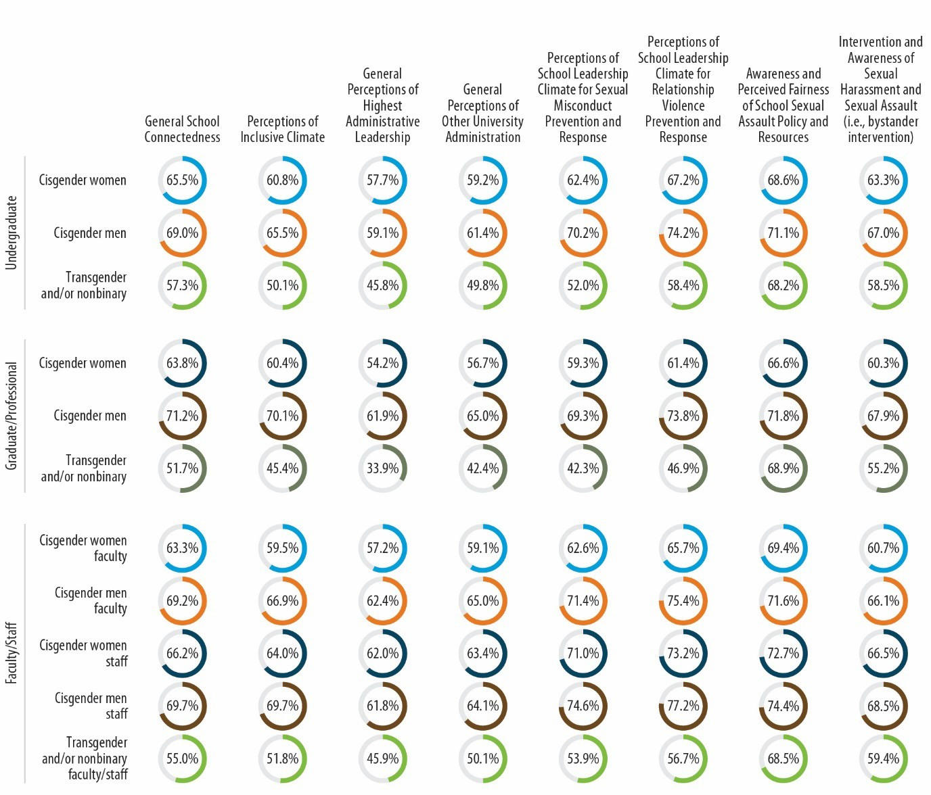Figure 38. Campus Climate (Mean Scale Scores), by Population
Note: For an accessible version of the information shown in this figure, see Appendix Tables F-8a1 through F-8b5.

    - The aspects of climate for which there was the most variation in perceptions were “General Perceptions of School Leadership Climate for Sexual Misconduct” (with mean scores ranging from 42.3 among transgender/nonbinary graduate/professional students to 70.2 among undergraduate cisgender men) and “General Perceptions of School Leadership Climate for Relationship Violence” (with mean scores ranging from 46.9 among transgender and/or nonbinary graduate/professional students to 74.2 among undergraduate cisgender men).
    - Across all climate scales, undergraduate cisgender men, faculty cisgender men, and staff cisgender men had the most positive perceptions of climate, whereas cisgender women graduate/professional students, transgender and/or nonbinary undergraduates, cisgender

women faculty, and transgender and/or nonbinary graduate/professional students provided the most negative perceptions of climate.
    - The climate scale that appeared to have the lowest scores (relative to the scale’s upper limit) was “General Perceptions of the Highest Administrative Leadership at the School,” which included the President and Board of Trustees.
    - The climate scales that appeared to have the highest scores (relative to the scales’ upper limit) were “General Perceptions of Perceptions of School Leadership Climate for Relationship Violence,” “Awareness and Perceived Fairness of School Sexual Assault Policy and Resources,” and “General School Connectedness.”
Figure 39 shows the percentage of each survey population that agreed or strongly agreed with a representative climate item from each of the seven scales that were developed. The full set of frequencies for each of the 57 climate items is included in Appendix F.

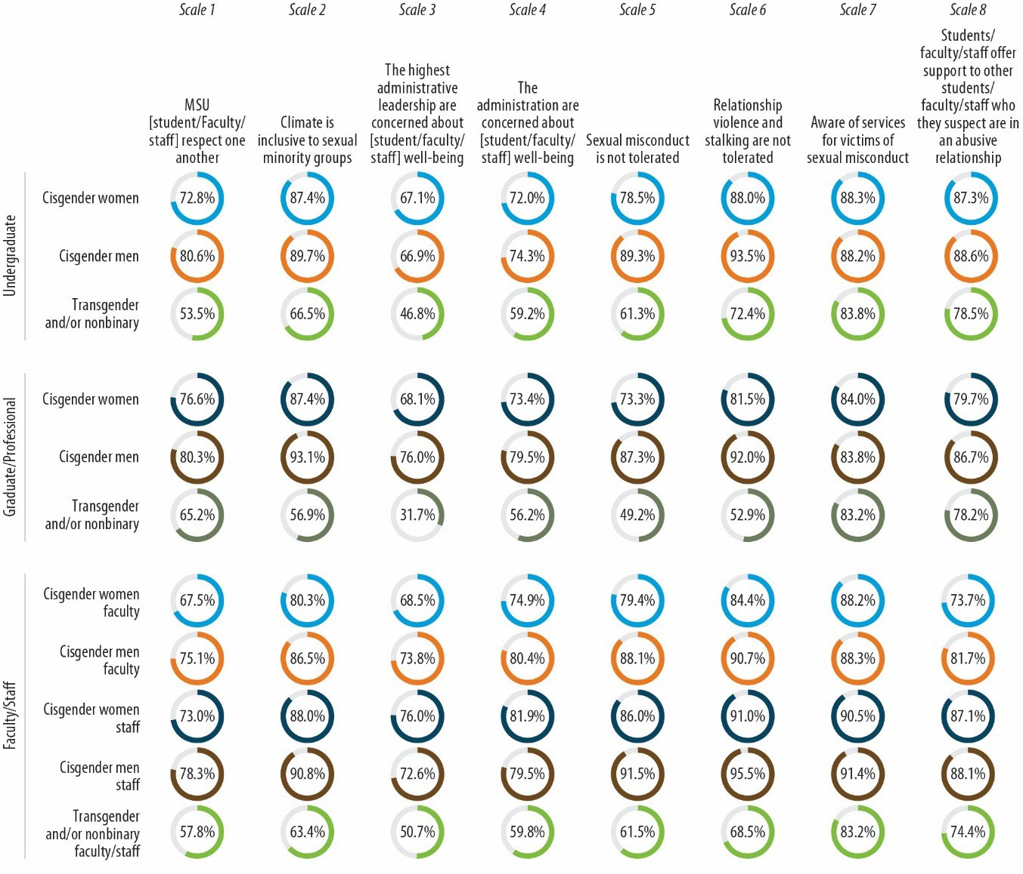Figure 39. Campus Climate (Sample Items Paraphrased), by Population
Notes: Percentages are of those agreeing with the statement. For an accessible version of the information shown in this figure, see Appendix Tables F-2a1 through F-3b5.

Perceptions of Hypothetical Treatment by MSU in the Event of Sexual Misconduct or Assault

Another dimension of climate measured in both the student and faculty/staff surveys was the survey participants’ perceptions about how they would be treated by MSU (e.g., whether the school would take their case seriously, protect their privacy, treat them with dignity and respect) if they were to experience sexual misconduct or sexual assault (students were asked about “sexual assault” and faculty/staff were asked about “sexual misconduct”). Reflecting a similar pattern evident for the other dimensions of climate discussed above, under- graduate cisgender men and faculty men conveyed the most positive perceptions, whereas cisgender women graduate/professional students and cisgender women faculty conveyed the most negative perceptions. For example, as shown in Figure 40, only 49.2% of trans- gender and/or nonbinary graduate/professional students agreed or strongly agreed that if they were to experience sexual misconduct, MSU would treat them with dignity and respect, whereas 89.7% of undergraduate cisgender men felt this way.

Awareness of MSU Services and Resources
A critical dimension of climate is the extent to which members of the campus community were aware of the various services and resources on campus related to sexual misconduct. Survey participants were asked about 13 specific programs or services; as evident from
Figure 41, awareness was mixed. Awareness among undergraduate cisgender women and men tended to be highest for MSU Safe Ride, the MSU Center for Survivors, and MSU Safe Place. Transgender/nonbinary undergraduates were also “very aware” of the MSU

Figure 40. “If I were to experience
sexual misconduct, MSU would treat me with dignity and respect”

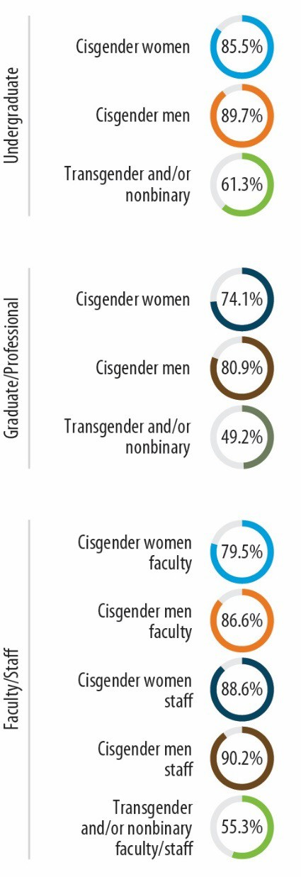
Notes: Percentages are of those agreeing with the statement. For an accessible version of the information shown in this figure, see Appendix Tables F-4a1 through F-4b5.

Gender and Sexuality Campus Center. Cisgender women graduate/professional students indicated being most aware of the MSU Center for Survivors, the MSU Office of Institutional Equity (OIE), and the MSU Office for Civil Rights & Title IX. Cisgender men graduate/professional students indicated being most aware of the MSU OIE and the MSU Office for Civil Rights & Title IX, and transgender and/or nonbinary

graduate/professional students indicated being most aware of the MSU Gender and Sexuality Campus Center and the MSU Center for Survivors. For faculty and staff, the MSU OIE, Office of University Ombudsperson, and the Office for Civil Rights & Title IX were all well-recognized. Cisgender women faculty also had high awareness of MSU’s Employee Assistance Program, as did staff cisgender women and men and transgender and/or nonbinary faculty/staff. Transgender and/or nonbinary faculty/staff also expressed strong awareness of MSU Safe Place and the MSU Gender and Sexuality Campus Center.

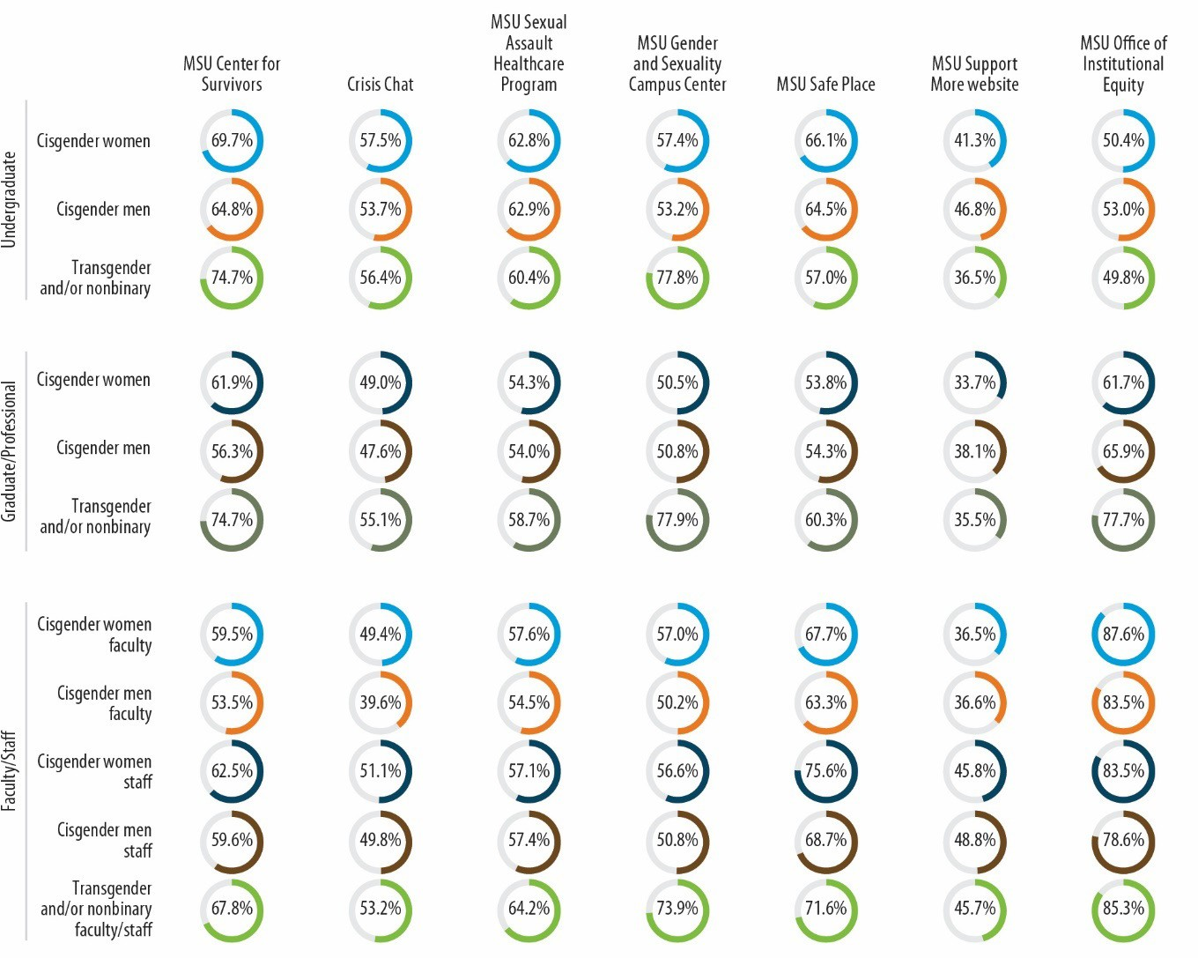Figure 41. Awareness of MSU Resources
(continued)

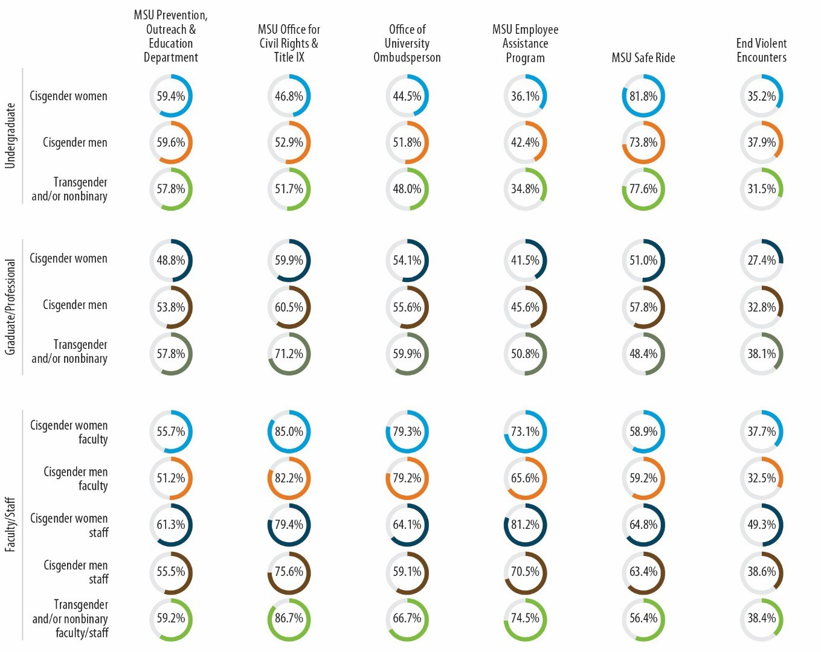Figure 41. Awareness of MSU Resources (continued)
Notes: Percentages are of those who reported being “very aware” or “somewhat aware” of the resource. For an accessible version of the information shown in this figure, see Appendix Tables F-5a1 through F-5b5.

Participation in Trainings
The surveys asked participants about the training or education they recall having received about sexual misconduct. Among students, 78.9% of undergraduates and 80.5% of graduate or professional students indicated that they had received information or education about sexual misconduct before enrolling at MSU. While at MSU, a large majority of all survey populations indicated having received trainings or having attended classes that cover a number of specific topics (Figure 42).37

37 It should be noted that during the 2021–2022 academic year, some trainings were given in real time, but online via Zoom. It is unknown whether survey respondents considered such trainings to be online.

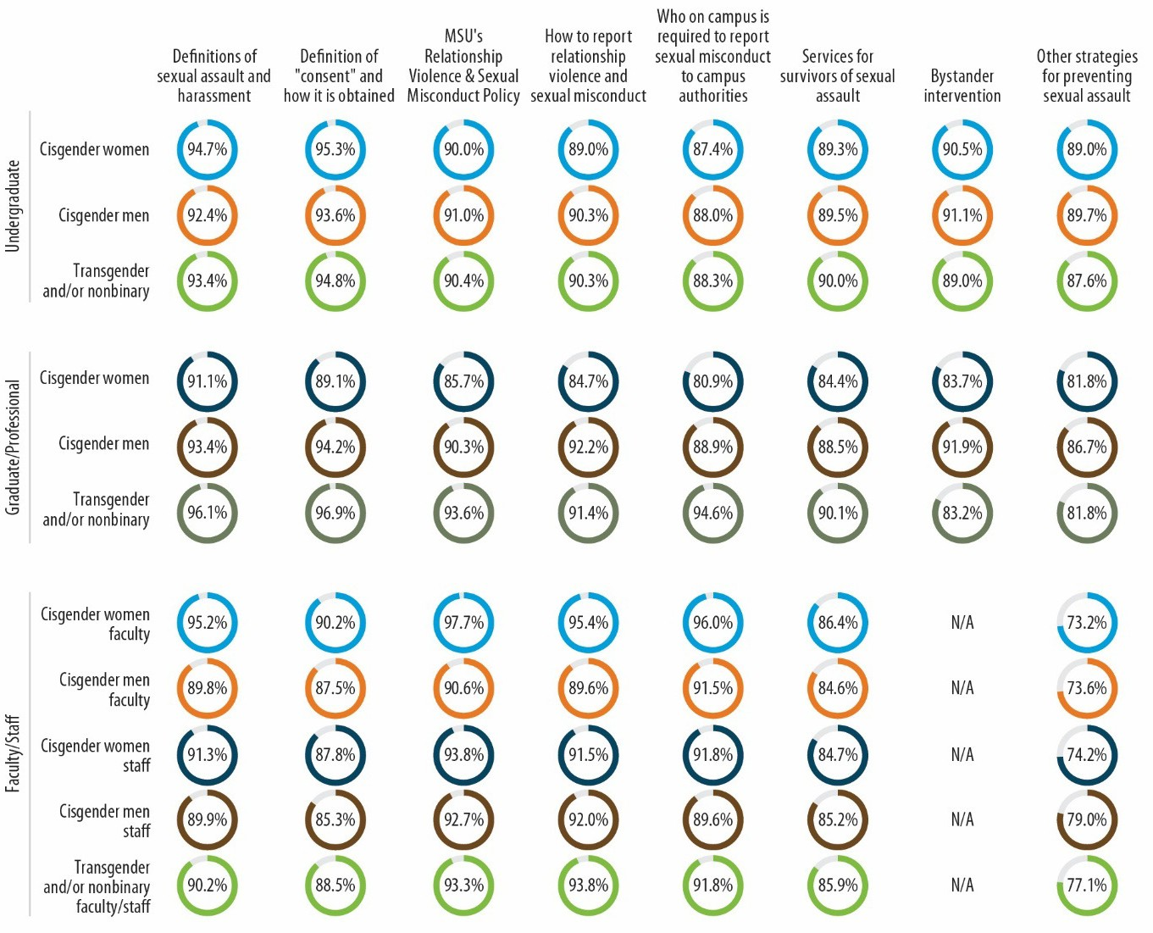Figure 42. Training on Specific Topics
Notes: Percentages are of those who indicated having received training. For an accessible version of the information shown in this figure, see Appendix Tables F-6a through F-6c.

The surveys also asked about specific programs and trainings that MSU offered. The percentage of undergraduate students receiving specific trainings is shown in Figure 43. Of the students who participated in a particular training, most perceived it as helpful or very helpful. For example, among undergraduates, 85.5% of cisgender women, 79.7% of cisgender men, and 70.8% of transgender or nonbinary students who indicated that they had participated in the Sexual Assault and Relationship Violence (SARV) Prevention program felt the training was helpful or very helpful.

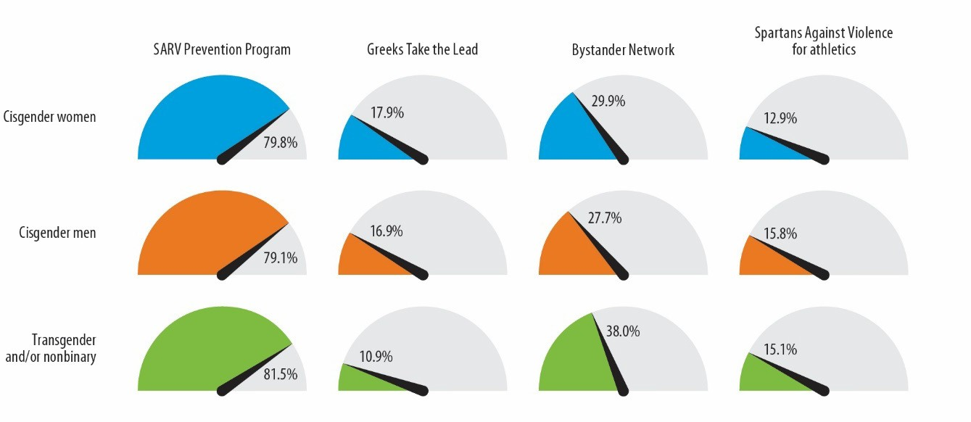Figure 43. Undergraduate Student Participation in Specific Trainings
Notes: Percentages are of those receiving training. For an accessible version of the information shown in this figure, see Appendix Table F-7a.

Graduate students were asked about receiving online training about RVSM (Figure 44), and the vast majority indicated they had participated. About a third indicated that they had taken some other in- person training on MSU’s RVSM policy.
All groups thought that online training was slightly less helpful than in-person training. For example, among graduate and professional students who had participated in an online training, 77.2% of cisgender women, 71.8% of cisgender men, and 57.2% of transgender and/or nonbinary students found it to be helpful/very helpful; of those who participated in an in-person training, 88.9% of

Figure 44. Graduate/Professional Student Participation in Specific Trainings

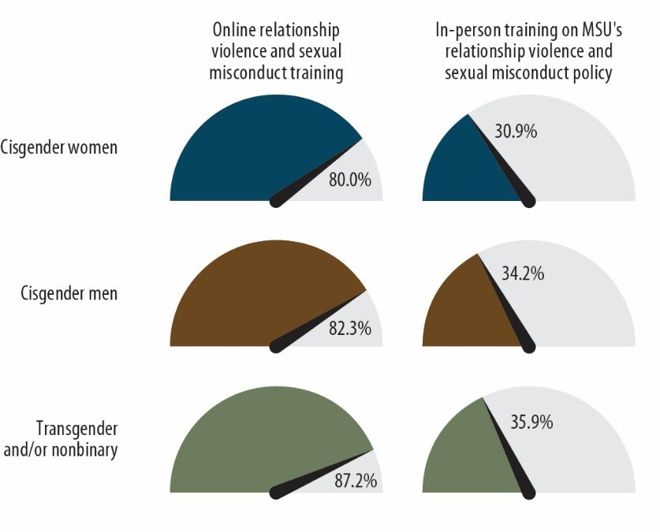
Notes: Percentages are of those who reported having received training. For an accessible version of the information shown in this figure, see Appendix Table F-7b.

cisgender women and 78.7% of cisgender men found it to be helpful or very helpful.

Faculty and staff were asked about their participation in three trainings; Figure 45 shows those results. The vast majority (over 85%) of all five groups recalled having received the online training on RVSM, but fewer than half indicated receiving an in-person training on MSU’s RVSM policy.
Cisgender faculty and staff women felt the in-person training was more helpful than the online training.

Faculty’s and Staff’s Confidence in Responding to Student and Staff Disclosure
Faculty and staff were also asked how much they remembered

Figure 45. Faculty/Staff Participation in Specific Trainings
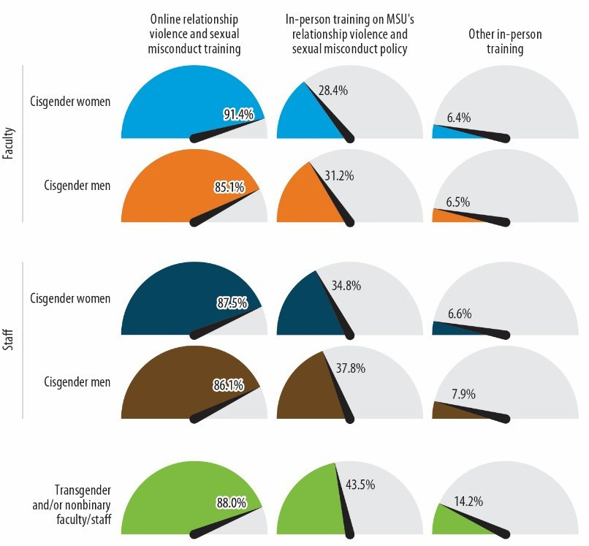
Notes: Percentages are of those who reported having received training. For an accessible version of the information shown in this figure, see Appendix Table F-7c.

about the information or training they received from MSU about RVSM. The majority of faculty and staff indicated that they remembered “most” or “almost all” of the information they were given (57.2% of cisgender women faculty, 70.1% for cisgender men faculty, 61.3% for cisgender women staff, and 68.3% for cisgender men staff).
Figure 46 illustrates faculty’s and staff’s confidence in their ability to respond according to MSU’s official procedures to a student disclosing RVSM. Although more than half of faculty and staff felt confident or very confident in their ability to respond according to MSU’s official procedures, cisgender men faculty expressed the highest levels of confidence. The same pattern was evident for faculty’s and staff’s confidence in their ability to handle disclosure from a staff member, administrator, or faculty member; for this type of disclosure, 58.3% of cisgender women faculty, 72.7% of cisgender men faculty, 63.0% of cisgender women staff, 70.8% of cisgender men staff, and 52.2% of transgender and/or nonbinary faculty/staff indicated they felt confident or very confident that they could respond in accordance with MSU’s official procedures.

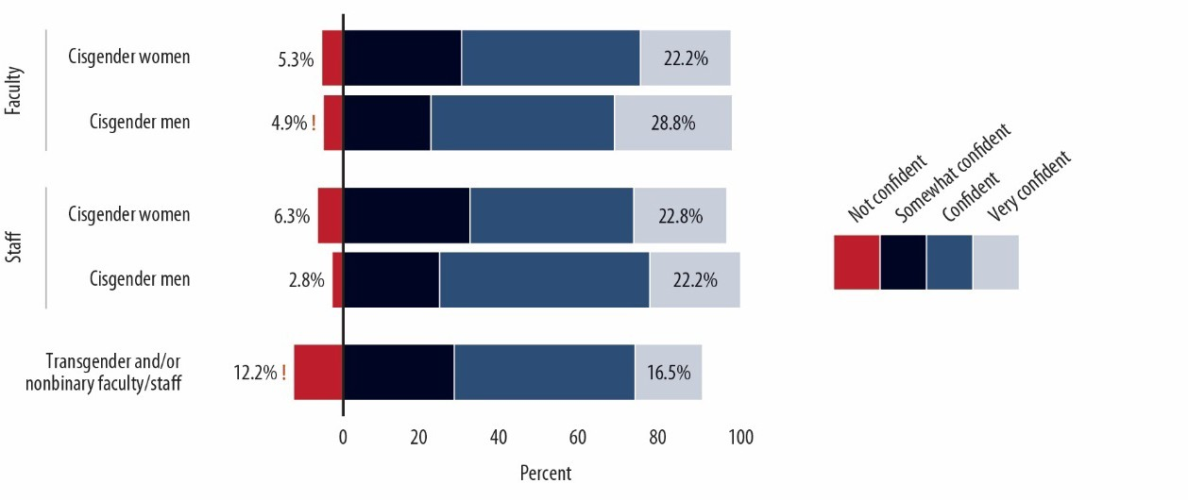Figure 46. Faculty’s/Staff’s Confidence in Their Ability to Respond According to MSU’s Official Procedures to a Student Disclosing RVSM
Notes: Percentages are of faculty and staff. For an accessible version of the information shown in this figure, see Appendix Table F-7c.

Changes from the 2018–2019 to the 2021–2022 Academic Year
In this chapter, data from the 2022 Know More @ MSU Campus Survey are compared to results from the 2019 survey in an effort to determine whether and how things have changed at MSU in the past 3 years. In 2022, we made a change in how we assessed and reported results by gender identity, which makes this comparison of results from 2019 to 2022 somewhat imperfect. In 2019, students, faculty, and staff who identified as being genderqueer and/or nonbinary, and could not be grouped with women and men, were not included in the analyses of women or men, and only a few estimates or results were presented separately for those identifying as genderqueer and/or nonbinary. In other words, transgender women and women who did not identify as transgender were grouped together, as were transgender men and men who did not identify as transgender. For 2022, we used two new survey questions to assess gender identity; students, faculty, and staff who identified as being transgender and/or nonbinary (or genderqueer) were put into their own gender identity groups and their data and results are presented separately, but alongside cisgender women and cisgender men. To make comparisons using 2019 and 2022 data, it is necessary to compare results for groups that are included in both years the survey was administered, so throughout this chapter, the experiences and perspectives of students, faculty, and staff who were categorized as women or men in 2019 (which included transgender women and men) are compared to those of the students, faculty, and staff who identified as being cisgender women or men in 2022. In other words, the students, faculty, and staff who identified as being transgender and/or nonbinary in 2022 are not included in these analyses, whereas the transgender respondents are included in the 2019 results. The makeup of the groups being compared is therefore not perfectly consistent, given the changes made to how gender identity was asked about in the survey and utilized analytically in 2022, but the differences in the groups and any impact that they might have on the associated results being compared are believed to be minimal.
When 2019 and 2022 estimates or results are compared in this chapter, the statistical significance of differences was assessed by determining whether the 95% confidence intervals for various estimates and outcomes overlap. When the 95% confidence intervals for two estimates being compared do not overlap, it is concluded with 95% confidence that the estimates are significantly different from one another statistically (i.e., that change in fact occurred from 2019 to 2022).
Figure 47 presents 2019 and 2022 prevalence estimates for eight different victimization outcomes experienced by undergraduate women. Statistically significant differences or changes are indicated with an asterisk (*) in the figure for four outcomes: sexual harassment, coerced sexual contact, sexual assault since enrolling at MSU, and sexual assault before enrolling at MSU. The prevalence of three of these victimization outcomes decreased from 2019 to 2022, and the prevalence of experiencing sexual assault before enrolling at MSU increased. As an example of how to interpret these findings, the prevalence of undergraduate women experiencing sexual harassment during the academic year decreased from 65.5% to 61.0%, and this decrease is statistically significant because the 95% confidence intervals on the two

estimates being compared, which are indicated by the thin black “whisker” lines that span the estimates, do not overlap.

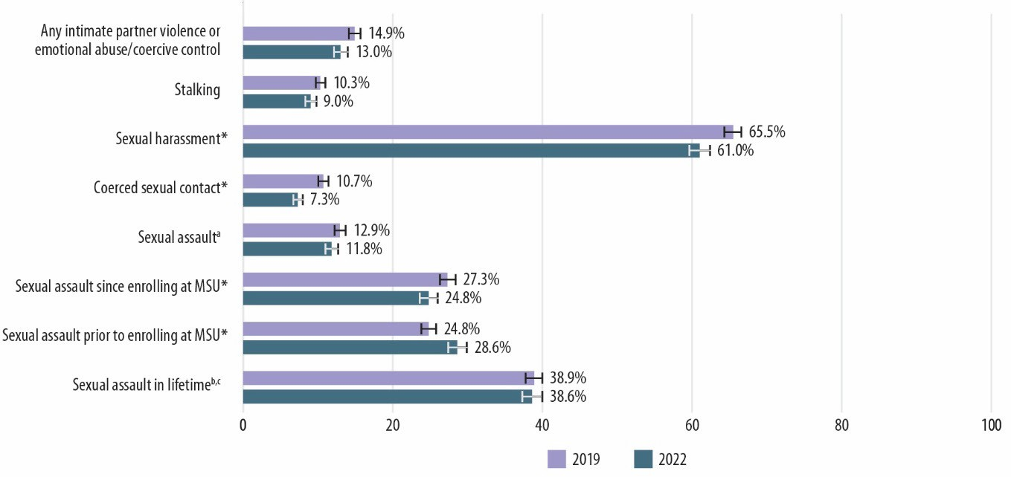Figure 47. Comparison of Victimization Prevalence for Undergraduate Women During 2019–2020 and 2021–2022 Academic Years
Notes: Percentages are of students. * Statistically significant at p < 0.05. For an accessible version of the information shown in this figure, see Appendix Table G-1a.
a The prevalence rates of rape and sexual battery may not sum to sexual assault because some respondents did not indicate a type of contact.
b Sexual assault in lifetime will not equal the sum of sexual assault prior to enrolling at MSU and sexual assault since entering MSU because some students endorsed both before and since enrolling.
c The lifetime sexual assault victimization estimate does not equal the sum of the lifetime rape victimization and the lifetime sexual battery victimization estimates, because not all items that could be used to identify lifetime sexual assault victimization captured enough information to determine whether it involved rape or sexual battery.

Figure 48 presents 2019 and 2022 prevalence estimates for eight different victimization outcomes experienced by undergraduate men. Statistically significant differences or changes are indicated for four outcomes: stalking, sexual harassment, coerced sexual contact, and sexual assault since enrolling at MSU, all of which decreased from 2019 to 2022.
Figures 49 and 50 present 2019 and 2022 prevalence estimates for eight different victimization outcomes experienced by women and men graduate/professional students, respectively. For both groups, a statistically significant difference or change is indicated for sexual harassment, the prevalence of which decreased considerably from 2019 to 2022.
Figure 51 compares the prevalence rates of disclosing sexual battery and rape incidents experienced by undergraduate women to different groups, including roommates, friends, and family; any MSU or off-campus office/organization; an MSU office; or an off-campus organization. The prevalence of disclosing sexual battery and rape incidents to different groups did not change from 2019 to 2022.
Comparisons of the rates of disclosure for the other groups lacked statistical precision.

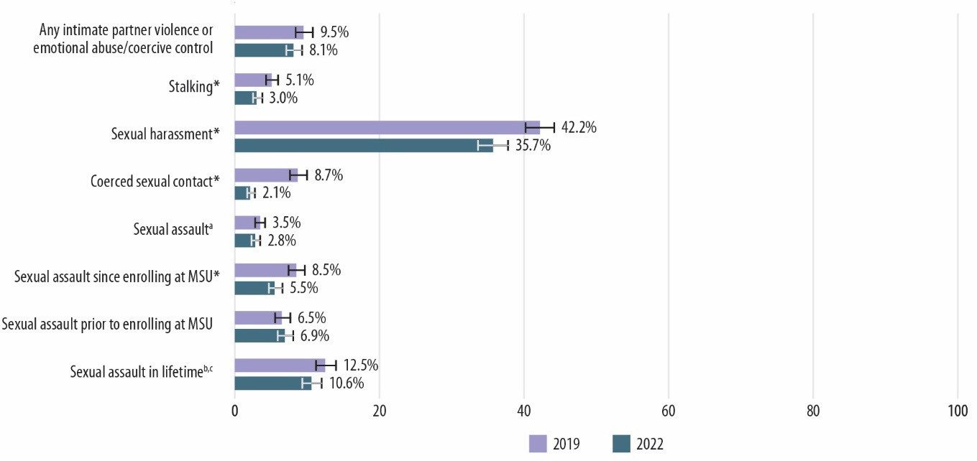Figure 48. Comparison of Victimization Prevalence for Undergraduate Men During 2019–2020 and 2021–2022 Academic Years
Notes: Percentages are of students. * Statistically significant at p < 0.05. For an accessible version of the information shown in this figure, see Appendix Table G-1b.
a The prevalence rates of rape and sexual battery may not sum to sexual assault because some respondents did not indicate a type of contact.
b Sexual assault in lifetime will not equal the sum of sexual assault prior to enrolling at MSU and sexual assault since entering MSU because some students endorsed both before and since enrolling.
c The lifetime sexual assault victimization estimate does not equal the sum of the lifetime rape victimization and the lifetime sexual battery victimization estimates, because not all items that could be used to identify lifetime sexual assault victimization captured enough information to determine whether it involved rape or sexual battery.

Figure 49. Comparison of Victimization Prevalence for Graduate/Professional Women During 2019–2020 and 2021–2022 Academic Years
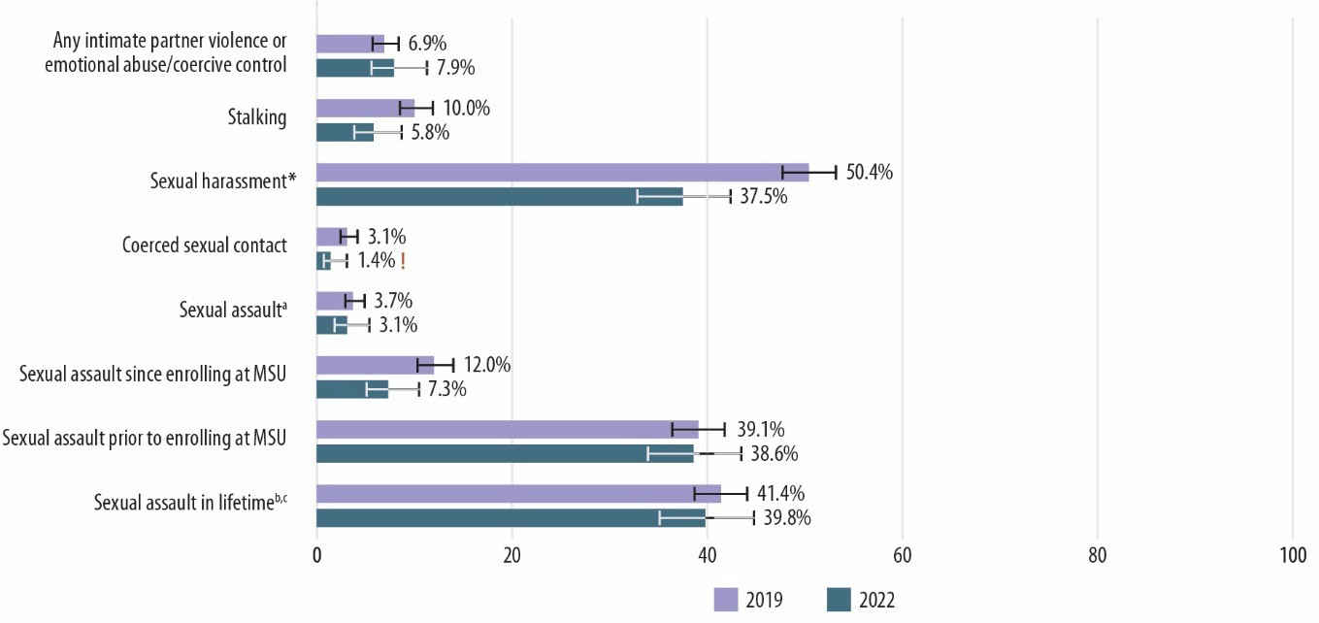
Notes: Percentages are of students. * Statistically significant at p < 0.05. ! Estimate is considered not statistically reliable because it is either based on fewer than 10 people or has a relative standard error greater than 30%. For an accessible version of the information shown in this figure, see Appendix Table G-1c.
a The prevalence rates of rape and sexual battery may not sum to sexual assault because some respondents did not indicate a type of contact.
b Sexual assault in lifetime will not equal the sum of sexual assault prior to enrolling at MSU and sexual assault since entering MSU because some students endorsed both before and since enrolling.
c The lifetime sexual assault victimization estimate does not equal the sum of the lifetime rape victimization and the lifetime sexual battery victimization estimates, because not all items that could be used to identify lifetime sexual assault victimization captured enough information to determine whether it involved rape or sexual battery.

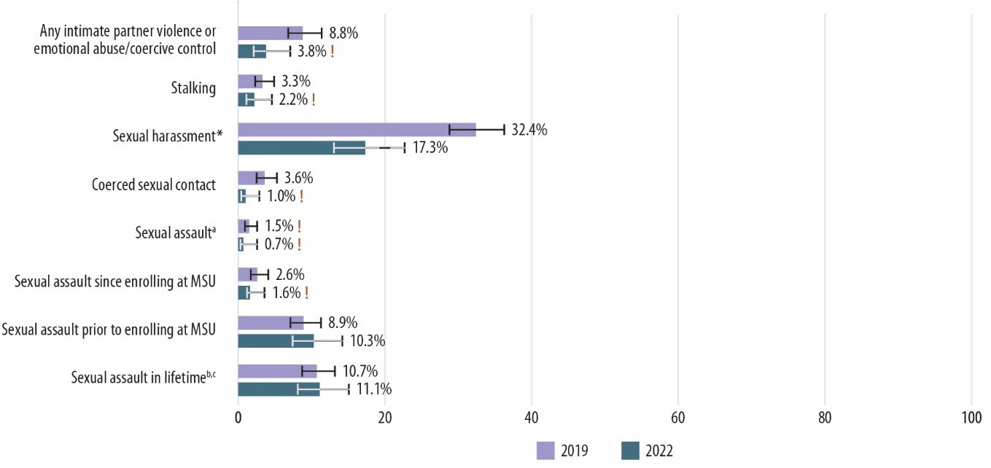Figure 50. Comparison of Victimization Prevalence for Graduate/Professional Men During 2019– 2020 and 2021–2022 Academic Years
Notes: Percentages are of students. * Statistically significant at p < 0.05. ! Estimate is considered not statistically reliable because it is either based on fewer than 10 people or has a relative standard error greater than 30%. For an accessible version of the information shown in this figure, see Appendix Table G-1d.
a The prevalence rates of rape and sexual battery may not sum to sexual assault because some respondents did not indicate a type of contact.
b Sexual assault in lifetime will not equal the sum of sexual assault prior to enrolling at MSU and sexual assault since entering MSU because some students endorsed both before and since enrolling.
c The lifetime sexual assault victimization estimate does not equal the sum of the lifetime rape victimization and the lifetime sexual battery victimization estimates, because not all items that could be used to identify lifetime sexual assault victimization captured enough information to determine whether it involved rape or sexual battery.

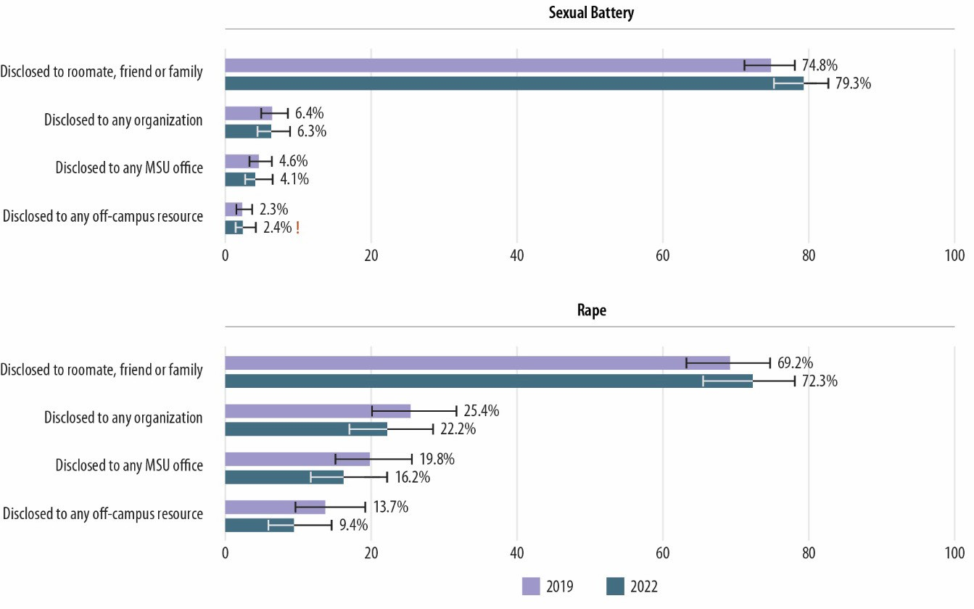Figure 51. Comparison of Disclosure Rates for Sexual Battery and Rape Incidents Experienced by Undergraduate Women During 2019–2020 and 2021–2022 Academic Years
Note: ! Estimate is considered not statistically reliable because it is either based on fewer than 10 people or has a relative standard error greater than 30%. For an accessible version of the information shown in this figure, see Appendix Tables G-2a and G-3a.

Figures 52 through 55 compare the 2019 and 2022 rates of disclosing, to various groups, sexual harassment experienced by undergraduate women, undergraduate men, women graduate/professional students, and men graduate/professional students, respectively. For undergraduate women and undergraduate men, the prevalence of disclosing sexual harassment experiences to friends, classmates, family members, or dating partners and to an MSU resource (Office of the University Ombudsperson, Counseling and Psychological Services, MSU Police, etc.) increased from 2019 to 2022. The estimates and comparisons for other groups lack statistical precision.

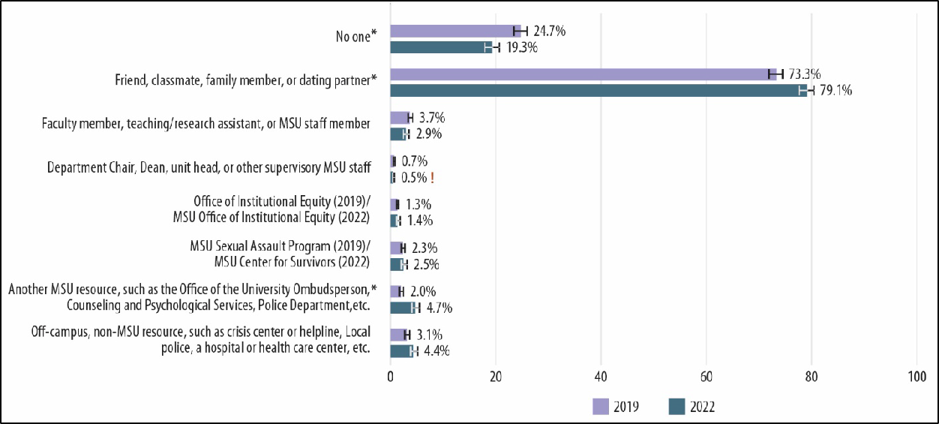
Figure 52. Comparison of Disclosure Rates for Sexual Harassment Incidents Experienced by Undergraduate Women During 2019–2020 and 2021–2022 Academic Years
Notes: * Statistically significant at p < 0.05. ! Estimate is considered not statistically reliable because it is either based on fewer than 10 people or has a relative standard error greater than 30%. For an accessible version of the information shown in this figure, see Appendix Table G-6a.

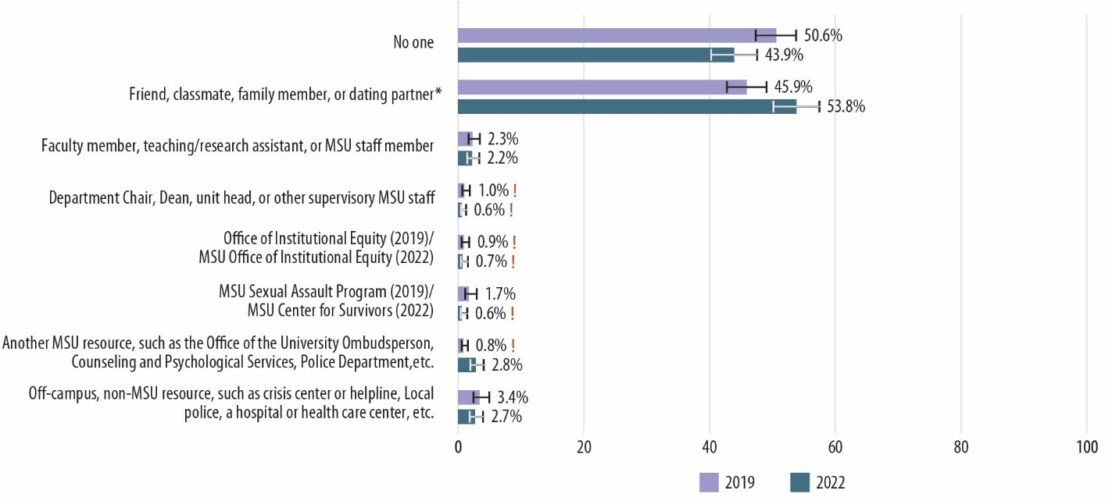Figure 53. Comparison of Disclosure Rates for Sexual Harassment Incidents Experienced by Undergraduate Men During 2019–2020 and 2021–2022 Academic Years
Notes: * Statistically significant at p < 0.05. ! Estimate is considered not statistically reliable because it is either based on fewer than 10 people or has a relative standard error greater than 30%. For an accessible version of the information shown in this figure, see Appendix Table G-6b.

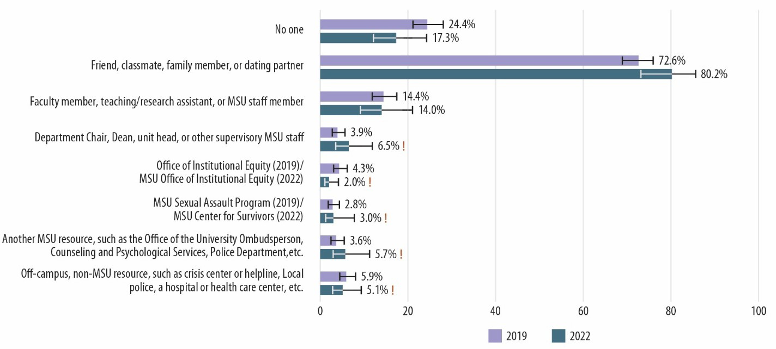Figure 54. Comparison of Disclosure Rates for Sexual Harassment Incidents Experienced by Graduate/Professional Women During 2019–2020 and 2021–2022 Academic Years
Note: ! Estimate is considered not statistically reliable because it is either based on fewer than 10 people or has a relative standard error greater than 30%. For an accessible version of the information shown in this figure, see Appendix Table G-6c.

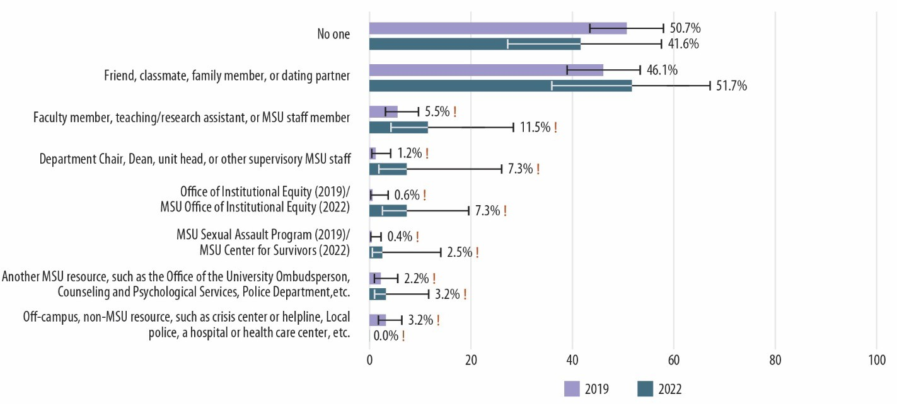Figure 55. Comparison of Disclosure Rates for Sexual Harassment Incidents Experienced by Graduate/Professional Men During 2019–2020 and 2021–2022 Academic Years
Note: ! Estimate is considered not statistically reliable because it is either based on fewer than 10 people or has a relative standard error greater than 30%. For an accessible version of the information shown in this figure, see Appendix Table G-6d.

Figures 56 through 59 compare the 2019 and 2022 prevalence estimates for experiencing workplace incivility and workplace sexual harassment for faculty women, faculty men, staff women, and staff men. All groups except faculty men experienced significantly less workplace incivility in 2022 than

they did in 2019. All four groups experienced significantly less workplace sexual harassment in 2022 than they did in 2019.

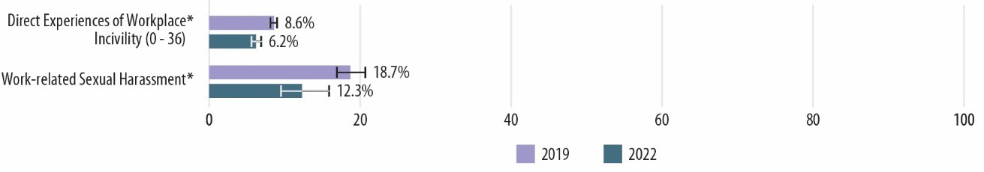Figure 56. Comparison of Workplace Incivility and Sexual Harassment Prevalence for Faculty Women During 2019–2020 and 2021–2022 Academic Years
Note: * Statistically significant at p < 0.05. For an accessible version of the information shown in this figure, see Appendix Tables G-4a and G-5a.

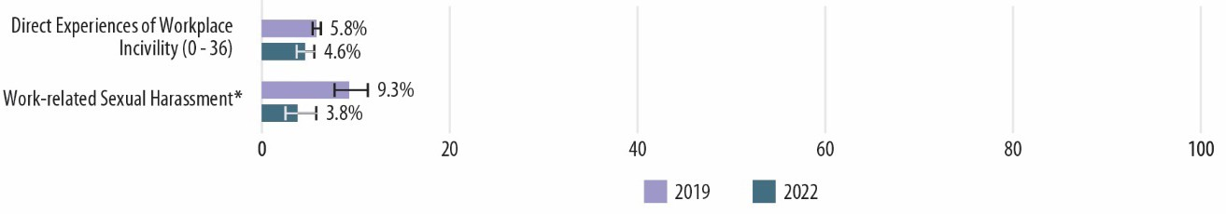Figure 57. Comparison of Workplace Incivility and Sexual Harassment Prevalence for Faculty Men During 2019–2020 and 2021–2022 Academic Years
Note: * Statistically significant at p < 0.05. For an accessible version of the information shown in this figure, see Appendix Tables G-4b and G-5b.

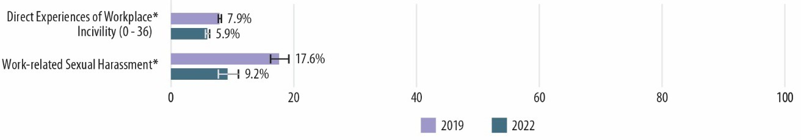Figure 58. Comparison of Workplace Incivility and Sexual Harassment Prevalence for Staff Women During 2019–2020 and 2021–2022 Academic Years
Note: * Statistically significant at p < 0.05. For an accessible version of the information shown in this figure, see Appendix Tables G-4c and G-5c.

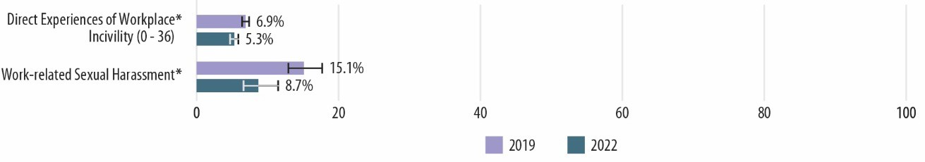Figure 59. Comparison of Workplace Incivility and Sexual Harassment Prevalence for Staff Men During 2019–2020 and 2021–2022 Academic Years
Note: * Statistically significant at p < 0.05. For an accessible version of the information shown in this figure, see Appendix Tables G-4d and G-5d.

Figures 60 through 63 compare the 2019 and 2022 rates of disclosing sexual harassment experienced by faculty women, faculty men, staff women, and staff men to friends, family members, or intimate/romantic partners; work colleagues; or no one. The prevalence of disclosing sexual harassment did not change from 2019 to 2022. Respondents were able to endorse other sources to which they could have disclosed their sexual harassment experiences, but the estimates for those other sources lack statistical precision.

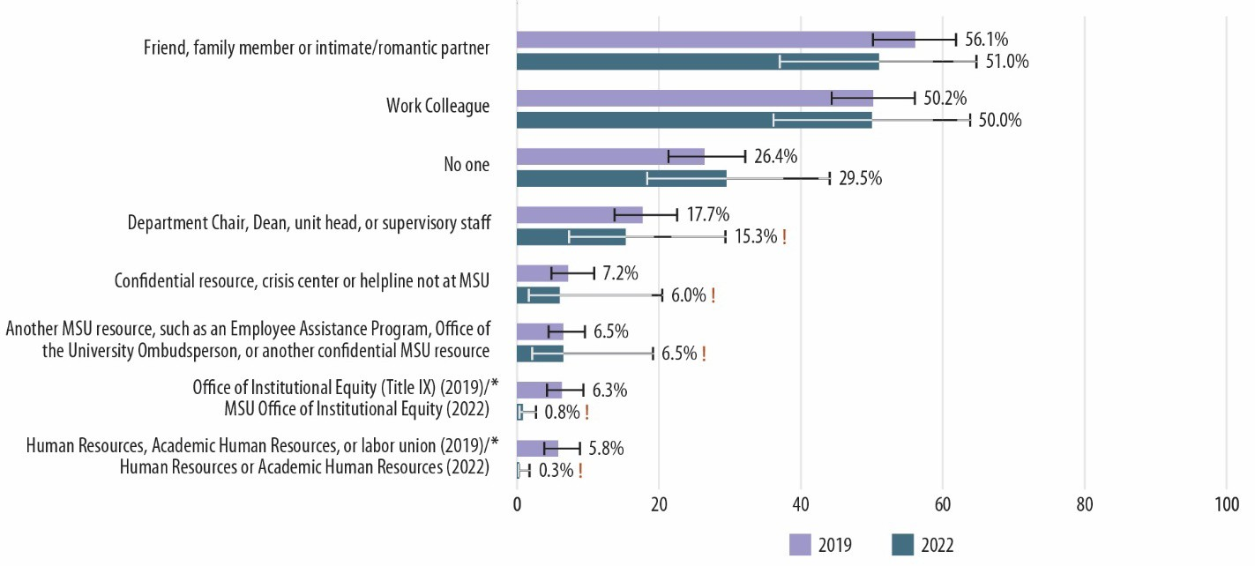Figure 60. Comparison of Disclosure Rates for Sexual Harassment Incidents Experienced by Faculty Women During 2019–2020 and 2021–2022 Academic Years
Notes: * Statistically significant at p < 0.05. ! Estimate is considered not statistically reliable because it is either based on fewer than 10 people or has a relative standard error greater than 30%. For an accessible version of the information shown in this figure, see Appendix Table G-7a.

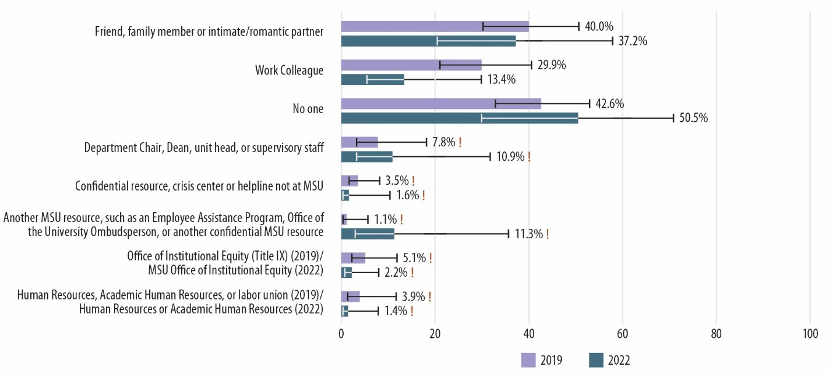Figure 61. Comparison of Disclosure Rates for Sexual Harassment Incidents Experienced by Faculty Men During 2019–2020 and 2021–2022 Academic Years
Note: ! Estimate is considered not statistically reliable because it is either based on fewer than 10 people or has a relative standard error greater than 30%. For an accessible version of the information shown in this figure, see Appendix Table G-7b.

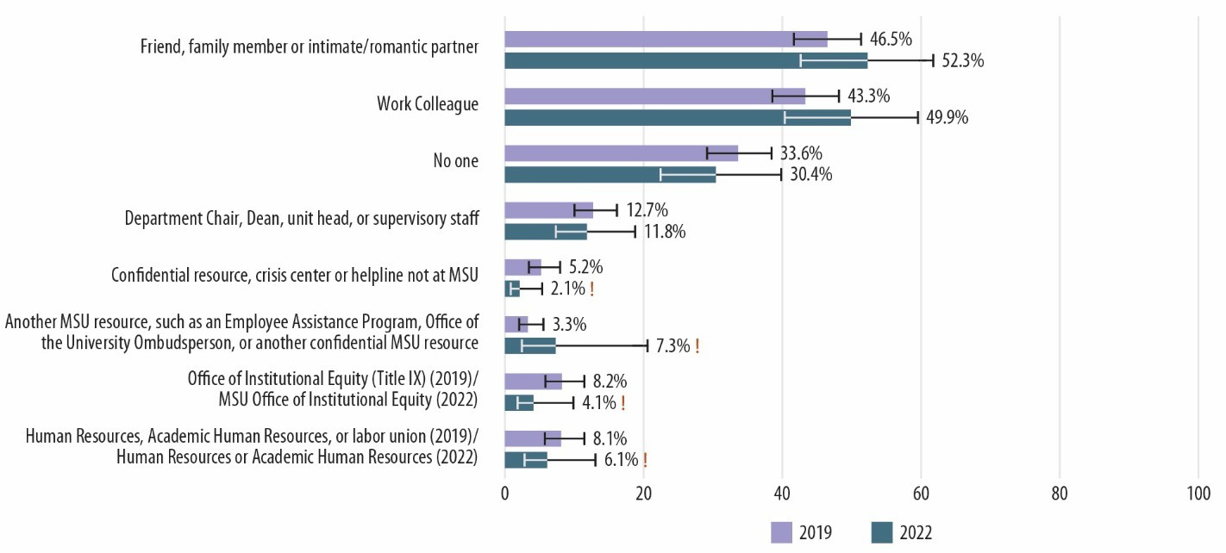Figure 62. Comparison of Disclosure Rates for Sexual Harassment Incidents Experienced by Staff Women During 2019–2020 and 2021–2022 Academic Years
Note: ! Estimate is considered not statistically reliable because it is either based on fewer than 10 people or has a relative standard error greater than 30%. For an accessible version of the information shown in this figure, see Appendix Table G-7c.

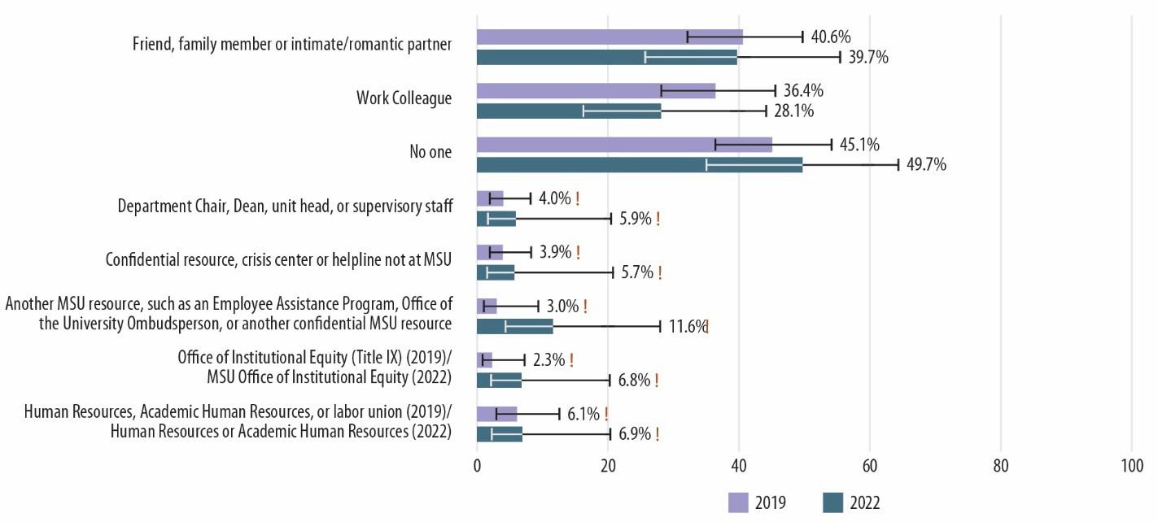Figure 63. Comparison of Disclosure Rates for Sexual Harassment Incidents Experienced by Staff Men During 2019–2020 and 2021–2022 Academic Years
Note: ! Estimate is considered not statistically reliable because it is either based on fewer than 10 people or has a relative standard error greater than 30%. For an accessible version of the information shown in this figure, see Appendix Table G-7d.

Figure 64 compares the 2019 and 2022 standardized scores for undergraduate women on the following seven climate scales that were included in both the 2019 and 2022 surveys.
- General School Connectedness
- Perceptions of Inclusive Climate
- General Perceptions of Highest Administrative Leadership
- General Perceptions of Other University Administration
- Perceptions of School Leadership Climate for Sexual Misconduct Prevention and Response
- Perceptions of School Leadership Climate for Relationship Violence Prevention and Response
- Awareness and Perceived Fairness of School Sexual Assault Policy and Resources

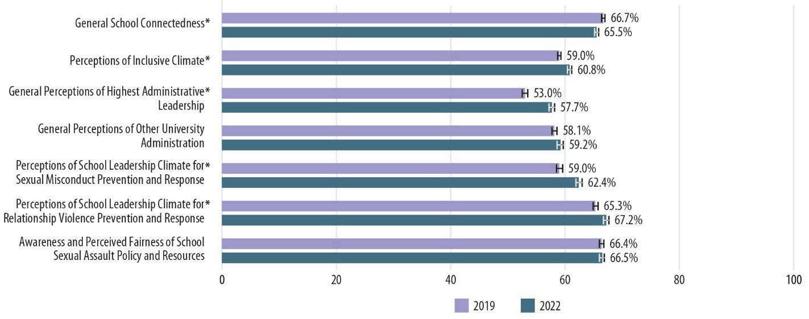Figure 64. Comparison of Standardized Climate Scale Scores for Undergraduate Women During 2019–2020 and 2021–2022 Academic Years
Note: * Statistically significant at p < 0.05. For an accessible version of the information shown in this figure, see Appendix Table G-8a.

The score for General School Connectedness decreased, which means it got worse; however, the scores for the following four scales increased or improved for undergraduate women from 2019 to 2022: Perceptions of Inclusive Climate, General Perceptions of Highest Administrative Leadership, Perceptions of School Leadership Climate for Sexual Misconduct Prevention and Response, and Perceptions of School Leadership Climate for Relationship Violence Prevention and Response.
Figure 65 compares the 2019 and 2022 standardized scores for undergraduate men on the seven climate scales. The scores for the following four scales increased or improved for undergraduate men from 2019 to 2022: Perceptions of Inclusive Climate, General Perceptions of Highest Administrative Leadership, Perceptions of School Leadership Climate for Sexual Misconduct Prevention and Response, and Perceptions of School Leadership Climate for Relationship Violence Prevention and Response.

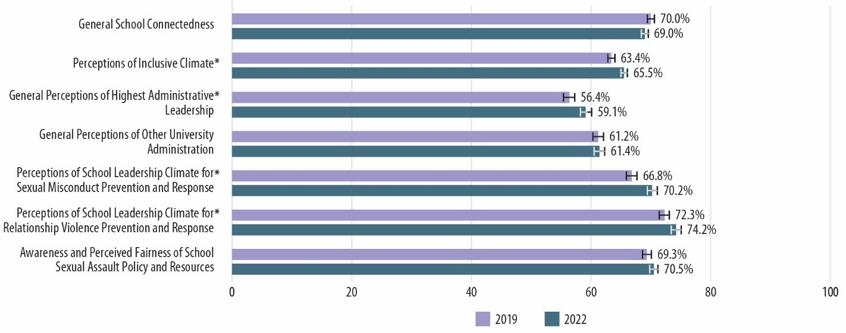Figure 65. Comparison of Standardized Climate Scale Scores for Undergraduate Men During 2019–2020 and 2021–2022 Academic Years
Note: * Statistically significant at p < 0.05. For an accessible version of the information shown in this figure, see Appendix Table G-8b.

Figure 66 compares the 2019 and 2022 standardized scores for women graduate/professional students on the seven climate scales. With the exception of the General School Connectedness scale, which did not change, the scores for the other six scales increased or improved from 2019 to 2022.

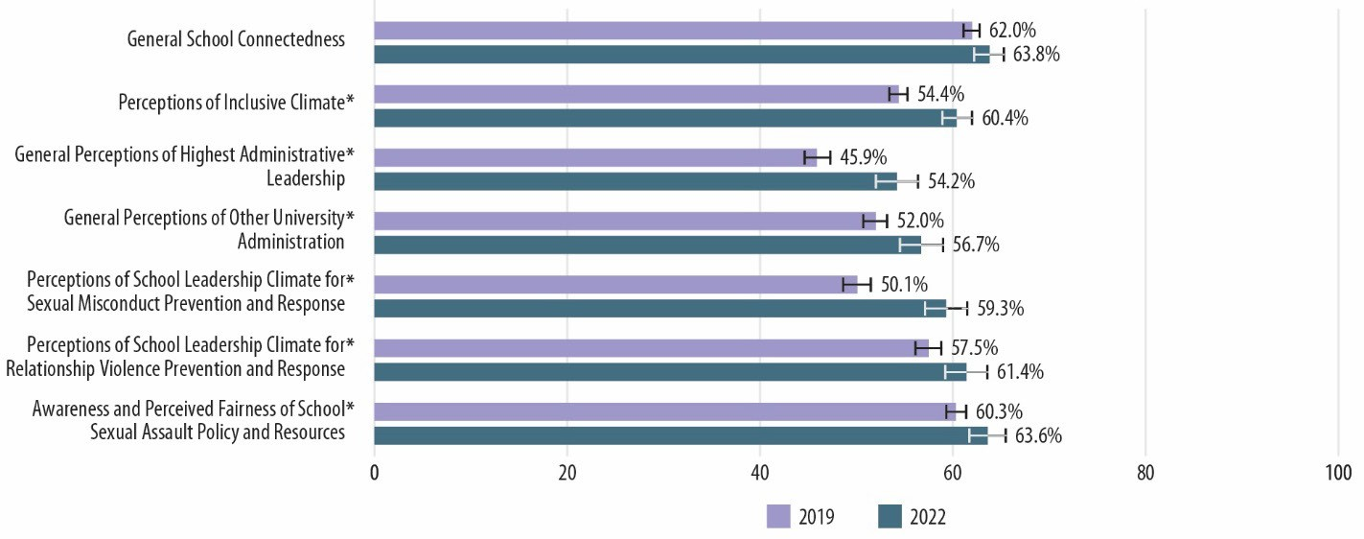Figure 66. Comparison of Standardized Climate Scale Scores for Graduate/Professional Women During 2019–2020 and 2021–2022 Academic Years
Note: * Statistically significant at p < 0.05. For an accessible version of the information shown in this figure, see Appendix Table G-8c.

Figure 67 compares the 2019 and 2022 standardized scores for men graduate/professional students on the seven climate scales. The scores for all seven scales increased or improved from 2019 to 2022.

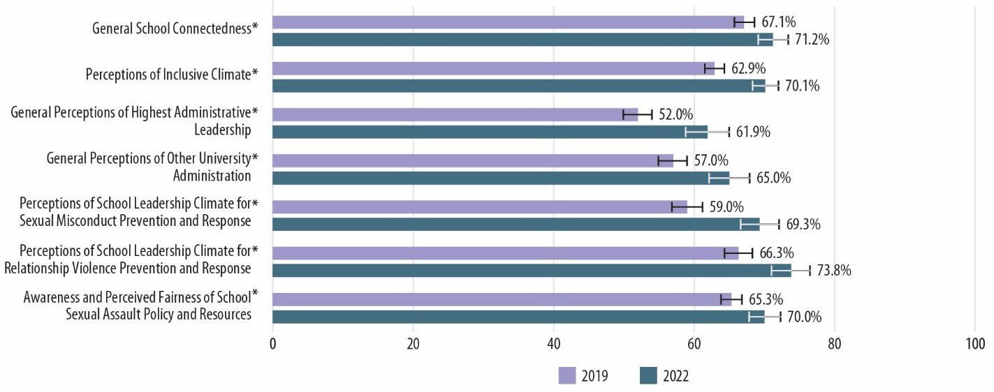Figure 67. Comparison of Standardized Climate Scale Scores for Graduate/Professional Men During 2019–2020 and 2021–2022 Academic Years
Note: * Statistically significant at p < 0.05. For an accessible version of the information shown in this figure, see Appendix Table G-8d.

Figure 68 compares the 2019 and 2022 standardized scores for faculty women on the seven climate scales. The scores for the following five scales increased or improved from 2019 to 2022: Perceptions of Inclusive Climate, General Perceptions of Highest Administrative Leadership, General Perceptions of Other University Administration, Perceptions of School Leadership Climate for Sexual Misconduct Prevention and Response, and Perceptions of School Leadership Climate for Relationship Violence Prevention and Response.

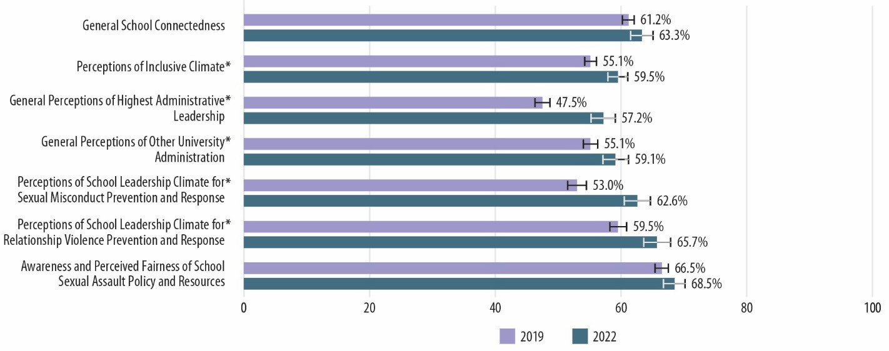Figure 68. Comparison of Standardized Climate Scale Scores for Faculty Women During 2019– 2020 and 2021–2022 Academic Years
Note: * Statistically significant at p < 0.05. For an accessible version of the information shown in this figure, see Appendix Table G-8e.

Figure 69 compares the 2019 and 2022 standardized scores for faculty men on the seven climate scales. The scores for the following three scales increased or improved from 2019 to 2022: General

Perceptions of Highest Administrative Leadership, Perceptions of School Leadership Climate for Sexual Misconduct Prevention and Response, and Perceptions of School Leadership Climate for Relationship Violence Prevention and Response.

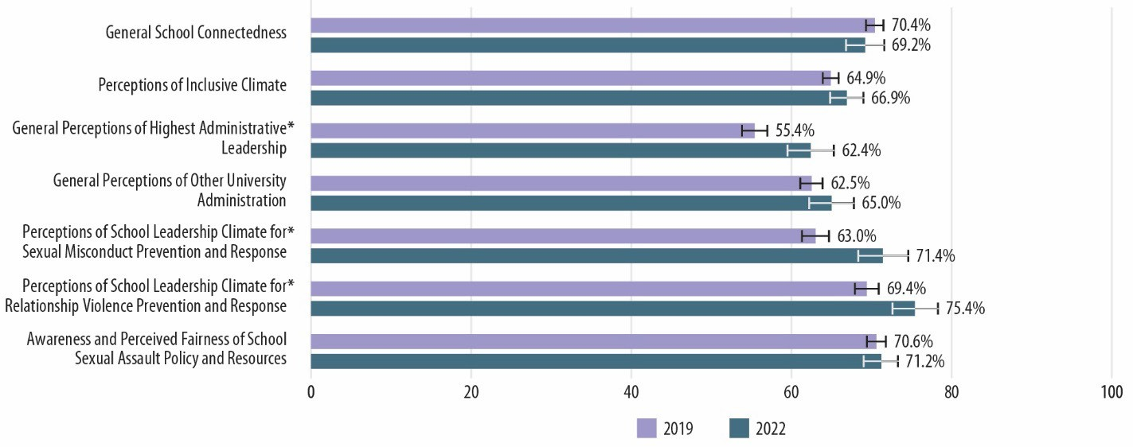Figure 69. Comparison of Standardized Climate Scale Scores for Faculty Men During 2019–2020 and 2021–2022 Academic Years
Note: * Statistically significant at p < 0.05. For an accessible version of the information shown in this figure, see Appendix Table G-8f.

Figure 70 compares the 2019 and 2022 standardized scores for women staff on the seven climate scales. With the exception of the General School Connectedness scale, which did not change, the scores for the other six scales increased or improved from 2019 to 2022.

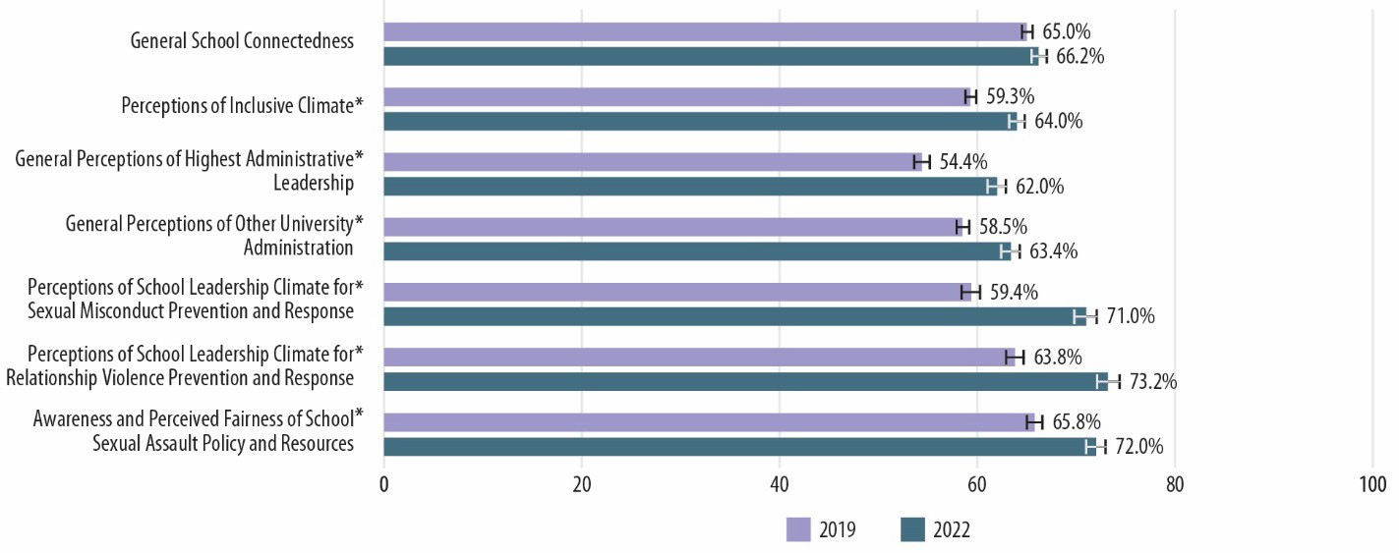Figure 70. Comparison of Standardized Climate Scale Scores for Staff Women During 2019–2020 and 2021–2022 Academic Years
Note: * Statistically significant at p < 0.05. For an accessible version of the information shown in this figure, see Appendix Table G-8g.

Figure 71 compares the 2019 and 2022 standardized scores for men staff on the seven climate scales. The scores for all seven scales increased or improved from 2019 to 2022.

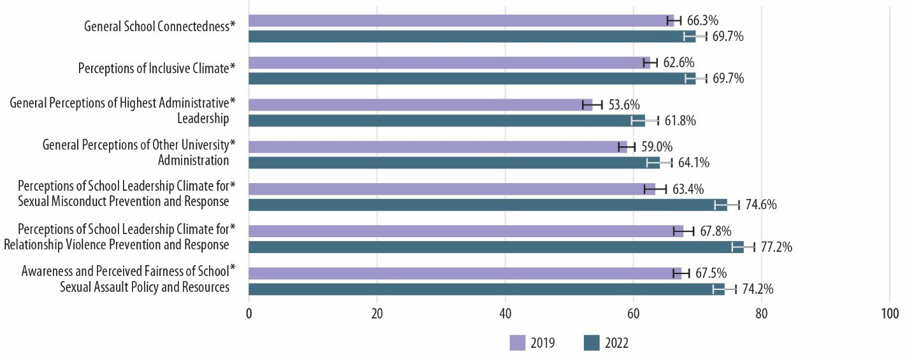Figure 71. Comparison of Standardized Climate Scale Scores for Staff Men During 2019–2020 and 2021–2022 Academic Years
Note: * Statistically significant at p < 0.05. For an accessible version of the information shown in this figure, see Appendix Table G-8h.

Figure 72 compares the percentage of undergraduate women who were “very aware” or “somewhat aware” of various offices or resources that are charged with helping address RVSM at MSU. The nine MSU offices and resources asked about are as follows:
- MSU Sexual Assault Program (2019) / MSU Center for Survivors (2022)
- MSU Crisis Chat
- MSU Safe Place
- MSU OIE
- MSU Prevention, Outreach & Education Department
- MSU Office for Civil Rights & Title IX
- MSU Office of University Ombudsperson
- MSU Safe Ride
- End Violent Encounters
The results are quite mixed in that awareness of a few offices and resources has increased significantly since 2019, whereas awareness of a few other offices and resources has decreased significantly since 2019. The results are similarly mixed for undergraduate men (Figure 73). All groups surveyed indicated being less aware of the MSU Sexual Assault Program (2019)/MSU Center for Survivors (2022) in 2022.

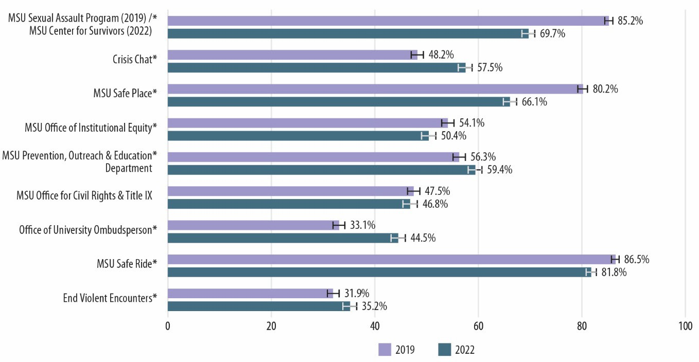Figure 72. Comparison of Undergraduate Women’s Awareness of Various MSU Offices and Resources During 2019–2020 and 2021–2022 Academic Years
Note: * Statistically significant at p < 0.05. For an accessible version of the information shown in this figure, see Appendix Table G-9a.

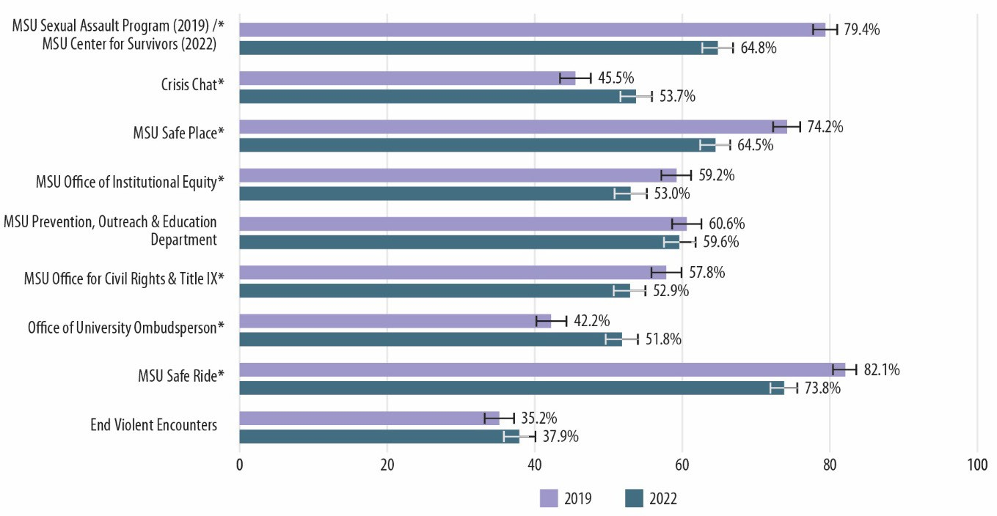Figure 73. Comparison of Undergraduate Men’s Awareness of Various MSU Offices and Resources During 2019–2020 and 2021–2022 Academic Years
Note: * Statistically significant at p < 0.05. For an accessible version of the information shown in this figure, see Appendix Table G-9b.

Figures 74 and 75 compare the percentage of graduate/professional women and men students, respectively, who were “very aware” or “somewhat aware” of various offices or resources that are charged with helping address RVSM at MSU. In 2022, both groups seem to be more aware of MSU Crisis Chat.

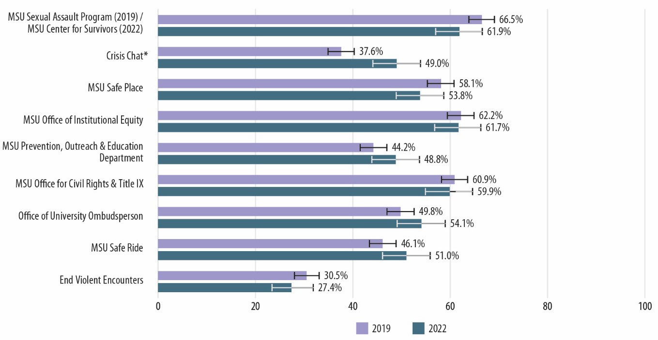Figure 74. Comparison of Graduate/Professional Women’s Awareness of Various MSU Offices and Resources During 2019–2020 and 2021–2022 Academic Years
Note: * Statistically significant at p < 0.05. For an accessible version of the information shown in this figure, see Appendix Table G-9c.

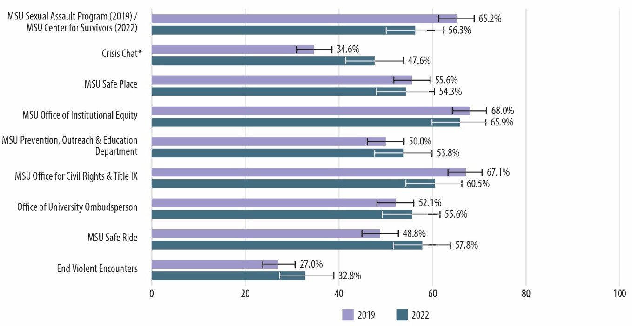Figure 75. Comparison of Graduate/Professional Men’s Awareness of Various MSU Offices and Resources During 2019–2020 and 2021–2022 Academic Years
Note: * Statistically significant at p < 0.05. For an accessible version of the information shown in this figure, see Appendix Table G-9d.

Figures 76 and 77 compare the percentage of faculty women and men, respectively, who were “very aware” or “somewhat aware” of various offices or resources that are charged with helping address RVSM at MSU. In 2022, both groups seem to be less aware of the MSU Sexual Assault Program (2019)/MSU Center for Survivors (2022). Faculty women became more aware of the MSU Office for Civil Rights & Title IX, and faculty men became less aware of the MSU Prevention, Outreach & Education Department.

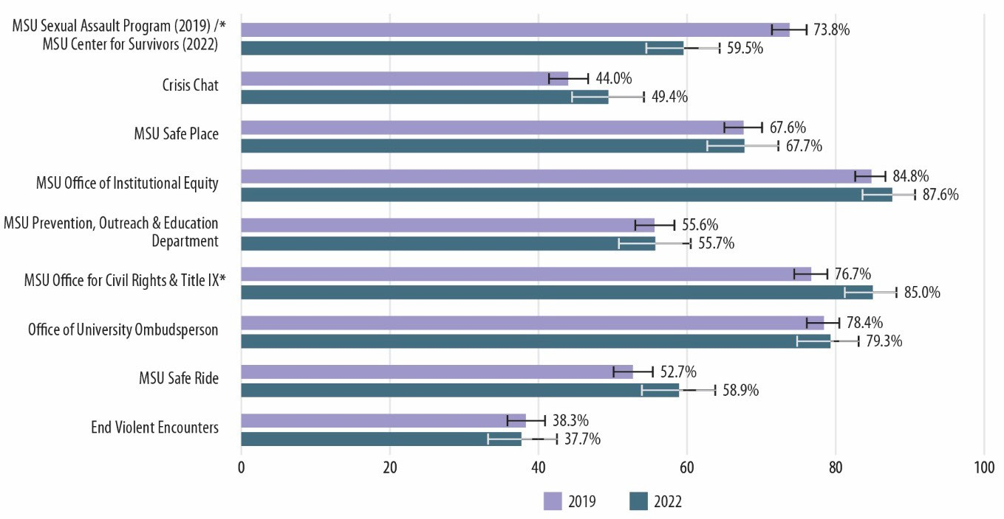Figure 76. Comparison of Faculty Women’s Awareness of Various MSU Offices and Resources During 2019–2020 and 2021–2022 Academic Years
Note: * Statistically significant at p < 0.05. For an accessible version of the information shown in this figure, see Appendix Table G-9e.

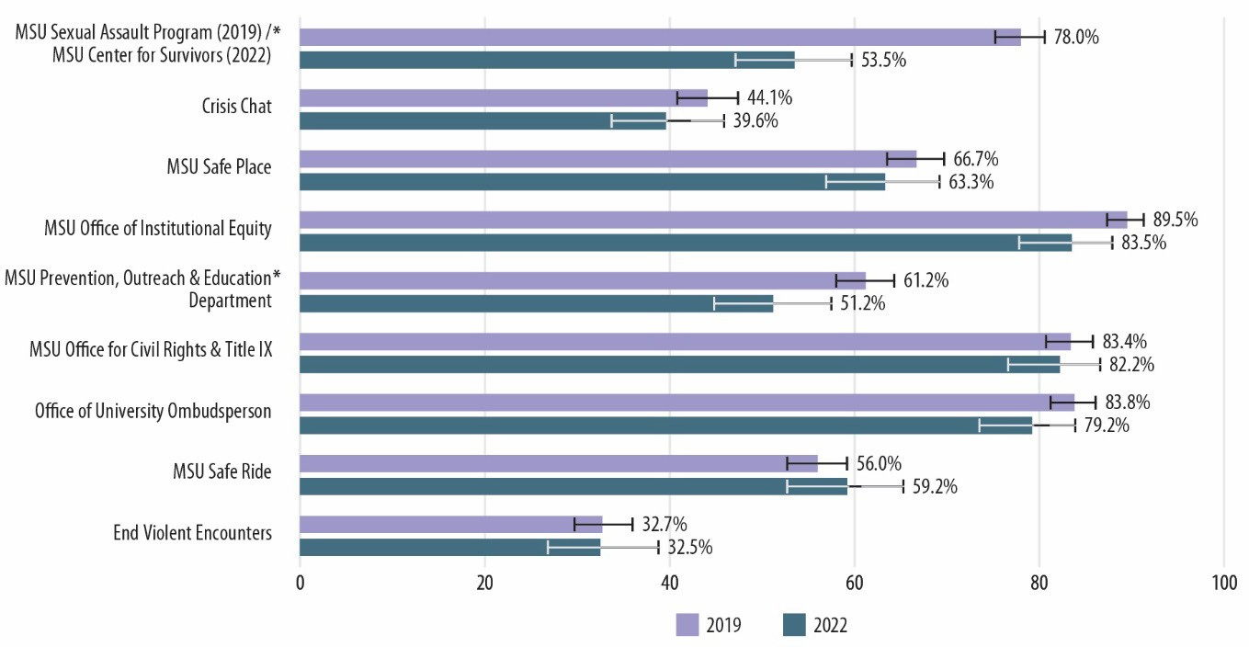Figure 77. Comparison of Faculty Men’s Awareness of Various MSU Offices and Resources During 2019–2020 and 2021–2022 Academic Years
Note: * Statistically significant at p < 0.05. For an accessible version of the information shown in this figure, see Appendix Table G-9f.

Figures 78 and 79 compare the percentage of staff women and men, respectively, who were “very aware” or “somewhat aware” of various offices or resources that are charged with helping address RVSM at MSU. In 2022, staff women indicated less awareness of the MSU Sexual Assault Program (2019)/MSU Center for Survivors (2022), no change in their awareness of MSU Safe Place, and more awareness of the remaining offices and resources. Staff men conveyed being less aware of the MSU Sexual Assault Program (2019)/MSU Center for Survivors (2022) and more aware of MSU Safe Ride.

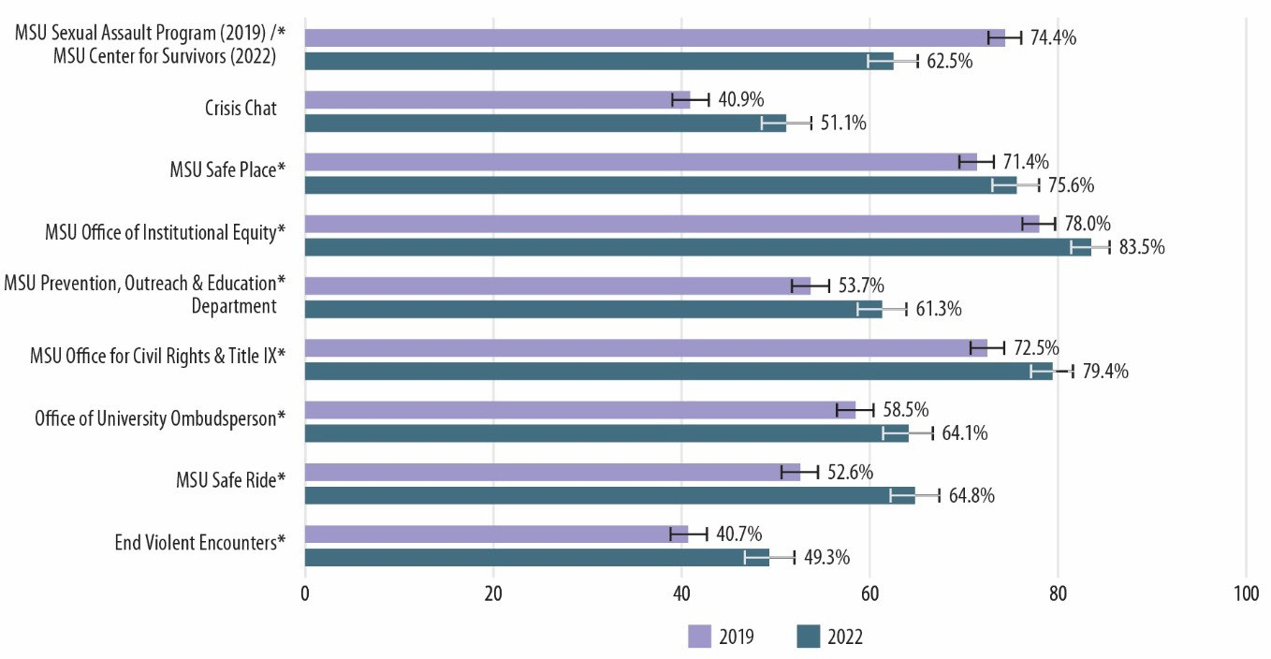Figure 78. Comparison of Staff Women’s Awareness of Various MSU Offices and Resources During 2019–2020 and 2021–2022 Academic Years
Note: * Statistically significant at p < 0.05. For an accessible version of the information shown in this figure, see Appendix Table G-9g.

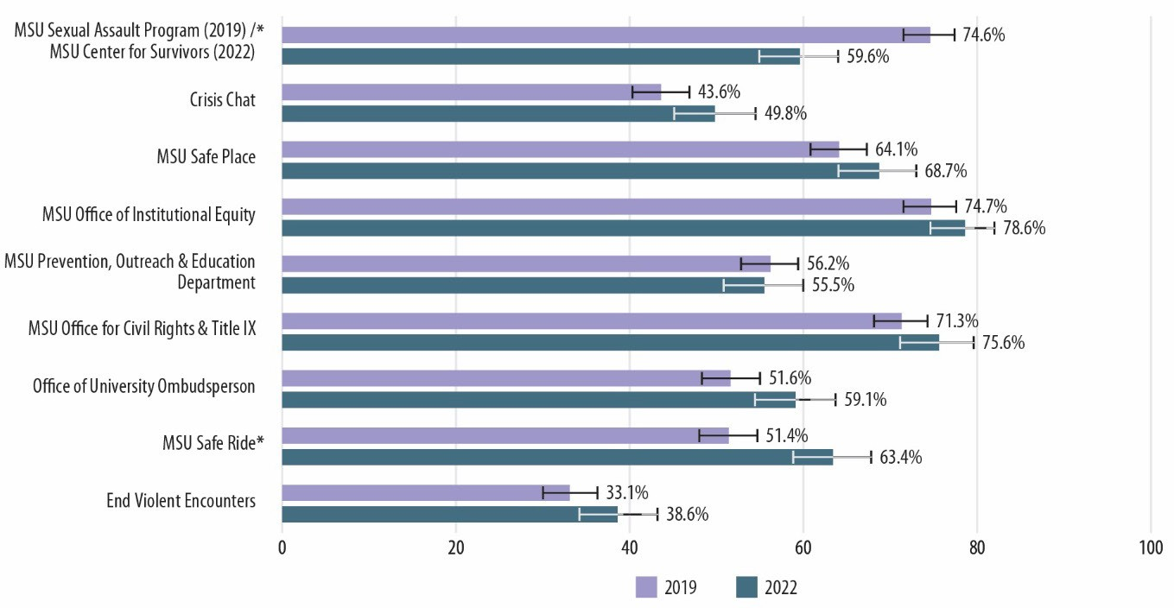Figure 79. Comparison of Staff Men’s Awareness of Various MSU Offices and Resources During 2019–2020 and 2021–2022 Academic Years
Note: * Statistically significant at p < 0.05. For an accessible version of the information shown in this figure, see Appendix Table G-9h.

Figure 80 compares the percentage of undergraduate women who indicated receiving training on various topics in 2019 and 2022. The eight training programs or topics asked about are as follows:

- Definitions of sexual assault and harassment
- Definition of "consent" and how it is obtained
- MSU's RVSM policy
- How to report RVSM
- Who on campus is required to report sexual misconduct to campus authorities
- Services for survivors of sexual assault
- Other strategies for preventing sexual assault
- Bystander intervention

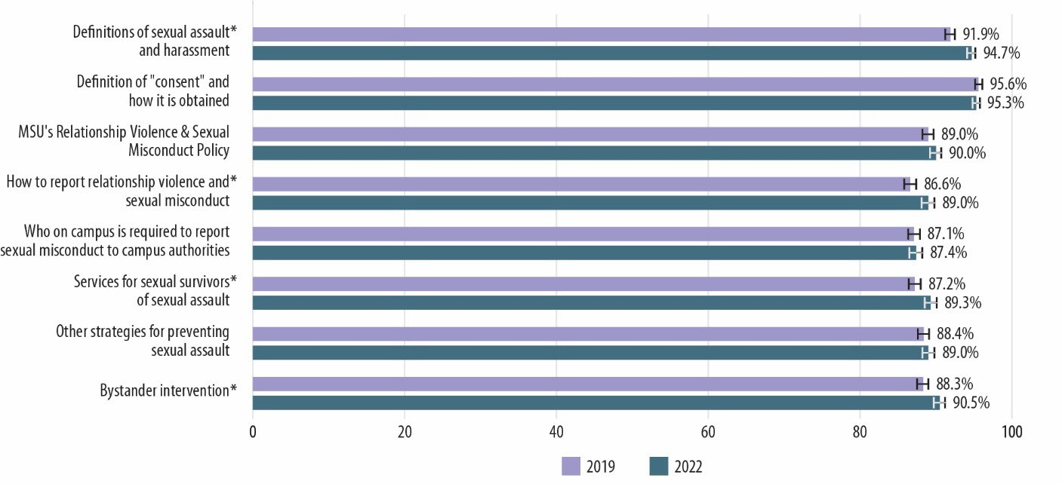Figure 80. Comparison of the Percentage of Undergraduate Women Who Received Training on Various Topics During 2019–2020 and 2021–2022 Academic Years
Note: * Statistically significant at p < 0.05. For an accessible version of the information shown in this figure, see Appendix Table G-10a.

In 2022, more undergraduate women indicated receiving training on definitions of sexual assault and harassment, how to report RVSM, services for survivors of sexual assault, and bystander intervention than in 2019.
No significant changes in the receipt of training from 2019 to 2022 are indicated for undergraduate men (Figure 81).
Figures 82 and 83 compare the percentage of graduate/professional women and men students, respectively, who indicated receiving training on various topics in 2019 and 2022. In 2022, more graduate/professional women students indicated receiving training in services for survivors of sexual assault and in other strategies for preventing sexual assault, and both graduate/professional women and men students indicated an increase in the rate of receiving training on bystander intervention.

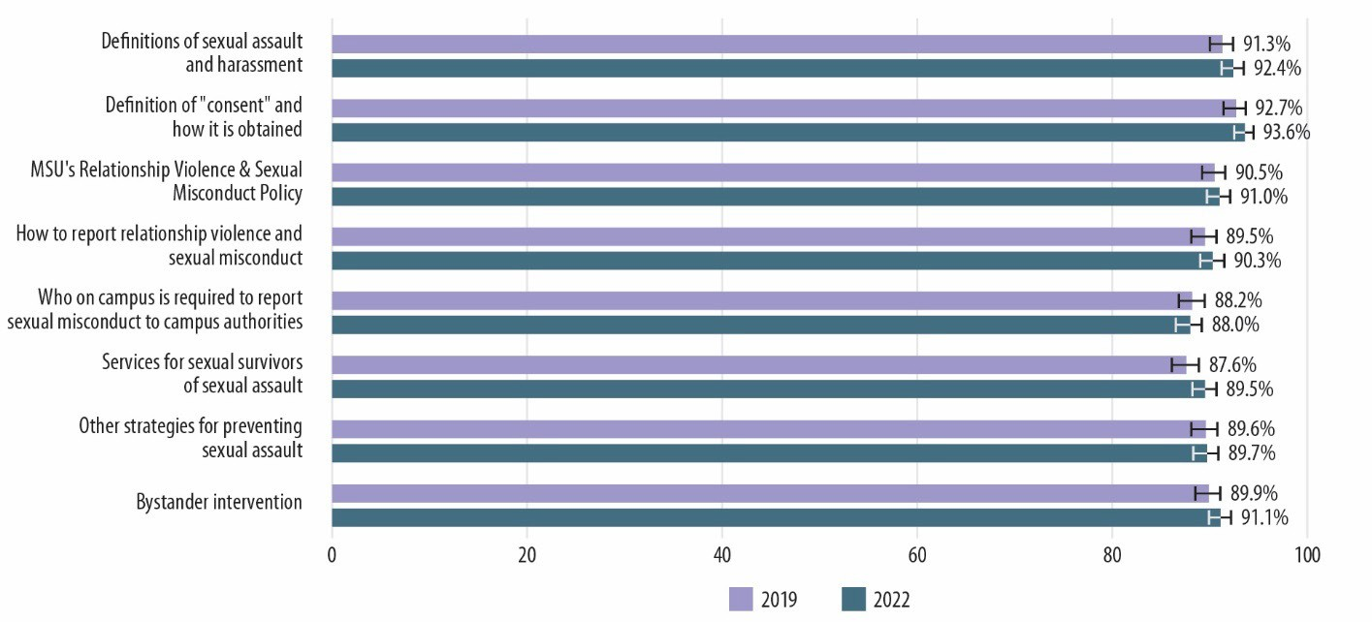Figure 81. Comparison of the Percentage of Undergraduate Men Who Received Training on Various Topics During 2019–2020 and 2021–2022 Academic Years
Note: For an accessible version of the information shown in this figure, see Appendix Table G-10b.

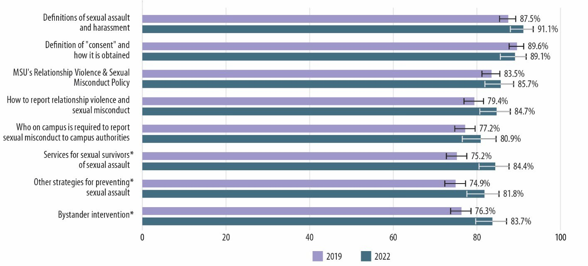Figure 82. Comparison of the Percentage of Graduate/Professional Women Who Received Training on Various Topics During 2019–2020 and 2021–2022 Academic Years
Note: * Statistically significant at p < 0.05. For an accessible version of the information shown in this figure, see Appendix Table G-10c.

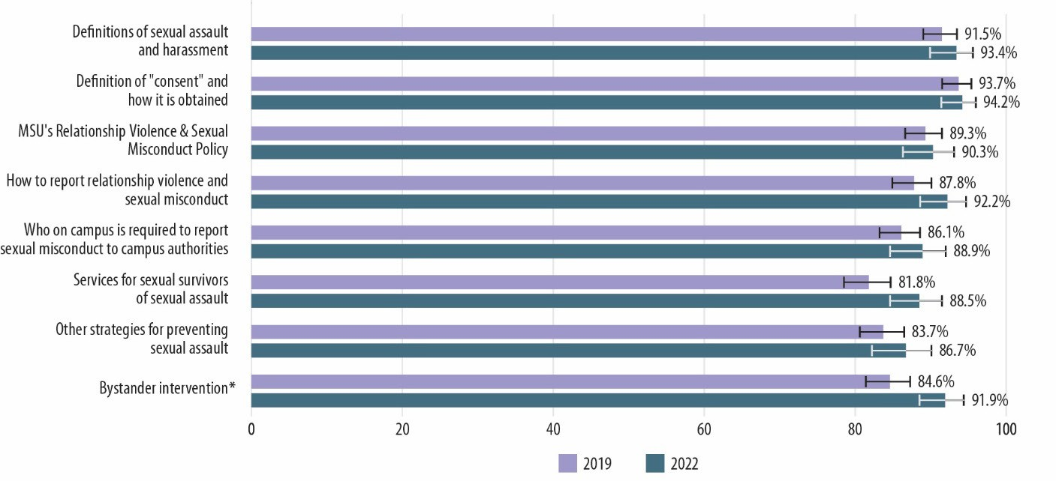Figure 83. Comparison of the Percentage of Graduate/Professional Men Who Received Training on Various Topics During 2019–2020 and 2021–2022 Academic Years
Note: * Statistically significant at p < 0.05. For an accessible version of the information shown in this figure, see Appendix Table G-10d.

Faculty and staff were asked about receiving training on seven training programs or topics (i.e., faculty and staff were not asked about bystander intervention training). Figure 84 compares the percentage of women faculty who indicated receiving training on various topics in 2019 and 2022. In 2022, there was no change in the proportion of women faculty who received training on the definitions of sexual assault and harassment; however, women faculty indicated increases in the receipt of training in the six remaining training programs/topics. No changes in the receipt of training from 2019 to 2022 are indicated for faculty men (Figure 85).

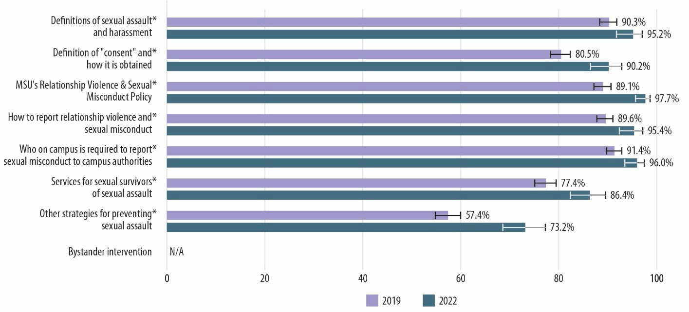Figure 84. Comparison of the Percentage of Faculty Women Who Received Training on Various Topics During 2019–2020 and 2021–2022 Academic Years
Note: * Statistically significant at p < 0.05. For an accessible version of the information shown in this figure, see Appendix Table G-10e.

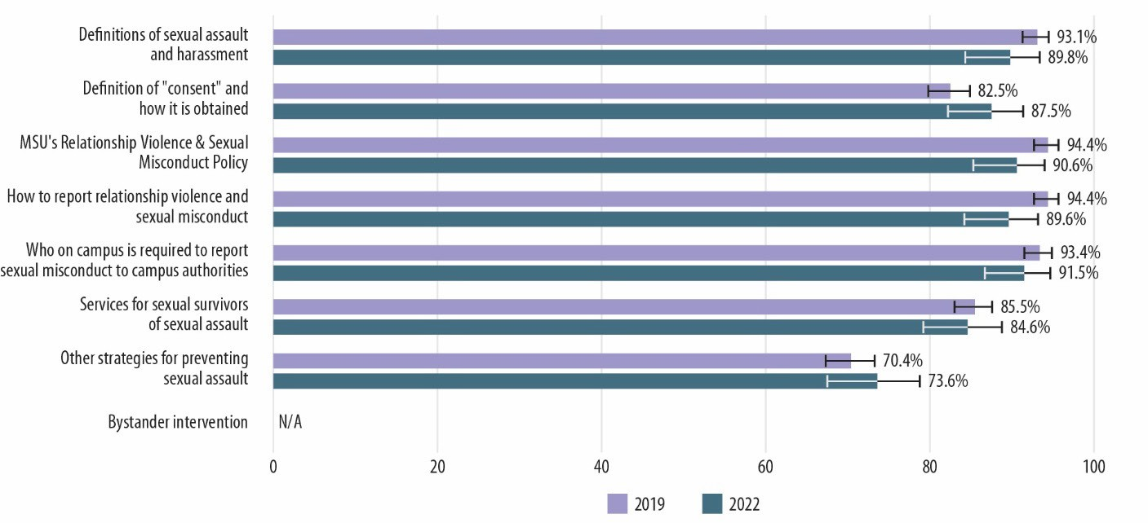Figure 85. Comparison of the Percentage of Faculty Men Who Received Training on Various Topics During 2019–2020 and 2021–2022 Academic Years
Note: For an accessible version of the information shown in this figure, see Appendix Table G-10f.

Staff women indicated increases in receipt of training from 2019 to 2022 on all seven programs/topics (Figure 86), and staff men indicated increases in receipt of training from 2019 to 2022 (Figure 87) on the following four programs/topics: MSU's RVSM policy, how to report RVSM, services for survivors of sexual assault, and other strategies for preventing sexual assault.

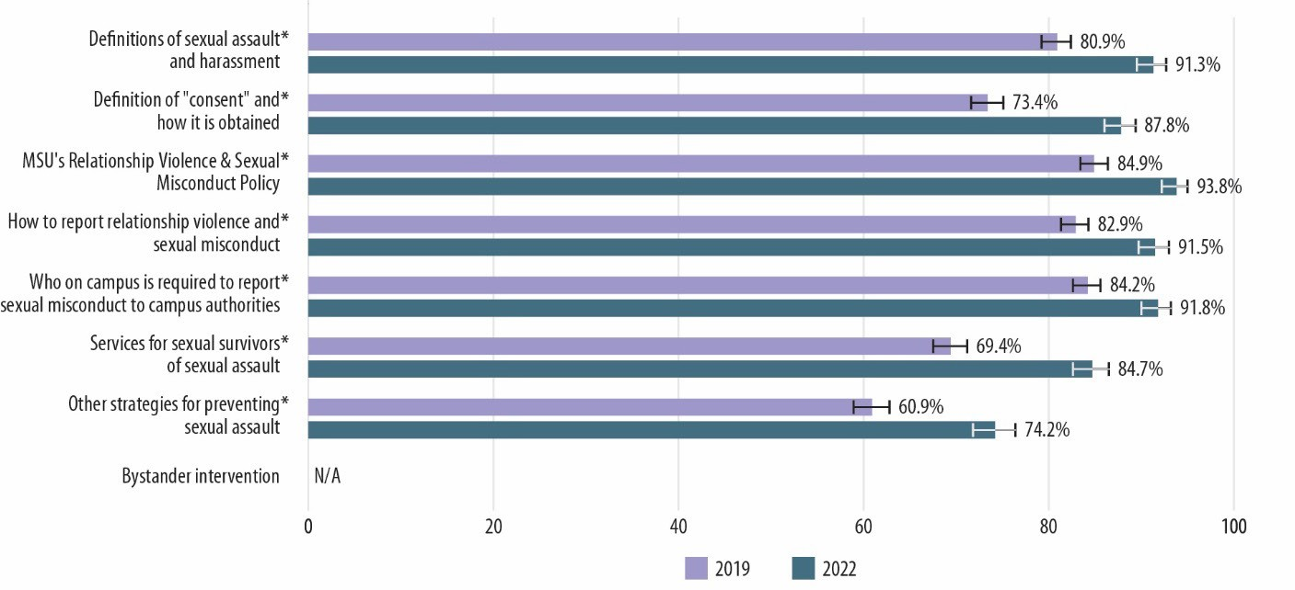Figure 86. Comparison of the Percentage of Staff Women Who Received Training on Various Topics During 2019–2020 and 2021–2022 Academic Years
Note: * Statistically significant at p < 0.05. For an accessible version of the information shown in this figure, see Appendix Table G-10g.

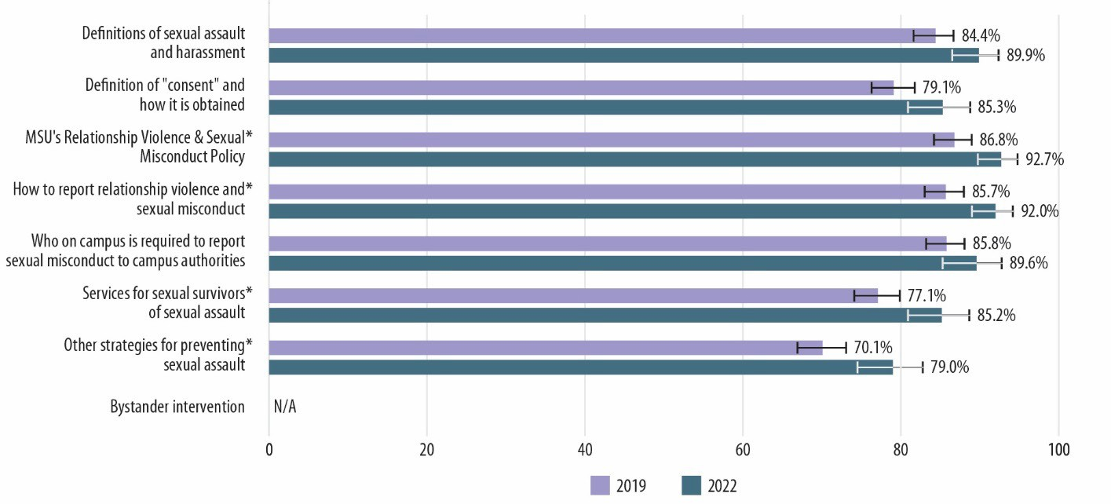Figure 87. Comparison of the Percentage of Staff Men Who Received Training on Various Topics During 2019–2020 and 2021–2022 Academic Years
Note: * Statistically significant at p < 0.05. For an accessible version of the information shown in this figure, see Appendix Table G-10h.

Figures 88 and 89 compare the percentage of undergraduate women and men, respectively, who participated in specific MSU training programs in 2019 and 2022. The four specific training programs asked about are as follows:
- SARV Prevention Program
- Greeks Take the Lead

- Bystander Network
- Online training about RVSM

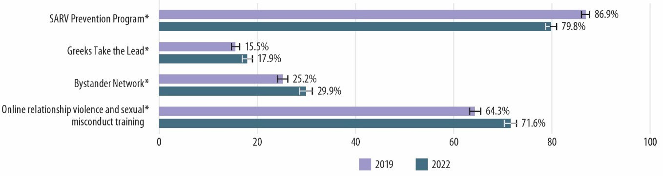Figure 88. Comparison of the Percentage of Undergraduate Women Who Received Specific Trainings During 2019–2020 and 2021–2022 Academic Years
Note: * Statistically significant at p < 0.05. For an accessible version of the information shown in this figure, see Appendix Table G-11a.

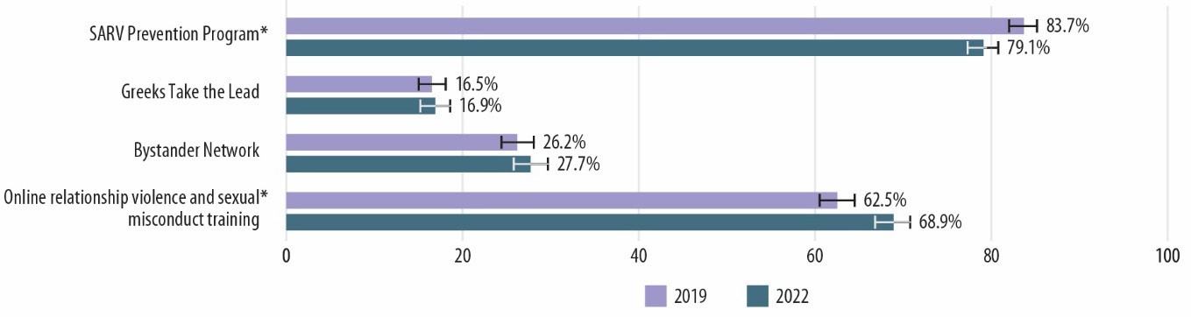Figure 89. Comparison of the Percentage of Undergraduate Men Who Received Specific Trainings During 2019–2020 and 2021–2022 Academic Years
Note: * Statistically significant at p < 0.05. For an accessible version of the information shown in this figure, see Appendix Table G-11b.

In 2022, undergraduate women and men indicated a decrease in participation in the SARV Prevention Program and an increase in participation in the online training about RVSM.38 Undergraduate women also indicated an increase in participation in Greeks Take the Lead and Bystander Network.
Figures 90 and 91 compare the percentage of graduate/professional women and men students, respectively, who participated in MSU training programs in 2019 and 2022. The training programs asked about are as follows:
- Online training about RVSM
- In-person training on MSU's RVSM policy

38 It should be noted, however, that in response to COVID multiple trainings were transitioned from being in person to being live but online via Zoom. For this reason, any indications that participation in some in-person trainings decreased and that online training increased should be interpreted with caution, as the online trainings may still have been given live but also online via Zoom.

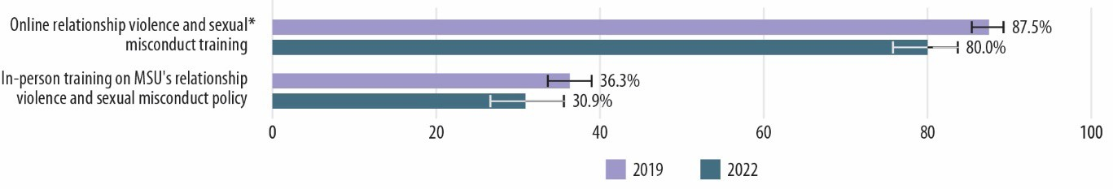Figure 90. Comparison of the Percentage of Graduate/Professional Women Who Received Trainings During 2019–2020 and 2021–2022 Academic Years
Note: * Statistically significant at p < 0.05. For an accessible version of the information shown in this figure, see Appendix Table G-12a.

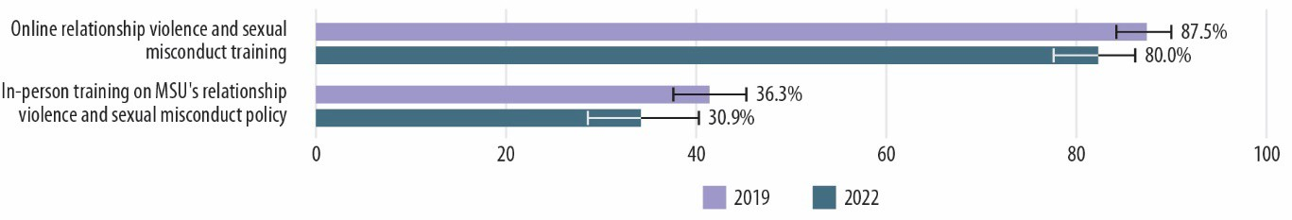Figure 91. Comparison of the Percentage of Graduate/Professional Men Who Received Trainings During 2019–2020 and 2021–2022 Academic Years
Note: For an accessible version of the information shown in this figure, see Appendix Table G-12b.

In 2022, the only significant change is that graduate/professional women students indicated a decrease in participation in the online training about RVSM.
Figures 92 through 95 compare the percentage of faculty women, faculty men, staff women, and staff men, respectively, who participated in MSU training programs in 2019 and 2022. The training programs asked about are as follows:
- Online training about RVSM
- In-person training on MSU's RVSM policy
- Other in-person training

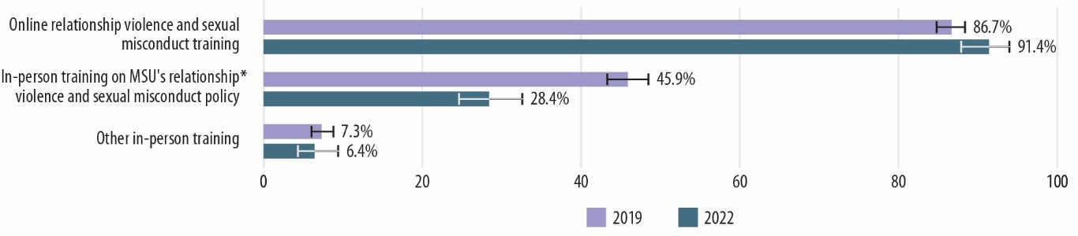Figure 92. Comparison of the Percentage of Faculty Women Who Received Trainings During 2019–2020 and 2021–2022 Academic Years
Note: * Statistically significant at p < 0.05. For an accessible version of the information shown in this figure, see Appendix Table G-13a.

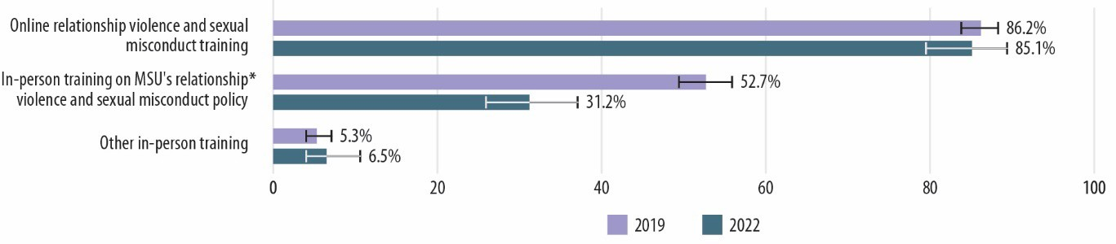Figure 93. Comparison of the Percentage of Faculty Men Who Received Trainings During 2019– 2020 and 2021–2022 Academic Years
Note: * Statistically significant at p < 0.05. For an accessible version of the information shown in this figure, see Appendix Table G-13b.

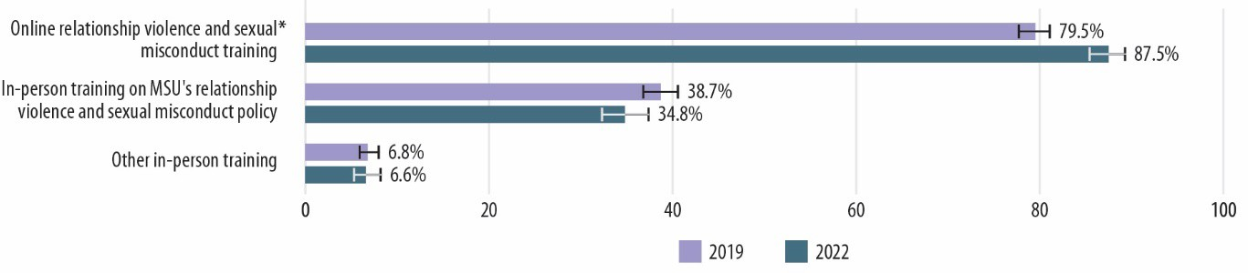Figure 94. Comparison of the Percentage of Staff Women Who Received Trainings During 2019– 2020 and 2021–2022 Academic Years
Note: * Statistically significant at p < 0.05. For an accessible version of the information shown in this figure, see Appendix Table G-13c.

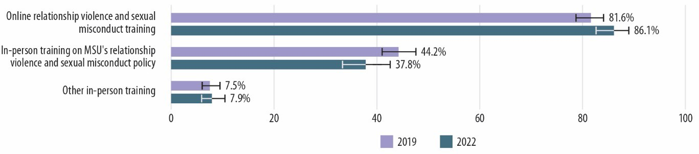Figure 95. Comparison of the Percentage of Staff Men Who Received Trainings During 2019–2020 and 2021–2022 Academic Years
For an accessible version of the information shown in this figure, see Appendix Table G-13d.

In 2022, faculty women and men indicated a decrease in participation in the in-person training on MSU's RVSM policy, and staff women indicated an increase in participation in the online training about RVSM. As noted in Chapter 4, this change might have been due to the conversion of multiple in-person trainings to live, online trainings via Zoom because of COVID.
This chapter includes many comparisons between the 2019 and 2022 Know More @ MSU Campus Survey results; however, many more comparisons are possible. For example, a reader who is interested in making more specific comparisons for particular groups can do so by using data and results in this report and comparing them to comparable data and results in the 2019 Know More @ MSU

Campus Survey Final Report39 and the accompanying appendices.40 For example, by reviewing the 2019 report and the associated and linked appendix tables, it is clear that 72.3% of undergraduate women who were involved in Greek life experienced sexual harassment during the 2018–2019 academic year, and the 95% confidence interval on that prevalence estimate ranges from 69.6% to 74.8%. By reviewing this report (2022) and the associated and linked appendix tables, we know that 64.3% of undergraduate women who were involved in Greek life experienced sexual harassment during the 2021–2022 academic year, and the 95% confidence interval on that prevalence estimate ranges from 61.0% to 67.5%. Since the 2019 and 2022 confidence intervals on the sexual harassment prevalence estimates being compared do not overlap, it can be concluded that undergraduate women who were involved in Greek life were less likely to experience sexual harassment during the 2021–2022 academic year than during the 2018–2019 academic year.
Overall, quite a few significant changes occurred from 2019 to 2022 at MSU, as indicated by statistically significant differences in the 2019 and 2022 Know More @ MSU Campus Survey results. Both undergraduate and graduate/professional students experienced a decrease in the prevalence of multiple types of victimization. Similarly, MSU faculty and staff experienced decreases in the prevalence of workplace incivility and workplace sexual harassment. In addition, from 2019 to 2022, a number of improvements occurred in terms of the climate or culture on campus, and there were considerable increases in awareness of offices and resources charged with addressing RVSM at MSU and in the participation in related trainings. The one area in which change was not detected was in the prevalence of disclosing victimization experiences to different groups, such as roommates, friends, and family; any MSU or off-campus office/organization; an MSU office; or an off-campus organization.

39 Lindquist, C., Krebs, C., Witwer, A., Berzofsky, M., Lee, P., Zimmermann, S., & Smith, A. (2019, November).
Findings from the KNOW MORE@MSU campus climate survey. Michigan State University. https://civilrights.msu.edu/_assets/documents/MSUreport.pdf
40 Lindquist, C., Krebs, C., Witwer, A., Berzofsky, M., Lee, P., Zimmermann, S., & Smith, A. (2019, November).
Findings from the KNOW MORE@MSU campus climate survey: Appendices. Michigan State University. https://civilrights.msu.edu/_assets/documents/MSUreportApps.pdf

Conclusions
Data from the 2022 Know More @ MSU Campus Survey provide a breadth of information that the MSU community can use to enhance its RVSM policies, prevention programming, and services to survivors, as well as to target specific areas of the campus climate and culture for potential improvements. In addition, comparisons between the 2019 and 2022 results enable MSU to document whether and how things have changed in the past 3 years. The results in Chapter 5 indicate that the prevalence of several types of victimization has decreased, most measures of climate and culture have improved, and awareness of various trainings and policies has increased. As noted previously, the time period covered by the 2022 survey includes times in which university operations were affected by the COVID-19 pandemic. We are unable to identify exactly how these unprecedented conditions may have influenced the results of this survey, though we do believe it is important contextual information.
The 2022 survey identified multiple strengths, including high awareness of MSU-specific resources and programs related to RVSM. Certain aspects of climate, particularly trust in the upper administration at MSU, remain relatively low and likely need sustained effort to improve—but results on this measure have improved since 2019. Additional research focused on cisgender women faculty; cisgender women graduate and professional students; cisgender women undergraduates; and transgender and/or nonbinary students, faculty, and staff may be necessary to understand the perceptions and experiences of these members of the MSU community, who provided the lowest campus climate ratings, and to identify and address areas in need of improvement.
A positive note is that the survey demonstrated fairly good reach and awareness of MSU’s training efforts about RVSM, showing that sizeable proportions of students, faculty, and staff have been trained in many key topics and recalled participating in MSU-specific programs. However, survey results also suggest that some improvements in the school’s training efforts are warranted, particularly more interactive approaches (or other improvements to increasing the utility of the online training) and efforts to ensure that all members of the MSU community engage with and remember completing required training.
The survey was also useful in documenting the extent and nature of numerous forms of RVSM that MSU undergraduate, graduate, and professional students experienced. Sexual harassment was quite prevalent among all student populations; the high rates suggest the need for prevention programming targeting the specific behaviors that students experienced with some frequency. It is important to note, however, that the prevalence of sexual harassment has declined significantly since 2019. Rates of sexual assault, student disclosure, and help-seeking from an MSU office or resource in the aftermath of a sexual assault incident have not changed significantly since 2019; however, the rates of disclosure at MSU, especially for rape incidents, were already fairly high compared to those at other universities. Generally, higher rates of disclosure are considered a good sign because they indicate that more survivors are reaching out, learning about their options, and getting connected to other services. MSU, therefore, has the opportunity to directly support many of the MSU students who experience sexual assault in a given year (in contrast to schools with very low rates of student disclosure to a school office, where the vast majority of incidents never come to the school’s attention). Rape incidents clearly affected survivors in

Findings from the Know More @ MSU Campus Survey November 2022
97

many ways, which suggests an important role for MSU offices and programs in supporting students to mitigate some of the negative impacts of these incidents. On the other hand, with fairly high disclosure rates, the resources and response protocols must be in place to ensure that MSU’s responses to survivors are appropriate and beneficial. The majority of survivors perceived that the support they received from MSU was helpful, but faculty and staff identified a number of needed improvements, including more timeliness and transparency/information sharing during investigations, more consistency in the application of policies, and more counseling resources for students.
Among faculty and staff, workplace incivility was fairly common (the majority of all faculty and staff had experienced at least some workplace incivility; cisgender women faculty and staff indicated experiencing more incivility than cisgender men), but the prevalence of workplace incivility has decreased significantly since 2019. Work-related sexual harassment was fairly common as well, but the prevalence of sexual harassment has also declined since 2019. The rates of workplace incivility and work-related sexual harassment are consistent with comments made by faculty and staff in the open-ended responses (the need for a holistic effort to address gender and racial discrimination and create a more inclusive, respectful environment at MSU), but the significant decreases in the prevalence of these behaviors indicate that things are moving in the right direction at MSU.
Finally, the disproportionate victimization of students, faculty, and staff who have a documented or diagnosed disability and/or who are gay, lesbian, bisexual, pansexual, or queer suggests the potential need for additional or new prevention programming to help these subgroups, along with efforts to ensure that MSU’s support services and survivor responses are tailored and appropriate. Similarly, the experiences of transgender and/or nonbinary students, faculty, and staff merit further attention to ensure that responses provided by MSU offices and programs are appropriate.
MSU will be delving into and using the findings presented in this report to inform its effort to continually improve the MSU campus; MSU’s related policies and procedures; and the environment and culture for all students, faculty, staff, and visitors. The MSU community has faced challenges related to RVSM, and the 2019 and 2022 Know More @ MSU Campus Survey efforts are informing MSU’s RVSM Strategic Plan and its related initiatives, which include expanding trauma-informed services; building a trauma-informed culture; strengthening RVSM policy violation, sanction, and discipline processes; assessing resources and support for respondents; strengthening RVSM prevention programming; creating respectful work environments; and promoting accountability. Those interested in tracking progress on the strategic plan can monitor this dashboard. The 2019 and 2022 Know More @ MSU Campus Survey efforts reflect MSU’s interest in transparency and recognition of the importance of collecting and using valid data as a means of assessing progress toward our ambitious and laudable mission to improve MSU for everyone.

Findings from the Know More @ MSU Campus Survey November 2022
98

