Approval of Agenda and Minutes
The Michigan State University Faculty Senate held a meeting on Tuesday, November 21, 2023 at 3:15 p.m. via Zoom with Chairperson Jack Lipton presiding. The agenda was approved as presented. The draft minutes of the October 17, 2023 and October 26, 2023 meetings were approved as presented.
Remarks
Interim Provost Thomas D. Jeitschko and Chairperson Lipton gave remarks.
Alcohol-Related Incidents at 2023 MSU Home Football Games
Vice President and Chief Safety Officer Marlon C. Lynch gave a presentation on statistics regarding alcohol-related incidents at the 2023 MSU home football games since the sale of alcohol at Spartan Stadium began in September.
Creation of PA Medicine Department in the College of Osteopathic Medicine
Interim Provost Jeitschko introduced a proposal to create the Department of Physician Assistant Medicine within the College of Osteopathic Medicine. The Faculty Senate approved the creation of the department by unanimous consent.
Adjournment
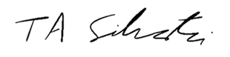
The meeting adjourned at 4:02 p.m.
___________________
Tyler Silvestri
Secretary for Academic Governance
Approved:

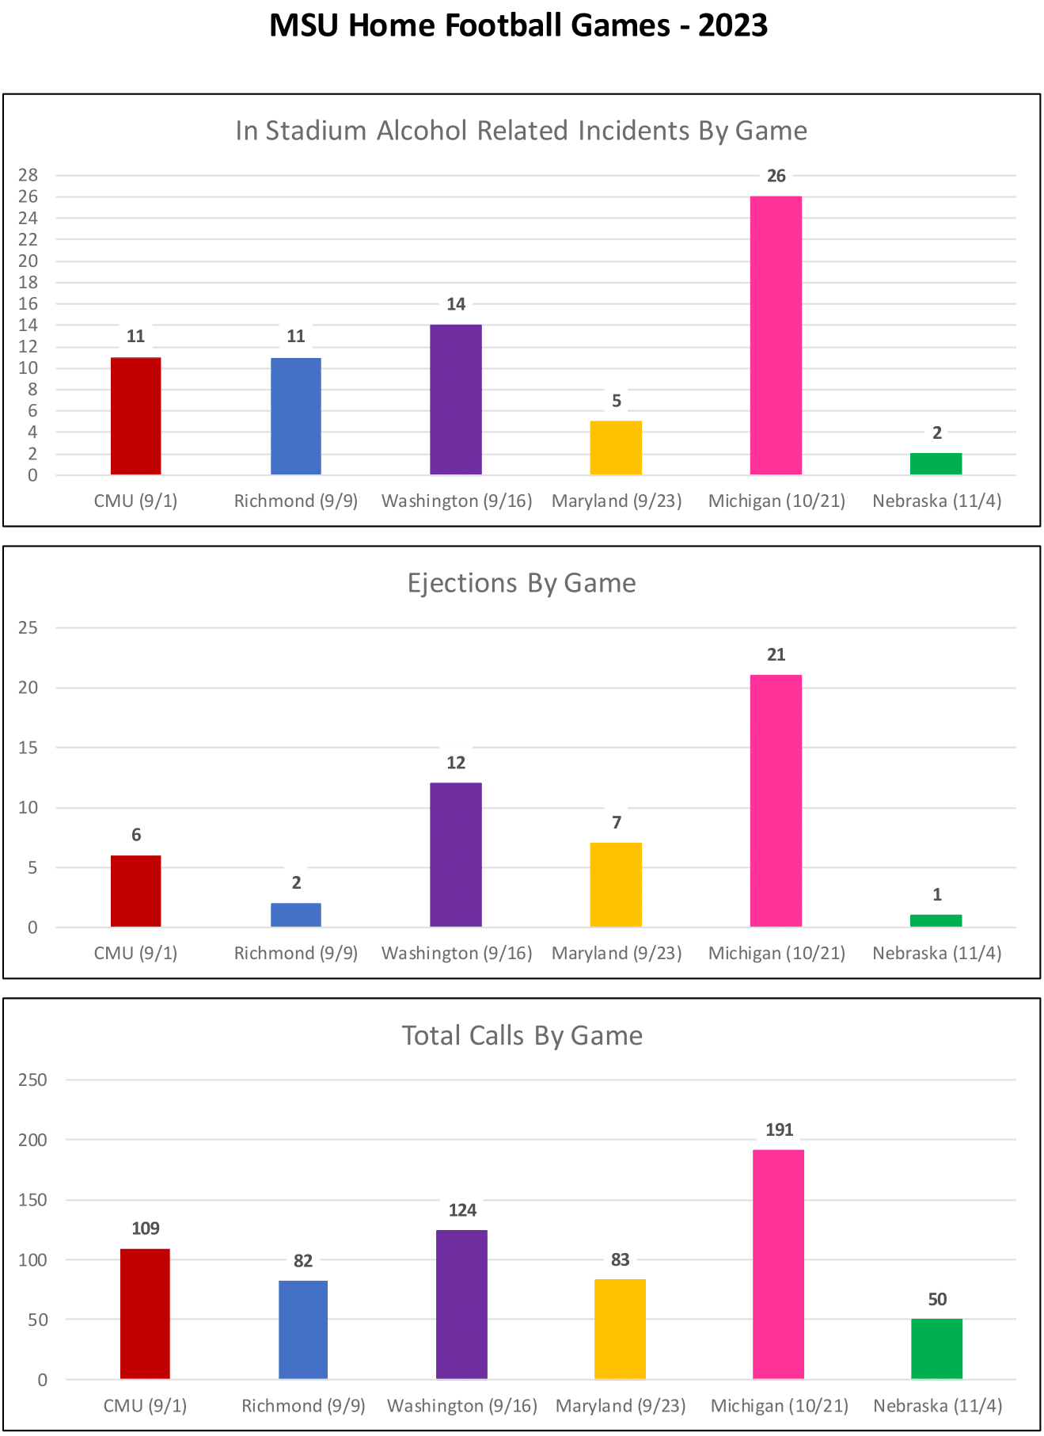
Attendance
Present | 66
Absent | 14
Total | 80
Quorum | 41

Constituency/Title | Name | Attendance
Academic Specialist Advisory Committee | Kelly Hodges | Present
Agriculture and Natural Resources | Cimberly Weir | Present
Agriculture and Natural Resources | Jeff Swada | Present
Agriculture and Natural Resources | Lorraine Weatherspoon | Present
Agriculture and Natural Resources | Matt Raven | Present
Agriculture and Natural Resources | Satish Joshi | Present
Arts and Letters | Danielle DeVoss | Present
Arts and Letters | Kate Birdsall | Present
Arts and Letters | Kristen Mapes | Present
Arts and Letters | Zach Kaiser | Present
Arts and Letters | Brahim Chakrani | Absent
Associated Students of Michigan State University | Alissa Hakim | Present
At Large | d'Ann de Simone | Present
At Large | Justin St. Charles | Present
At Large | Angela Wilson | Present
At Large, Chairperson | Jack Lipton | Present
At Large, Vice Chairperson | Rebecca Malouin | Present
Business | Ayalla Ruvio | Present
Business | Hanyong Park | Present
Business | John Spink | Present
Communication Arts and Sciences | Dan Hiaeshutter-Rice | Present
Communication Arts and Sciences | Rabindra "Robby" Ratan | Present
Communication Arts and Sciences | Alexandra Thrubis Stanley | Absent
Council of Graduate Students | Hannah Jeffery | Present
Education | Amelia Gotwals | Present
Education | Emre Umucu | Absent
Education | Matthew Pontifex | Absent
Emeriti Faculty | Gary Stone | Absent
Engineering | Andrew Mason | Present
Engineering | Chengcheng Fang | Present
Engineering | Mark Worden | Present
Engineering | Neil Wright | Present
Executive Vice President for Health Sciences | Norman Beauchamp | Absent
Faculty Grievance | Francisco Villarruel | Absent
FRIB | Chris Wrede | Present
Human Medicine | Claire Margerison | Present
Human Medicine | Cristian Meghea | Present
Human Medicine | Hua Xiao | Present
Human Medicine | Michael Williams | Present
Human Medicine | Scott Counts | Absent
Interim President | Teresa Woodruff | Absent
Interim Provost | Thomas Jeitschko | Present
James Madison | Daniel Ahlquist | Present
James Madison | Russell Lucas | Present
Law | Noga Morag-Levine | Present
Law | David Favre | Absent
Libraries | Kathleen Weessies | Present
Libraries | Tad Boehmer | Present
Lyman Briggs | Peter White | Present
Lyman Briggs | Samantha Cass | Present
Music | Jane Bunnell | Substitute:Cara Stroud
Music | Guy Yehuda | Present
Natural Science | Aaron Odom | Present
Natural Science | Brian Gulbransen | Present
Natural Science | Francois Greer | Present
Natural Science | Gustavo de los Campos | Absent
Natural Science | Min-Hao Kuo | Absent
Nursing | Chastity Warren | Present
Nursing | Gayle Lourens | Absent
Osteopathic Medicine | Amit Sachdev | Present
Osteopathic Medicine | Janice Schwartz | Present
Osteopathic Medicine | Jason Bazil | Present
RCAH | John Aerni-Flessner | Present
RCAH | Tama Hamilton-Wray | Present
Social Science | Guo Chen | Present
Social Science | James Dulebohn | Present
Social Science | Laurie Bulock | Present
Social Science | Raymond Jussaume | Present
Social Science | Zeenat Kotval-Karamchandani | Present
UCAG | Dean Rehberger | Present
UCC | Valeta Wensloff | Present
UCFA | Jamie Alan | Present
UCFT | Sue Barman | Present
UCGS | Trixie Smith | Present
UCL | Jackeline Iseler | Present
UCSLE | Jeffrey Tsang | Absent
UCUE | Antoinette Tesmmer | Present
Veterinary Medicine | Sean Crosson | Present
Veterinary Medicine | Stephan Carey | Present
Vice Provost for Undergraduate Education and Dean of Undergraduate Studies | Mark Largent | Present

A video of their remarks (and the rest of the meeting) can be found at https://mediaspace.msu.edu/media/Faculty+Senate+%7C+November+21%2C+2023/1_7e50fpy5.
Charts from the presentation are attached.

