August 24, 2020
Subject: Inclusion of Postdoctoral Association in Academic Governance

The Graduate
School

Office of Postdoctoral Affairs

W101 Owen Graduate Hall Michigan State University 735 East Shaw Lane
East Lansing, MI 48825

517-353-2425
Fax: 517-432-1054
postdocs.msu.edu
Dear colleagues and Steering Committee members,
We believe it is the right time to examine the possibility of formally acknowledging postdoctoral affairs in Academic Governance. The MSU Office of Postdoctoral Affairs will be celebrating its first year of establishment in October 2020. Predating its formation was an extensive history of postdoctoral support from the Graduate School, as well as the formation of an official Postdoctoral Association (MSU-PDA). The MSU- PDA represents over 600 postdocs employed under a variety of titles at MSU, is led by a steering committee made of postdocs volunteers, and abides by a set of bylaws established by the MSU-PDA. It was in large part through their efforts that the recent salary cut discussion was reexamined and changed by President Stanley, which led to national recognition and praise from the National Postdoctoral Association (NPA).
The NPA was established with the goal of fostering necessary improvements to the postdoctoral situation in the United States, and has developed a list of recommendations for postdoctoral policies and practices. Academic Governance can help MSU improve postdoctoral affairs by addressing two of these recommendations.
- Ensure postdoctoral scholar representation on relevant institutional committees: Postdoctoral scholars should be represented [. . .] on institutional committees that have operational or governance oversight of issues pertinent to the postdoctoral community.
- Establish a postdoctoral advisory committee: The postdoctoral office activities and postdoctoral policies should be directed by a Postdoctoral Advisory Committee. [. . .] Administrators from the postdoctoral office, human resources, grant management, international/diversity office, and most importantly postdoctoral scholars [. . .] should be included.
Thus, we formally request that the Steering Committee and the rest of Academic Governance consider developing a similar relationship with the MSU-PDA as they have established with the Council of Graduate Students, and acknowledge the MSU-PDA in its formal structure. Additionally, we formally request that Academic Governance consider creating a university-level standing committee dedicated to postdoctoral affairs. We would be pleased to provide you with a more extensive list of suggested potential revisions to the MSU Bylaws for Acadmic Governace at a later date, and thank you for your consideration in these matters.

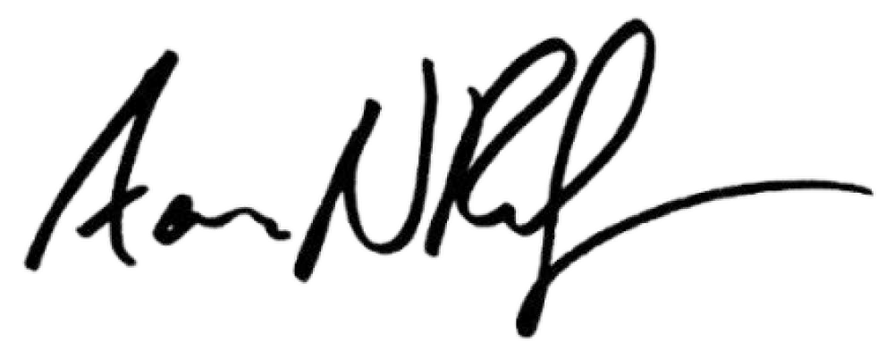
Cordially,

Aaron Reifler, Ph.D., M.Ed.
Director, Office of Postdoctoral Affairs
Christina Reppucci, Ph.D. Chair, MSU-PDA

