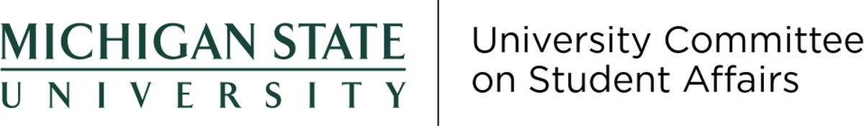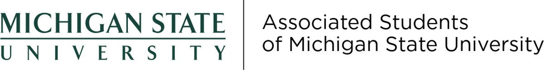

**Report to the Steering Committee | November 2, 2021**

**Actions Taken at Recent Meetings**

The Associated Students of Michigan State University held two full General Assembly meetings.

**October 7, 2021**

At the October 7, 2021 full General Assembly meeting, two presentations occurred. One from the Gender and Sexuality Campus Center and another from the University Ombudsperson. Three bills, one resolution, and a statement approval were passed:

•

•

•

[Bill 58-28](https://docs.google.com/document/d/1yyUa44-VoPc6valM4TUzEguNiT4eTp5e6JYVW31jwEQ/edit?usp=sharing), which appointed eight delegates to Academic Governance.

[Bill 58-29](https://docs.google.com/document/d/1okIiiqTfAB6PIEJ86fAimDli2EyskCIqSe-MTzr9ZSo/edit?usp=sharing), which appointed one member to the ASMSU Student Allocation Board. [Statement](https://drive.google.com/file/d/1qZjLWSsdi-hw8MtnAxTY8-SJzVaMJ7lT/view?usp=sharing), which was sent to Athletic Director Haller, President Stanley, and the Board of Trustees to communicate the needs of the Swim and Dive team.

[Bill 58-26](https://docs.google.com/document/d/1ywHfaQL8K0uyDItSoZllxDgw_CwoAm-qwYKVpms1JRM/edit?usp=sharing), which advocates that colleges reassess their credit amount requirements to address accessibility and flexibility.

[Bill 58-27](https://docs.google.com/document/d/1p2sg0GkAEhJTkGJAnOlswZp5aw5HRxNXflFEwJwJrDE/edit?usp=sharing), which was a resolution that recognized October 20 as International Day of Action Against Contract Cheating and reaffirms ASMSU’s support of the Spartan Code of Honor.

•

•

**October 21, 2021**

On the October 21, 2021 full General Assembly meeting one presentation occurred. Provost Woodruff addressed the changes to the Academic Calendar and took questions from the General Assembly. Three bills were passed:

•

[Bill 58-30](https://docs.google.com/document/d/13btTpFHwmDi6TO_yb13k5WjXxI3wBT1FrgeGHytNwEA/edit?usp=sharing), which allocated $1,352 from the General Fund towards Central Staff for First Generation Appreciation Week.

[Bill 58-31](https://docs.google.com/document/d/1G_Vq8CBMkTHjlG-o4eMuC1GwOX8ZJfqAsM6icuhZYNQ/edit?usp=sharing), which tasks ASMSU with the formation of an Internship Study ad-hoc Committee to evaluate undergraduate experience while pursuing or undergoing internship requirements.

[Bill 58-32](https://docs.google.com/document/d/1JU1hCpcVZq-P9o9oOsDzxokQtcoIurmIblqWkIrGKrI/edit?usp=sharing), which advocates that the College of Education exempt current seniors from the Global Experience Requirement during the 2021-22 AY due to the pandemic.

•

•

**Anticipated Items at Upcoming Meetings**

ASMSU is currently planning two awareness weeks for the month of November. Mental Health Awareness Week will be held the week of November 1. First Generation Appreciation Week will be held the week of November 8.

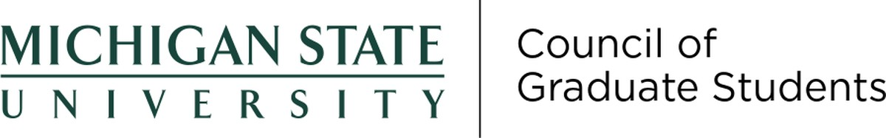

**Report to the Steering Committee | November 2, 2021**

**Actions Taken at Recent Meetings**

**October 20, 2021**

The Council of Graduate Students held its second Full Council Meeting on October 20th, 2021.

At the meeting, there were two external guest presentations. One was from Meg Moore, Director of Graduate Life and Wellness updating graduate student representatives on opportunities through that office, including various fitness and mental health related programs. The other was Sophie Walters from the Prevention, Outreach & Educations Department. Dr. Walters updated graduate student representatives on the resources in that department, as well as shared a document so representatives could add ideas for RVSM related events and trainings.

The Council of Graduate Students voted to approve its Spring Semester Meeting Dates, which are below:

•

•

•

•

January 19th, 2022

February 16th, 2022

March 16th, 2022

April 20th, 2022

The Full Council passed the following legislation:

•

•

•

[21-FS-04](https://cogs.msu.edu/wp-content/uploads/2021/10/21-FS-04-Resolution-to-Accept-Finance-Committee-Recommendations-for-Professional-Development-Award-Funding.pdf) which awarded eight students funds for Professional Development [21-FS-05](https://cogs.msu.edu/wp-content/uploads/2021/10/21-FS-05-Resolution-to-Accept-Finance-Committee-Recommendations-for-Conference-Award-Funding.pdf) which awarded six students funds for Conference Expenses

[21-FS-07](https://cogs.msu.edu/wp-content/uploads/2021/10/21-FS-07-A-Resolution-to-Support-the-WILD-Conference-2021.pdf) which awarded $1000 support for the planning of the *WILD*

Conference through Women Student Services

**Anticipated Items at Upcoming Meetings**

The Council expects to discuss in which format (online, in person, hybrid) to conduct Spring Semester Meetings at the next meeting. The next meeting will also include a Special Election for the Vice President of External Affairs, a position left vacant when Sara Hugentobler transitioned to the role of President.

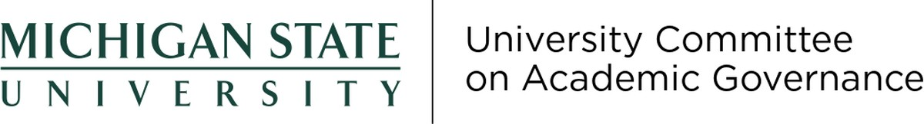

**Report to the Steering Committee | November 2, 2021**

**Actions Taken at Recent Meetings**

**October 7, 2021**

The University Committee on Academic Governance continued its review of proposed Athletic Council procedures and corresponding amendments to the *Bylaws for Academic Governance* and agreed to draft a letter to the Athletic Council and continue discussion at a later UCAG meeting.

The committee reviewed expectations and reporting processes for colleges’ bylaw reviews. UCAG agreed that it is preferable for college bylaws to explicitly state the requirements of the *Bylaws for Academic Governance* on certain issues instead of only including the requirements by reference.

**October 21, 2021**

The committee continued its review of Athletic Council procedures and corresponding amendments to the *Bylaws for Academic Governance*.

The committee nominated Holly Flynn and Dustin Petty to fill the vacancy on the Committee on Student Affairs created by d’Ann de Simone’s election as an at-large member of the Steering Committee. The term will expire on August 16, 2023. The nominees have been submitted to the secretary for academic governance for further action by Faculty Senate.

UCAG considered the process by which the All-University Awards Committee nominations would proceed.

The committee adopted bylaw review reports for the College of Law, the College of

Communication Arts and Sciences, and the College of Human Medicine.

**Anticipated Items at Upcoming Meetings**

The review of the remaining colleges’ bylaws is expected to continue at the November 18, 2021 meeting.

Consideration of whether the word “deans” includes acting deans in the *Bylaws for Academic Governance* is expected to be addressed at a future meeting.

All-University Awards Committee nominees are expected to be considered at a future meeting.

Consideration of the role of the executive vice president for health sciences in the

*Bylaws for Academic Governance* is expected to be continued at a future meeting.

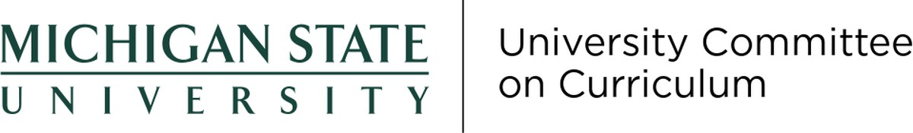

**Report to the Steering Committee | 11.02.21**

**Actions Taken at Recent Meetings**

*10.28.21*

•

•

•

Approved the following program request 0 new and 31 changes

With this we approved course requests 10 new, 45 changes, and 21 deletions.

The only moratorium is Judicial Administration, Graduate Specialization, UCGS consulted, and Provost approved Fall 2021 through Spring 2022

**Anticipated Items at Upcoming Meetings**

The committee is planning to continue to review the curriculum changes from the colleges through the work of college curriculum committees, UCUE, and UCGS.

There is an item coming from Peach Corp looking for an undergraduate certificate program. How it will be operationalized/will it be transcriptable.

**Requested Support from the Steering Committee and/or the Office of Academic Governance**

The committee there are no request for the Steering Committee.

The committee there are no request for the Secretary for Academic Governance.

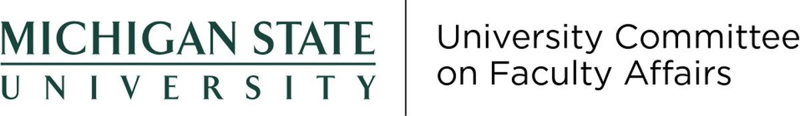

**Report to the Steering Committee | November 2, 2021**

**Actions Taken at Recent Meetings**

**October 12, 2021**

•

Discussion concerning COVID communications re: dorm surveillance, messaging to students and faculty including addition of a decision tree. Guests were Vice President and University Spokesperson Emily Guerrant, Senior Communications Manager Kelly Mazurkiewicz, and Jason Cody of University Communications and Blue Moon Consulting

Welcomed Senior Associate Provost Thomas Jeitschko as a replacement for David Byelich Re: budget and financial interactions

Seeking guidance concerning COVID impact statement on annual reports and tenure documents – Provost’s Office to respond

Report from Office of Inclusion and Intercultural Initiatives that a data analyst position has been added in response to a request and support from the Budget Subcommittee concerning information as it relates to hiring and financial support (initial and continuing) in relation to diversity, equity and inclusion.

Awarding Emeritus Status Policy revision – subcommittee established to focus on this issue. A response to UCFA currently being the final approval on Emeritus revocation.

•

•

•

•

*No meetings later in October.*

**Anticipated Items at Upcoming Meetings**

•

•

•

•

Update on 10-month versus 12-month pay issue (AcadGov 2021-12) Faculty Authored Works Policy – Provost’s Office

Code of Professional Standards and Behaviors – General Counsel’s Office

Office of Institutional Equity – filing of a non-finding in the personnel file of individuals found innocent of Title IX investigations.

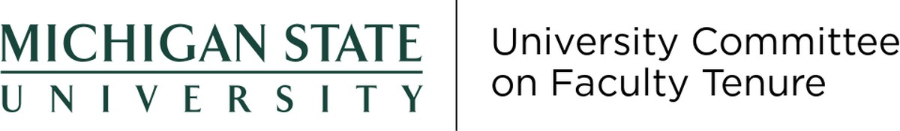

**Report to the Steering Committee | November 2, 2021**

**Actions Taken at Recent Meetings**

**September 29, 2021**

Cancelled due to lack of agenda items.

**October 13, 2021**

Cancelled due to lack of agenda items.

**Anticipated Items at Upcoming Meetings**

A review of the recommendations from the Task Force on Discipline Process and Sanction Review is expected at the November 17, 2021 meeting.

We expect to review requests for extension of the tenure clock at future meetings.

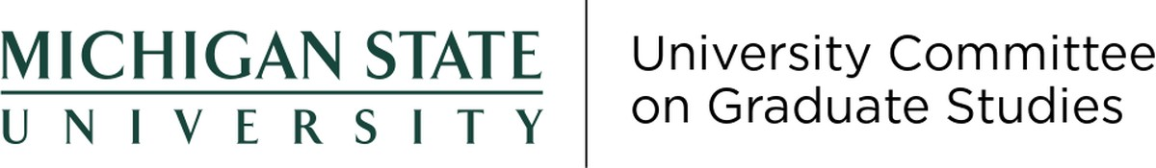

**Report to the Steering Committee | November 2, 2021**

**Actions Taken at Recent Meetings**

UCGS held its second meeting of the 2021–2022 Academic Year on:

**October 15, 2021**

•

Dean Jeitschko presented a charge to the committee to review the graduate academic dishonesty policies for graduate students. A taskforce of members from both the Academic Research Policy and Graduate Instruction subcommittees, which included both faculty and graduate students was formed. They will evaluate the current policies and present recommendations to the full committee by the end of the academic year.

Research Integrity Officer Jim Pivarnik presented the research integrity office annual report.

Fifteen program change requirements requests were approved, 1 moratorium (Graduate Specialization in Judicial Administration) and 1 phase out and discontinuation (Master of Arts in Teaching Mathematics) was approved, 3 new programs were approved (2 new masters of science degrees and 1 new graduate certificate).

•

•

**Anticipated Items at Upcoming Meetings**

The Academic Research Policy subcommittee will be conducting a review of the RIO this academic year. The Graduate Instruction and Employment and Mentoring Policy subcommittee will be reviewing the mentoring policy this year.

**Requested Support from the Steering Committee and/or the Office of Academic Governance**

The committee also requests guidance in identifying contact at IPPSR in regards to conduction of the evaluation of the research integrity officer at this time from the Secretary for Academic Governance so that the committee can proceed with the evaluation of the RIO.



**Report to the Steering Committee | November 2, 2021**

**Actions Taken at Recent Meetings**

**October 15, 2021**

The University Committee on Student Affairs met on the 15th of October 2021 at 8:30am virtually.

Provost Woodruff was invited to the committee to address concerns related to COVID- 19 and the work her office has been doing. Due to the short availability, we moved on to sending her our comments, questions, and suggestions via email after she addressed the committee.

Assistant Vice President for Student Affairs and Services Allyn Shaw and Dean Of Students Anthony Williams Jr. gave an update on the new Division of Student Life and Engagement, and helped understand the rationale behind the same. They mentioned in their reports that after the approval on the 29th of October, it would be a 18-month process divided into 4 phases before the implementation of the same.

There was an update from the Dean of Students office about the General Student Regulations as well as off–campus conduct and the work they have done so far.

The committee also decided to reschedule the next meeting to the 12th of November 2021 from 1:00pm to 2:30pm.

**Anticipated Items at Upcoming Meetings**

The committee expects to discuss the new division at its November 12th, 2021 meeting.



**Report to the Steering Committee | October 5, 2021**

**Actions Taken at Recent Meetings**

**The University Committee on Undergraduate Education (UCUE)** took the following actions at the October 7, 2021 meeting:

•

Approved request phase out and discontinue the Disciplinary Teaching Minor in Journalism available for secondary certification

Approved request to change the admission requirements for the minor in Real Estate

Approved request for a New Minor in Resource Management From the Individual, Family, and Societal Perspective.

•

•

UCUE had no policy items to consider for the meeting planned for October 21, 2021. Due to the lack of agenda items, the meeting was cancelled.

**Anticipated Items at Upcoming Meetings**

The UCUE is planning to discuss the following policy issues at upcoming meetings:

•

Code for Academic Advising and feedback on it that was solicited from ASMSU, Academic Advising Leads and the Academic Specialist Advising Committee.

Whether there should be a required diversity-focused Course for undergraduate students. A subcommittee is being formed to examine this and report to UCUE for further discussion.

Consider if MSU should adopt biannual registration. A subcommittee is being formed to examine this and report to UCUE for further consideration

•

•

The UCUE will consider curriculum requests at future meetings, which have yet to be sent to us.