Report to the Steering Committee | April 4, 2023

Actions Taken at Recent Meetings

March 15, 2023
- External Speakers: Dr. Teresa Woodruff (Interim President of Michigan State University) and representatives from the GSR and SRR Revision Committee
- Re-announcement of the credit/no credit option for graduate students
- Resolutions passed to provide funds to the annual Juneteenth celebration, the Chavez-Huerta celebration, and a tax webinar for international students.
- COGS Election Results:
- President: Hannah Jeffery
- Vice President of Internal Affairs: Clara Devota
- Vice President of External Affairs: Harkirat Kaur
- Treasurer: Miles Roberts
- Recording Secretary: Semiha Kevser Bali
- Executive reports
- Treasurer Roberts: Professional Development awards have reopened thanks to the generosity of the Graduate School
- Recording Secretary Amaniampong: The Graduate Academic Conference will take place in the Kellogg Conference Center on Apr. 29th

Anticipated Items at Upcoming Meetings
- External speakers: Trustee Kelly Tebay, representative from Culinary Services, and the Ombudsperson
- Welcoming of the new COGS Executive Board
- Discussion about the re-opening of the MSU Union
- Resolution to include campus/Nassar survivors on OIE hiring groups and RVSM working groups?

Report to the Steering Committee | April 4, 2023

Updates on Outstanding Items

Item 2021-08: Code of Professional Standards
We are gathering data.

Item 2223-14: Faculty Vacation Policy
This is related to Item 2021-08. Still in the data gathering stage.

2223-20: 9-Month and 12-Month Appointment System Supervisors
We are working with administration to find the best way to address the issues.

Item 2223-08: Course Fee Policy Change to Include Part Time Employees
This item needs a financial analysis, which is underway.

Item 2223-27: Interim Faculty Conflicts of Interest Policy
We are data gathering for this policy now.

Item 2223-25: Proposed CHM Departments
These were approved at the March 28, 2023 meeting.

Item 2223-21: Faculty Sick Leave Policy
This is related to item 2021-08. Still in the data gathering stage.

Anticipated Items at Upcoming Meetings
Review of the FGO and faculty raise memo.

Requested Support from the Steering Committee and/or the Office of Academic Governance
We need to add discussion of the faculty raise memo to the next faculty senate agenda.

Report to the Steering Committee | April 4, 2023

Actions Taken at Recent Meetings

March 20, 2023
We approved 6 requests related to graduate programs. We also discussed additional ways to support graduate and professional students in response to the campus violence on February 13. Although we did not vote on a motion, we discussed the importance of supporting graduate and professional students given their responsibilities both as students and as university employees (as research assistants and teaching assistants).

Updates on Outstanding Items

Item 2021-11: Replacement of SIRS
On March 4, the UCGS affirmed the institution-level questions and also offered a few additional thoughts on the 8 questions.

Item 2223-20: 9-Month and 12-Month Appointment System Supervisors
Our meeting in March was canceled and is currently being rescheduled.

Item 2223-27: Interim Faculty Conflicts of Interest Policy
The UCGS discussed this policy at our March 20 meeting. We have invited Dr. Gage and Dr. McCabe to attend our April 17 UCGS meeting to answer the committee's questions.

Item 2223-25: College of Human Medicine Departments
The UCGS discussed these departments at our March 20 meeting. We have invited Dean Sousa to attend our April 17 meeting to respond to the committee's questions.

Anticipated Items at Upcoming Meetings
We plan to discuss the draft Interim Faculty Conflicts of Interest Policy. We also plan to discuss the new departments in the College of Human Medicine.

Report to the Steering Committee | April 4, 2023
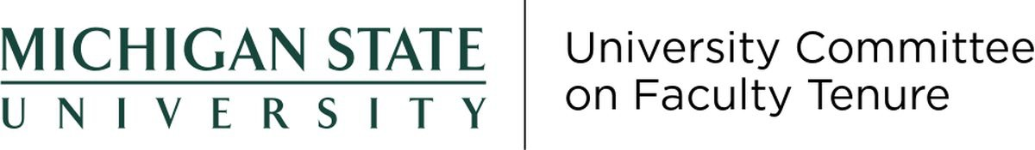

Actions Taken at Recent Meetings
The University Committee on Faculty Tenure did not hold any meetings in March.

Anticipated Items at Upcoming Meetings
Discuss tenure clock requests.

Report to the Steering Committee | April 4, 2023

Actions Taken at Recent Meetings

March 16, 2023
UCUE provided feedback to Interim Provost Jeitschko on guiding principles for interpretations of existing policies in view of the campus shooting and its aftermath.

Updates on Outstanding Items

Item 2223-10: Presence and Absence Policies
None to report

Item 2021-11: Replacement of SIRS
The committee is in the process of preparing 12 additional survey questions to serve as guidelines for Colleges.

Item 2223-18: Course Equivalency for Study Abroad
A first draft of proposed improvements to the existing process is being reviewed by the committee.

Anticipated Items at Upcoming Meetings
UCUE anticipates a final report by the sub-committee on Presence, Absence, and Short Leaves. UCUE anticipates a final report by the sub-committee on Course Equivalency for Semester Abroad Experiences.

