Note: This document was converted from a PDF by the Office of Academic Governance for accessibility purposes and may contain errors as a result of the conversion process.

October 20, 2023

Dear Colleagues:
As laid out in the State Constitution, the Michigan State University Board of Trustees is entrusted with the general supervision of the institution, including control and direction of all its expenditures and final authority over its governance. The Board delegates responsibility to the president, and through the president to other domain experts in University administration and the faculty, to create a strong and efficient organization to accomplish the University's objectives in education, discovery, and service for the people of Michigan.
As a proud MSU graduate and mother of a Spartan, I ran for a Trustee position knowing that I was coming here to do my utmost to ensure that this University could move forward from past traumas, and to restore MSU to its well-earned national and international reputation as a leader in higher education. The Board is no place for personal agendas, bullying, or vendettas against colleagues.
Since the election of Dr. Rema Vassar as chairperson-an election in which I was the deciding vote-the BOT has become more fractured, more contentious, and Dr. Vassar has developed a pattern of violating our codes of conduct, ethics, and conflict of interest, including engaging in repeated undue influence, and bullying of Board members and administrators.

We tried to manage this behind closed doors. However, it has only led to more bullying from Dr. Vassar and potentially harmful consequences for the University we have been entrusted to protect. According to Paragraph 8 of the MSU Board of Trustees Code of Ethics and Conduct, we must "support open communication, transparency, and the free expression of ideas and will not condone any form of deceit, incivility, intimidation, silencing, or retaliation." It is with that responsibility in mind that I am calling for Dr. Vassar to resign from the Board of Trustees. If she chooses not to do so, I call upon my fellow trustees to remove her as Chair and to refer her to the Governor for removal pursuant to MCL 168.293. I make this request based upon the examples listed below of Dr. Vassar acting outside of her authority as Chair and/or as··a Trustee and the examples of bullying and undue influence.

Examples of Dr. Vassar Acting Outside of Her Authority as Chair and/or as a Trustee

- In January 2023, Dr. Vassar attempted to negotiate a settlement with Sanjay Gupta in his lawsuit against the University without authority to do so from the interim president or members of the BOT. This included Vassar authorizing a statement as part of a potential settlement that the president and BOT had not seen and did not agree with. This occurred before the BOT was named in the lawsuit, and the BOT was not informed until after her efforts failed. The interim president communicated to the BOT that this interfered with the ability of the University to effectively engage in settlement negotiations. Dr. Vassar's actions were in violation of the Board of Trustees Code of Ethics and Conduct, Paragraph 7 (which provides in relevant part: "We will ... avoid involvement in administrative matters not subject to the direct authority of the Board") and Paragraph 9 (which provides in relevant part: "We will communicate through the President, Secretary of the Board of Trustees, or other administrator designated by the President when conducting official University business...").
- On March 31, 2023, Dr. Vassar unilaterally (without discussing with the BOT) released the Quinn Emanuel report against the advice of MSU's general counsel and the Quinn Emanuel attorneys, who recommended that release of the report be delayed after Gupta named the BOT in his lawsuit against the University. Dr. Vassar's actions were in violation of the Board of Trustees Code of Ethics and Conduct, Paragraph 5 (which provides in relevant part: "We will exercise responsible stewardship, uphold our fiduciary duties to the University and the State of Michigan, and ensure necessary and proper controls safeguarding public resources") and Paragraph 6 (which provides in relevant part: "We will ... not disclose nonpublic information, including privileged attorney/client communications, without proper authorization").
- In April 2023, Dr. Vassar contacted the Michigan Attorney General's office regarding documents related to the Larry Nassar case without prior discussion or authority to do so from the administration or the BOT and requested that the Attorney General send a letter to the BOT asking for the waiver of attorney client privilege related to those documents. See State News article, April 21, 2023 ("Michigan State University board chair Rema Vassar contacted the state's attorney general to tell her she had the votes to release thousands of long-withheld documents relating to the university's handling of disgraced ex-MSU doctor Larry Nassar. Attorney General Dana Nessel told The State News that Vassar asked her to send the recent letter re-affirming the demand for the documents' release in hopes of reopening the investigation, and that it would be voted on at the meeting Friday.") https://statenews.com/article/2023/04/nessel-msu­ board-chair-orchestrated-plan-to-release-nassar-documents-but-didnt-follow-through

Vassar's actions were in violation of the Board of Trustees Code of Ethics and Conduct, Paragraph 7, which provides in relevant part: "We will ... avoid involvement in administrative matters not subject to the direct authority of the Board."
This action further hurt MSU and resulted in the Board being sued per the State News Report in which Attorney General Dana Nessel told The State News she had "literally no idea" why Vassar changed her mind: "They requested this letter and said they needed it in order to be able to conduct a vote," Nessel said in April. "Then at the meeting there's not even a vote. It's bizarre. It's perplexing. I think it does a disservice to the survivor community as well as to the student body at Michigan State that, like us, has long awaited answers." Vassar's actions prompted survivors of Nassar's abuse to file a lawsuit against the board. https://statenews.com/article/2023/09/crying-lying­ crocodile-tears-nassar-survivors-skewer-msu-trustees-over-decision-to-withhold­ documents

- In spring 2023, Dr. Vassar authorized her photo with former trustee Brian Mosallam and his Spartan Wealth Management group, to be used in advertising on behalf of his private business which appeared in media across the state, including the Lansing State Journal. The caption reads "A Spartan's Greatest strength is the Warrior Standing Next to Him Her." The ad goes on to state, "Her leadership is what MSU needs as we usher in the 22nd President in the university's history. Spartan Wealth Management has over 2 billion reasons to stand with you". Dr. Vassar's appearance in an advertisement with MSU imagery and specifically referencing her position as the "Board of Trustees Chairwoman" is not consistent with our fiduciary responsibilities to the University pursuant to the Board of Trustees Code of Ethics and Conduct, Paragraph 3, which provides in relevant part: "We will avoid ... appearances of impropriety." This image appears to promote Spartan Wealth Management above other investment firms through a de facto endorsement by Dr. Vassar.

� lansingstatejournal.com

Q. Lansing State Journal
Advertisement

- In September 2023, Dr. Vassar engaged in a text exchange with former trustee Pat O'Keefe about the leaking of Brenda Tracy's name in connection with her claim against Mel Tucker. Dr. Vassar placed a "heart" on a text that engaged in victim­ blaming and minimizing the trauma to a claimant. The exchange also involved communications about plotting to remove interim president Teresa Woodruff and general counsel Brian Quinn. These sorts of communications with third parties about the removal of an interim president or general counsel are never appropriate for a chair of the BOT and are not consistent with the Board of Trustees Code of Ethics and Conduct which provides, in relevant part, that Trustees must "maintain and respect the confidentiality of University records and information, including personnel information." (Moreover, at no time has the BOT considered removing Woodruff or Quinn.) Even after the communications became public in an article by Deadspin, Dr. Vassar did not apologize or denounce them. See Deadspin article, October 12, 2023 ("Troubling texts between former, current MSU trustees shed new light on Mel Tucker sexual harassment allegations. The exchange, obtained by Deadspin, hint at victim blaming and a chance to use the scandal as an excuse to fire interim president

Teresa Woodruff.") https://deadspin.com/texts-michigan-state-university-trustees­ mel-tucker-1850921140
- On Sept. 11, 2023, the BOT learned that a specific member of the Board of Trustees was alleged to have leaked Brenda Tracy's name to two former trustees during the pending OIE investigation involving Mel Tucker. This prompted the need for the Administration and the Board of Trustees to request an investigation to determine if the allegation is true. The investigation will cost MSU thousands if not millions of dollars, with the likely result being inconclusive, in part because Dr. Vassar has not yet allowed a forensic review of her cell phone to potentially rule her out as being the source of the leak.
- In the aftermath of the horrific mass shooting on Feb. 13, 2023, Dr. Vassar overstepped her role as Chair and Trustee, as documented by the independent external After-Action Review by the firm Security Risk Management Consultants. When the BOT received a preliminary overview of the findings from SRMC before they were released to the public, Dr. Vassar inappropriately suggested to the firm consultants during their briefing to the BOT that they might consider revising the finding that she and the three other trustees who were involved had acted outside of their authority. Specifically, SRMC found: "Board of Trustees members desperately wanted to help and became involved in the incident beyond their expertise and outside of their appropriate role." The firm ultimately produced a watered-down finding regarding those trustees' involvement, but still concluded: "Our takeaway based on multiple interviews is that the Board of Trustees members wanted to help but became involved in the incident beyond the customary role and expectations of a governance board during an emergency."
- On at least two occasions, Dr. Vassar has traveled on university business via a MSU donor's private jet with Mel Tucker and donors (ex.: MSU Men's Basketball game against Rutgers at Madison Square Gardens). Per the Board of Trustees Code of Ethics and Conduct, Paragraph 4, Trustees are not allowed to accept special benefits or anything of value for themselves or others in consideration of their duties as a Trustee. If accepting a flight, Trustees should pay fair market value for it. In addition, the BOT Conflict of Interest Policy states that Trustees will endeavor to remain free from the influence of, or the appearance of, any conflicting interest in fulfilling their Board duties, and no Trustee will solicit or accept any gift, loan, or other thing of value, or the promise thereof in the future, from anyone outside the University which would tend to influence improperly the manner in which the Trustee performs his/her duties. Therefore, even if the Trustee asserts that this gift will not influence their decision-making, it has the appearance of doing so and could implicitly influence the

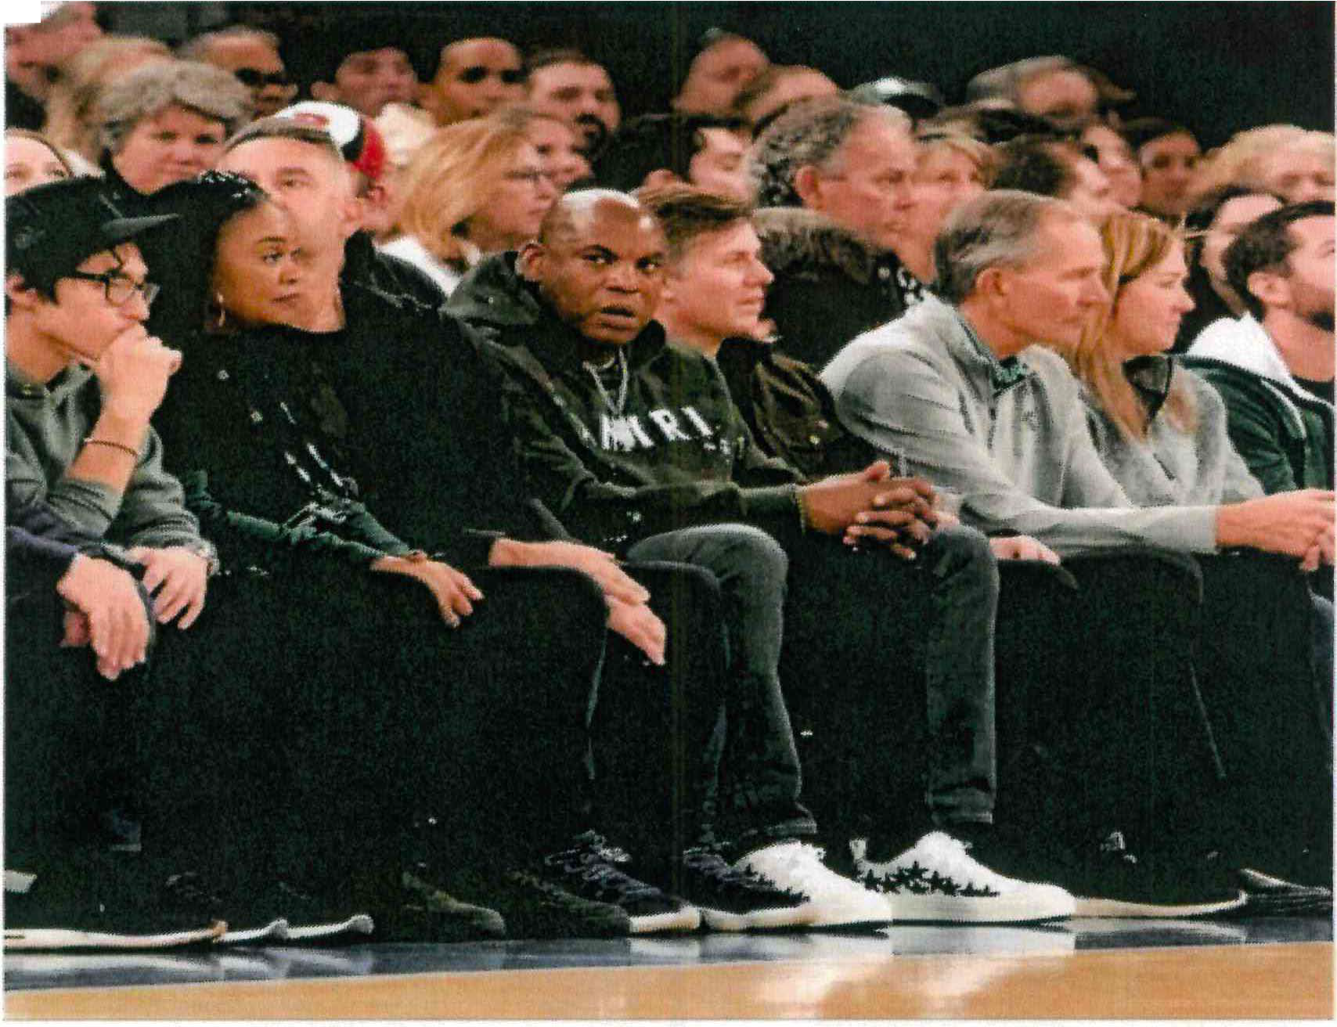
decision-making. If the flight is to an MSU event, there is an even greater appearance of influence in public duties.

- The Board of Trustees Code of Ethics and Conduct, Paragraph 10, which provides in relevant part that we "will not condone any form of deceit, incivility, intimidation, silencing, or retaliation." Since becoming Chair, Dr. Vassar has bullied Interim President Teresa Woodruff on multiple occasions and has usurped her authority. In fact, she has gone so far as to admonish Interim President Woodruff about speaking independently with other Trustees, advising her that she was only to speak with Dr. Vassar. Further, she has requested Interim President Woodruff's speaking schedule and demands to be allowed to speak as well at those engagements. There are other examples of this behavior exhibited by Dr. Vassar on a regular basis - from holding meetings and discussing Board action without the knowledge or participation of the interim president, inserting herself into events handled by the president without invitation, and demanding University-sponsored events be delayed until she arrives. Specific examples include multiple meetings with Lansing officials to pitch moving university colleges and students to a Lansing site and delaying the Student Leaders Reception program for 90-minutes due to her late arrival.

- During the September 2023 Public Board Meeting, Trustees were called by Dr. Vassar to come to the Administration Building early so that she could attempt to convince Trustees not to approve amendments to the Bylaws which would change the term of the Board Chairs to one year on an alternating basis beginning in January 2025. She proceeded to threaten BOT members that she would call them racist and specifically told me that I needed to "read a book" and that if we did not side with her the BOT

would regret voting in support of a Bylaws amendment to change the process for selection of the chair. The reform was proposed in 2019, even before Vassar was a member of the Board. Her baseless claims of racism harmed the university. See Lansing State Journal article, September 8, 2023 "Michigan State board chair suggests bylaw change targets her because of race."https://www.lansingstatejournal.com/story/news/local/2023/09/08/rema-vassar­ race-:michigan-state-trustees-bylaw-change/70798428007/
Also, during that meeting, questions were raised by trustees about whether Dr. Vassar's flights on private planes and sitting in floor seats at a Madison Square Garden game while on university business violated the Board of Trustees Conflicts of Interest Policy or Code of Conduct. When it was suggested that the policy or code might require paying fair market value for these benefits, Dr. Vassar refused.

This has been a difficult statement to write. I have been threatened by Dr. Vassar that speaking out against her decisions would result in her turning the Black community against me - and I myself am a Black woman. I have also been warned that speaking out will cause unwanted attention to the Board of Trustees and will harm the university and interfere with our current Presidential Search. But of the many values I've developed as a Black person, as a woman, and as a Spartan, chief among them is standing up for what's right and what is in the best interest of the university I love so dearly.
Similarly, some might contend that in sharing the multitude of incidents regarding Dr. Vassar's conduct, I am violating the very Board of Trustees Code of Ethics and Conduct I repeatedly cite in this statement. However, as a Trustee and as an attorney, I must weigh the harm of sharing these internal issues against the standards of transparency we are tasked with upholding. If I must choose one, then I choose the latter.

Sincerely,
Brianna T. Scott
Trustee, Michigan State University

