May 25, 2022

MEMORANDUM

TO: The Steering Committee of Academic Governance

FROM: Teresa K. Woodruff, Provost and Executive Vice President of Academic Affairs

RE: Name change of Department of Writing, Rhetoric, and American Cultures

I am requesting the advice of Academic Governance on the proposed name change of the Department of Writing, Rhetoric, and American Cultures (WRAC) to the “Department of Writing, Rhetoric, and Cultures (WRaC).”

OFFICE OF THE

PROVOST

Michigan State University Hannah Administration Building 426 Auditorium Road, Room 430 East Lansing, Michigan 48824

Phone: 517-355-6550
Fax: 517-355-9601
provost.msu.edu

The proposed name change has been carefully considered by the Department and College, and is endorsed by Dean Chris Long. Background and rationale are provided on the attached materials from Interim Chairperson, Dànielle Nicole DeVoss, and Dean Long, which also notate unanimous support from the College Advisory Council.

Your advice is appreciated as I make my recommendation to President Stanley, who in turn will make a recommendation to the Board of Trustees.

Attachments

MSU is an affirmative-action, equal-opportunity employer.

To: Teresa Woodruff, Provost and Executive Vice President for Academic Affairs

From: Christopher P. Long, Dean

Re: Department of Writing, Rhetoric, and American Cultures Name Change Proposal

Date: May 15, 2022

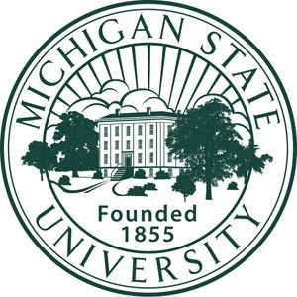
The College of Arts & Letters at Michigan State University requests a Department name change from the current Department of Writing, Rhetoric, and American Cultures (WRAC) to the Department of Writing, Rhetoric, and Cultures (WRaC). This unit contains the First Year Writing Program as well as programs in Professional and Public Writing (PPW) and Experience Architecture (XA) and graduate programs in Rhetoric and Writing. The attached proposal describes the challenges associated with the current name and the rationale for the new name. Upon the recommendation of the Department Advisory Committee, the Department faculty voted unanimously for the new name in April 2021. The Department Interim Chairperson Dànielle DeVoss brought the proposal before the College Advisory Committee (CAC) at its November 4, 2021 meeting. After a brief discussion, the CAC voted unanimously to endorse the proposed name change.

College of Arts & Letters

Office of the Dean

Christopher P. Long
Dean

479 West Circle Drive
320 Linton Hall East Lansing, MI 48824

517-355-4597
Fax: 517-355-0159
www.cal.msu.edu
A primary drawback of the current name of Writing, Rhetoric, and American Cultures is that it limits what has become a translingual and transcultural approach to rhetorical analysis in the department. The department name itself dates back to the last name change from American Thought and Language in 2003, when it was believed that the department would create an American Studies program along with its additional writing and rhetorics focus. This plan never truly materialized and the department went less in the direction of cultural studies and rather toward cultural rhetorics through PPW and technical writing, digital humanities, and design in the highly successful XA program. “American” has also since become both limiting and vague given its apparent focus either solely on US or the multiple Americas in the western hemisphere. As is argued in the proposal, the department now takes a much more global focus. Its students and faculty are more diverse themselves and work in various inter- and multi-national rhetoric studies. The term “cultures” rather than “American cultures” creates room for other rhetorics such as African and African American Rhetorics, Asian Rhetorics, and Latinx Rhetorics.

Recent department faculty successes include the NSF grant Growing Convergence Research. A Convergent Discipline in Socio-Technological System Transitions–Research on Michigan Community & Anishinaabe Renewable Energy Sovereignty (2019-2024). The department houses two major Andrew W. Mellon grants, including a Presidential Grant – “Archivo de

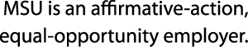

Respuestas Emergencias de Puerto Rico” (AREPR) and a Mellon-funded Just Futures Initiative “Creativity in the Time of COVID-19: Art as a Tool for Combating Inequity and Injustice” that is a project that explores how everyday people are using creativity to cope with the pandemic. It houses the research group Writing, Information and Digital Experience (WIDE) as well as The Cube: Publishing Process Praxis, a publishing space that supports a range of research-related activities anchored by a commitment to community and equity. The Cube currently supports a monthly magazine, a literary quarterly, several scholarly journals, a community of feminist filmmakers, a collaborative fandom, book and monograph production, web design, and experiential learning. Faculty have won recent awards for their books and projects.

Our request for the name change advances one of the central priorities of the University to recruit and retain a diverse faculty whose backgrounds, knowledge, and experiences allow us to offer a truly transformative learning experience for undergraduate and graduate students. Moreover, the College of Arts & Letters remains committed to practice inclusion as a matter of institutional habit. It is essential that all scholarly and pedagogical approaches in a department are reflected in a unit’s name so that their faculty and students feel that both they and their work are visible and valued. The shortened and more inclusive Writing, Rhetoric, and Cultures (WRaC) does just this.

It remains our commitment as a leading critical land-grant University to make education accessible to a wide diversity of citizen scholars, and through this education, to advance knowledge that will redress the most intractable challenges of our time. Today more than ever, these challenges require us to understand the complex roles that language and writing play in shaping our basic perceptions of the world and intercommunication with each other. The College thus endorses and supports those who do this important work in a newly named Department of Writing, Rhetoric, and Cultures.

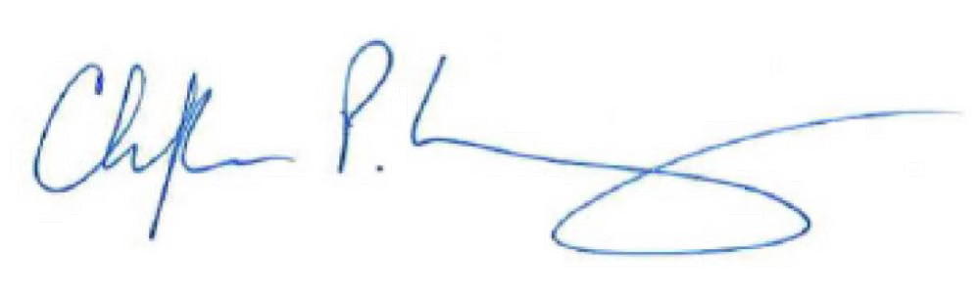
Sincerely,

Christopher P. Long, Dean

September 17, 2021

To: Chris Long, Dean College of Arts & Letters

From: Dànielle Nicole DeVoss, Interim Chair Writing, Rhetoric, and American Cultures

re: department name change request

During AY 2020–2021, an ad hoc subcommittee of our department Advisory Council met to discuss issues of equity and justice in the department. (This ad hoc committee has been established, per department vote and a bylaws revision, as a standing department committee.)

One of the subcommittee’s recommendations was to change the name of the department to Writing, Rhetoric, and Cultures (WRaC).

COLLEGE OF

ARTS & LETTERS

WRAC: Department of Writing, Rhetoric, and American Cultures

Michigan State University 434 Farm Lane, Rm 235
East Lansing, MI 48824-1033
517/355-2400
FAX: 517/353-5250
wrac.msu.edu

MSU is an equal-opportunity institution.
The subcommittee presented a compelling case for the removal of “American” from our department name, arguing that the inclusion of “American”:

- is a vestige of when the department last changed names (from American Thought and Language in 2003; at that time, the department anticipated the development and launch of an undergraduate program in American Studies that would be housed in Writing, Rhetoric, and American Cultures);

- is limiting and exclusive, and negates the variety of inter- and multinational writing studies and rhetoric work students and faculty engage in our department; and

- is a prohibition to our cultural rhetorics emphasis and our inclusion of, for instance, African and African American Rhetorics, Asian Rhetorics, Latinx Rhetorics, etc.

The rationale the subcommittee provided the Advisory Council was that the name change would

recognize our global perspective and move forward to establish a just, equitable, and accountable department community. Renaming our department will allow us to better recognize the breadth of work of our students and faculty, and to

department name change request 2
9-17-21

better reflect the emphases across our First-Year Writing program, undergraduate majors, and graduate program.

The Advisory Council agreed with the rationale and the suggested name change, which were then brought before the department as a whole at an April 2021 meeting. The name change was approved to move forward for electronic vote; the results of the vote were in favor of the name change.

The name change will require no curriculum or program changes; the name change will not require any system or code changes.

I updated CAL chairs and directors on Teams to let them know we would be seeking a name change; I received no questions, comments, or concerns in response to this notification.

My understanding of process is that the name change and rationale should be shared, pending your approval, with the College Advisory Council and that I should anticipate a conversation with the CAC regarding the proposed change. After, the name change request should be implemented in the Registrar’s Office system as a “request for changes in an academic program” and would move forward through academic governance review.

I look forward to pursuing these next steps and am happy to address any questions you may have. Thank you for your consideration.

