Report to the Steering Committee | October 4, 2022

Actions Taken at Recent Meetings

October 6, 2022
Two presentations occurred-- one from Dr. Shannon Burton regarding the MSU Ombuds Office and another from Tamer Morsy regarding ASMSU's new readership service "Spotlight."

Five bills passed:
59-16 which advocated for accessible seating within learning spaces 59-17 which supports Joint Senate Resolution F
  - which reallocated funding
  - which declared a vote of no confidence in the MSU Board of Trustees 59-23 which recognized October as Domestic Violence Awareness Month

Anticipated Items at Upcoming Meetings
ASMSU is planning two programming events. From November 7 to November 11, we will be hosting First Generation Appreciation Week. From November 14 to November 18, we will be hosting Mental Health Awareness Week.

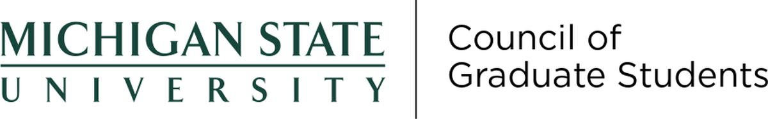

October 19, 2022
    - Discussed changes to the Student Rights and Responsibilities document with Dean Anthony Williams
    - Responded to problems students had with the Student Information System
    - Expanded funding for a Graduate and Professional Fellowship Tax Webinar
    - Passed a resolution of no confidence in the Board of Trustees
    - Passed a resolution to provide funding for the WILD Conference
    - Heard reports from the Graduate Academic Conference committee and the University Student Commission"

Anticipated Items at Upcoming Meetings
    - Reforming CAPS presented by Dr. Patishnock, Dr. Gaines, and Dr. Scott
    - Funding for graduate students affected by Hurricane Ian
    - Resolution to fund the Wakanda Forever Proposal presented by BGSA Rep and DEI Committee Member Antonio White

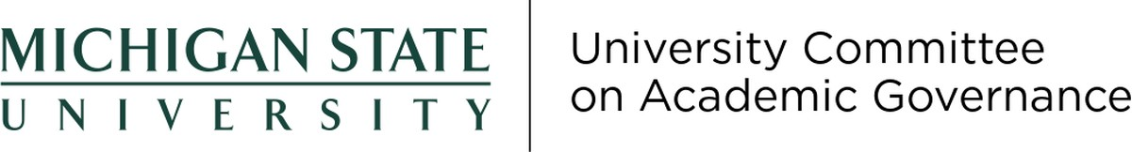

Updates on Outstanding Items
Item 2021-33: At UCAG's April 21, 2022 meeting, the committee approved an amendment to the Bylaws for Academic Governance that would add the executive vice president for health sciences to the Steering Committee as a voting member and to the Faculty Senate as a non-voting member.
Item 2223-04: At UCAG's April 21, 2022 meeting, the committee approved an amendment to the Bylaws for Academic Governance that would change the composition of the University Committee on Student Affairs to add more students and non-voting staff members, as well as change the name of the committee to the University Committee on Student Life and Engagement. At the committee's September 29 meeting, the committee made slight editorial changes to the same.

October 20, 2022 Meeting
Provost Teresa K. Woodruff visited the committee at its most recent meeting.
Acting under its authority to interpret the Bylaws for Academic Governance, UCAG issued three interpretations of the Bylaws in response to questions posed by a faculty member. First (2223-12), UCAG interpreted the list of those whom colleges and departments may give internal voting rights to be exclusive, meaning non-academic staff cannot be granted those rights. Second (2223-13), UCAG interpreted the Bylaws to mean that a non-academic staff members is not eligible to be a voting member of a college advisory committee. Finally (2223-14), UCAG reviewed several seemingly conflicting provisions involving the process of electing Faculty Senate/University Council representatives and proposed an amendment to clarify.

Anticipated Items at Upcoming Meetings
UCAG expects to wrap up its college bylaw reviews in the coming weeks. The committee will also consider questions related to staff representation.

Requested Support from the Steering Committee and/or the Office of Academic Governance
That the proposed Bylaws amendment arising out of Item 2223-14 be referred to University Council for further action

    - Meetings cancelled due to a lack of agenda items.

Anticipated Items at Upcoming Meetings
UCUE representation on the new standing Survey Committee.

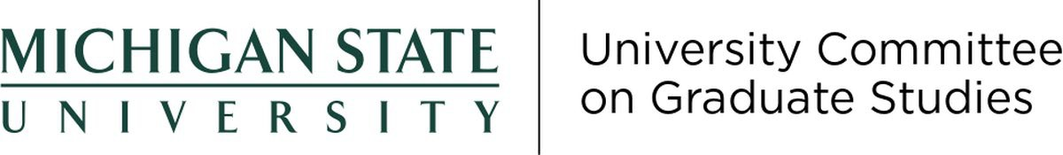

Report to the Steering Committee | October 4, 2022

Actions Taken at Recent Meetings

Updates on Outstanding Items
    - Item 2021-11: At the 10-16-22 UCGS Meeting, Dr. Marilyn Amey and Dr. Nate Clason presented an update on the work of the Replacement of the SIRS System: history of the efforts, phases of their work, and next steps. Phas 5 (US23): Pilot test and review. Phase 6 (FS23): soft launch and on-boarding of units. Phase 7 (SS24): official launch; and Phase 8 (FS24): review and assessment of system. No action was taken at this time.

October 17, 2022
We selected a new Chair (Anne-Lise Halvorsen) and Vice-Chair (Bruno Takahashi). Halvorsen shared that the Faculty Senate took a vote of no confidence in the Board of Trustees at the October 11, 2022 meeting. We approved the request to change the policy in Master's and Doctoral Programs Transfer Credits and approved 30 requests to changes in graduate programs. We tabled one request: Request for a Moratorium on Admission to the Doctor of Philosophy Degree in Sociology until our November meeting.

Anticipated Items at Upcoming Meetings
We anticipate discussing the following: updates from sub-committees; requests to changes in requirements to graduate programs; and finalizing committee chairpersons.

