The General Assembly met on December 8, 2022. A presentation from Regina Gong, MSU Student Success Librarian, was given on the topic of Open Education Resources.

Twelve bills passed:
59-31 – which advocates for data transparency on communicable diseases
  - – which advocates for Michigan State University to increase the accessibility of free condoms on campus through the implementation of free condom dispensers placed around campus, to be maintained by MSU and MSU Infrastructure Planning and Facilities
  - – which advocates for Michigan State University to increase the selling of internal condoms, external condoms, dental dams, and lubrication at every Sparty’s convenience store
  - – which recognizes APIDA/A Heritage Month
  - – which allocates $2,500 to the City of East Lansing for alleyway string lighting 59-39 – which allocates $3,180 to Services Week
59-40 – which allocates $8,500 for the “Spartan Flow and Glow” event hosted by the Office of Spartan Experiences
  - – which advocates for demands in regard to the upcoming permanent President Search Committee
  - – which advocate for Election Day protections
  - – which advocate for the banning of the LGBTQ+ “Panic” Defense 59-45 – which appoints one student to the University Hearing Boards
  - – which sponsors an ABTS resolution calling for ABTS to advocate for recipients to use federal and state financially dependent benefits to purchase menstrual hygiene products

Anticipated Items at Upcoming Meetings
ASMSU will have one full session meeting on January 19, 2023. ASMSU will also be participating in the Association of Big Ten Students Winter Conference in January.

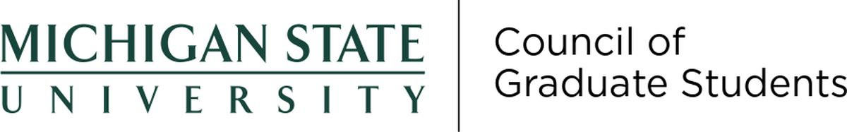
    - Approved funding for three graduate student conference travel awards applications from the fall semester
    - Brief Memoria was held for Quintin Whitsitt
    - External speaker
      - SIRS Replacement Committee – Dr. Jim Lucas (Assistant Dean, Global Education & Curriculum)
    - New Business
      - 22-FS-17: Increasing donor accountability at Michigan State University

Anticipated Items at Upcoming Meetings
The committee is planning to discuss: welcoming back students; presentations from VP of Research and Innovation Doug Gage; the University Sustainable Investment working group; continued efforts to restore MSU Swim and Dive/related Title IX suit; funding applications for Graduate Student Organization events; improving graduate student mental health; and Graduate Academic Conference planning and execution at the January 18, 2023 meeting.

Requested Support from the Steering Committee and/or the Office of Academic Governance
N/A

December 7, 2022
Members were updated on topics discussed at Faculty Senate/University Council. The action item was to review two requests for extension of the tenure clock.

Anticipated Items at Upcoming Meetings
The committee is planning to discuss and review extension requests and will continue to update members on items discussed by academic governance at the January 18, 2023 meeting.

Requested Support from the Steering Committee and/or the Office of Academic Governance
N/A

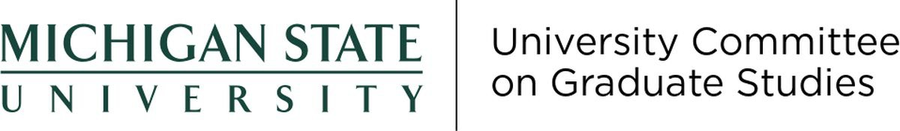

UCGS did not hold any December meetings; therefore, there are no committee updates.

Updates on Outstanding Items
    - Item 2021-11: Replacement of SIRS
      - No progress update.

Anticipated Items at Upcoming Meetings
The committee is planning to discuss ways that UCGS can support the Research Integrity Office. Dr. Doug Gage and Dr. Lee Cox (the RIO) will be attending the January 23, 2023 UCGS meeting.

Requested Support from the Steering Committee and/or the Office of Academic Governance
N/A

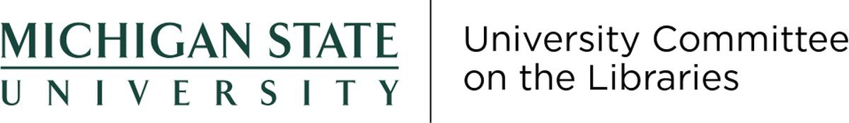

December 9, 2022
Meeting canceled.

Anticipated Items at Upcoming Meetings
The committee is planning to discuss the new library catalogue interface, floor plan for Special Collections, and library hours during finals and game days.

Requested Support from the Steering Committee and/or the Office of Academic Governance
N/A

January 5, 2023
    - Supported a request to add an Admission Requirement for the Bachelor of Science Degree in Urban and Regional Planning.
    - Discussed issues around the process of establishing course equivalencies for semester abroad experiences. The item will be further discussed at the next meeting.

Updates on Outstanding Items
    - Item 2021-56: College of Education Fifth-Year Internship Requirement
      - No progress to report.
    - Item 2122-28: Guidelines for In-Person vs. Online Classes
    - Item 2021-11: Replacement of SIRS
      - On 10/3/22, UCUE representatives on the SIRS replacement committee reported progress made in three main focus areas: A) listening tour with colleges and stakeholder groups to help understand the process, B) weekly IT meetings with vendor, C) and development of a SIRS Enhancement Policy Considerations document.
      - On 1/5/23, UCUE selected two replacement representatives. The new representatives are Patty West and Kathy Gallo.
    - Item 2223-10: Presence and Absence Policies
      - UCUE discussed the matter at its November 10th, 2022 meeting. UCUE formed a subcommittee on attendance and short-term leaves to address the issue and propose policies and resources to address attendance and short-term leaves. Members include Aaron Iturradle (ASMSU), Marissa King (RCAH), Chris Kaiser (Education), Ebony Green (APUD), Rich Enbody (Engineering), Thomas Summerhill (CSS).

Anticipated Items at Upcoming Meetings
The committee is planning to discuss a document submitted by the SIRS replacement committee; consider a plan of action in support of a boilerplate language for a centralized syllabus; and further discuss the course equivalencies process for semester abroad experiences at the January 19, 2023 meeting.

January 10, 2023

Office of Academic Governance

Owen Graduate Hall Michigan State University 735 E Shaw Ln, Room W32 East Lansing, MI 48825

517-355-2337
acadgov@msu.edu acadgov.msu.edu
MEMORANDUM
TO: The Steering Committee
FROM: Tyler Silvestri
Secretary for Academic Governance
SUBJECT: Matters Referred to Committees | December 2022 to Present
Pursuant to the reviewable authority granted to me by the Steering Committee on October 4, 2022, I received the following requests for referral and took the actions associated with each.
Item 2223-19: Faculty and Academic Staff Voting Rights
On December 31, 2022, Faculty Senator Kate Birdsall contacted the Office of Academic Governance to propose a change to the Bylaws for Academic Governance such that “all faculty and academic staff be afforded the right to vote in their units, colleges, and in governance matters, regardless of their HR classification (UNTF, specialist, tenure system).”
Section 8.3.1. of the Bylaws for Academic Governance reads, “Proposed amendments [to the Bylaws] shall be submitted to the University Committee on Academic Governance. After review by UCAG, proposed amendments may be submitted to the University Council for action under 3.2.4.10. by UCAG, or by any member of the University Council.” Accordingly, I referred the matter to UCAG.
Item 2223-07: Bereavement Policy
The Office of Faculty and Academic Staff Affairs requested input from academic governance in 2022 regarding potential changes to the bereavement policy for faculty and academic staff. The Steering Committee referred the issue to the University Committee on Faculty Affairs on October 4, 2022. The University Committee on Faculty Affairs offered feedback and endorsed an amended policy at its November 29, 2022 meeting.
Section 3.3.4.1. of the Bylaws for Academic Governance states that the Faculty Senate is “the major, regularly meeting body in which . . . faculty salary and benefit issues are presented.” Since the bereavement policy sets out benefits for faculty and academic staff, and because UCFA has already given its input, I have placed the matter on the Faculty Senate’s tentative agenda for further action.

1 of 1
