UCFA: Bereavement Policy Proposed Revisions
Endorsed by UCFA on November 29, 2022

The current policy concerning faculty and academic staff bereavement leave is as follows:
https://hr.msu.edu/policies-procedures/faculty-academic-staff/faculty-handbook/funeral_bereavement.html

—----------—----------—----------—----------—----------—----------
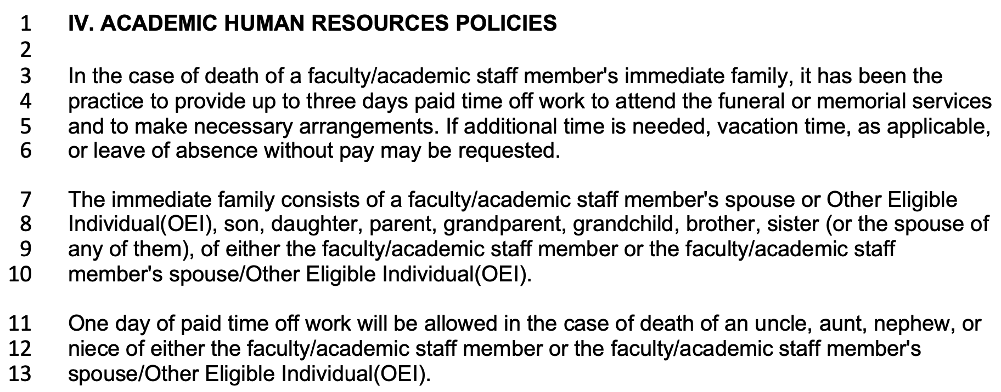
—----------—----------—----------—----------—----------—----------

Recommended Changes:

(1) Line 3:

What is written:
“In the case of death of a faculty/academic staff member's immediate family…”

Recommendation:
Eliminate the distinction of immediate family.

(2) Lines 3-4:

What is written:
“... has been the practice to provide up to three days…”

Recommendation:
Definitive language should be used to describe the policy.

(3) Line 4:

What is written:
“.... to provide up to three days paid time off work….”

Recommendation:
Allow for five days.

(4) Line 4-5:

What is written:
“... to attend the funeral or memorial services and to make necessary arrangements.”

Recommendation:
“... for the purposes of bereavement and associated activities.”

(5) Line 5-6:

What is written:
“If additional time is needed, vacation time, as applicable, or leave of absence without pay may be requested.”

Recommendation:
If additional time is needed, the faculty/academic staff member may make a request, in writing, to their unit's administrator, who will communicate their decision in writing. Decisions will be made in consideration of individual and unit needs. The faculty/academic staff member may appeal an adverse decision to the appropriate administrator at the next higher administrative level

(6) Lines 7-10:

What is written:
“The immediate family consists of a faculty/academic staff member's spouse or Other Eligible Individual(OEI), son, daughter, parent, grandparent, grandchild, brother, sister (or the spouse of any of them), of either the faculty/academic staff member or the faculty/academic staff member's spouse/Other Eligible Individual(OEI).”

Recommendation: “The distinction of who qualifies as a “family member” shall be made by the faculty/academic staff member, but is generally taken to mean a person to whom the faculty/academic staff member has close familial, or familial-like ties.”

(7) Lines 11-13:

What is written:
“One day of paid time off work will be allowed in the case of death of an uncle, aunt, nephew, or niece of either the faculty/academic staff member or the faculty/academic staff member's spouse/Other Eligible Individual(OEI).”

Recommendation:
Eliminate this section.

—----------—----------—----------—----------—----------—----------

Proposed Revised Policy

IV. ACADEMIC HUMAN RESOURCES POLICIES
Funeral / Bereavement Leave for Faculty/Academic Staff

In the case of death of a faculty/academic staff’s family member, five days of paid time off work for the purposes of bereavement and associated activities shall be allowed. If additional time is needed, the faculty/academic staff member may make a request, in writing, to their unit's administrator, who will communicate their decision in writing. Decisions will be made in consideration of individual and unit needs. The faculty/academic staff member may appeal an adverse decision to the appropriate administrator at the next higher administrative level. The granting of such requests shall be made at the discretion of the administrator. If the additional requested time results in a total leave of more than ten working days then vacation time, as applicable, or a leave of absence without pay may be considered.

The distinction of who qualifies as a “family member” shall be made by the faculty/academic staff member, but is generally taken to mean a person to whom the faculty/academic staff member has close familial, or familial-like ties.

—----------—----------—----------—----------—----------—----------

