February 15, 2023
Emergency consent agenda (funding resolutions passed) 2. Speakers a. Pero Dagbovie
b. Allyn Shaw c. Thomas Jeitschko 3. Community time (open discussion about the tragic shootings on Feb. 13th with Megumi Moore)

Anticipated Items at Upcoming Meetings
- Juneteenth celebrations funding
- Tax return webinar for internationals students funding
- Committee to review the Nassar documents and make recommendations about improving resources for survivors.
  - Becky Campbell
- COGS elections

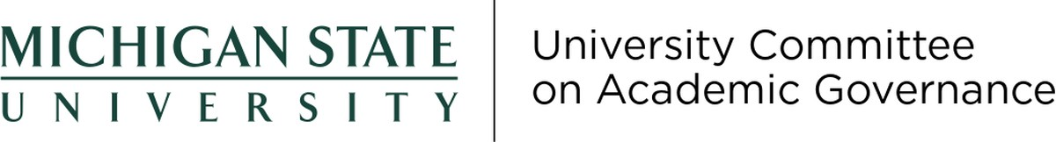

Actions Taken at Recent Meetings
The February UCAG meeting were cancelled pending University Council’s approval of the faculty voting rights Bylaw amendments.

Anticipated Items at Upcoming Meetings
The committee plans to continue discussing faculty and academic staff voting rights and finish reviewing college bylaws.

Requested Support from the Steering Committee and/or the Office of Academic Governance
The committee requests that the Steering Committee place the Bylaw amendment regarding faculty voting rights on the next University Council agenda.

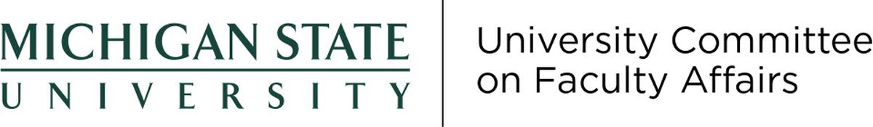

Tracking System Items

Item 2021-08: Code of Professional Standards
This is on our docket, will be looked at later in the year.

Item 2021-58: UCFA Budget Subcommittee Request for Demographic Collection of Salaries
We have received some information, and the budget subcommittee will use this to craft a faculty raise memo.

Item 2223-14: Faculty Vacation Policy
This is on our docket, and will be looked at in the fall.

Item 2223-20: 9-month and 12-month Appointment System Supervisors
We have formed a working group. Jamie will write a memo to the Provost, asking for a more broad work group.

Item 2223-08: Course Fee Policy Change to Include Part Time Employees
This item is being finalized in the personnel subcommittee

Item 2223-12: University Observed Days Off
This is on our docket, and will be looked at in the fall.

Other Actions Taken at Recent Meetings

February 28, 2023
Interim Provost Jeistchko provided feedback on the purpose, intent, and process regarding the budget raise memo.

Anticipated Items at Upcoming Meetings
We will continue work on outstanding items.

March 1, 2023
The UCFT met on March 1 to discuss the request for extending the tenure clock of a faculty member.

Anticipated Items at Upcoming Meetings
Continue to review requests for extension of the tenure clock. Respond to any requests from Steering Committee.

The SPLS Team gave a short presentation on the 8 Institution-Level Questions of the Student Perceptions of Learning Survey. UCGS subcommittees delivered their reports. We approved 10 requests related to graduate programs. Also, we passed the following motion: UCGS recommends a version of Credit/No Credit for graduate courses in Spring 2023, but the decision needs to be made in careful consultation with students' local units and with flexibility.

Updates on Outstanding Items
- Item 2021-11: Replacement of SIRS
  - The SPLS Team presented at our February 20 meeting. Following that presentation and question and answer, the UCGS affirmed support of the 8 Institution-Level Questions Student Perceptions of Learning Survey, with some minor suggestions.
- Item 2223-20: 9-Month and 12-Month Appointment System Supervisors
  - We will have our first meeting on Wednesday, March 15 at 9 am. Three members of the UCGS are serving on this working group.

Anticipated Items at Upcoming Meetings
At our March 20 meeting, we will discuss six requests related to graduate programs. We will also discuss ways we can further support graduate students in light of the violence the campus community experience.

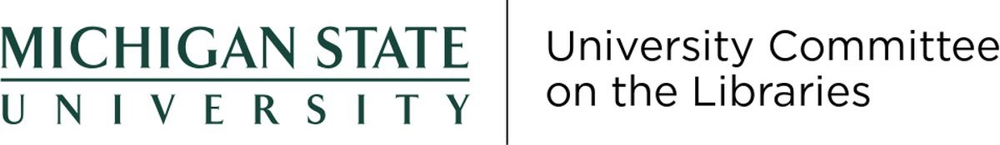
Meeting canceled.

Anticipated Items at Upcoming Meetings
None.

Requested Support from the Steering Committee and/or the Office of Academic Governance
N/A

UCUE supported a request for a Moratorium on Admission to the Minor in Forestry Field Applications UCUE supported a request for a Moratorium on Admission to the Disciplinary Teaching Minor in Mathematics-Elementary Available for Elementary Teacher Certification UCUE supported a request for a New Minor in Literature and Cultural Studies

February 16, 2023
UCUE supported a request for a new Bachelor of Science Degree in Mathematics- Secondary Education UCUE supported a request for a New Bachelor of Science Degree in Integrated Science-Secondary Education UCUE approved an extension of the date to select CR/NC to the last class day of SS23 semester (April 30, 2023). The date extension only applies to SS23. UCUE approved that SS23 CR/NC credits will not be counted in the 20-credit limit on the CR/NC system. The no-counting only applies to SS23. UCUE approved that all SS23 courses be extended CR/NC option, with a 2.0 threshold for earning CR, including general education, major, minor, and elective courses. The course extension only applies to SS23.

Updates on Outstanding Items
[Updates on current Open Items in the academic governance tracking system that have been assigned to the committee]
- Item 2223-10: Presence and Absence Policies
  - Nothing to report.
- Item 2021-11: Replacement of SIRS
  - On February 2nd, a proposed list of institution-wide questions were emailed to UCUE membership asking for feedback to Patty West by 2/10. On March 2nd, UCUE supported the proposed list of institution-level questions to be used in the new SPLS
- Item 2223-18: Course Equivalency for Study Abroad
  - Nothing to report.

Anticipated Items at Upcoming Meetings
Boilerplate language for a centralized syllabus.

