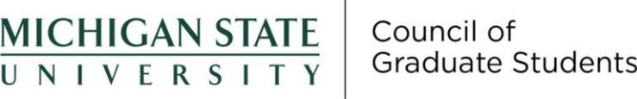
Report to the Steering Committee | November 7, 2023

Actions Taken at Recent Meetings

October 18, 2023

- External Speakers

- Dr. Nicole (Nikki) Schmidtke (she/her) (oie.nicoleschmidtke@msu.edu) – Interim Senior Deputy Title IX Coordinator, Director of ADP Response and Investigations and Title VI Coordinator – Office of Institutional Equity

  - Kevin McCarthy (he/him) (kmccarthy@hcg.com) – SRR and GSR Advisory Committee – Huron Consulting Group 2

- New Business

  - 23-FS-13: Transfer of endowment funds - Passed 40-1-0 (yes-no-abstain)

- 23-FS-14: Recreational and Wellness Center relief fund endorsement revision - 43-0-0

- 23-FS-15: Approval of the nominee for the Director of Event Planning - Passed 43-0-0

  - Presidential Search feedback form is now effectively closed

- Special elections

  - Recording Secretary

    - Savior Kitcher - Successfully elected

Anticipated Items at Upcoming Meetings

The committee is planning to have two external speakers, Kathryn Naber (Center for Survivors) and Doug Gage (Office for Research and Innovation) present. COGS will discuss their responses to the war in Gaza and their subsequent collaboration with Dr. Alexis Travis and stance on the Board of Trustees' internal conflicts.

Requested Support from the Steering Committee and/or the Office of Academic Governance

Not applicable.

Other

Not applicable.

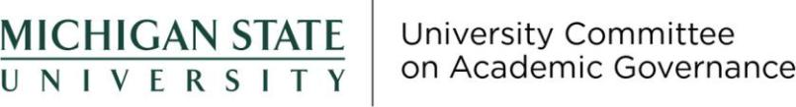
Report to the Steering Committee | November 7, 2023

Actions Taken at Recent Meetings

October 12, 2023

Dean Rehberger was elected chairperson, and Gordon Sly was elected vice chairperson.

The committee voted to meet remotely for the 2023–2024 academic year.

The committee became acquainted with several issues that are expected to appear on future UCAG agendas (listed in the next section).

UCAG reviewed the proposed changes to the composition of the University Advisory Committee on the Naming of Buildings and Facilities. Members strongly felt that the drastic reduction in the number of faculty on the committee is undesirable.

Anticipated Items at Upcoming Meetings

UCAG expects to address the following items at upcoming meetings:

- Eligibility of Health Professions Faculty to Serve as Deans

- Faculty Participation in Awarding Honorary Degrees

- Athletic Council’s Role, Procedures, and Bylaws

- Best Practices for Dean Reviews

- International Studies and Programs Representation on
UCUE

Report to the Steering Committee | November 7, 2023

Actions Taken at Recent Meetings

October 10, 2023

- Faculty Raise Memo will be delivered to the January Faculty Senate meeting

- Items to be discussed at Faculty Healthcare Council

- Discussed Faculty Emeriti Policy

- Set priorities for Faculty Work During the Summer group

- Discussed Fixed-Term Faculty Policies and Best Practices Workgroup

October 31, 2023

- Discussed liaison to Faculty Healthcare Council

- Update on modified operations policy

Updates on Outstanding Items

- Item 2021-08: Code of Professional Standards

  - Discussed with Theresa Kelly. Will continue discussion.

- Item 2223-14: Faculty Vacation Policy

  - Tied to the 9-month and 12-month faculty issue and is on hold.

- Item 2223-20: 9-Month and 12-Month Appointment System Supervisors

  - Established priorities for this item at the October 10, 2023 meeting.

- Item 2223-08: Course Fee Policy Change to Include Part Time Employees

  - Undergoing a feasibility study

- Item 2223-27: Interim Faculty Conflicts of Interest Policy

  - Discussed at the October 31, 2023 meeting.

- Item 2223-21: Faculty Sick Leave Policy

  - Tied to several other policies UCFA is looking at and is on hold.

Anticipated Items at Upcoming Meetings

The committee is planning to discuss UCFA communication to various colleges.

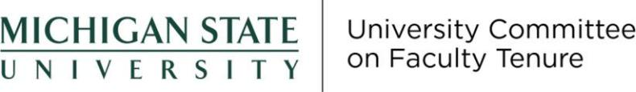
Report to the Steering Committee | November 7, 2023

Actions Taken at Recent Meetings

No meetings have been held since last report.

Anticipated Items at Upcoming Meetings

The committee is planning to continue to review requests for extending the tenure clock.

Requested Support from the Steering Committee and/or the Office of Academic Governance

Not applicable.

Other

Not applicable.

Report to the Steering Committee | November 7, 2023

Actions Taken at Recent Meetings

October 12, 2023

- UCUE supported the Request to Phase Out and Discontinue the Bachelor of Arts Degree in Media and Information Report on Subcommittee on Spring Calendar Revision: Membership is being finalized with representation from UCGS, UCUE, ASMSU, and Registrar.

October 26, 2023 – Canceled

Updates on Outstanding Items

- Item 2223-18: Course Equivalency for Study Abroad

  - The sub-committee held a first meeting on 10/3/23 It was decided that information should be gathered about - a new platform to increase equivalency process efficiency. - best practices among Big Ten colleges.

- Item 2021-11: Replacement of SIRS

  - At its 9/28/23 meeting, UCUE designated representation on the Replacement of SIRS task force: Antoinette Tessmer, Emilia Marcyk-Taylor, and Patty West. At its 10/12/23 meeting, Patty West provided a comprehensive summary of progress on SPLS implementation.

Anticipated Items at Upcoming Meetings

Not applicable.

Requested Support from the Steering Committee and/or the Office of Academic Governance

The committee also requests Item 2223-023 be closed and Item 2122-30 be moved to University Committee on Curriculum.

Other

Will report out to Steering Committee regarding UCUE’s September 7, 2023 and September 28, 2023 meetings.

