UCFA Personnel SubCommittee: Bereavement Policy Proposed Revisions
November, 2022

The current policy concerning faculty bereavement leave is as follows:
https://hr.msu.edu/policies-procedures/faculty-academic-staff/faculty-handbook/funeral_bereavement.html

—----------—----------—----------—----------—----------—----------
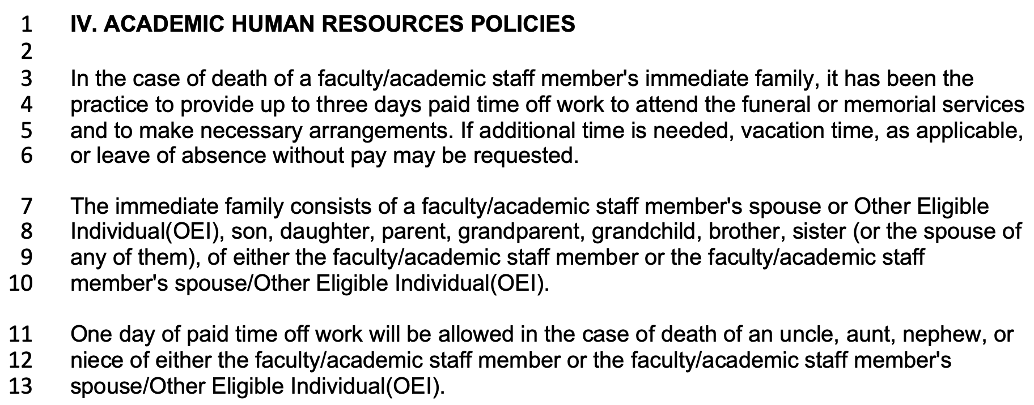
—----------—----------—----------—----------—----------—----------

Recommended Changes:

(1) Line 3:

What is written:
“In the case of death of a faculty/academic staff member's immediate family…”

Recommendation:
Eliminate the distinction of immediate family.

(2) Lines 3-4:

What is written:
“... has been the practice to provide up to three days…”

Recommendation:
Definitive language should be used to describe the policy.

(3) Line 4:

What is written:
“.... to provide up to three days paid time off work….”

Recommendation:
Allow for five days.

(4) Line 4-5:

What is written:
“... to attend the funeral or memorial services and to make necessary arrangements.”

Recommendation:
“... for the purposes of bereavement and associated activities.”

(5) Line 5-6:

What is written:
“If additional time is needed, vacation time, as applicable, or leave of absence without pay may be requested.”

Recommendation:
“If additional time is needed, the faculty/academic staff member may make a request, in writing, to their unit’s administrator. The granting of such requests shall be made at the discretion of the administrator.”

(6) Lines 7-10:

What is written:
“The immediate family consists of a faculty/academic staff member's spouse or Other Eligible Individual(OEI), son, daughter, parent, grandparent, grandchild, brother, sister (or the spouse of any of them), of either the faculty/academic staff member or the faculty/academic staff member's spouse/Other Eligible Individual(OEI).”

Recommendation: “The distinction of who qualifies as a “family member” shall be made by the faculty/academic staff member, but is generally taken to mean a person to whom the faculty/academic staff member has close familial, or familial-like ties.”

(7) Lines 11-13:

What is written:
“One day of paid time off work will be allowed in the case of death of an uncle, aunt, nephew, or niece of either the faculty/academic staff member or the faculty/academic staff member's spouse/Other Eligible Individual(OEI).”

Recommendation:
Eliminate this section.

—----------—----------—----------—----------—----------—----------

Proposed Revised Policy

IV. ACADEMIC HUMAN RESOURCES POLICIES

In the case of death of a faculty/academic staff’s family member, five days of paid time off work for the purposes of bereavement and associated activities shall be allowed. If additional time is needed, the faculty/academic staff member may make a request, in writing, to their unit’s administrator. The granting of such requests shall be made at the discretion of the administrator. If the additional requested time results in a total leave of more than ten working days then vacation time, as applicable, or a leave of absence without pay may be considered.

The distinction of who qualifies as a “family member” shall be made by the faculty/academic staff member, but is generally taken to mean a person to whom the faculty/academic staff member has close familial, or familial-like ties.

—----------—----------—----------—----------—----------—----------

