Present: J. Alan, A. Austin, K. Bieda, C. Borchgrevink, T. Craig, J. Fitzsimmons,
J. Flessner, M. Helton, B. Holtz, N. Lajevardi, D. McCole, T. Pence, E. Rapinchuk,
F. Ravitch, F. Villarruel, L. Walesby, D. Weatherspoon, P. White, H. Wu, K. Yermak
Absent: J. Buchweitz, J. Schuster-Craig
A regular meeting of the University Committee on Faculty Affairs was held on February 28, 2023 at 1:00 p.m. with Chairperson Jamie Alan presiding. The agenda was approved as presented. The minutes from the January 31, 2023 meeting were approved as presented.
Chairperson Alan, Interim Associate Provost for Faculty and Academic Staff Affairs Ann Austin, Director of Faculty and Academic Staff Affairs Kara Yermak, Associate Provost of Enrollment and Strategic Planning Dave Weatherspoon, and Faculty Grievance Official Francisco Villarruel gave remarks.
Adjournment
The meeting adjourned at 1:31 p.m.
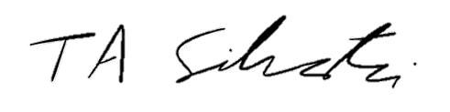
_______________________
Tyler Silvestri
Secretary for Academic Governance
Approved: March 14, 2023

