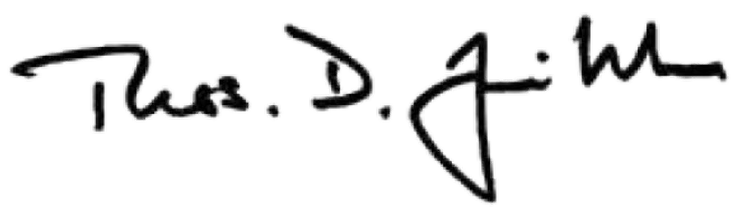

February 28, 2023

To: University Committee on Faculty Affairs

From: Thomas D. Jeitschko, Ph.D.
Interim Provost and Executive Vice President for Academic Affairs Subject: Support in Granting Emeritus status for Stephanie Valberg
The Emeritum policy in the Faculty Handbook provides that “Faculty and academic staff who end their employment at the University after a substantial period of distinguished service, but short of the years of service needed for retirement eligibility, may be granted emeritum status by the President upon the written recommendation of the Provost after the Provost consults with the UCFA.”

Pursuant to the Emeritum policy, I seek your consultation on the attached request from Dean Puschner. I have reviewed the request and recommend the granting of Emeritum status to Dr. Stephanie Valberg. Dean Pushner’s letter provides the basis for the recommendation and Dr. Stephanie Valbergs’ accomplishments and contributions to MSU during her career at Michigan State University. I ask that this request be considered by the University Committee on Faculty Affairs at their next meeting on Tuesday, March 14, 2023.

Cc: Ann E. Austin, Ph.D. Kara Yermak, MHRLR

OFFICE OF THE
PROVOST

Michigan State University Hannah Administration Building 426 Auditorium Road, Room 430 East Lansing, Michigan 48824

Phone: 517-355-6550
Fax: 517-355-9601
provost.msu.edu

MSU is an affirmative-action, equal-opportunity employer.

