Jamie Alan
Chair, University Committee on Faculty Affairs Associate Professor
Department of Pharmacology and Toxicology Michigan State University
Life Sciences Building Rm 305

April XX, 2023

Dear Interim Provost Jeitschko and Interim President Woodruff:

In accordance with the MSU Faculty Grievance Policy, Appendix II, UCFA has completed a review of the current Faculty Grievance Official’s years of service and are submitting a recommendation regarding reappointment to the position. This review was conducted by Peter White, Chair of the Personnel Subcommittee of the UCFA with the support of an Ad-Hoc Committee of the UCFA, consisting of Carl Borchgrevink and Dan McCole.

Dr. Villarruel first began his work in the context of the Faculty Grievance Official (FG Official) in August 2018 when he was appointed as the Responsible Administrator of the Faculty Grievance Office (FG Office). In October, 2018, he was appointed into the position of Acting Faculty Grievance Official. He became the Faculty Grievance Official on February 15, 2019 and has been serving in that capacity since then. He has a 0.5 FTE assignment as the FG Official.
Although Dr. Villarruel’s assignment as the FG Official has technically lapsed, he has continued to serve as the FG Official, pending the outcome of the review and reappointment process. Both Dr. Villarruel and the UCFA had mis-remembered the length of his term as a 5 year appointment, rather than a 3 ½ year appointment, hence his extended tenure as FG Official, beyond his term, without reappointment.

This review was conducted throughout the spring 2023 semester. It was discussed and approved by UCFA on April XX, 2023. The review encompasses the period from Dr. Villarruel’s initial appointment at the FG Official (on 02/15/2019) through to the end of 2022 (12/31/2022).

It is the finding of the UCFA that Dr. Villarruel has demonstrated a high degree of effectiveness and professionalism, and has maintained positive collaborative working relationships throughout his tenure in the position of the FG Official. He has consistently operated within the scope of the MSU Faculty Grievance Policy, and has built a reputation for being a fair and neutral actor in the dispute and grievance processes at MSU.

There were no areas of concern that Dr. White or the UCFA Personnel Subcommittee identified during the review process that would support an alternative finding regarding Dr. Villarruel’s

performance. That is not to say that Dr. Villarruel has no areas for continued growth. In fact, one of the hallmarks of his tenure as the FG Official is his growth-mindset and his desire to continually improve in providing the best mediation and dispute-resolution services as possible to the faculty, academic staff, and administrators at MSU. Disputes are often challenging for those involved, and are often as unique as they are complex. Dr. Villarruel sees his role as an opportunity to help those involved, as well as an opportunity for him as FG Official to grow in the mastery of his role.

Given these findings, we recommend reappointment of Dr. Villarruel to the position of
Faculty Grievance Official without reservation.

In the pages of this report, we provide qualitative and quantitative evidence of Dr. Villarruel’s excellence, over a nearly four year period. Primarily, this report includes a recap and synthesis of four years’ worth of survey data from people who have used the services of the FG Office, survey data from the FASA Directors who have worked with Dr. Villarruel, and reflections provided by Dr.Villarruel himself.

Please feel free to reach out to me should you have any questions, or require further information.

Sincerely

Jamie Alan Chair, UCFA

Table of Contents
Cover Letter 1
Table of Contents 3
Faculty Grievance Office Activities for the Period Under Review 4
Data Considered in the Writing of this Report 4
General Structure of Annual Reviews of Dr. Villarruel, as Conducted by UCFA 4
Synopsis of Dr. Villalrruel’s Annual Review from the 2019 Calendar Year 5
Synopsis of Dr. Villalrruel’s Annual Review from the 2020 Calendar Year 6
Synopsis of Dr. Villalrruel’s Annual Review from the 2021 Calendar Year 7
Synopsis of Dr. Villalrruel’s Annual Review from the 2022 Calendar Year 8
Feedback from FASA Directors 9
Professional Development Activities and Outreach 12
Dr. Villarruel’s Self Reflections 13
Appendix 1, 2019 UCFA FG Official Review 15
Appendix 2, 2020 UCFA FG Official Review 21
Appendix 3, 2021 UCFA FG Official Review 27
Appendix 4, 2022 UCFA FG Official Review 34

Faculty Grievance Office Activities for the Period Under Review
During the period under review, the FG Office received a total of 30 formal grievances (range: 2
- 11 per year, Table 1). In this same period, Dr. Villarruel engaged in 468 Conferences with faculty, administrators, and other individuals, e.g., attorneys, as appropriate; (range 99 - 156 per year, Table 1). Of these conferences, 60% were with faculty, 35% were with administrators, and 5% were with other relevant individuals. These conferences occurred over phone, zoom, and
in-person. During the pandemic, an increasing number of these consultations occurred over phone and zoom. Finally, Dr. Villarruel responded to a total of 1747 email inquiries in his capacity as the FG Official (range 271 - ~700 per year, Table 1). Of these, 54% were with faculty, and 32% were with administrators; 14% were with other relevant individuals (Table 1).

Table 1: FG Office Activity 2019-2022
FG Office Activity | 2019 | 2020 | 2021 | 2022
Formal Grievances Filed  (# Resolved informally, or withdrawn) | 10 (2) | 7 (1) | 2 (1) | 11 (2)
Conferences  Via Zoom/Phone/In Person | 156 | 102 | 111 | 99
Inquiries/Contacts  Via email | 522 | 700 | 271 | 543

Data Sources Considered in the Writing of This Report
Multiple sources of data were incorporated into the writing of this report.
  - The Annual Yearly UCFA Reviews of Dr. Villarruel and the FG Office.
  - Feedback from the Directors of the Faculty and Academic Staff Affairs Office.
  - A review of Dr. Villarruel’s professional development and outreach activities.
  - Dr. Villarruel’s Annual Self Reflections.

General Structure of Annual Reviews of Dr. Villarruel, as Conducted by UCFA
Dr. Villarruel was evaluated each year from 2019-2022 (inclusive) by the University Committee on Faculty Affairs. The evaluations relied heavily on a survey that was sent out to faculty and administrators who engaged with the FG Office for the respective year under review. The survey instrument was largely the same each year, and was co-designed by the UCFA Personnel Subcommittee and Dr. Villarruel. The survey was administered and analyzed by a third party - the MSU Institute for Public Policy and Social Research - who provided aggregate and anonymized results back to the UCFA Personnel Subcommittee for their review.

Synopsis of Dr. Villarruel’s Annual Review from the 2019 Calendar Year In the 2019 calendar year, 125 individuals were solicited for feedback regarding their interactions with the FG Office and with Dr. Villarruel. Of those, 39 provided feedback. Report Highlights:
- The FG Office received high ratings for being approachable, conducting work in a timely manner, their knowledge of university policies and regulations, their clear communication, and for their penchant for attempting to resolve conflicts informally.
- Dr. Villarruel consistently rated very highly across almost all axes of the survey that pertained to respondent perception of his job performance. For example:
  - 78.2% of respondents Somewhat or strongly agreed that Dr. Villarruel acted as a fair and impartial advisor.
  - 80% of respondents Somewhat or Strongly Agreed that Dr. Villarruel demonstrated concern for and awareness of issues of diversity.
  - 78.2% of respondents Somewhat or Strongly Agreed that Dr. Villarruel administered grievances in a fair manner.
  - 83.3% of respondents Somewhat or Strongly Agreed that Dr. Villarruel maintained neutrality.
- The lowest scores pertained to the perception of some respondents that Dr. Villarruel was not able to “[Act] as an effective mediator between parties.” In this case, 25% of respondents either Somewhat or Strongly Disagreed that he was effective, while 65% Somewhat or Strongly Agreed that he was effective, and 10% were neutral.
- His ratings did not qualitatively or quantitatively differ between those who identified as being a member of an underrepresented group, and those who did not.
- Open-ended feedback commended the FG Office on being welcoming and inclusive.
- Dr. Villarruel’s self-reflection noted successes on updating the Faculty Grievance Policy, and on keeping the FG Office accessible for Faculty, Staff, and Administrators. He also noted an intention to collaborate more effectively with the Associate FG Official.
- Overall, the review found Dr. Villarruel’s performance in the position as FG Official to be effective, characterizing the survey data as “extremely positive with no areas being problematic.”
- The full 2019 calendar year review is attached as Appendix 1.

Synopsis of Dr. Villarruel’s Annual Review from the 2020 Calendar Year
In the 2020 calendar year, 90 individuals were solicited for feedback regarding their interactions with the FG Office and with Dr. Villarruel. Of those, 34 provided feedback.
Report Highlights:
- The FG Office received high ratings for being approachable, responding to inquiries in a timely manner, for their knowledge of university policies and regulations, and their willingness to schedule meetings at times that were convenient for respondents.
- Dr. Villarruel consistently rated very highly across almost all axes of the survey that pertained to respondent perception of his job performance. For example:
  - 85.7% of respondents Somewhat or Strongly agreed that Dr. Villarruel acted as a fair and impartial advisor.
  - 84% of respondents Somewhat or Strongly Agreed that Dr. Villarruel was an effective problem solver.
  - 92.3% of respondents Somewhat or Strongly Agreed that Dr. Villarruel maintained confidentiality.
  - 88.9% of respondents Somewhat or Strongly Agreed that Dr. Villarruel maintained neutrality.
- The lowest scores pertained to the belief of some respondents that Dr. Villarruel was not able to “[Act] as an effective mediator between parties.” In this case, 25% of respondents either Somewhat or Strongly Disagreed that he was effective, while 75% Strongly Agreed that he was effective. It was noted that, while this represented his lowest rating, it was still quite positive.
- His ratings from those who self-identified as being a member of an underrepresented minority were markedly lower than his ratings from those who did not. However, there was a large discrepancy between the number of survey respondents between the two groups (i.e., approximately 5 vs 26, respectively), and thus any analysis to determine whether the difference was significant suffers from low statistical power.
- Open ended feedback commended Dr. Villarruel on being courteous, dedicated, and available.
- The review for the 2020 calendar year did not cite any items of self-reflection that Dr.
Villarrual may have provided to the committee for that year under review.
- Overall, the review found Dr. Villarruel’s performance in the position as FG Official to be “positive with no areas seen as especially problematic.”
- The full 2020 calendar year review is attached as Appendix 2.

Synopsis of the Dr. Villarruel’s Annual Review from the 2021 Calendar Year
In the 2021 calendar year, 82 individuals were solicited for feedback regarding their interactions with the FG Office and with Dr. Villarruel. Of those, 40 provided feedback.
Report Highlights:
- The FG Office received high ratings for being approachable, responding to inquiries in a timely manner, their knowledge of university policies and regulations, and their willingness to schedule meetings at times that were convenient for respondents.
- Dr. Villarruel consistently rated very highly across almost all axes of the survey that pertained to respondent perception of his job performance. For example:
  - 77.4% of respondents Somewhat or Strongly Agreed that Dr. Villarruel acted as a fair and impartial advisor.
  - 84.4% of respondents Somewhat or Strongly Agreed that Dr. Villarruel treated them with respect regardless of the outcome of the case.
  - 88.4% of respondents Somewhat or Strongly Agreed that Dr. Villarruel maintained confidentiality.
  - 88% of respondents Somewhat or Strongly Agreed that Dr. Villarruel maintained neutrality.
- The lowest scores pertained to the belief of some respondents that Dr. Villarruel was not able to “[Act] as an effective mediator between parties.” In this case, 50% of respondents either Somewhat or Strongly Disagreed that he was effective, while 30% Strongly Agreed that he was effective. The report suggested that the low score on this item might stem from a misunderstanding that the FG Official is meant to be a faculty advocate rather than a neutral third party and thus, Dr. Villarruel’s scores here may be skewed due to a “kill the messenger” effect.
- Ratings from respondents who identified as being members of underrepresented groups were generally lower for most survey items, but were well within the margin of error (i.e., in most cases within 1/3rd of a standard deviation).
- Many open-ended comments commended Dr. Villarruel’s effectiveness. There were also comments of concern regarding the vaccine mandate and how to “grieve” it.
- The review for the 2021 calendar year did not cite any items of self-reflection that Dr.
Villarrual may have provided to the committee for that year under review.
- Overall, the review found Dr. Villarruel’s performance in the position as FG Official to be “positive with no areas seen as especially problematic.”
- The full 2021 calendar year review is attached as Appendix 3.

Synopsis of the Dr. Villarruel’s Annual Review from the 2022 Calendar Year
In the 2021 calendar year, 85 individuals were solicited for feedback regarding their interactions with the FG Office and with Dr. Villarruel. Of those, 32 provided feedback.
Report Highlights:
- The FG Office received high ratings for being approachable, responding to inquiries in a timely manner, their knowledge of university policies and regulations, their ability to maintain confidentiality, and his ability to answer questions.
- Dr. Villarruel consistently rated very highly across almost all axes of the survey that pertained to respondent perception of his job performance. For example:
  - 72.4% of respondents Somewhat or Strongly Agreed that he acted as a fair and impartial advisor.
  - 90% of respondents Somewhat or Strongly Agreed that Dr. Villarruel treated them with respect regardless of the outcome of the case.
  - 93.2% of respondents Somewhat or Strongly Agreed that Dr. Villarruel was knowledgeable of MSU policies and regulations.
  - 80.9% of respondents Somewhat or Strongly Agreed that Dr. Villarruel sought and respected diverse perspectives.
- The lowest scores pertained to the belief of some respondents that Dr. Villarruel was not able to “[Act] as an effective mediator between parties.” In this case, 25% of respondents either Somewhat or Strongly Disagreed that he was effective, while 70% Somewhat or Strongly Agreed that he was effective. The remaining 5% were neutral. It was noted that, while this represented his lowest rating, it was still quite positive.
- Ratings from respondents who identified as being a member of an underrepresented group were generally lower for many survey items. Notably, respondents who identified as being members of an underrepresented group tended to rate Dr. Villarruel lower on his ability to act as an effective mediator between parties, and his ability to be an effective problem solver. Dr. Villarruel reflected on this discrepancy and surmised that some of the difference might be due to inequitable lived experiences at MSU for those from underrepresented groups. He described a few such instances in his reflection, and though he was empathetic, he noted that it was not within the purview of his office to mediate DEI-based conflicts if they did not stem from a violation of MSU policy.
- Open-ended comments were somewhat bimodal, either praising the excellence and effectiveness of Dr. Villarruel’s work, or expressing dissatisfaction in the fact that the FG Official or FG Office was not in a position to act as an advocate for faculty during disputes. It should be noted that that is not the role of the FG Office or Official.
- Overall, the review found Dr. Villarruel’s performance in the position as FG Official to be “positive with no areas seen as especially problematic”, and encouraged Dr. Villarruel to continue to brainstorm ways that he can help those who engage with his office to better understand his neutral-by-design role in conflict resolution.
- The full 2022 calendar year review is attached as Appendix 4.

Feedback from FASA Directors
Preamble:
The Faculty and Academic Staff Affairs (FASA) Directors serve as a collaborative resource for the FG Official and the FG Office. There are many times throughout a given year that the FG Office and the FG Official will consult with the FASA Directors. Generally, these are often inquiry-based communications regarding a particular policy that relates to a conflict brought forward by a faculty member, academic staff, or unit directors. There are also times where additional background information is needed should the issues presented by a faculty member or administrator seem to divulge only part of a particular conflict. In addition, proposed modifications of MSU Policy, relevant to the FG Office, are vetted with the FASA office before being presented to UCFA for consideration. In Dr. Vilalrruel’s tenure in the FG Official position, inquiries were most often directed to Kara Yermak, but was not atypical to communicate directly with any of four FASA Directors depending on the nature of a given situation that may a have arisen in a given semester. These interactions, though sometimes frequent, tended to be short
(most less than 20 minutes). In addition to instances where Dr. Villarruel initiated communication with one of the FASA directors, there were also times when the FASA Directors contacted Dr.
Villarruel, requesting that he reach out to faculty members who may have been working with the FASA Office to engage in relevant discussions regarding a conflict.

FASA Director Feedback:
In March 2023, three of the four FASA Directors were interviewed to solicit feedback on their interactions with the FG Office and with Dr Villarruel (note: the fourth FASA Director was not available for interview at the time of the writing of this report). The interviews were conducted by the UCFA Personnel Subcommittee Chair, Dr. Peter White. The interviews were transcribed and coded by Dr. White, and common themes were identified. These themes are reported below.

Interview Instrument:
- Describe your interactions with the Faculty Grievance Office over the past year.
- If not covered in your prior answer, what interactions have you had with Francisco Villarruel over the past three years, in a professional capacity.
- What do you consider to be Villarruel’s strengths?
- How would you describe Villarruel’s attention to process, integrity, and effectiveness of working with FASA directors, faculty, and/or administrators?
- Are there areas of growth you would recommend that Villarruel focus upon should he be reappointed?
- What concerns do you have regarding a potential reappointment of Villarruel as the FGO?
- How well do you feel that Villarruel upholds the University’s commitment to DEI? Please explain.

Interview Results:

Prompt 3: Strengths

All three FASA Directors lauded Dr. Villarruel’s commitment to deep and reflective listening. They also noted that he was a prompt, clear, and responsive communicator. Two directors highlighted Dr. Villarruel’s ability to excel in the area of policy interpretation. Two directors identified Dr. Villarruel’s strong analysis and decision-making skills.

For example, one Director remarked:

“[He] knows when to ask for more information, and when he is in a scenario where he needs [to call for] outside expertise.”

In the area of conflict resolution, one Director explained:

“He has a calm demeanor, [and is] able to do conflict resolution even in some of the most heated spaces.”

Prompt 4: Attention to Process, Integrity, and Effectiveness

Regarding Process, all three directors remarked on Dr. Villarruel’s even-keeled approach to conflict resolution. Two directors noted that he focuses on solving problems, and not on assigning blame.

Put another way, one director remarked:

“[Dr. Villarruel] does not assume any mal intent”, when engaging in conflict resolution.

Feedback from the directors indicated that Dr. Villarruel recognizes that there is no
one-size-fits-all approach when he interacts with administrators and staff. When someone engages him with an issue, sometimes he tries to help them better understand relevant policy, other times he focuses on trying to bridge a misunderstanding that seems to be contributing to a conflict, and yet other times he may help someone in a conflict-scenario to better-understand their options when it comes to navigating a grievance or mediation type scenario. These examples also speak to Dr. Villarruel’s Effectiveness.

- Regarding Integrity, none of the Directors expressed any concern regarding the FG Official or the FG Office in their time working with Dr. Villarruel.

One Director remarked:

“I’ve never felt the need to question [Dr. Villarruel’s] integrity.” Another noted:
“Operating with integrity is key, and I think [Dr. Villarruel] knows that.”

- Regarding Effectiveness, in addition to the elements mentioned above, all Directors felt that Dr. Villarruel had been operating at moderate-to-high levels of effectiveness. One Director expressed a concern that the FG Official might be more effective if he had more frequent interactions with MSU’s Deans, Directors, and Chairs. The sentiment was that Dr. Villarruel might play a role in helping unit administrators better-understand the grievance process so that they could better-inform the faculty and other administrative personnel in their respective units. They also suggested that Dr. Villarruel could engage in further conflict resolution training to further improve his effectiveness.
Prompts 6 & 7: Areas of Growth /Concern about Potential Reappointment of FG Official Aside from the feedback that Dr. Villarruel might play a role in helping Deans, Directors, and
Chairs better understand his role, and that he might seek to engage in regular conflict resolution
training (both mentioned in the preceding paragraph), none of the Directors identified other areas where the FG Official could seek to grow.

Regarding areas for potential growth, one FASA Director said:

“I honestly don’t know… I think [Dr. Villarruel] is top notch.” Another said:
“Nothing comes to mind.”

Along these lines, none of the FASA Directors that were interviewed expressed any reservation or hesitation, regarding the potential reappointment of Dr. Villarruel as the FG Official. One Director explained it thus:

“I don’t have any concerns [about Dr. Villarruel’s potential reappointment]; he has been a really good partner to our office.”

Prompt 8: Commitment to Diversity, Equity and Inclusion

None of the FASA Directors expressed any concerns regarding Dr. Villarruel’s commitment to DEI. There was a general sentiment that he has a good reputation along the three axes of DEI.

Conclusion

The feedback from the FASA Directors was overwhelmingly positive regarding their interactions with- and the operations of Dr. Villarruel. During the interview process, they repeatedly noted that he was effective and excellent in his work.

Professional Development Activities and Outreach
Dr. Villarruel regularly participated in professional development seminars and workshops, and engaged in continuing education opportunities during his tenure as the FG Official.

For the period of 2019-2022*, this includes:
- Over 60 hours of workshops and training in mediation and dispute resolution, put on by the State Bar of Michigan.
- Over 35 seminars and workshops at MSU ranging in topics from Working with Support Staff, to Discipline, Relationship Violence, and Sexual Misconduct (RVSM) and Sexual Harassment, to Prioritizing Time and Email Management.

Dr. Villarruel has also been a member of key working groups, and task forces at MSU, including*:
- Exploring Academic Leadership Workshop (AAN, 2022)
- Engaging with Faculty and Academic Staff on Retirement Workshop (AAN, 2022)
- Building Trust and Morale in a Changing Landscape Workshop (AAN, 2022)
- The Best Practices for Risk Management Involving Faculty Activities Working Group (2021, 2022)
- The MSU Restorative Justice Learning Community Group (2021)
- The MSU Restorative Justice Learning Community Group (2021)
- The DEI Task Force (2020, 2021)
- The MSU Task Force for Racial Equity (2020, 2021)

Dr. Villarruel has also sought to share his expertise with the broader MSU community through seminars and training sessions, including:*
- Presenting at the “Dean School” for new Deans (2020)
- Participating in New Administrator Orientation Resource Panel (2020, 2021)
- Serving on the AAN Panel on Exploring Academic Leadership (2022)
- Serving on the AAN Panel on Engaging With Faculty and Academic Staff on Retirement (2022)
- Serving on the AAN Panel on Building Trust and Morale in a Changing Landscape (2022)

*Note: These are not intended to be an exhaustive list, but rather, representative of Dr. Villarruel’s activities in this area.

Dr. Villarruel’s Reflective Self-Assessments
Dr Villarruel provides a reflective self-assessment and reflection for each year in his role as the FG Official. These roughly correspond to calendar years; he provided three reflective
self-assessments during his 3 ½ year tenure. It should be noted that these reflective
self-assessments are not required. Instead, Dr. Villarruel provides them to the UCFA in the interest of transparency, accountability, and to assist the UCFA with their annual evaluations of his work as the FG Official. We find this an excellent practice!

Structure of Reflective Self-Assessments
The reflective self-assessments that Dr. Villarruel has provided to the UCFA during his tenure as the FG Official have have generally been structured to include: (1) an overview of his position,
- a summary of professional growth activities and development activities, (3) either a qualitative or quantitative accounting of the formal and informal proceedings that he and the FG Office engaged in during the given year, (4) a description of any significant staff and/or organizational changes that the FG Office underwent in the given year, and (5) a description of how he and the FG Office attempted to address goals that he had for the year, and (6) a concluding self-assessment paragraph, tied to a description of areas where he felt that he met or exceeded expectations, and areas where he felt he and the FG Office could improve.

Common Themes in Self-Assessments
While it seems evident that Dr. Villarruel takes pride in his quest for excellence – both as the FG Official, and when it comes to the operations of the FG Office – he is also very forthright about areas where he has felt that the operations of the FG Office (or his own work as the FG Official) could improve. These have ranged from efforts to optimize the organizational structure of the FG Office personnel, to improving the layout and accessibility of the FG Office’s website, to being intentional about broadening ways that he and the FG Office can better understand issues of DEI that MSU faculty and administrators may face.
Each annual reflective self-assessment has also included goals for the year ahead. These have often focused on training that Dr. Villarruel felt he could participate in, in order to broaden his capacities and skills as the FG Official.
In his annual reflective self-assessments, Dr. Villarruel has also clearly articulated ways in which he, and/or the FG Office more broadly, has excelled. In his reflections for the 2019 calendar year, he highlighted his efforts in the areas of accessible and timely communications, his fidelity to the Faculty Grievance Policy (FGP), and his work to improve the FG Office’s infrastructure and grievance processing practices. For 2020, he again highlighted his fidelity to the FGP along with the summative feedback that he received from faculty who engaged with his office, applauding him for his ability to provide them with helpful tools and resources to bolster their ability to advocate for themselves. For 2021, he highlighted how the FG Office had to be adaptive and flexible during the pandemic in order to maintain efficiency in a changing academic landscape.

Dr. Villarruel’s approach to his work as the FG Official is exemplified in an excerpt from his 2020 reflective self-assessment:

“I attempt to deal with all FGO activities in a similar manner: to respond to each person with respect, dignity, trust, authenticity, and with integrity. In their communications, faculty, staff, and administrators often convey that they are stressed, angered, and/or confused, seeking an outcome that meets their individual expectations. Unfortunately, a satisfactory outcome for them is not always possible, resulting in some feeling that issues were resolved unfavorably. I adhere to the parameters of the FGP and do my best to explain to stakeholders how the process works and that my determinations are made based on Policy, not on my personal opinion.”

Takeaway:
It seems clear that Dr. Villarruel is motivated to undertake thoughtful and critical analyses of both his role as the FG Official, and the operations of the FG Office, on an annual basis. He is transparent about areas for improvement, and is timely in providing these reflective
self-assessments to the UCFA Personnel Subcommittee for review. These reflective
self-assessments constitute strong evidence of a growth-mindset, and a quest for excellence. Put another way, Dr. Villarruel operates as though he always feels he can learn and grow more in his role as the FG Official to provide the best services possible to MSU Faculty and Administration.

Appendix 1, Review of the FG Office and FG Official from the 2019 Calendar Year

April 21, 2020

To: Dr. Richard Fulton, Chair
University Committee on Faculty Affairs

From: Dr. Martha Faner, Chair
UCFA Personnel Policy Subcommittee Subject: Faculty Grievance Official--Annual Review
During the 2019 calendar year the Faculty Grievance Office had two officials working in the office: Faculty Grievance Official, Dr. Francisco Villarruel and Associate Faculty Grievance Official, Dr. Michelle Kaminski. The Personnel Policy Subcommittee of the University Committee on Faculty Affairs completed the usual annual review of the Faculty Grievance Official and Faculty Grievance Office for 2019.

The survey used this year was the same as last year’s survey and asked about the services provided by the office historically. There has been an expansion of services provided this year and those have not been captured in this survey. The participants were asked to identify which individual(s) they had worked with during the year and answer questions about that(those) individual(s).

In preparing its report, the committee worked with Karen Clark (Senior Project Manager) of the Office of Survey Research to survey those using the services of the Faculty Grievance Office during the year. Surveys were sent to 125 individuals whose names were provided by the Faculty Grievance Office. Thirty-nine (39) of those individuals completed the survey, for a 31.2% response rate. The response rate was slightly higher than last year.

Use of the Office in 2019

To give an idea of who used the Faculty Grievance Office during 2019, information about those who responded to the survey is shown in Tables 1 and 2. The largest group of users were faculty in the tenure system. Of all who answered the survey, 47.4% identified themselves as members of an underrepresented group at MSU.

Most interactions with the office in 2019 were general inquiries and informal discussions, as seen in Table 3. Respondents were asked to choose all answers that applied. The number of contacts and hours of contacts are shown in Tables 4 and 5.

Impressions of the Office Staff and Web site
The staff in the Faculty Grievance Office remained the same over the year. Table 6 shows that respondents indicated overwhelmingly favorable impressions of the staff as accessible and

approachable, able to communicate clearly, conducting work in a timely manner, maintaining confidentiality, knowledgeable of university polices and to be able to answer questions.
Ratings of staff were still very favorable but slightly lower by those that identified as being a member of an underrepresented group at MSU (Table 7).
When asked about ease of use of the web site, most respondents found it easy or somewhat easy to use, although 13.4% found it difficult or very difficult to use (Table 8).

Impressions about Interactions with Professor Francisco Villarruel
Out of the 38 respondents that consented to the survey 33 had interactions with Professor Villarruel. The ratings of those interactions are shown in Table 9.
Dr. Villarruel received his highest ratings for being approachable, conducting work in a timely manner, knowledge of university policies and regulations (this is an area of improvement from last year), clearly communicating and trying to resolve conflicts informally.
He received some lower ratings overall for administering grievances in a fair manner, being an effective problem solver and seeking and respecting diverse perspectives. His lowest rating was in his ability to act as an effective mediator between parties (this is the same as last year).
When these ratings were broken out between those who did or did not identify as being a member of a underrepresented group, there was no difference. In addition, there were no differences between those who had a formal grievance and those that did not.
Upon self-reflection Prof. Villarruel noted successes including updating the Faculty Grievance Policy, maintaining the integrity of the office, being accessible to faculty, staff and administrators. He cites the need to work more closely with the Associate Faculty Grievance Officer to develop the dispute resolution component of the office for peer-to-peer conflict.

Impressions about Interactions with Professor Michelle Kaminski
Out of the 38 respondents that consented to the survey none had interactions with Professor Michelle Kaminski. This reflects the fact that she was not assigned to any of the work by the office. Instead, she engaged in work that would not be represented on the survey. When asked to share with us a self-reflection of the work that she has done she noted that she has focused on expanding the role of the office in alternative conflict resolution. That included speaking with faculty about options that they might have regarding a conflict and speaking with administrators to inform them of the role of non-grievance conflict resolution. This is a new role for the office which is why it was not included in the survey. We are concerned that none of the work in the office was assigned to Michelle and hope that her skills will be utilized in the future. The goal in hiring two faculty grievance officials was to add diversity to the office. That goal is not being reached if one individual is not being included in the work of the office.
As for the future, Prof. Kaminski shared that she would like to contribute to the offices handling of formal grievances. In addition, she envisions two other important roles for herself as the Associate FGO:
  - Advising faculty, staff, and administrators on issues related to bullying and the code of conduct and working to resolve those informally.
  - Offering expertise in restorative justice in the workplace.

Open-Ended Comments
The survey allowed for open-ended textual comments and suggestions for improvement. There were comments commending the office on being welcoming and inclusive. Several respondents indicated that they were unaware of the office or that there is ambiguity regarding the roles of the Faculty Grievance Official and Associate Faculty Grievance official. One comment indicated that it would be helpful to have links to relevant university policies. There are also comments expressing a lack of due process and a partiality toward administration. One comment mentioned a lack of knowledge on a policy that was not followed up on.

Conclusions and Recommendations

Overall, the ratings on all items were extremely positive with no areas being problematic. When considering overall satisfaction 17% and 19% of respondents were very dissatisfied with the process or the outcome of their grievance respectively (Table 10). When comparing how faculty versus administrators answered questions on satisfaction, faculty were slightly less satisfied though the difference was not statistically significant (Table 11).
At this time, we would also like to comment on an issue that was not asked about in the survey (though it was commented upon in the open comments) but has presented a significant problem to the office. The roles of the Faculty Grievance Official and the Associate Faculty Grievance Official have not been established. The hiring of two officials is a new arrangement and was undertaken with the goal of creating a well-rounded office by combining two complementary skill sets. In reality, that has been a challenge and the two officials have not been able to articulate a clear vision for the office and how the two roles should work together. We recognize that this issue has presented itself out of the novelty of having two Faculty Grievance Officials, but it is our concern that until it is resolved the office will function below its potential.
The committee suggests that:
- Professor Villarruel review the table of rankings with a goal towards identifying skills to work on.
- Professors Villarruel and Kaminski work together and with the Office of the Provost to outline and agree upon the roles for their positions.

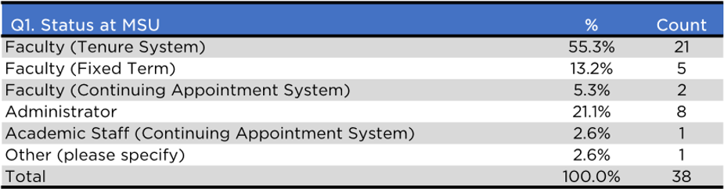
Data Tables Table 1

Table 2
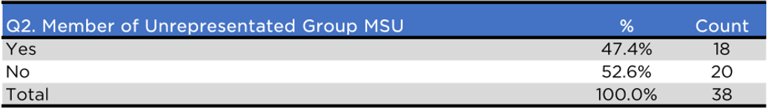

Table 3
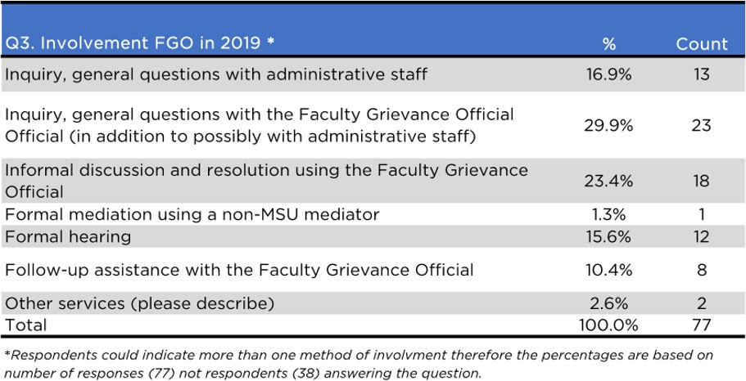

Table 4

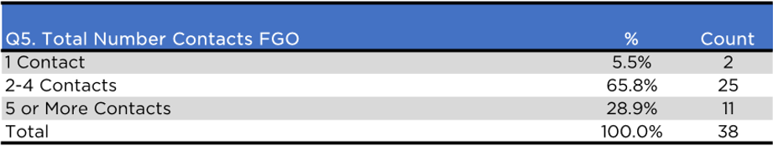
Table 5
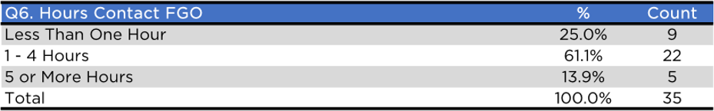

Table 6
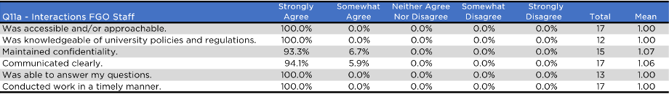
Table 7
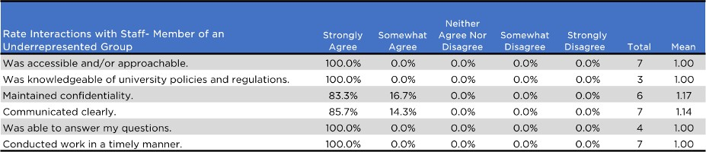

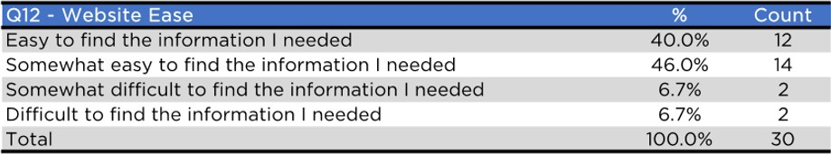
Table 8

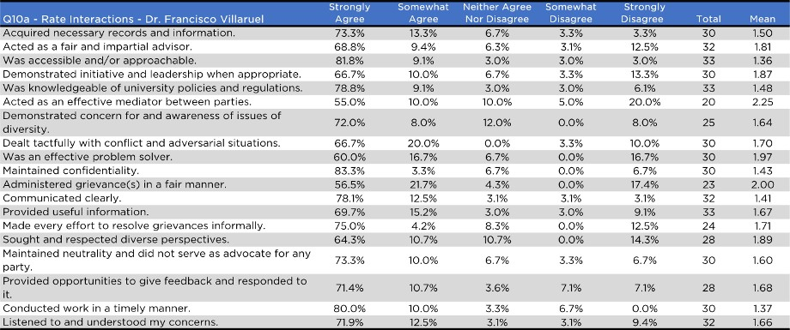
Table 9

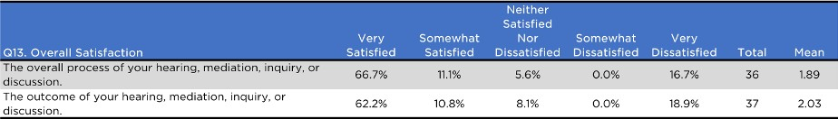
Table 10

Table 11

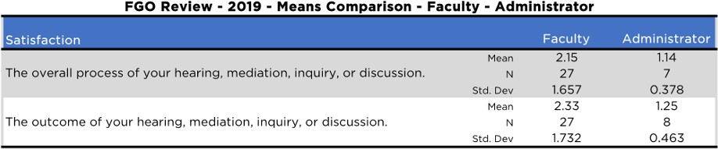

Appendix 2, Review of the FG Office and FG Official from the 2020 Calendar Year

April 16, [2021]
To: Dr. Richard Fulton, Chair
University Committee on Faculty Affairs

From: Dr. Mark Waddell, Chair UCFA Personnel Subcommittee

Subject: Faculty Grievance Official--Annual Review

The Personnel Subcommittee of the University Committee on Faculty Affairs has completed its annual review of the Faculty Grievance Official, Dr. Francisco Villarruel, and the Faculty Grievance Office for the calendar year 2020.

The survey used this year was amended and improved in consultation with Dr. Villarruel and with the rest of the Personnel subcommittee, to provide more useful and actionable feedback to the FGO. In preparing its report the subcommittee worked with Karen Clark, Senior Project Manager in the Office of Survey Research, to survey those using the services of the Faculty Grievance Office during the year. Surveys were sent to 90 individuals whose names were provided by the Faculty Grievance Office. Thirty-four (34) of those individuals completed the survey, for a 38% response rate. The number of individuals interacting with the FGO was lower in 2020 than in 2019, but the response rate to the survey was higher than in 2019 (when it was 31.2%).

Use of the Office in 2020

To give an idea of who used the Faculty Grievance Office during 2020, information about those who responded to the survey is shown in Tables 1 and 2. The largest group of users were faculty in the tenure system (70.6%). Of those who completed the survey, 14.7% identified themselves as members of an underrepresented group at MSU (down from 47.4% last year).

Most interactions with the office in 2020 were general inquiries and informal discussions, as seen in Table 3. Respondents were asked to choose all answers that applied. The methods of contact, number of contacts, and hours of contacts are shown in Tables 4 and 5.

Impressions of the Office Staff and Website

The staff in the Faculty Grievance Office remained the same over the year. Table 7 shows that respondents indicated overwhelmingly favorable impressions of the staff as accessible and approachable, able to communicate clearly, conduct work in a timely manner, maintain confidentiality, and were knowledgeable of university policies and to be able to answer questions.

When asked about ease of use of the website, most respondents found it easy (58.3%) or somewhat easy (25%) to use, although 16.6% found it difficult or very difficult to use (Table 10).

Impressions about Interactions with Professor Francisco Villarruel

Out of the 34 respondents that completed the survey, all of them had interactions with Professor Villarruel. The ratings of those interactions are shown in Table 6. Since the number of responses to the survey represents merely 38% of those faculty who interacted with the office, it is very difficult to draw rigorous conclusions from this data set.

Dr. Villarruel received his highest ratings for being approachable, responding to inquiries in a timely manner, his knowledge of university policies and regulations, and his willingness to schedule meetings at times that were convenient for respondents.

The lowest ratings overall reflect respondents’ beliefs that Professor Villarruel did not administer grievances in a fair and impartial manner, did not acknowledge when he did not know the answer to particular questions or concerns, and did not administer grievances in accordance with the Faculty Grievance Policy. Note that even though these were among the lowest scores, around 85% of respondents either strongly or somewhat agreed that Professor Villarruel performed these tasks well, meaning that these ratings reflect only a small minority of an already small sample size.

Table 11 provides a means comparison of these ratings between individuals who self-identified as members of an underrepresented group and those who did not. Because the N for underrepresented individuals is extremely small (4-5 individuals) the results here are tenuous at best. However, there is a stark difference in the responses between these two cohorts from this year, with individuals from underrepresented groups reporting significantly lower levels of agreement and/or satisfaction with the items surveyed, especially in responding to the question of “acted as an effective mediator between parties.”

Table 8 includes a question about overall satisfaction “with the outcome of your hearing, mediation, inquiry, or discussion.” This question has been posed in past surveys and, when he worked with the subcommittee to revise the 2020 survey, Dr. Villarruel identified this question in particular as not helpful. He proposed a rewording that asked about satisfaction with the FGO’s adherence to the Faculty Grievance Policy, and we submitted this rewording to Karen Clark for inclusion in this survey. Unfortunately, this revision did not make its way into the survey, and we are unable to draw conclusions that are helpful. Hopefully, future iterations of the survey will include the revised language.

Open-Ended Comments

The survey allowed for open-ended comments and suggestions for improvement. There were comments commending Dr. Villarruel on being courteous, dedicated, and available. Several respondents indicated that they were unaware of the 30-day time limit on filing a grievance,

and/or felt that this was an unreasonably short length of time. There are also comments expressing a belief in the partiality of the FGO toward administration (a common theme in previous iterations of this survey going back several years).

Conclusions and Recommendations

Overall, the ratings across the survey were positive with no areas seen as especially problematic.

Moving forward, the committee suggests that:

- Professor Villarruel review the table of rankings with a goal towards identifying skills to work on, and consider how the office might address the differences between respondent groups evident in Table 11 if Professor Villarruel believes this would be worthwhile.
- Professor Villarruel consider creating a survey that can be sent to individuals as soon as their interactions with the FGO are finished. With the present survey, if an individual interacted with the FGO in January of 2020 they only received a survey in March of 2021. This significant lag might account for the historically
- Professor Villarruel work to improve the amount of information available on the FGO website – for example, ensuring that basic information such as timeline required to file a grievance, role of the FGO, etc., is presented clearly and immediately upon reaching the website. Asking or requiring individuals to consult the Faculty Grievance Policy to find answers to basic or common questions may discourage some people from using the office, and/or may make it more likely for faculty to make a mistake in filing a grievance.

Data Tables
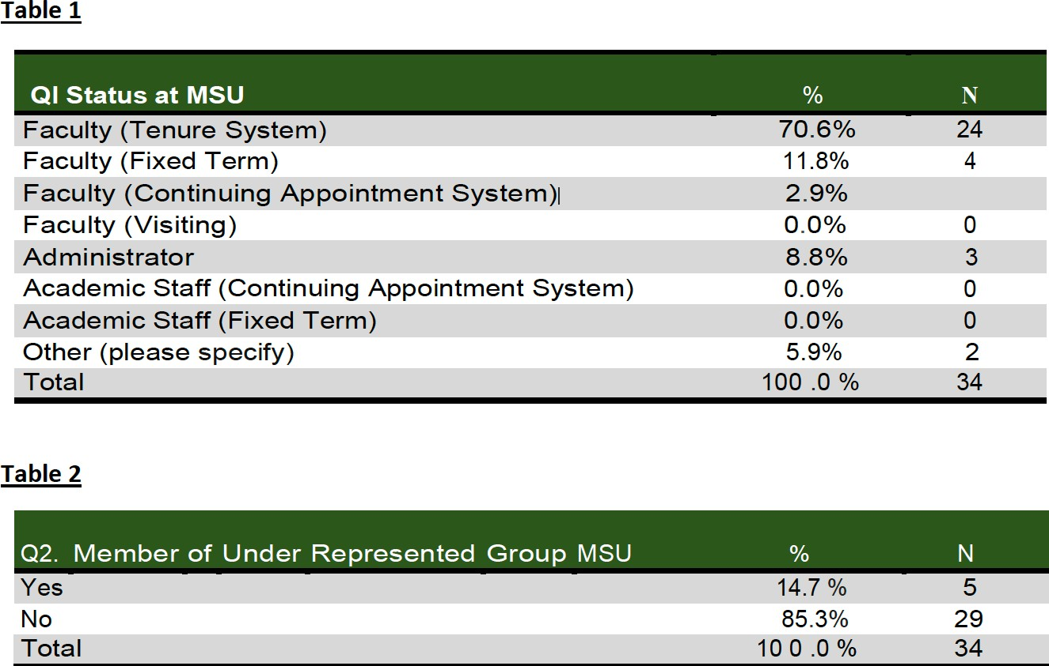

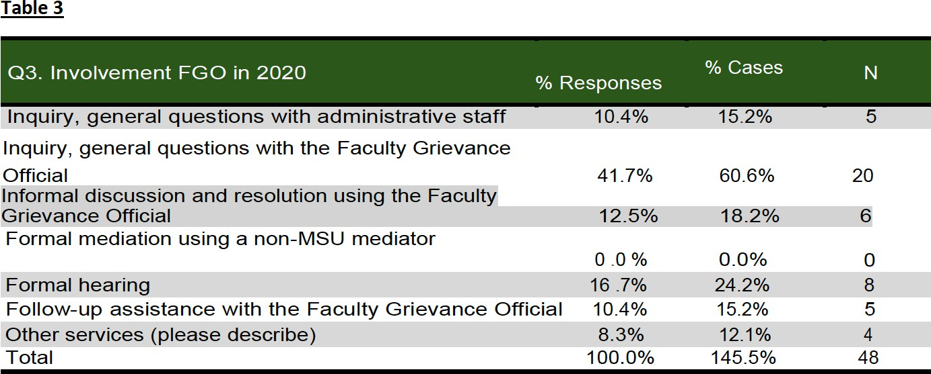
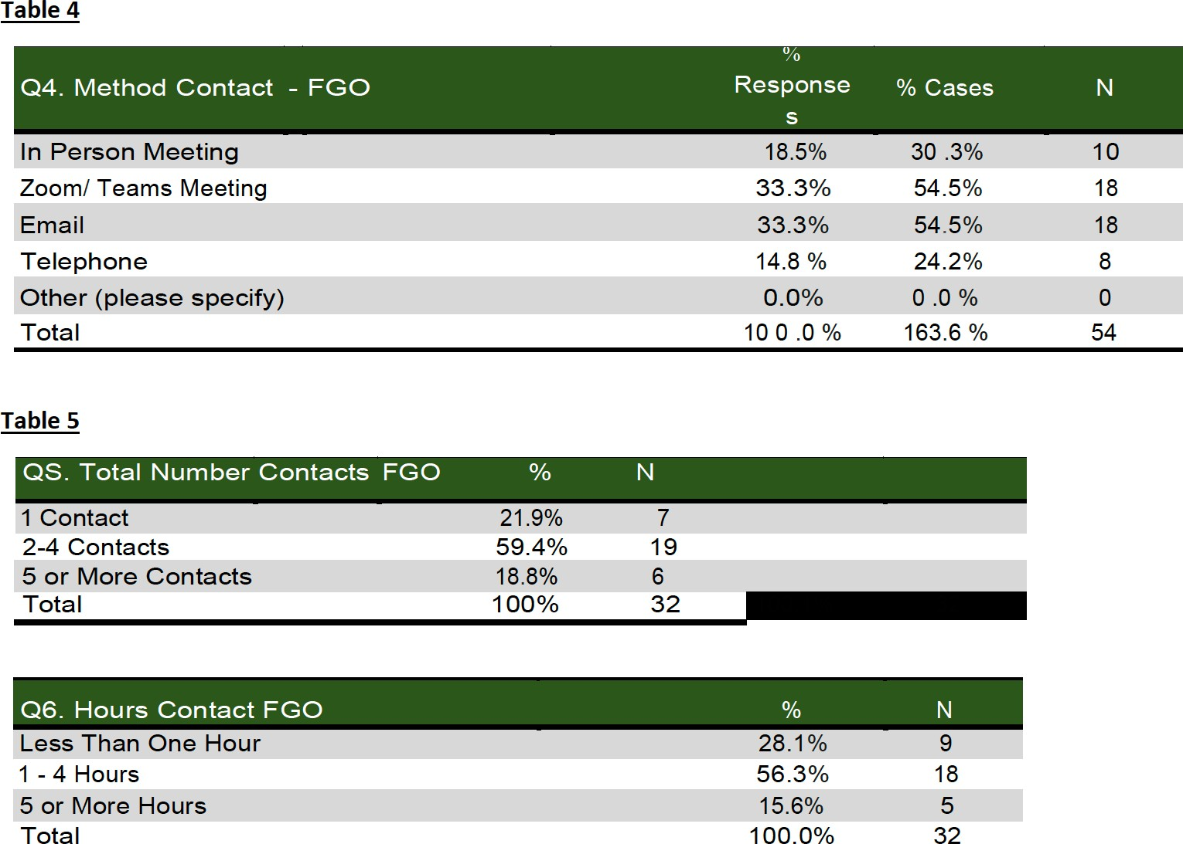

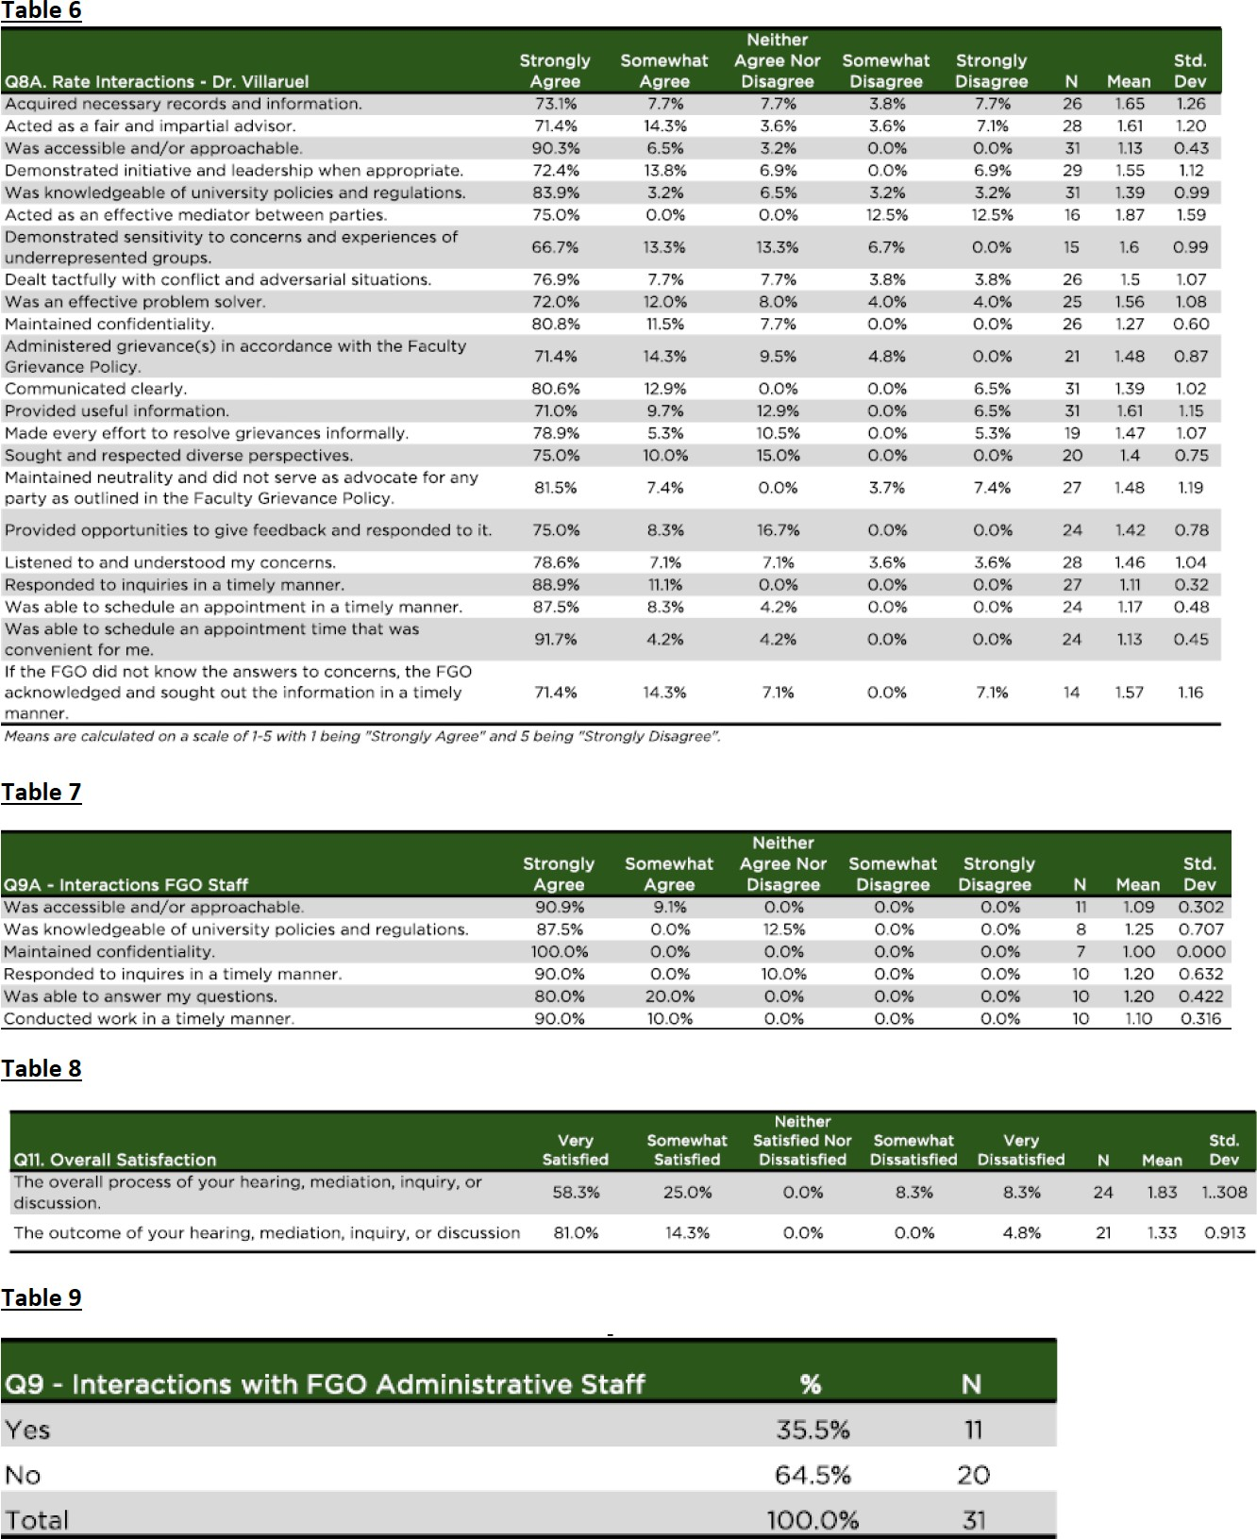

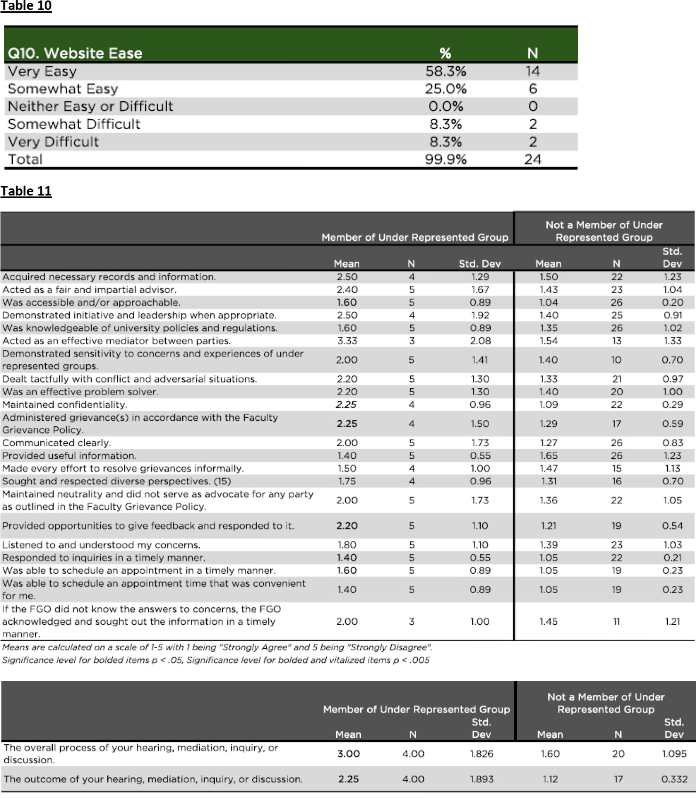

Appendix 3, Review of the FG Office and FG Official from the 2021 Calendar Year

April 26, 2022

To: Dr. Richard Fulton, Chair
University Committee on Faculty Affairs

From: Dr. Claudia Finkelstein, Chair UCFA Personnel Subcommittee

Subject: Faculty Grievance Official--Annual Review

The Personnel Subcommittee of the University Committee on Faculty Affairs has completed its annual review of the Faculty Grievance Official, Dr. Francisco Villarruel, and the Faculty Grievance Office for the calendar year 2021.

The survey used this year was the same as that used in 2020 (other than minor wording changes)

The subcommittee is extremely grateful to Karen Clark, Senior Project Manager in the Office of Survey Research who surveyed those using the services of the Faculty Grievance Office during the year.

Surveys were sent to 82 individuals whose names were provided by the Faculty Grievance Office. Forty of those individuals completed the survey, for a much improved 51.2% response rate (compared with 38% for 2020 and 31.2% in 2019.) Two people declined consent for their information to be used in this report.

The number of individuals interacting with the FGO was lower in 2021 than in 2020. There is a general consensus in the world of survey research that making comparisons to any data collected during the pandemic should be done with caution or not at all. Any differences between 2020 – 2021 should not be taken as a signal for change but if the trend continues in subsequent years then it could be indicative of an issue.

Use of the Office in 2021

Table one shows the distribution of utilizers of FGO in 2021. Again, as in 2020 the largest group of users were faculty in the tenure system (in 2021 55.3% down from 70.6% in 2020).

Of those who completed the survey, 45.9% identified themselves as members of an underrepresented group at MSU (more consistent with the number in 2019 47.4% than with the 14.7% in 2020 - perhaps an outlier?).

Interactions with the office in 2021 were once again many general inquiries and informal discussions, as seen in Table 2. Of note a full 25.4% of interactions resulted in informal resolution. Respondents were asked to choose all answers that applied.

Table 2 also includes methods of contact.

Table 3 contains the number of contacts and contact hours of survey respondents. Of note, 13.5% had 5 or more hours of contact with the FGO.

Informal/Formal Resolution

The majority of cases (91.7%) were handled informally as seen in Table 4. This is work taken on by FGO, sparing those offices involved in formal process.

Table 4 also demonstrates the roles of the involved parties. There was 100% agreement on full adherence to policy by the three individuals involved in formal grievance.

Impressions of the Office Staff
The staff in the Faculty Grievance Office remained the same over the year. Table 5 shows that respondents indicated overwhelmingly favorable impressions of the staff as accessible and approachable, able to communicate clearly, conducting work in a timely manner, maintaining confidentiality, knowledgeable of university polices and to be able to answer questions.

Impressions about Interactions with Professor Francisco Villarruel
Out of the 38 respondents that completed the survey and allowed use of their data, 97.2% of them had interactions with Professor Villarruel. The ratings of those interactions are shown in Table 6.
Dr. Villarruel again received his highest ratings for being approachable, responding to inquiries in a timely manner, his knowledge of university policies and regulations, and his willingness to schedule meetings at times that were convenient for respondents.
The lowest rating, in fact the only one with fewer than 50% “strongly agree” responses, was that Francisco Villarruel did not act as an effective mediator between parties. This may be partly explained by the false belief that the FGO is a faculty advocate rather than a neutral party. The comments section will develop this further. Lower scores are often influenced by the outcome or if the information given (although correct) may not be in the direction the person was hoping.
The “kill the messenger” effect.

Underrepresented Groups
When comparing the means in all categories of satisfaction which were surveyed (see Table 7) the trend was lower satisfaction in underrepresented groups. The reason is unclear. Of note, differences between the two groups were not statistically significant. On most climate surveys, etc members of underrepresented groups have lower satisfaction scores across items.

Open-Ended Comments
The survey allowed for open-ended comments and suggestions for improvement. There were comments commending Dr. Villarruel.

There were a number of comments reflecting lack of clarity in the role of the FGO. Comments wishing for an orientation on the office and its role. Also, several questions from people opposed to vaccine mandates and where and how to “grieve” these.

Conclusions and Recommendations

Overall, the ratings across the survey were positive with no areas seen as especially problematic.
Moving forward, the committee suggests that:
  - Professor Villarruel be commended for the informal resolution of most issues and the generally high rates of satisfaction with both the Faculty Grievance office and officer.
  - The institution consider broadening the role of the ombuds to assist in faculty: faculty disputes while clarifying the role of the FGO as the person ensuring fidelity to the process of the grievance as opposed to the misperception that the FGO is a faculty advocate.
  - Professor Villarruel review the table of rankings with a goal towards identifying skills to work on, and consider how the office might address the differences between underrepresented and other respondent groups.
  - Professor Villarruel and his office work to expand knowledge of the existence and role of the FGO at MSU.
  - That the administration considers a merit raise for FGO.

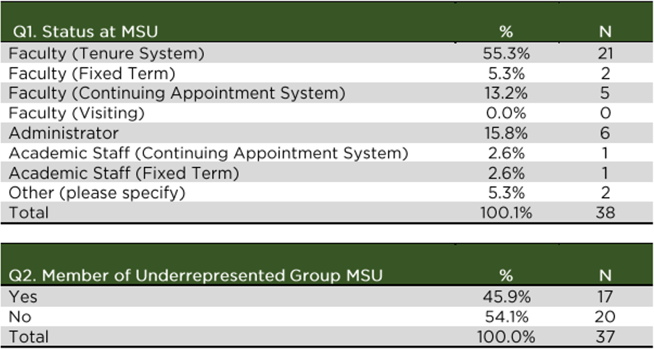
Data Tables Table 1

Table 2
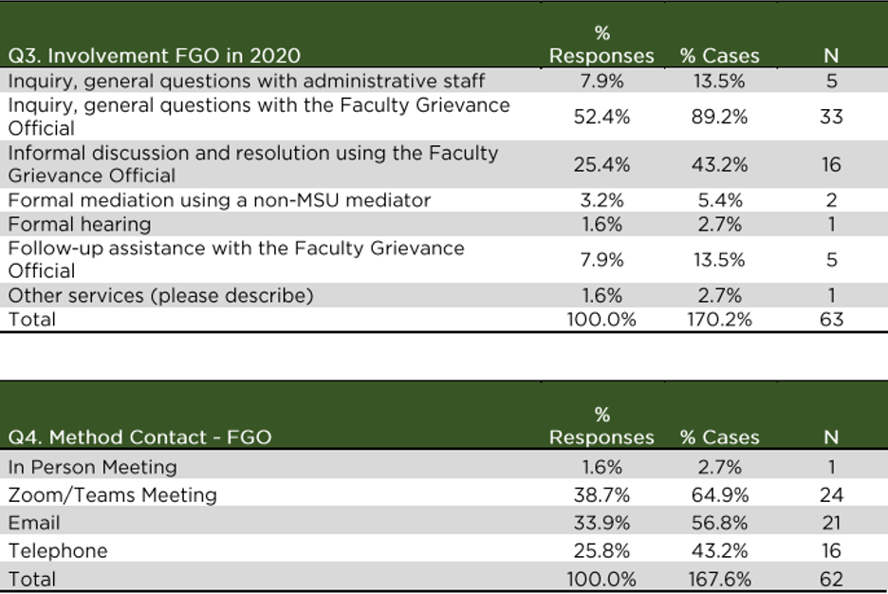

Table 3
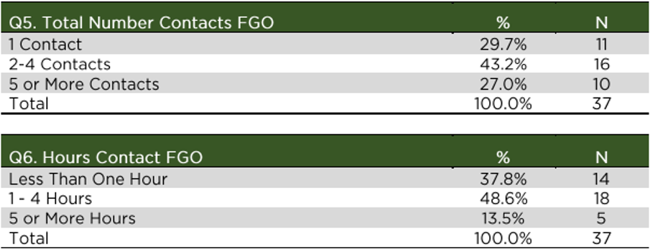

Table 4
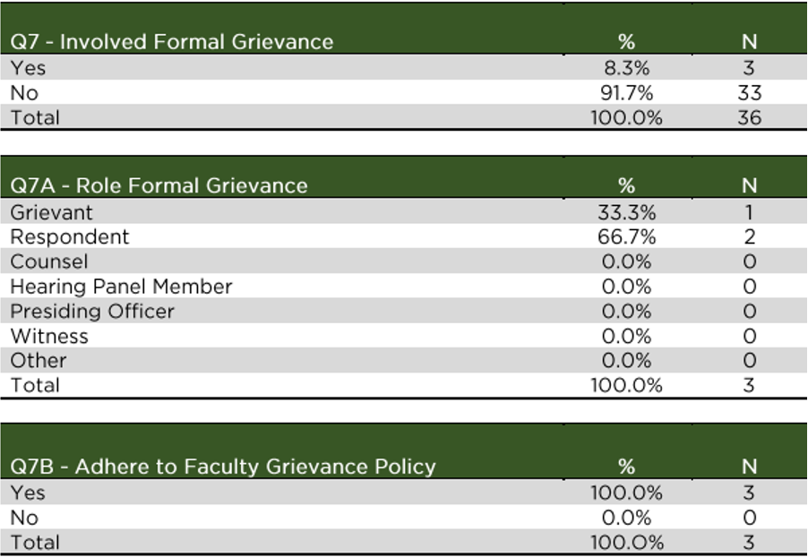

Table 5
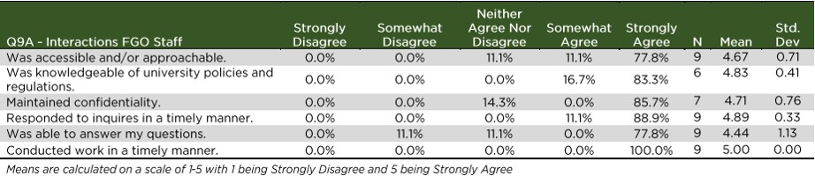

Tables 6
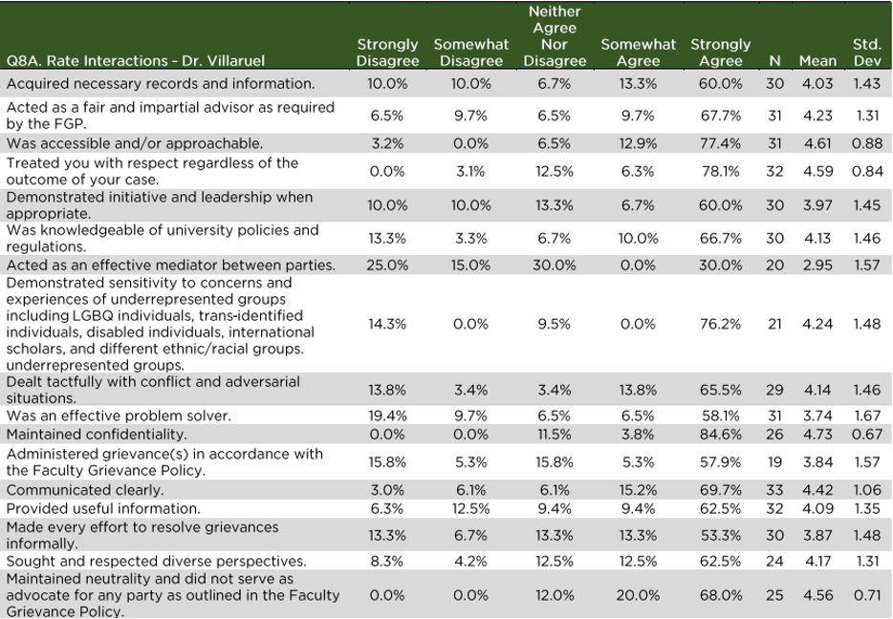
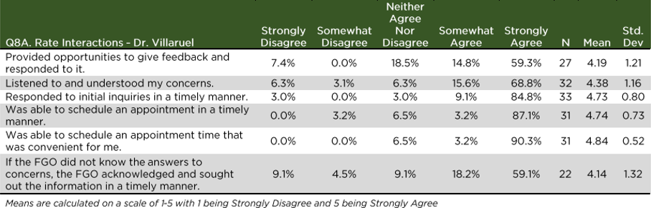

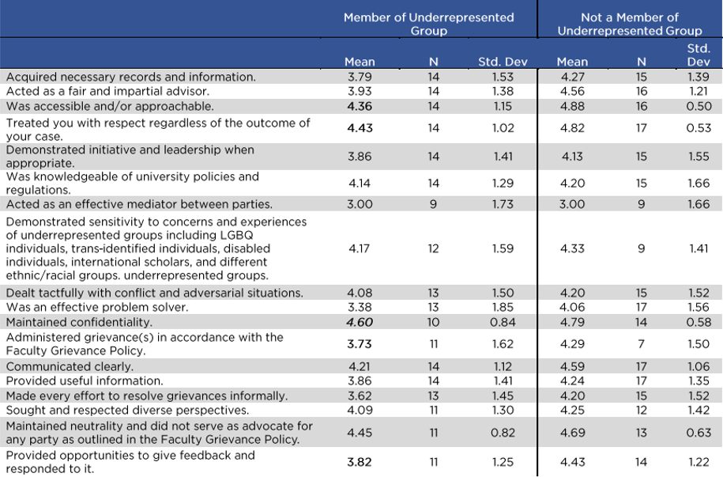
Table 7

Table 8

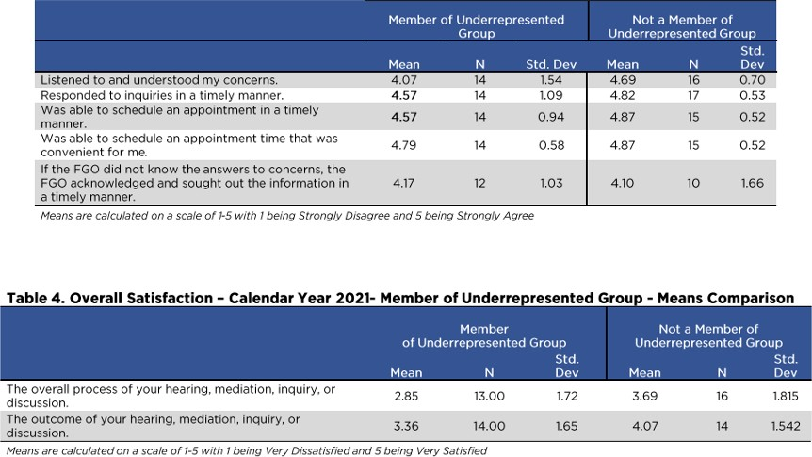

Appendix 4, Review of the FG Office and FG Official from the 2022 Calendar Year
April 6, 2023

To: Dr. Jamie Allan, Chair
University Committee on Faculty Affairs

From: Dr. Peter White, Chair
UCFA Personnel Subcommittee

Subject: Faculty Grievance Official--Annual Review

The Personnel Subcommittee of the University Committee on Faculty Affairs has initiated its annual review of the Faculty Grievance Official, Dr. Francisco Villarruel, and the Faculty Grievance Office for the calendar year 2022. The below review was compiled for the purposes of being included in the broader 3-year review of Dr. Villarruel, which has been assembled for the purposes of making a recommendation to the Provost regarding Dr. Villarruel’s reappointment. At the time of the writing of this 3-year review document, this 2022 annual review of the FG Official and the FG Office has not been reviewed by the UFCA Personnel Subcommittee.

The survey used this year was the same as that used in 2021 (other than minor wording changes).

The UCFA is extremely grateful to Karen Clark, Senior Project Manager in the Office of Survey Research who surveyed those who used the services of the Faculty Grievance Office during the 2022 calendar year.

Surveys were sent to 85 individuals whose names were provided by the Faculty Grievance Office. Responses were received from 32 individuals, corresponding to a 37.6% response rate. This rate is comparable to the survey response rates from the preceding three years (i.e., response rates were 51.2% in 2021, 38% in 2020, and 31.2% in 2019.)

In 2022, 11 formal grievances were filed. Of these, five resulted in jurisdictional findings, two were filed as appeals, one was referred to OIE, one is being held in abeyance, and two are pending resolution. The FGO engaged in 99 zoom, phone, and in-person conferences with faculty, administrators, and other relevant individuals. The FGO also engaged in 543 pieces of correspondence over email with the same constituency. These engagement rates are similar to the rates in 2019 and 2021; engagement rates in 2021 were lower, possibly as a result of the pandemic.

Survey Demographics: Use of the Office in 2022

Table 1 shows the assignment distribution of survey respondents who engaged the services of the FGO in 2022. The largest group of survey respondents were Faculty in the tenure system (50%), followed by Administrators (31.3%) and faculty outside of the tenure system (6.3%).

Of those who completed the survey, 43.3% identified themselves as a member of an underrepresented group at MSU (Table 2).

Among survey respondents, the majority of interactions with the FGO consisted of general questions (75%) and informal resolution-oriented discussions (59%; Table 3). Note, the case numbers sum to greater than 100% because respondents could choose more than one answer.

A majority of survey respondents interacted with the FGO for between 1 and 4 hours (69.8%; Table 4).

Informal/Formal Resolution

The majority of cases involving survey respondents did not involve a formal grievance (90.6%; Table 5.) Those who engaged in a formal grievance process all agreed that Dr. Villarruel adhered to the appropriate Faculty Grievance Policy.

Impressions of the Office Staff
Survey respondents were also polled on their interactions with the Faculty Grievance Office Staff (Table 6). Of respondents who provided feedback in their interactions with the FGO Staff, all but one Somewhat or Strongly Agreed that the staff members were accessible and approachable, knowledgeable of university policies and regulations, maintained confidentiality, responded in a timely manner, were able to answer questions, and conducted work in a timely manner. The dissenting survey respondent Strongly Disagreed with most of these FGO Staff qualities, and was Neutral on the matters of policy knowledge and confidentiality.

Impressions about Interactions with Professor Francisco Villarruel
Out of the 32 respondents that completed the survey and allowed use of their data, 100% had interactions with Professor Villarruel (see Table 7 for full response data). Dr. Villarruel received his highest ratings for being approachable, maintaining confidentiality, engaging respondents with clear communication, knowledge of university policies and regulations, responding to inquiries in a timely manner, and scheduling appointments in a convenient and timely manner. In addition, Dr. Villarruel received exemplary scores across the vast majority of the 23 questions posed regarding his interactions with survey respondents (Table 7).
Two questions where Dr. Villarruel received more mixed scores probed survey respondent opinion on his ability to act as an effective mediator between parties and his ability as an effective problem solver. In these instances, upwards of 70% of respondents Somewhat or Strongly agreed that Dr. Villarruel, with the remaining ~30% providing neutral or dissenting ratings. The open-ended comments provided by respondents at the end of the survey might provide some clarity on the reasons for some of these lower scores. For example, three

comments expressed dissatisfaction that the Faculty Grievance Official/Office were not better advocates for faculty in disputes and grievance processes. This reflects a misunderstanding of the role of the FG Office and FG Official. In one dissenting comment, the respondent felt that Dr. Villarruel was overly focused on reaching an informal resolution, and felt discouraged from entering into a formal grievance process that the FGO felt the respondent “wouldn’t win.” They then concluded the comment wondering whether there was a hidden agenda of the FG Office/Official to discourage cases from formal proceedings.

Underrepresented Groups
Respondents who self-identified as being a member of an underrepresented group (n = 13) were generally less-satisfied with their interactions with the FG Official than respondents who did not self-identify as being a member of an underrepresented group (n = 17). Although all scores were more positive than negative (Table 8), most notable amongst the lower scores was regarding respondent opinion on whether Dr. Villarruel was an effective mediator between parties, where 44% Strongly Disagreed. In following up with Dr. Villarruel, he provided these reflections, and two example scenarios:
—
From Correspondence from Dr Villarruel to Dr. White on 3/28/2023 and 3/29/023
[I wonder] this is tied to their disappointment that their issues are not always supported by policy as much as they hoped. Often, time is spent helping individuals to identify the appropriate policy and this itself is both laborious and eye opening for grievant. They begin to see that there may not be the desired recourse.
…..
An example – a faculty member was not pleased with the approach utilized by the unit director. However, as defined in the Unit bylaws, the unit director was conducting unit business in accordance with the existing bylaws. The faculty member did not agree with what was stated in the bylaws. The faculty member insisted that the unit director was acting in a way that was inequitable. We discussed alternatives (e.g., that they were within their rights to bring it to the attention of the unit to propose modifications of policy) but that from a review of the unity bylaws the chair was following the bylaws. Moreover, we discussed what the risk/benefit of their pursuing the issue would do to the long-term climate in the unit, and whether there were informal ways that could be approached to address the issue of concern. Did the faculty member (a person of color) get the desired outcome? Perhaps, and then again, maybe not.
……
I continue to strive, and enroll in webinars dealing with meditation and persons from underrepresented groups.
—
From Correspondence from Dr Villarruel to Dr. White on 3//31/2023
Early fall, we received a document (well over 50 pages) from a faculty member (African American) [who] was reassigned [their] teaching responsibilities. The faculty member is a tenured full professor. There were multiple issues leading to the reassignment (i.e., SIRS, student complaints) that were mentioned by the faculty member. Also, throughout [their written

request] the faculty member raised the issue that there were historical acts of discriminatory practices that had impacted their standing within the unit. The term “discrimination” was used numerous times.

[My] initial response to the faculty member was that if they wanted to process this matter through the Faculty Grievance Office, the term ‘discrimination’ would need to be removed as OIE has jurisdiction over MSU’s Anti Discrimination Policy (ADP). The faculty member disagreed and stated that they did not trust OIE, and instead wanted the FGO to process this. The FGP [Faculty Grievance Policy] was shared, along with the specific language that states that the FGO does not have jurisdiction on issues related to Title IX. Despite the documentation provided, the faculty member insisted that the FGO did in fact have jurisdictional responsibility to process their concerns, with the focus on historical (over 20 years) perceived discriminatory actions that they believe were directed at them.

—

Open-Ended Comments
The survey allowed for open-ended comments and suggestions for improvement.

There were comments commending Dr. Villarruel. Thirteen survey respondents provided general comments. Of these, seven of these were positive, commending Dr. Villarruel for his work in his role as the FG Official. Three comments were critical of the technical jurisdiction of the FG Office itself; three were critical (or implied criticism) of Dr Villarruel’s performance. A separate open-ended question probed respondents for suggested improvements; 12 respondents provided a response. Within these, the most common sentiment (n = 4) was that the grievance process itself should be run through an office that is external to MSU to ensure that it is truly an “unbiased third party.” The other comments predominantly consisted of either praise or critique of Dr. Villarruel, often directly citing either a favorable or unfavorable outcome (respectively) of their grievance experience.

Conclusions and Recommendations

Overall, the ratings across the survey were positive with no areas seen as especially problematic.

The UCFA makes no recommendations stemming from this year’s annual review in lieu of the forthcoming 3-year review and report of Dr. Villarruel’s work in his tenure as the FG Official.

Data Tables Table 1
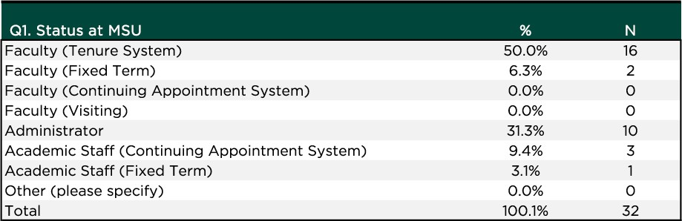

Table 2
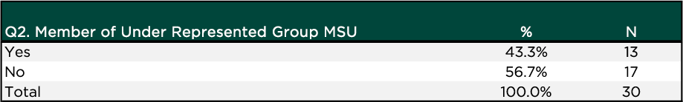

Table 3
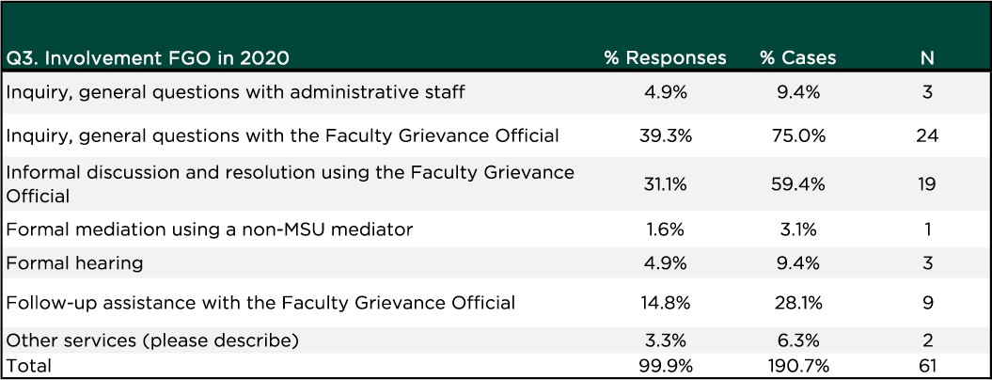

Table 4
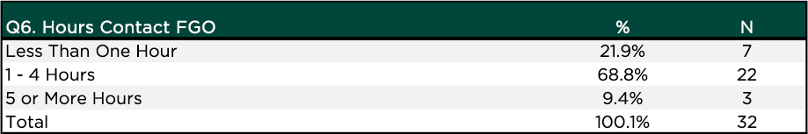

Table 5
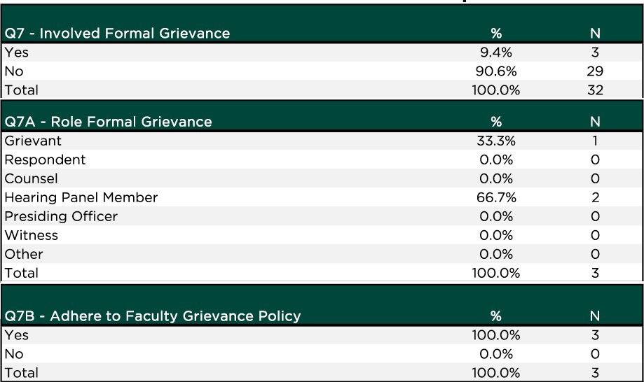

Table 6
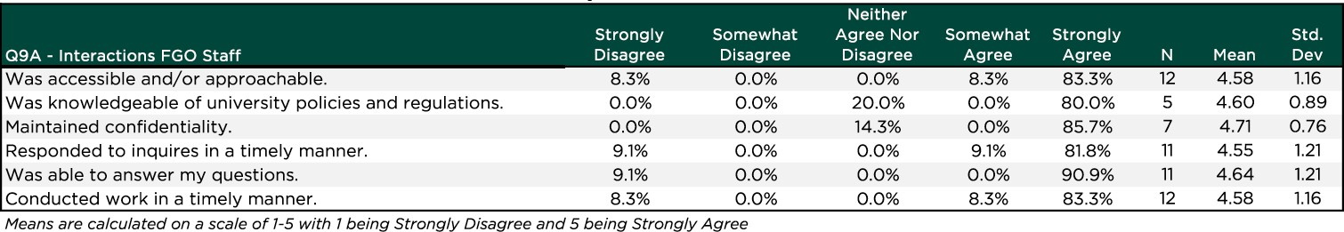

Table 7
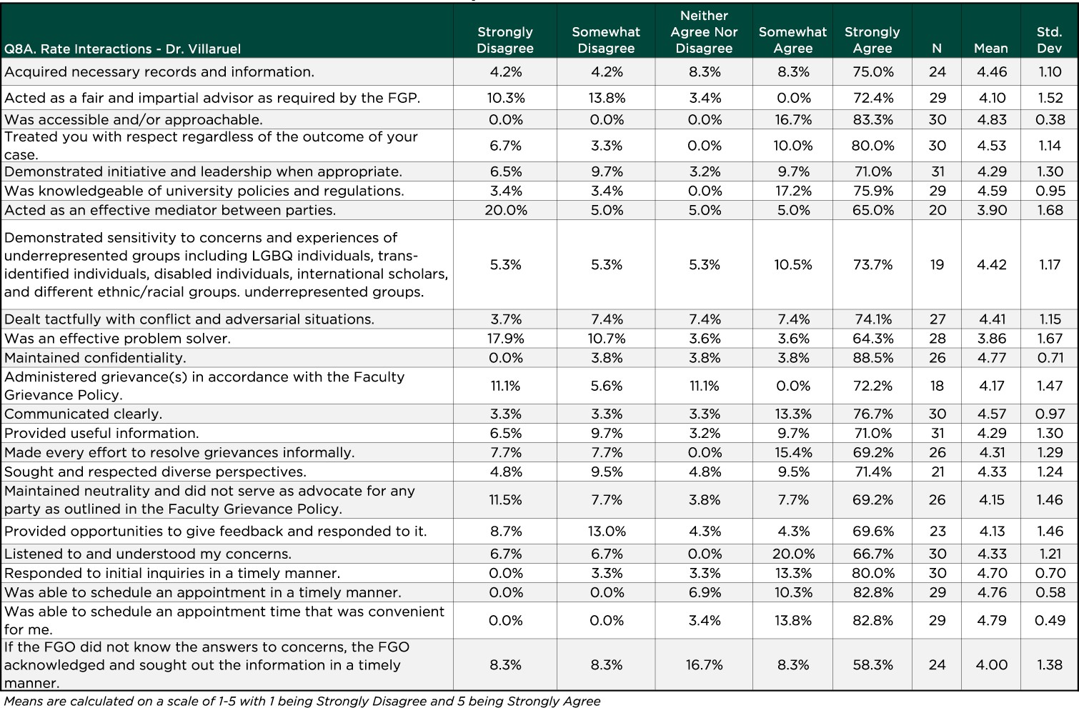

Table 8
