Present: J. Aerni-Flessner, J. Alan, A. Austin, K. Bieda, C. Borchgrevink, J. Fitzsimmons, M. Helton, B. Holtz, N. Lajevardi, D. McCole, T. Pence, F. Ravitch, J. Schaeffer, J. Schuster-Craig, T. Silvestri,
T. Thrush, F. Villarruel, L. Walesby, D. Weatherspoon, P. White, H. Wu
Absent: J. Buchweitz, T. Craig, E. Rapinchuk
A regular meeting of the University Committee on Faculty Affairs was held on April 25, 2023 at 1:00 p.m. in the Corniche Room of the Kellogg Center with Chairperson Jamie Alan presiding. The agenda was approved as presented. The draft minutes of the April 11, 2023 meeting were approved as presented.
Chairperson Alan, Interim Associate Provost for Faculty and Academic Staff Affairs Ann Austin, Associate Provost of Enrollment and Strategic Planning Dave Weatherspoon, and Faculty Grievance Official Francisco Villarruel gave remarks.
Review of the Faculty Grievance Official [2223-15]
FGO Villarruel excused himself from the room, after which the subcommittee responsible for the review of the Faculty Grievance Official presented its report. Following discussion, the committee approved the report, which is on file with the Office of the Provost and the Office of Academic Governance.
Adjournment
The meeting adjourned at 2:51 p.m.
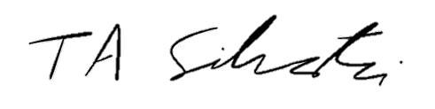
Tyler Silvestri
Secretary for Academic Governance
Approved:

