Present: J. Alan, A. Annis, A. Austin, J. Buchweitz, B. Cantwell, S. Carlson, K. Prouty (for M. Helton), B. Holtz, N. Lajevardi, D. McCole, J. McElroy, T. Pence, E. Rapinchuk, A. Simon, T. Silvestri,
F. Villarruel, L. Walesby, D. Weatherspoon, J. Doherty (for P. White), K. Yermak, S. Yoder, L. Zhang
Absent: L. Zhang
A regular meeting of the University Committee on Faculty Affairs was held in Room 437 of the Hannah Administration Building and via Zoom on October 31, 2023 at 1:00 p.m. with Chairperson Jamie Alan presiding. The agenda was approved as presented. The draft minutes of the October 10, 2023 meeting were approved as presented.
Interim Vice Provost and Associate Vice President for Faculty and Academic Staff Affairs Ann Austin, Assistant Provost Kara Yermak, Faculty Grievance Official Francisco Villarruel, and Chairperson Alan gave remarks.
Modified Operations Policy
Assistant Provost Yermak presented on proposed changes to the Modified Operations policy, as well as a draft “business continuity plan” and an FAQ document. Members of the committee gave feedback, including calling for a definition of “unit” and adding an annual process for units to designate critical employees.
Faculty Healthcare Council’s Benefits Benchmarking
The chairperson shared that Faculty Healthcare Council was convening a group to benchmark faculty benefits (especially dental) at other institutions. Scott Carlson volunteered to join.
Adjournment
The meeting adjourned at 1:53 p.m., and the Personnel and Budget Subcommittees met afterward.
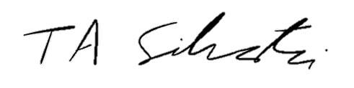
Tyler Silvestri
Secretary for Academic Governance
Approved: November 14, 2023

