October 10, 2024

To: University Committee on Faculty Tenure (UCFT) University Committee on Faculty Affairs (UCFA)

From: Teresa Mastin, Ph.D. 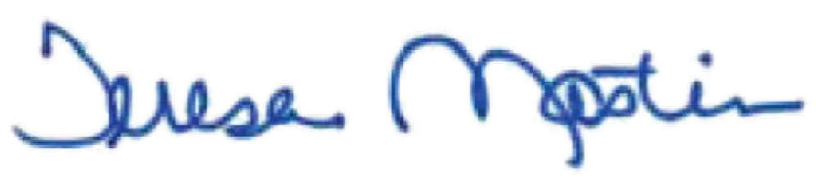

Vice Provost and Associate Vice President for Faculty and Academic Staff

Affairs

Subject: Request for Feedback on External Reference Letters Policy

Background

The [External Letters of Reference policy](https://hr.msu.edu/policies-procedures/faculty-academic-staff/faculty-handbook/external_ref-letters.html) requires letters of reference for

all reviews of tenure system faculty involving the granting of tenure or promotion.

Issue

Recently, a question arose in connection to this policy. Specifically, if a faculty member withdraws from the tenure review process after external letters have been solicited, should new referees be sought when they resubmit their tenure dossier, or is it more appropriate to request updated letters from the original referees?

Request

This issue is not addressed in policy. There are different options on how to handle this, with pros and cons to each of these options. The options we see include:

OFFICE OF THE

**PROVOST**

Michigan State University Hannah Administration Building 426 Auditorium Road, Room 430 East Lansing, Michigan 48824

Phone: 517-355-6550

Fax: 517-355-9601

provost.msu.edu

1. request letters from new referees,
2. request updated letters from the previous referees, or
3. a combination of the first two options.

Our preference is to request new external letters to ensure a fair and equitable process. This option treats the process as brand new, with referees who can provide a fresh perspective. We have concerns with reaching out to the previous reviewers and asking them to update what they submitted, as that can lead to bias in their new response. Whereas a new reviewer would have no awareness of a review that didn’t take place the year prior.

Regardless of the direction decided, we also recommend updating the current policy on external reference letters to provide greater clarity on this issue.

Thank you for your time and consideration. Attachment

Cc: Kara Yermak

MSU is an affirmative-action, equal-opportunity employer.

1D S 2E L3F FG4 T ! JG5 H P IG4 HFJH 6R"K U!J 7LO HK #1M K5$ IF%G 8HH& J9'JL (7N&O O%L 4P )GV :J* IN W QX RY H ;RHE<+DJJ9 SL X LP 5FJT#! JO P ;LG FV=H RJ<,QU- POX1 KI5#P K1R F Hc ;H_J J`>? aO a@L bAVdB CIF HW MX.Y IH#RG!FZ G[G![XI/JFPN0G/QOR!L H"E\ JI eP !W[E[FW]J^O_[`aHEaJbfIPLONTOQGRHOL\IR

wp # #/ "q , # # tus t #u ! # # ! , 't ! #! !u" y!# ! ! q t ! . u ! # . ! , ! t u !# '#!# # , " ! ! #! ," ! " s! # u } "u ,u # u #u t # #w ! u t ! ' ! ! " # ! t '# " #! . "u # .# ! xu u q# t ! # . # ! w! ! w# , " u" # ! # ! u s .u# t #q ! ! # ! " ,# "#" ! ,

ug V,sp e _#Iq"W !`uW H O aX# # "Q aY ! HtJb R! t P!h " D i` ,JK ! o ,L ! _j Xu `YP vJ# aJ ! K ]" # O ] Ju L , LI u # HL!e .I N ,#HW F !H ZqO# L j#Q PJ#M F PY , I!# `t] wG #^r`0t t#P _ _ J ` ` k ! #a a X #] ] rF !P]` J, h NI#, .#"L F# NL#, ,x,Z` ua j# ua P F l Y " m ` a # o c "t_uh " ` # n a!J s ] T !t ` !F w G_ p F IO w ,!qL *# uNG # MQ # RJ #u P u Hq# JE ! #J J ",L u !S N # L ,t O! t F#PT G J ,!J, P N#s G F Q ,H" R R .# UH! E u O J ! # Ku tS #"K L F# F uH TH J!Ju #JP .! Gr# O F! HtL" Rvt #uV"U . uI O!#s#W K X KY H R F # H#s . ZHuyJ #u [ J ["#"I,! O Fy LP G O L#

)( w+p/ 0*! , q . s ! , # #q . q # ' # w# y yu " ! # # "! !w t # #, ! ,# # s '#!, t, # #" t , , # # u u ! # #" ! , ! !" # ! t! s ut " ! #u # # !, ", # " s #" t , t!s t # t ! # , t ! # w ! t! # ! #t # s " ! ! t# u #, " !#q # !# ! w # 0# s, t t " # #! ! # . # s !#! w t u" ,# #

%"w * p z" q , , ~ .# . .  , ! !# " * , # # { ! # y, t t# w ! ,w ! uq!#* # # ,# !# u! # ! ! "# # t ~ u ! #u s * #t * # , , t #!% ! t ! ! y# !# q w ! u # !. "#! !"} " #s st "!"# ! q " #!t# # ! # ! ! #s , #u ! # # s! u#,# "! #w # 0 u" ! # !" , u ! ! # t # ,w u # | ! t !" " ! " ! !w#

! ! " # , " ! t ! # !~** ! !w

wt  u "!" #!" u t # t#, u t t #u #qt# ! u # ,! # # ty ' ,'! q ! ", " "u# # # ," " ' # # # u u # !t ! w# # # ! !.! ,q # tu' 'u, ' ,!# # # #t # " t, # # ! , , # ! #w ' ! / q ! # " w s ! } s . . #' ' . ! u' ! # } u t # #u, t t # , !# t" w 0t 's ! } " u #" . u # " ! # # x ut,# !# . "y! . ux .s s # "!. " ! # " s . " . xq!. "u u '"#u # , #u! t # # ! t,u#u # # ! "us w '! ! # s ", ! u # t # ,

#$ % # % ! *! ! " ( ( ) * & * ' !+

## / #,-. 0 #, " & ! & ,

'0#' ,-. 401 6 ' 2 5 5 65 ' 8 3 7 7 ' ' ! 5 5 + 5 ' ' 7 56 ' ' 5 ' 5 + 5 ' ' 0 5 " * 6 ) 5 5

',< 1 / " / 5 ' ; "9 : 6 :