University Committee of Faculty Affairs
Draft Minutes
December 10, 2024

Present: J. Alan, A. Annis, A. Broglin-Peterson, J. Buchweitz, B. Cantwell, S. Carlson, B. Holtz, N. Lajevardi, Masani, T. Mastin, D. McCole, L. MacDonald, J. Morningstar J. McElroy, T. Pence, K. Prouty (for M. Helton), A, Simon, F. Villarruel, D. Weatherspoon K. Yermak,

Absent: S. Carlson, S. Yoder, E. Rapinchuk

Guests: A. Lamborghini, V. Nelson, A. Wilson

A regular meeting of the University Committee on Faculty Affairs was held via Zoom on
December 10, 2024 at 1:00 p.m. with Chairperson Jamie Alan presiding. The agenda was approved as written. The draft minutes from November 26, 2024, were approved.

T. Mastin Vice Provost and Associate Vice President for Faculty and Academic Staff Affairs , D. Weatherspoon, Vice Provost of Enrollment and Academic Strategic Planning and Chairperson Alan gave remarks.

New Business

Faculty Conflict Management Working Group formation J. Alan and K. Yermak- The committee discussed and endorsed the formation of an ad hoc working group to discuss faculty conflict management.

Revised COI/Outside Activities policy- update A. Lamborghini and K. Yermak The group met to discuss this policy further and provide feedback.

Roundtable
No items were discussed.

Adjournment
The meeting was adjourned at 2:15 p.m. and the subcommittees met afterward.
Prepared by:

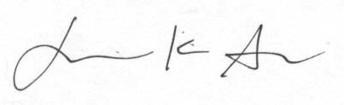
Jamie K. Alan PharmD PhD
Chairperson, UCFA

Approved

