University Committee of Faculty Affairs
Draft Minutes
January 14, 2025

Present: A. Annis, A. Broglin-Peterson, J. Buchweitz, B. Cantwell, B. Holtz, N. Lajevardi, Masani, T. Mastin, D. McCole, L. MacDonald, J. Morningstar J. McElroy, T. Pence, K. Prouty (for M. Helton), A, Simon, F. Villarruel, D. Weatherspoon, K. Yermak, E. Rapinchuk

Absent: J. Alan, S. Carlson, S. Yoder

Guests: A. Lamborghini

A regular meeting of the University Committee on Faculty Affairs was held via Zoom on January 14, 2025 at 1:00 p.m. with Vice Chairperson Bree Holtz presiding. The agenda was approved as written. The draft minutes from December 12, 2024, were approved.

T. Mastin Vice Provost and Associate Vice President for Faculty and Academic Staff Affairs gave remarks.

New Business
  - Ad-Hoc Conflict of Commitment Policy Working Group. The committee discussed the best way to advance this policy. The group voted to steer this to the personnel subcommittee to work on and advance this policy.
  - Faculty Raise Memo- A draft of the faculty raise memo was discussed. The memo was approved by the committee.

Roundtable
No items were discussed.

Adjournment
The meeting was adjourned at 2:00 p.m. and the subcommittees met afterward.
Prepared by:

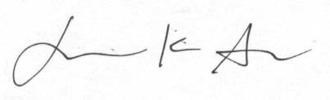
Jamie K. Alan PharmD PhD
Chairperson, UCFA

Approved

