University Committee of Faculty Affairs
Draft Minutes
January 28, 2025

Present: J. Alan A. Annis, A. Broglin-Peterson, J. Buchweitz, B. Cantwell, B. Holtz, (N. Hsieh (for N. Lajevardi), Masani, T. Mastin, D. McCole, L. MacDonald, J. Morningstar J. McElroy, T. Pence, K. Prouty (for M. Helton), E. Rapinchuk, A, Simon, F. Villarruel, D. Weatherspoon, and K. Yermak,

Absent: S. Carlson, S. Yoder

Guests: A. Lamborghini, V. Nelson, N. Schmidtke

A regular meeting of the University Committee on Faculty Affairs was held via Zoom on
January 28, 2025 at 1:00 p.m. with Chairperson Jamie Alan presiding. The agenda was approved as written. The draft minutes from January 13, 2025, were approved.

T. Mastin Vice Provost and Associate Vice President for Faculty and Academic Staff Affairs gave remarks.

New Business
- External Letters of Reference- This policy was reviewed and endorsed by UCFA.

- Course Fee Courtesy policy- This policy was reviewed and endorsed by UCFA

- Faculty Raise Memo- The memo was reviewed and feedback from the Provost was considered. The memo was approved with no new revisions.

Roundtable
No items were discussed.

Adjournment
The meeting was adjourned at 2:00 p.m. and the subcommittees met afterward.
Prepared by:

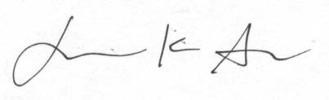
Jamie K. Alan PharmD PhD
Chairperson, UCFA

Approved

