University Committee of Faculty Affairs
Draft Minutes
February 11, 2025

Present: J. Alan A. Annis, J. Buchweitz, B. Cantwell, B. Holtz, N. Lajevardi, Masani, T. Mastin, D. McCole, L. MacDonald, J. Morningstar J. McElroy, T. Pence, K. Prouty (for M. Helton), A, Simon, F. Villarruel, D. Weatherspoon, and K. Yermak,

Absent: A. Broglin-Peterson, E. Rapinchuk S. Carlson, S. Yoder

Guests: A. Lamborghini, N. Schmidtke

A regular meeting of the University Committee on Faculty Affairs was held via Zoom on
February 11, 2025 at 1:00 p.m. with Chairperson Jamie Alan presiding. The agenda was approved as written. The draft minutes from January 28, 2025, were approved.

T. Mastin Vice Provost and Associate Vice President for Faculty and Academic Staff Affairs, D. Weatherspoon, Vice Provost of Enrollment and Academic Strategic Planning, Francisco A. Villarruel Faculty Grievance Official and Chairperson Alan gave remarks. gave remarks.

New Business

Institutional Base Salary The committee discussed this agenda item and steered further consideration of this item to the policy committee Paid Family Sick Leave.

Paid Family Sick Leave The committee reviewed the policy and endorsed it as presented. The committee will be able to review the best practices document (to be developed) in the future.

Roundtable
No items were discussed.

Adjournment
The meeting was adjourned at 2:00 p.m. and the subcommittees met afterward.
Prepared by:

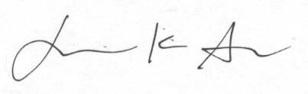
Jamie K. Alan PharmD PhD
Chairperson, UCFA

Approved

