University Committee of Faculty Affairs
Draft Minutes
February 25, 2025

Present: J. Alan A. Annis, A. Broglin-Peterson, J. Buchweitz, B. Cantwell, N. Lajevardi, Masani, T. Mastin, L. MacDonald, J. Morningstar J. McElroy, T. Pence, K. Prouty (for M. Helton), E. Rapinchuk, A, Simon, F. Villarruel, D. Weatherspoon, and K. Yermak,

Absent: B. Holtz, D.McCole, S. Carlson, S. Yoder

Guests: A. Lamborghini, N. Schmidtke

A regular meeting of the University Committee on Faculty Affairs was held via Zoom on
February 25, 2025 at 1:00 p.m. with Chairperson Jamie Alan presiding. The agenda was approved as written. The draft minutes from February 11, 2025, were approved.

T. Mastin Vice Provost and Associate Vice President for Faculty and Academic Staff Affairs, D. Weatherspoon, Vice Provost of Enrollment and Academic Strategic Planning, and Chairperson Alan gave remarks.

New Business

Update on COI policy- The committee was updated on the status of the COI policy, which was previously steered to the personnel subcommittee.

Roundtable
No items were discussed.

Adjournment
The meeting was adjourned at 1:20 p.m. and the subcommittees met afterward.
Prepared by:

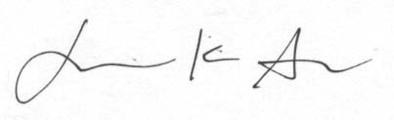
Jamie K. Alan PharmD PhD
Chairperson, UCFA

Approved

