Present: J. Alan, K. Yermak (for A. Austin), J. Buchweitz, B. Cantwell, K. Prouty (for M. Helton),
B. Holtz, N. Lajevardi, D. McCole, J. McElroy, T. Pence, E. Rapinchuck, T. Silvestri, A. Simon,
F. Villarruel, L. Walesby, D. Weatherspoon, S. Yoder, L. Zhang
Absent: S. Carlson, P. White
A regular meeting of the University Committee on Faculty Affairs was held via Zoom on September 12, 2023 at 1:00 p.m. with Chairperson Jamie Alan presiding. The agenda was approved as presented. The draft minutes of the August 29, 2023 meeting were approved with one amendment.
Assistant Provost Kara Yermak gave remarks on behalf of herself and Interim Vice Provost and Associate Vice President for Faculty and Academic Staff Affairs Ann Austin. Vice Provost of Enrollment and Strategic Planning Dave Weatherspoon, Faculty Grievance Official Francisco Villarruel, and Chairperson Alan gave remarks.
Adjournment
The meeting adjourned at 1:27 p.m., and the Personnel Subcommittee and the Budget Subcommittee met afterward.
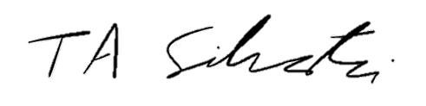
Tyler Silvestri
Secretary for Academic Governance
Approved: September 26, 2023

